RogueScript

CS470 Proposal / Design Document
Dillon Salsman Pressley
2/3/14

- Introduction

This project aims to create a roguelike as a web service written in Ruby JavaScript and HTML5. Roguelikes have been a longstanding niche genre of video games popular among advanced computer users. Roguelikes found their roots as console classics for Unix-based systems before evolving with graphical computers to make use of tile sets. Since their inception they have heavily influenced the creation of new genres such as hack-and-slash (Diablo) and turn based RPGs (Final Fantasy).

- Project Overview

This project is for personal growth and interest. I’ve chosen Ruby as it is a language I am interested in becoming familiar with that provides strong frameworks for web services. Basic roguelike gameplay involves movement, inventory management, combative actions such as attacking or firing a projectile, and non-combative such as eating, tunneling, and closing doors. Character creation before gameplay begins allows each game to be considered a unique experience. High scores post-mortem allow for each unique experience to be recorded. Advanced features could include a scriptable AI and a formal library (API) for creation of other roguelikes. Due to the dynamic nature of this content using JavaScript and Canvas elements from HTML5 along with a database appears to be the most plausible way to implement this project.

2.1 Data

Game files:
Several of the games configuration files will be written in XML and parsed using DOM or JSON.
How data will look:
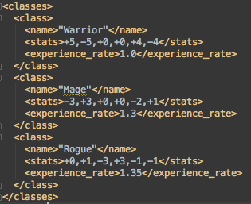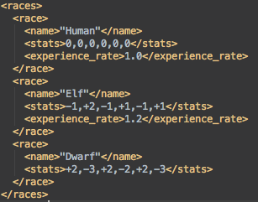
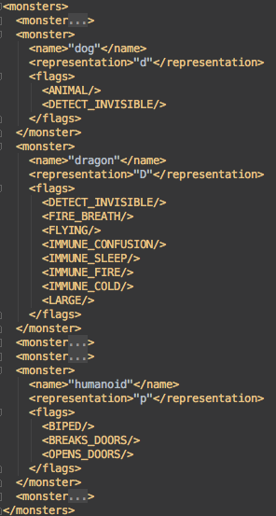
Over time these files should eventually be responsible for storing the following:
- Race details
  - Base stats such as Strength, Agility, Constitution, etc.
  - Resistances from different sources of damage.
  - Playable classes dictate what classes a specific race can play as.
  - Intrinsic properties such as Detect Invisible or Infravision (allowing the ability to sense warm-blooded or fire/ice-based monsters).
- Class details
  - Stat bonuses to each skill relevant to that class such as Dexterity to Rangers, Strength to Warriors, etc.
  - Intrinsic properties (see above).
- Monster details
  - Race such as snake, dog, dragon, etc.
  - Class warrior, mage, priest, etc.
  - Character representation such as ‘d’ for dog, ‘D’ for dragon, ‘o’ for orc, etc.
  - Unique name if the monster is unique.
- Items
  - Equipment
    - Weapons
      - Damage [min, max] measures what range of damage can be dealt on a successful blow
      - Speed measured in attacks per second
      - Ammo type for projectile weapons
      - Dual-wieldable for one handed weapons
    - Armor
      - Slot such as chest, head, legs, waist, feet, hands, etc.
      - Defense [min, max] measures what range of damage an individual piece of armor can mitigate.
    - Utility such as a torch or lantern.
  - Consumables
    - Potions provide various effects such as healing, nausea, or stat modifiers.
      - It should be noted that each potion has two names:
        - True name this is the name of the potion once it has been identified, such as “Potion of Healing.”
        - Color name this is potion appears before its effect is known, such as “Cyan Potion.”
      - Effect (defined below)
    - Food to prevent starvation and allow characters to continue performing actions.
      - Caloric value essentially dictates how many turns a piece of food provides satiation for.
    - Scrolls that any literate character can read (assuming there is light) causing a magical effect.
Unique to each user will be:
- Login and contact information.
- Preferences such as color palette or keybindings.
- Character data.
  - Each character the user has or had requires several dozens of variables such as name, race, class, stats, equipment worn, inventory, etc.

Login and contact information will be collection at registration time via form. Users will be required to login to access and play their characters. Contact information such as e-mail addresses allow for the recovery of accounts.

Preference data will likely be stored in XML format for easy parsing and to relieve the need for consistent database access. Changes from defaults will likely be done in game via menu navigation or a settings dialog.
Character data will be serialized and written to a binary file for smaller file size as well as easier saving and loading.
It should be noted that each level (known as a floor) of a roguelike is procedurally generated and would not normally need to be stored in a roguelike. However, due to the browser session nature of this implementation’s environment it becomes fundamental to be able to store the current floor within character files.
2.2 User Interface

Roguelike interfaces are generally either displayed using ASCII/ANSI text or using a tile set. Below are exaples of both types of interface in Angband, a popular roguelike.
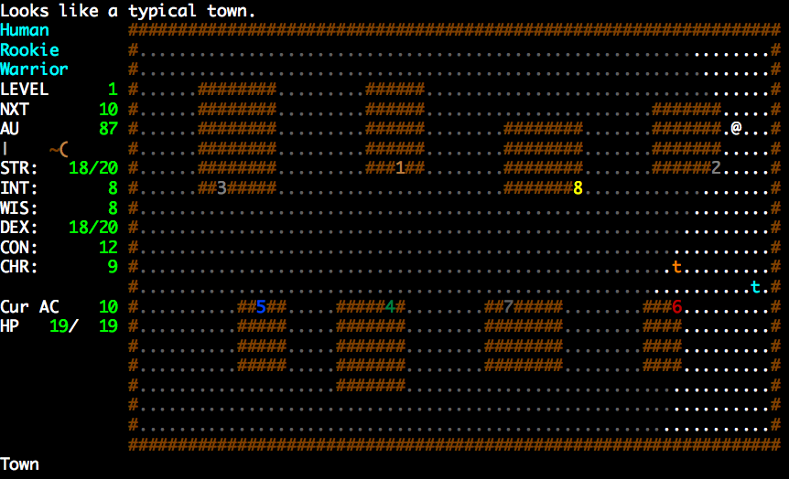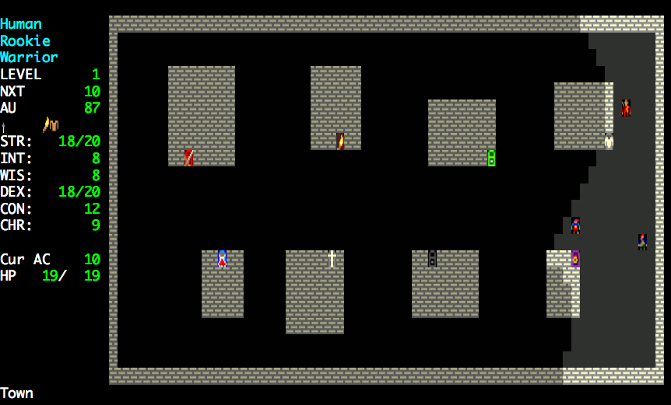
While this project will focus on an ASCII interface near the beginning, tile set support is a likely feature.

3. Project Requirements

Requirements are mostly inherently prescribed to the project as features considered staples to the roguelike genre. Due to the web interface, however, there are challenges that must be considered and overcome.

3.1 Functional Specifications

- The system must display a user interface for the user to interact with via keyboard.
- The user interface must consistently display all relevant information to the user in an intuitive and organized way.
- Key bindings must be set in such a way that they do not interfere with web browser key bindings.
- Users need a clear way to start, save, or close a session.
- Users must be able to change common preferences.

3.2 Interface Mock-Up
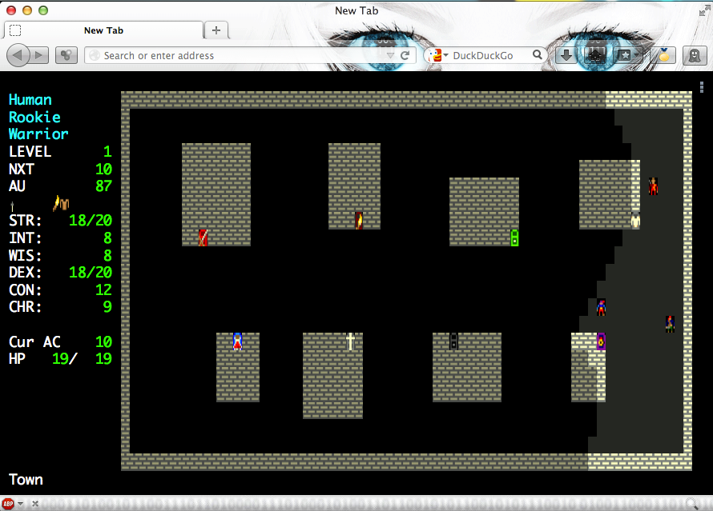
3.3 System Specifications

The project will be written in HTML5 and JavaScript in various text editors. The resulting web service will be hosted on a Linux webserver. The web service must accessible and run reasonably in modern browsers, with exception of Internet Explorer, running on modern operating systems and hardware.
4. System Design

Following is a minimal outline of what classes and algorithms must be implemented.

4.1 Classes

- Entity
  - Integers X and Y represent where an entity is within a floor.
  - Representation
    - ASCII/ANSI character
    - Color
    - Tile
- LivingEntity – extends Entity
  - PropertyMap
    - Associates string representations of stats/properties with values.
    - Can perform a union/intersection with another PropertyMap to add numeric values and merge binary properties.
    - Holds many values such as currentHP, maxHP, strength, dexterity, isBlind, etc.
  - Race – represents the race of the player and other NPCs
    - PropertyMap
  - Class – represents the class of the player and other NPCs
    - PropertyMap
  - Inventory
    - Collection of wielded and carried items.
  - String description
- Player – represents the player, extends LivingEntity
- NPC – represents NPCs, extends LivingEntity
- ItemEntity – extends Entity, serves as a physical wrapper for items when they are laying on the floor
  - Item – the item which is being wrapped
- Item – representation of item in
  - Enum ItemType
  - Numeric weight
  - String name
  - String description
- Properties – stores during runtime a users properties such as username, color palette, and key bindings
  - PropertyMap
- Floor
  - Integer depth (floor number)
  - 2D Tile array representing the floor itself.
  - List of Entities contained in the level

4.2 Webpages
- Landing page
  - Welcomes new and returning players
  - Displays news and change logs
  - Shows the game in action
- Registration
  - Allows new players to register an account to being playing
- Login
  - Allows returning players to login to the website and access their characters
- Account Details
  - Displayer and allow modification of account details
- Play
  - The page at which the game is played

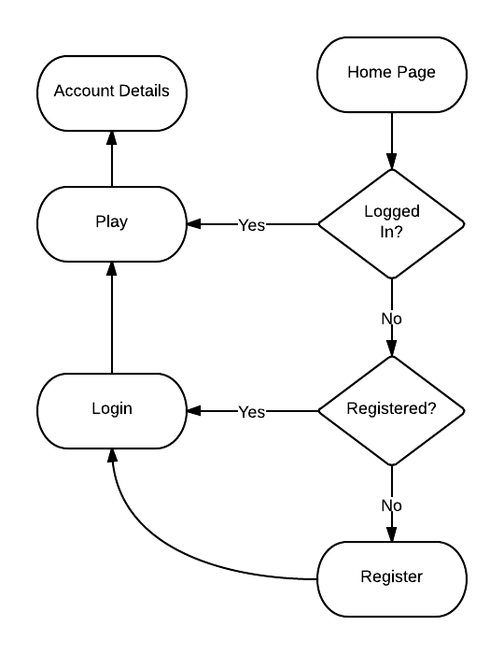
4.3 Game Loop

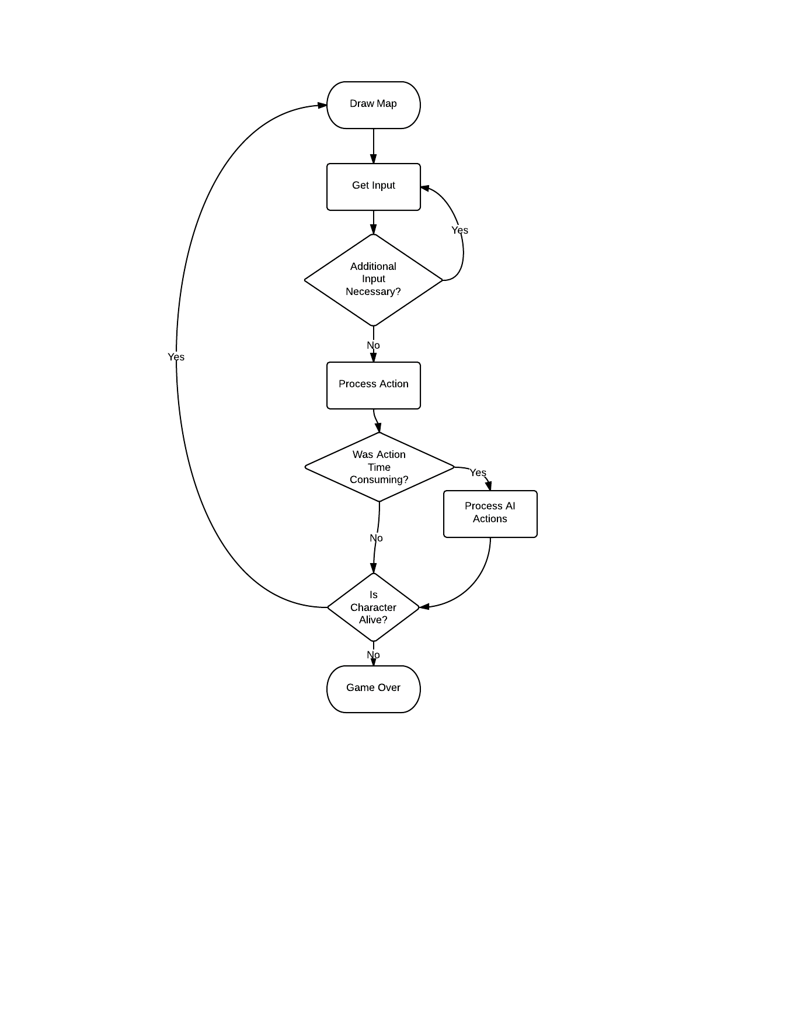

  - Algorithms

Algorithms will be necessary for:
- Procedural generation of levels
- Scaling stats and experience gain to both player level and floor depth
- Determining whether a tile is visible, account for line of site, light, etc.

5. Planning and Schedule
Due to the extensive base feature set expected of roguelikes, I intend to use evolutionary prototyping. I will begin by building a robust prototype and refine it throughout feature development, allowing additional features and improvements to be made throughout lifecycle.

Due to being the sole developer and my clients being fictitious, besides my professor and myself, I anticipate a significant portion of time in each of research, feature design and development, and testing.

I estimate that I will be able to spend approximately 12 hours per week working on the project. With 13 weeks remaining in the semester, this amounts to a total of 156 hours. The breakdown for each phase is then:

Requirements: 18 hours Design: 18 hours
Implementation: 60 hours Testing: 36 hours
Write-up: 12 hours Presentation: 12 hours

The large first prototype will take several weeks, especially for some of the unknowns such as data encapsulation, session management, processing user input, and learning how to use HTML5 canvas. Once that is completed it will be easier to provide a timeframe of when additional features can be completed.

6 Summary

This project is being developed in HTML5 and JavaScript for my own personal growth and interest with the goal of creating a roguelike. Because of the broad base feature set, I will be using evolutionary prototyping with spiral methodology to ensure that I remain on track, development time is always spent towards a finished product, and that features and improvements can be added at any point during the development process. Challenges of this project will be session management, feature creep, and ensuring uniform behavior across different platforms.

