**Presentation, Ethics/Professional Issues, Social/Global Impact   
Dillon Salsman Pressley**

**Communication**

After watching my presentation, I was actually rather pleased with myself. I think I might have spent a bit more time looking at the screen than I’d prefer, but I appeared in control of the subject matter, and only slightly nervous.   
  
My powerpoint presentation could have had a little more work put into it but what’s done is done.

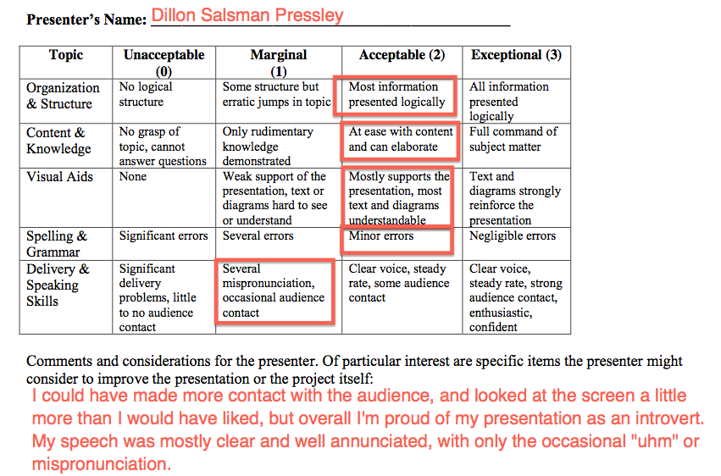

**Ethics/Professional Activities**

**Google’s EU Data Protection Direction conformance:**

1. Notice—data subjects should be given notice when their data is being collected;

By agreeing to Google’s privacy policy you acknowledge that information you submit is being collected, as well as your behaviors and actions using Google services. Additionally, information about your device may be collected.

1. Purpose—data should only be used for the purpose stated and not for any other purposes;

According to Google, “We use the information we collect from all of our services to provide, maintain, protect and improve them, to [**develop new ones**](http://www.google.com/policies/privacy/example/develop-new-ones.html), and to [**protect Google and our users**](http://www.google.com/policies/privacy/example/protect-google-and-our-users.html). We also use this information to offer you tailored content – like giving you more relevant search results and ads.”

1. Consent—data should not be disclosed without the data subject’s consent;

“We will share personal information with companies, organizations or individuals outside of Google when we have your consent to do so. We require opt-in consent for the sharing of any [sensitive personal information](http://www.google.com/policies/privacy/key-terms/#toc-terms-sensitive-info).

…

We will share personal information with companies, organizations or individuals outside of Google if we have a good-faith belief that access, use, preservation or disclosure of the information is reasonably necessary to:

* meet any applicable law, regulation, legal process or enforceable governmental request.
* enforce applicable Terms of Service, including investigation of potential violations.
* detect, prevent, or otherwise address fraud, security or technical issues.
* protect against harm to the rights, property or safety of Google, our users or the public as required or permitted by law.”

1. Security—collected data should be kept secure from any potential abuses;

“We work hard to protect Google and our users from unauthorized access to or unauthorized alteration, disclosure or destruction of information we hold. In particular:

* We encrypt many of our services [using SSL](http://support.google.com/websearch/bin/answer.py?answer=173733&en).
* We offer you [two step verification](http://www.google.com/intl/en/landing/2step/) when you access your Google Account, and a [Safe Browsing feature](http://www.google.com/chrome/intl/en/more/security.html) in Google Chrome.
* We review our information collection, storage and processing practices, including physical security measures, to guard against unauthorized access to systems.
* We restrict access to personal information to Google employees, contractors and agents who need to know that information in order to process it for us, and who are subject to strict contractual confidentiality obligations and may be disciplined or terminated if they fail to meet these obligations.”

1. Disclosure—data subjects should be informed as to who is collecting their data;

Google clearly outlines across several pages what data is collected by its services.

1. Access—data subjects should be allowed to access their data and make corrections to any inaccurate data;

“Whenever you use our services, we aim to provide you with [**access to your personal information**](http://www.google.com/policies/privacy/example/access-to-your-personal-information.html). If that information is wrong, we strive to give you ways to update it quickly or to delete it – unless we have to keep that information for legitimate business or legal purposes. When updating your personal information, we may ask you to verify your identity before we can act on your request.”

1. Accountability—data subjects should have a method available to them to hold data collectors accountable for not following the above principles

There are no clear guidelines about how to hold Google accountable in the event that a breach of its policy occurs.

**Summary**

It would seem that other than accountability, Google has strived to make its privacy policy conform to EU’s Data Protection Directive.

**Kim Dotcom**

I believe that Kim Dotcom’s actions have been justified under consequential utilitarianism. The services Megaupload provided is one that is needed. The misuse by users is somewhat unfortunate for copyright owners. However, to say that they have lost any figure of income due to piracy accomplished via Megaupload is absurd. Piracy will always find a platform, and users who pirate copyrighted material would often not have purchased the copyrighted material if purchasing were the only avenue of obtainment. The piracy that occurred at Megaupload is still occurring elsewhere, while the legitimate users of Megaupload have been harmed in its abolition. The abolition of Megaupload has been a net loss in terms of the happiness and usefulness of services available on the Internet to its denizens.

**Stupendous Software**

**Dilemma: Should Bob use the software?  
   
Stakeholders:**

* Junior Programmers – The junior programmers have a right to privacy, but also benefit from the software being used. However, they could be fired for the unproductive habits throughout the day.
* Bob the Senior Programmer – Bob must meet his own boss’s expectations and deliver functional software on time. By using this software Bob encourages productivity and is able to better help his subordinates when they need guidance.

**Conclusion:** Bob’s use of the software provides a net positive affect on the happiness and productivity of all parties involved. Bob is better able to train his junior programmers, and is able to provide better productivity to Bill, his own boss. Under consequential utilitarianism, it seems appropriate for Bob to use the software.  
  
Additionally, under points 7 and 10 of the IEEE Code of Ethics, Bob’s use can be argued as appropriate due to the ability provided by the Junior Programmers to seek, accept, and offer honest criticism of technical work, to acknowledge and correct errors, and to assist the Junior Programmers in their professional development.

**Dilemma: Should Bill use the software?**

**Stakeholders**:

* Junior Programmers – If Bill were to use the software, the junior programmers would be at risk of having only a small portion of their work habits representing their productivity as a whole.
* Bob – Bob can be seen as a poor supervisor if Bill evaluates productivity negatively due to a small snapshot of day-to-day work as apposed to the overall productivity of each employee over a span of time.
* Bill – Bill’s measure of productivity would likely be misguided by using this software.

**Conclusion**: Under consequential utilitarianism, I feel that Bill’s use of the software is unjustified as it poses to do harm to his employees without actually measuring their productivity.

**Workplace Monitoring in the United States:**It appears that federal law in the United States permits nearly all forms of workplace computer monitoring.

**Project License:**

I have chosen the MIT license for my project as follows:  
The MIT License (MIT)

Copyright (c) 2014 dmsalsman of github.com

Permission is hereby granted, free of charge, to any person obtaining a copy

of this software and associated documentation files (the "Software"), to deal

in the Software without restriction, including without limitation the rights

to use, copy, modify, merge, publish, distribute, sublicense, and/or sell

copies of the Software, and to permit persons to whom the Software is

furnished to do so, subject to the following conditions:

The above copyright notice and this permission notice shall be included in

all copies or substantial portions of the Software.

THE SOFTWARE IS PROVIDED "AS IS", WITHOUT WARRANTY OF ANY KIND, EXPRESS OR

IMPLIED, INCLUDING BUT NOT LIMITED TO THE WARRANTIES OF MERCHANTABILITY,

FITNESS FOR A PARTICULAR PURPOSE AND NONINFRINGEMENT. IN NO EVENT SHALL THE

AUTHORS OR COPYRIGHT HOLDERS BE LIABLE FOR ANY CLAIM, DAMAGES OR OTHER

LIABILITY, WHETHER IN AN ACTION OF CONTRACT, TORT OR OTHERWISE, ARISING FROM,

OUT OF OR IN CONNECTION WITH THE SOFTWARE OR THE USE OR OTHER DEALINGS IN

THE SOFTWARE.

**Smartphone Mouse Application**:  
I do not believe the application, as a whole, is patentable. It may be that the additional features could be patented.

If the patent was received I would be allowed to license the innovation to other software creators, send take-down notices to developers using the innovation without license, as well as claim a portion of profits gained from software which uses this innovation without license.

**Local/Global/Societal Impact**

My project was created for personal growth as a developer and somebody who enjoys the roguelike genre. It does not impact others in any way what-so-ever.