L3-W4-DBS301-select with date

Due: Friday midnight of week 4 (better if week 3)

*STEP 1: rename this file to L3-your id name*

*STEP 2: Put the SQL and the results after each question below*

*STEP 3: Email this back before the deadline. Subject line L3-your id Section ???*

1. Write a query to display the tomorrow’s date in the following format:

*September 28th of year 2006*

Your result will depend on the day when you create this query.

Label the column Tomorrow.

SELECT TO_CHAR(SYSDATE + 1, 'fmMonth ddth "of" YYYY') AS "Tomorrow"

FROM DUAL;



2. For each employee in departments 20, 50 and 60 display last name, first name, salary, and salary increased by 7% and expressed as a whole number.

Label the column Good Salary.

Also add a column that subtracts the old salary from the new salary and multiplies by 12.

Label the column Annual Pay Increase.

SELECT last_name, first_name, salary,

ROUND(salary * 1.07) AS "Good Salary",

((salary * 1.07) - salary) * 12 AS "Annual Pay Increase"

FROM employees

WHERE department_id IN(20, 50, 60);

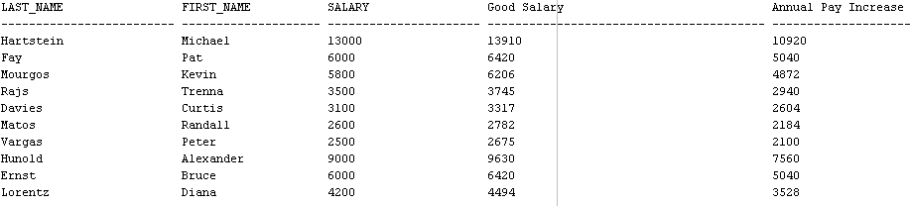

3. Write a query that displays the employee’s Full Name and Job Title in the following format:

*DAVIES, CURTIES is Store Clerk*

Only employees whose last name ends with *S* and first name starts with *C* or *K*.

Give this column an appropriate label like *Person and Job*

Sort the result by the employees’ last names.

SELECT UPPER(first_name || ',' || last_name) || ' is ' ||

CASE job_id WHEN 'AC_ACCOUNT' THEN 'Accountant'

WHEN 'AC_MGR' THEN 'Account Manager'

WHEN 'AD_ASST' THEN 'Advertising Assistent'

WHEN 'AD_VP' THEN 'Advertising VicePresident'

WHEN 'IT_PORG' THEN 'IT Programmar'

WHEN 'MK_MAN' THEN 'Marketing Management'

WHEN 'MK_REP' THEN 'Marketing Representative'

WHEN 'SA_MAN' THEN 'Sales Management'

WHEN 'SA_REP' THEN 'Sales Representative'

WHEN 'ST_CLERK' THEN 'Store Clerk'

WHEN 'ST_MAN' THEN 'Store Management'

END

AS "Person and Job"

FROM employees

WHERE UPPER(last_name) LIKE '%S' AND

(UPPER(first_name) LIKE 'C%' OR UPPER(first_name) LIKE 'K%')

ORDER BY last_name;

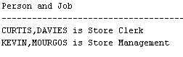

4. For each employee hired before 1992, display the employee’s last name, hire date and calculate the number of YEARS between TODAY and the date the employee was hired. Label the column Years worked.

Order your results by the number of years employed.

Round the number of years employed up to the closest whole number.

SELECT last_name, hire_date,

ROUND((SYSDATE - hire_date)/365) AS "Years worked"

FROM employees

WHERE hire_date < '92-01-01'

ORDER BY 3;

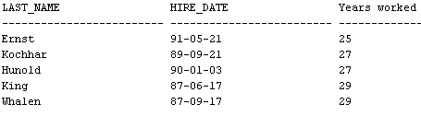

5. Create a query that displays the city names, country codes and state province names, but only for those cities that start on *S* and have at least 8 characters in their name. If city does not have province name assigned, then put *Unknown Province.*

SELECT city, country_id,

nvl(state_province, 'Unknown Province') AS "STATE_PROVINCE"

FROM locations

WHERE city LIKE 'S%'

AND LENGTH(city) > 8;

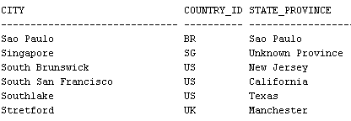

6. Display each employee’s last name, hire date, and salary review date, which is the first Tuesday after a year of service, but only for those hired after 1997.

Label the column REVIEW DAY.

Format the dates to appear in the format similar to

*TUESDAY, August the Thirty-First of year1998*

SELECT last_name, hire_date,

TO_CHAR(NEXT_DAY(ADD_MONTHS(hire_date, 12), 'Tuesday'), UPPER('fmDay') || '"," Month "the" ddspth "of year" YYYY')

AS "REVEIW DAY"

FROM employees

WHERE hire_date > '97-12-31'

