SQL-DBS201 ASSIGNMENT-1

DUE DATE: Nothing will be accepted after this date. It will get a zero

**Due BEFORE MIDNIGHT on the Monday, February 29, 2016**

**Submission:**

Submit this document with SQL query and OUTPUT of the query.

**WHEN YOU PRINT OUTPUT MAKE SURE YOUR COLLECTION NAME SHUOLD BE THERE.**

If any output goes on for more than 10 lines, only cut and paste the first 10 or so. I don't want to get this word document too big.

**PLAGIARISM**   
When you submit an assignment, you are saying that the submission is your own work and as such you wish to be given credit for the work.

INSTRUCTION:

The following tables are used for this assignment.

Create following tables in your collection and insert minimum 10 rows for all TABLES.

|  |  |
| --- | --- |
| CREATE TABLE CUSTOMER  (CNAME CHAR(20) PRIMARY KEY,  CSTREET CHAR(20) NOT NULL,  CCITY CHAR(20) NOT NULL,  CPROV CHAR(20) NOT NULL,  CPOSTAL CHAR(10),  CHPHONE CHAR(13),  CBPHONE CHAR(13)  ); | CREATE TABLE CAR  (SERIAL CHAR(8) PRIMARY KEY,  CNAME CHAR(20) REFERENCES CUSTOMER(CNAME),  MAKE CHAR(10) NOT NULL,  MODEL CHAR(8) NOT NULL,  CYEAR CHAR(4) NOT NULL,  COLOR CHAR(12) NOT NULL,  TRIM CHAR(16) NOT NULL,  ENGINETYPE CHAR(10) NOT NULL,  PURCHINV CHAR(6),  PURCHDATE DATE,  PURCHFROM CHAR(12),  PURCHCOST DECIMAL(9,2),  FREIGHTCOST DECIMAL(7,2),  TOTALCOST DECIMAL(9,2),  LISTPRICE DECIMAL(9,2)); |
| CREATE TABLE PROSPECT  (CNAME CHAR(20) NOT NULL REFERENCES CUSTOMER(CNAME),  MAKE CHAR(10) NOT NULL CHECK (MAKE IN ('ACURA','MERCEDES','LAND ROVER','JAGUAR')),  MODEL CHAR(8) UNIQUE,  CYEAR CHAR(4) UNIQUE,  COLOR CHAR(12) UNIQUE,  TRIM CHAR(16) UNIQUE,  ); | CREATE TABLE SERVINV  (SERVINV CHAR(5) PRIMARY KEY,  SERDATE DATE NOT NULL,  CNAME CHAR(20) NOT NULL REFERENCES CUSTOMER(CNAME),  SERIAL CHAR(8) NOT NULL REFERENCES CAR(SERIAL),  PARTSCOST DECIMAL(7,2),  LABORCOST DECIMAL(7,2),  TAX DECIMAL(6,2),  TOTALCOST DECIMAL(8,2)  ); |
| CREATE TABLE SALEINV  (SALEINV CHAR(6) PRIMARY KEY,  CNAME CHAR(20) NOT NULL REFERENCES CUSTOMER (CNAME),  SALESMAN CHAR(20),  SALEDATE DATE NOT NULL,  SERIAL CHAR(8) NOT NULL REFERENCES CAR (SERIAL),  TOTALPRICE DECIMAL(9,2),  DISCOUNT DECIMAL(8,2),  NET DECIMAL(9,2),  TAX DECIMAL(8,2),  LICFEE DECIMAL(6,2),  COMMISSION DECIMAL(8,2),  TRADESERIAL CHAR(8) REFERENCES CAR (SERIAL),  TRADEALLOW DECIMAL(9,2),  FIRE CHAR(1) CHECK (FIRE IN ('Y','N')),  COLLISION CHAR(1) CHECK (COLLISION IN ('Y','N')),  LIABILITY CHAR(1) CHECK (LIABILITY IN ('Y','N')),  PROPERTY CHAR(1) CHECK (PROPERTY IN ('Y','N'))); |  |

1. List all the data in all tables.

**Cut and paste the code here (queary)**. It must be written in good readable form and not all jammed together.

**SELECT** *

**FROM** PREME19.CUSTOMER;

**SELECT** *

**FROM** PREME19.PROSPECT;

**SELECT** *

**FROM** PREME19.CAR;

**SELECT** *

**FROM** PREME19.SERVINV;

**SELECT** *

**FROM** PREME19.SALEINV;

**Cut and paste the result here**.

**CUSTOMER**

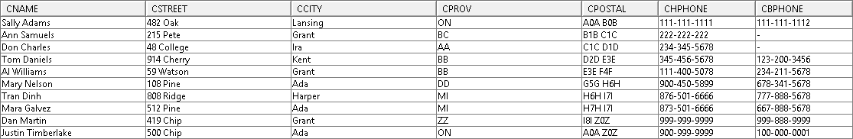

**PROSPECT**

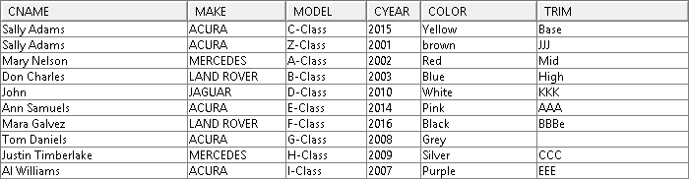

**CAR**

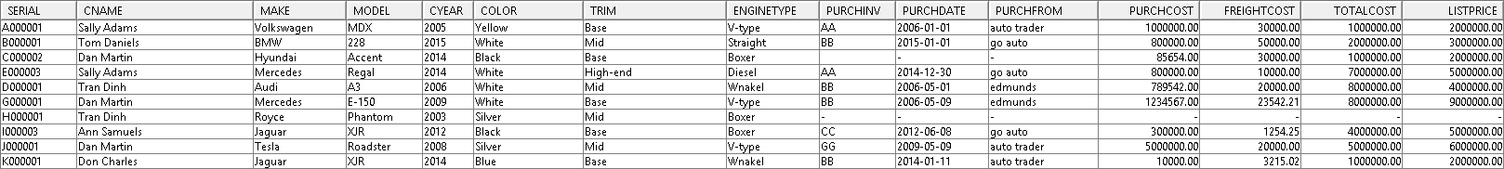

**SERVINV**

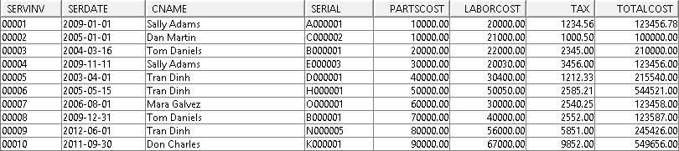

**SALEINV**

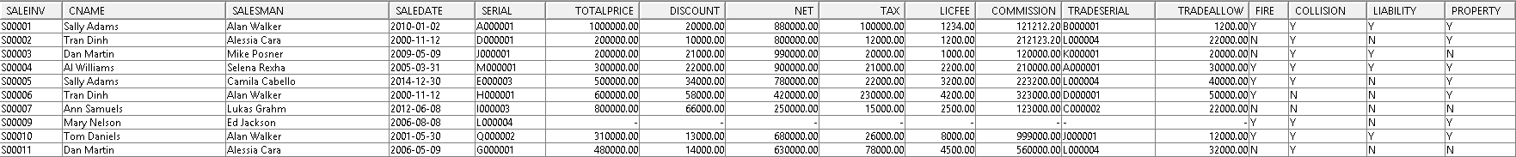

2. How many vehicles were sold with some kind of insurance?

**SQL:**

**SELECT** COUNT(*) AS "Sold Cars"

**FROM** PREME19.SALEINV

**WHERE** FIRE = 'Y' OR COLLISION = 'Y' OR LIABILITY = 'Y' OR PROPERTY = 'Y';

**OUTPUT:**



3. Show all customer information for people interested in blue Jaguars.

**SQL:**

**SELECT** c.CNAME, c.CSTREET, c.CCITY, c.CPROV, c.CPOSTAL, c.CHPHONE, c.CBPHONE

**FROM** PREME19.CAR ca, PREME19.CUSTOMER c

**WHERE** ca.CNAME = c.CNAME

**AND** MAKE = 'Jaguar'

**AND**  COLOR = 'Blue';

**OUTPUT:**



4. List the names and home phone numbers of customers who purchased Jaguar XJRs and who do not have a business phone. (Descending name order) (No duplicates.)

**SQL:**

**SELECT** DISTINCT c.CNAME, c.CHPHONE

**FROM** PREME19.SALEINV s, PREME19.CUSTOMER c, PREME19.CAR ca

**WHERE** s.CNAME = c.CNAME

**AND** ca.SERIAL = s.SERIAL

**AND** MAKE = 'Jaguar'

**AND** MODEL= 'XJR'

**AND** c.CBPHONE IS NULL

**ORDER BY** c.CNAME DESC;

**OUTPUT:**



5 What is the average cost of service visits on 2009 Mercedes?

**SQL:**

**SELECT** AVG(s.TOTALCOST) AS "Average Cost"

**FROM** PREME19.CAR c, PREME19.SERVINV s

**WHERE** c.SERIAL = s.SERIAL

**AND** CYEAR = 2009

**AND** MAKE = 'Mercedes';

**OUTPUT:**



6 List the name and phone number of all customers who have purchased a car

**SQL:**

**SELECT** c.CNAME, c.CHPHONE, c.CBPHONE

**FROM** PREME19.CUSTOMER c, PREME19.SALEINV s

**WHERE** c.CNAME = s.CNAME;

**OUTPUT:**

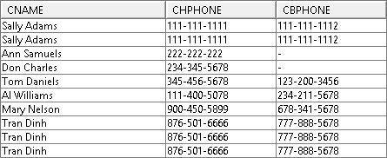

7 Print a list of salespersons names who have sold less than 3 cars.

**SQL:**

**SELECT** SALESMAN

**FROM** PREME19.SALEINV

**GROUP BY** SALESMAN

**HAVING** COUNT(SALEINV) < 3;

**OUTPUT:**

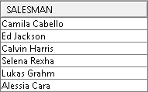

8 Update the customer street by ‘Moldovan drive’ for customer JOHN.

**SQL:**

**UPDATE** PREME19.CUSTOMER

**SET** CSTREET = 'Moldovan dirve'

**WHERE** CNAME = 'John';

**OUPUT:**

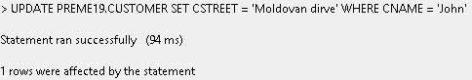



9 Remove the row from the car table for make “ACURA”.

**SQL:**

**DELETE FROM** PREME19.CAR

**WHERE** MAKE = ‘Acura’;

**OUTPUT:**



The system won’t let us delete it because it’s a reference key.

10 Create a VIEW which includes the customer name, address, service invoice number and date along with the total value of each invoice. Give it a reasonable name.

**SQL:**

**CREATE VIEW** CUSTOM_SERV **AS**

SELECT c.CNAME, c.CSTREET || c.CCITY || c.CPROV || c.CPOSTAL AS "Customer Address", s.SERVINV, s.SERDATE || ' : ' || s.TOTALCOST AS "Total value"

**FROM** PREME19.CUSTOMER c, PREME19.SERVINV s

**WHERE** c.CNAME = s.CNAME;

**OUTPUT:**



