EHPT-SCANNING ENUMERATION- LAB2
SCANNING and Enumeration technique
1. Open Windows powershell.
2. Type arp -a
3. Identify how many other IP addresses are connected to the same network as you.

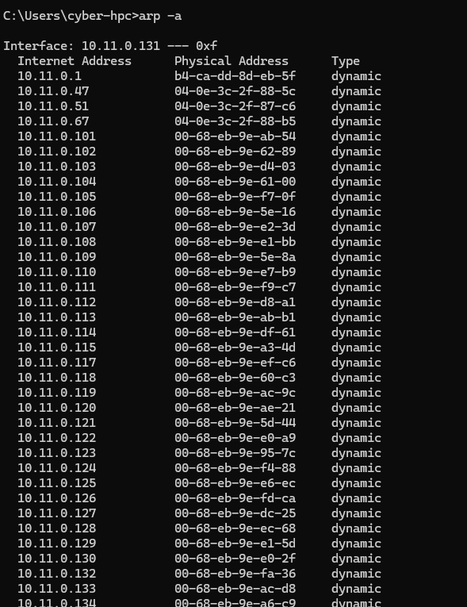

1.Download nmap
2.Additionally install ncap
Open powershell after installation
