In order to complete this digital flight and service reservation system upgrade task better and more efficiently. We will make three system tests according to the progress and write three reports to feedback our system development. This task was implemented on August 25, with an estimated completion time of 52 days and completed on November 4. The three reports are expected to be on October 4, October 24, and October 28.

**The first part of the report:**

Our project manager held a meeting after receiving the task, and the project manager and project designer participated in the discussion. The work content and requirements are given by the project designer, and then passed to the programmers. The specific content of the requirement is that the air ticket reservation system should facilitate users to classify and query tickets, improve work efficiency, facilitate operation, and can effectively update and query data, thereby achieving automation to a certain extent.

(1) Function Provides ticket booking service for tourists, which facilitates the ticket sales of the tourism bureau and improves the service quality and efficiency of the tourism bureau. Provide airport staff with a management system for ticket-related content such as ticket refunds to facilitate the management of air tickets by airport staff and improve the efficiency of air ticket management by airport staff.

(2) Performance accuracy: The entered information (including flight information, airline ticket reservations, etc.) must be accurately recorded in the system. Real-time: It can be reflected on the ticket management system platform in time, and can be refreshed, backed up and restored in time. Security: The data entry adopts the verification method as much as possible to strictly verify, the maintenance and management of the data is specifically responsible for the system administrator, and the system has strong scalability.

(3) The system inputs various information contained in the process of airline ticket reservation.

(4) The output of the system: query results and various report data should be complete, detailed, concise, fast and real-time.

(5) Security and confidentiality requirements: the system provides different functional modules for users with different permissions. Only users with certain permissions can perform changes to historical data and add new data. General users can only perform query operations. The key data of the database shall be kept confidential. The overall requirement is the realization of the system, which greatly improves the efficiency of the ticket reservation service of the Tourism Bureau. Reduce the error rate in air ticket management, reduce the tedious process of information exchange and unnecessary expenses.

Under the supervision of the project manager, the division of labor is discussed within the programmer group and a work plan is made. According to the plan, we need 14 days to complete the product demand survey. During this period, we made a series of judgments on the customer's situation through telephone contact, questionnaire survey and face-to-face interviews. Based on the understanding of customers, we have made several important assessments of products, including product risk assessment, product development cost assessment and product value assessment. Risk assessment is mainly for the long process of developing large-scale software. Faced with extremely intricate problems, people’s subjective perceptions cannot fully conform to the objective reality, and the communication and cooperation between various types of personnel closely related to the project cannot be perfect. . Product consumption is mainly research funds and system maintenance costs. The value of the product lies in the number of customers using the system, as well as basic customer information and transaction information.

**The second part of the report:**

Due to the incompleteness of the existing airline ticketing system, there are many defects in the ticket processing system. Especially in recent years, the rapid popularization of the Internet has made the artificial system unable to keep up with the pace of the times, while the computer system is too old and does not have some new functions, so it can be updated, inquired, etc. It is very necessary for the multifunctional and automated air ticket reservation system that can perform accurate, real-time, and fast processing of data, and the price can be accepted by the majority of users.

The design processing flow and data flow are as follows:

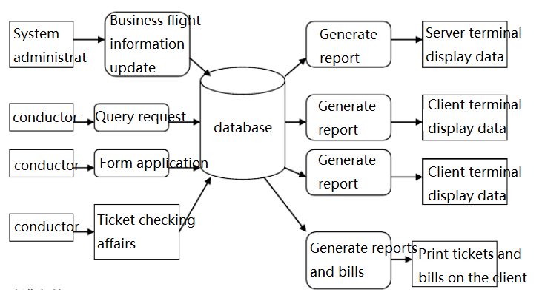

Improvements: The system is conducive to the centralized and effective processing of data, enhances the flexibility of the system, and can better ensure the security of the database.

Impact:

1. Impact on equipment

Machines above 586 can use this software.

2. Impact on software

The existing application software and supporting software are fully adapted to the proposed system.

3. Impact on user organizations

The adoption of this system will greatly increase the hit rate for users to find relevant information, which will help optimize decision-making and improve office efficiency. At the same time, this system will help save office supplies and further reduce expenditures.

4. Impact on system operation

a. The user should operate in accordance with the operation manual of this product and the relevant supporting materials provided;

b. No influence on the preprocessing of input process data;

c. No effect on the output processing;

d. An abnormal situation will occur after the system fails, and the recovery method will be to end the current task or restart the computer;

5. Impact on development

a. With the development of computer technology, the software can be upgraded to make the operation interface more beautiful, more convenient to use, and to correct deficiencies in time;

b. At the same time, a certain amount of manpower and equipment resources must be updated;

c. Apply for a patent and use legal means to protect the system;

6. Impact on location and facilities

The project does not require major changes to the original location and facilities.

7. Impact on expenditures

For the development of the proposed system, all the costs required are expected to be recovered in two years.

**The third part of the report:**

Black box testing: Black box testing is also called functional testing, which is to test whether each function can be used normally. In the test, the program is regarded as a black box that cannot be opened, and the program interface is tested without considering the internal structure and internal characteristics of the program. It only checks whether the program functions are used normally according to the requirements specification. Whether the program can properly receive input data and produce correct output information. Black box testing focuses on the external structure of the program without considering the internal logical structure, and mainly tests the software interface and software functions. Black box testing is based on the user's perspective, starting from the corresponding relationship between input data and output data. Obviously, if there is a problem with the design of the external feature it or the specification is wrong, the black box test method cannot be found.

White box testing: White box testing is also called structural testing or logic-driven testing. It is based on the internal structure testing procedure of the program. It checks whether the internal actions of the product are carried out normally in accordance with the design specifications and inspects each path in the program. Whether it can work correctly as scheduled. This method treats the test object as an open box. The tester designs or selects test cases based on the information related to the internal logic structure of the program, tests all the logic paths of the program, and determines the actual status by checking the status of the program at different points. Whether the status is consistent with the expected status.

Test items:

User part:

1. Name: Login and Register

Content: When the user logs in to the system for the first time, he needs to register an account and fill in relevant information to log in to the system. When the user already has an account, you can enter the account and password to log in.

Purpose: To control the personnel entering the system, to increase the system's security, and to protect the user's personal information.

2. Name: Change Password

Content: After the user successfully logs in, he can click the related button to modify the password, enter the account name, old password, and enter the new password twice.

Purpose: To facilitate users to change their passwords and increase user information security.

3. Name: Query flight information and book tickets.

Content: After logging in, the user can query by flight information and query the origin and destination. After the two inquiries or not through the inquiry, the function of booking tickets can be realized. In the ticket booking, you can select each of the existing aircraft in the system, and you can book economy class, business class, and first class.

Purpose: To facilitate users to inquire about flight information in the system and realize ticket reservation.

4. Name: Refund

Content: If the user has already booked the relevant air ticket, and there are some special things that cannot catch the plane, the ticket can be refunded in the system.

Purpose: To facilitate users to change or cancel bookings.

Administrator part:

1. Name: Login

Content: The administrator enters the account name and password to log in.

Purpose: To facilitate the management of flight information and user bookings.

2. Name: Add flight information

Content: If the system needs to add a certain flight of related flight, it can be realized by adding flight information.

Purpose: Update flight information in the system to facilitate users' query operations.

3. Name: Query and delete flights

Content: After logging in, the administrator can perform the operation of querying flight information, and can perform the operation of deleting related flights.

Purpose: To update the flight information in the system in real time to facilitate user inquiries.

4. Name: Query user booking status

Content: After the administrator logs in, he can click to query the user's booking status.

Purpose: Real-time understanding of user booking status in the system.

Black box test: Use the black box test method to test the user login function

White box test: Use the white box test to test the user login and ticket booking module the test flow chart is as follows

1. Account login

2. User account information verification

3. Air ticket booking

4. Ticket information query

5. Save and submit

Get conclusion:

1. This software can basically realize the user's ticket booking, query, modification, and refund; and the administrator's query delete function.

2. The conversion of the window may be a little imperfect, the page using C language is not beautiful enough, and C language cannot use the database.

3. When I tested it, I found that the password could be entered even when the password was incorrect. So I modified part of the code, improved it with string matching, and solved the bug.

4. This software has passed the test and can run.