Dmitriy Tarasov
CSCI 4446
HW1
The logistic map is defined by the equation
for R=2, the plots
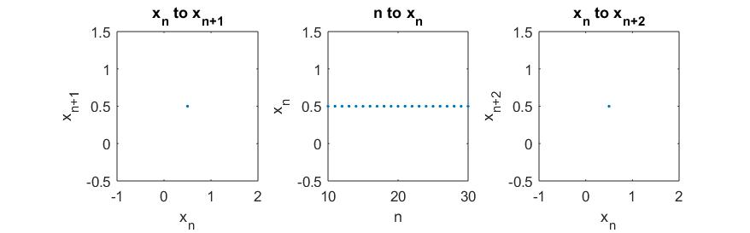
show there's a fixed point at and that the time series converges to the fixed point.
for R=3.3, there is a pitchfork bifurcation in the logistic map
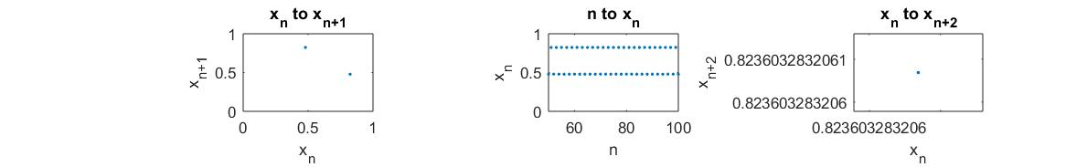
which for the has a stable fixed point due to the period 2 cycle switching between q and p at everyof the logistic map .

For R=3.8 there is chaotic behavior the plots are for and
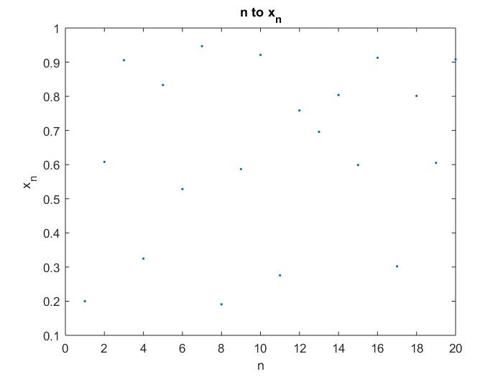
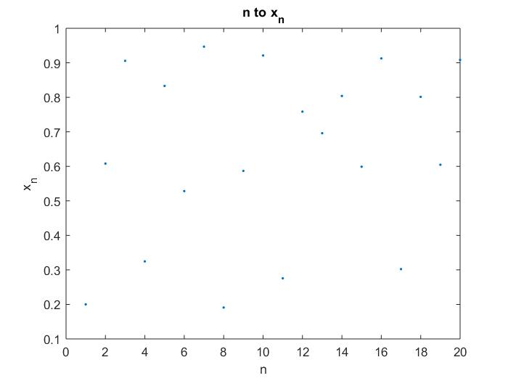
which exhibit similar initial behavior and then diverges as shown by this difference plot of the two initial conditions.
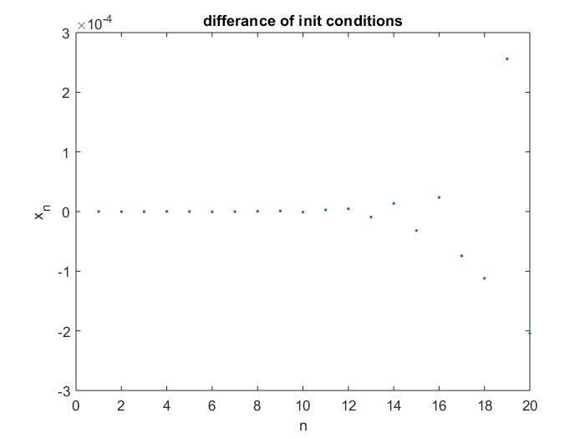

For R > 4, the system diverges from the mapping function f ( [0,1] → [0,1] )
For R=2.5 the logistic map has a stable fixed point which converges to the value of x*= 0.6
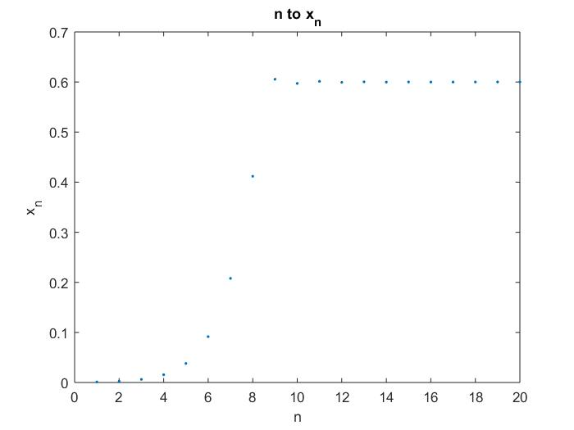
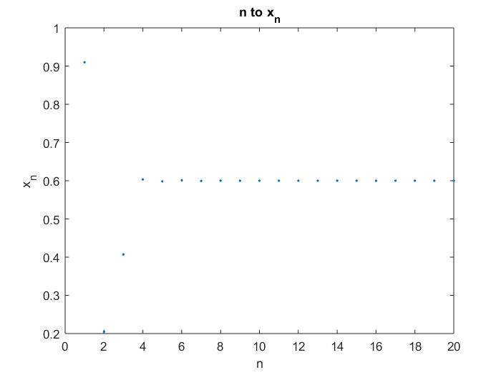
Summary of behavior
R | Behavior
R<1 | convergence to fixed point at x=0
1<R<3 | convergence to fixed point
3<R<3.4 | Period two cycle
R>3.6 | chaotic behavior in logistic map
R=3.83 | period 3 cycle
R>4 | system diverges to infinity

