Dmitriy Tarasov
CSCI 4446
Assignment 12: Two body problem
The two body problem is defined by the equations

where The initial conditions of the system are the following
=(0,0,0,0,0,0,2,0,0,0,1,0)
The numerical parameters of the Runge-Kutta 4 were a time-step of h=0.001 and 20,000 time steps.
The graph of the two body problem masses is the following.
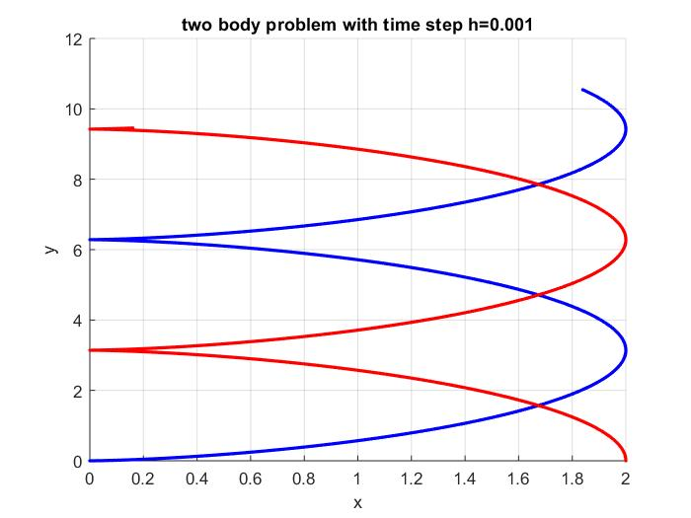
The movement of the center of mass is strictly upwards. This makes sense due to the initial conditions of having one mass being still and the other having upward velocity. Thus the center of mass which would be in the middle would have half of the second masses velocity by conservation of energy.

