Dmitriy Tarasov
CSCI 4446
Assignment 13: Three Body Problem
The initial conditions of the system are defined as the 18 variables

which are set as [0,0,0,0,0,0,2,0,0,0,1,0,0,b,0,0,-0.15,0] where b is the configurable parameter of the third mass. The system was solved with an fixed time Runge-Kutta with time-step h=0.001 and the 500,000 steps
- when the parameter b=10000 then the system is the following.
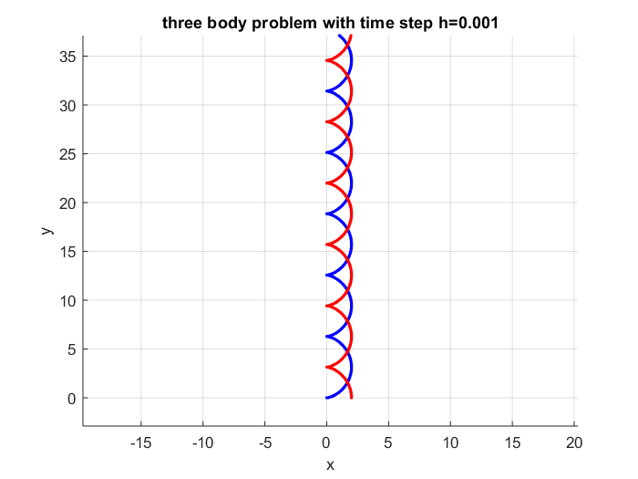
The system makes sense as the gravity field of the third mass is so far away that it would have negligible effect on the interaction of the other two masses.
- The initial conditions of the system change is to [0,0,0,0,0,0,2,0,0,0,1,0,1,b,0,0,-0.15,0] so the field star would be in the center of the orbit of the other two stars. When the configurable parameter b=20, then the system has the following graph.
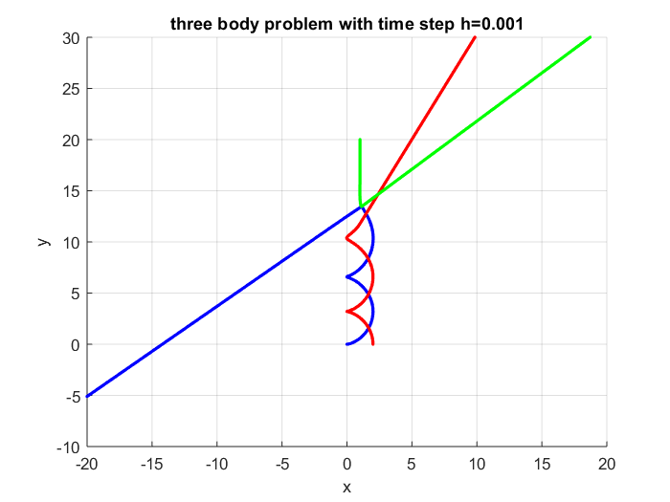
The system doesn't match the behavior of the Hut & Bahcall paper. A plausable reason to the behavior is that the position of the field star relative to the rotation of the other two stars when they approach very near.
- Changing the true anomaly with the perturbation of the initial condition of the field start.
Having the parameter b=22 gives the resulting graph
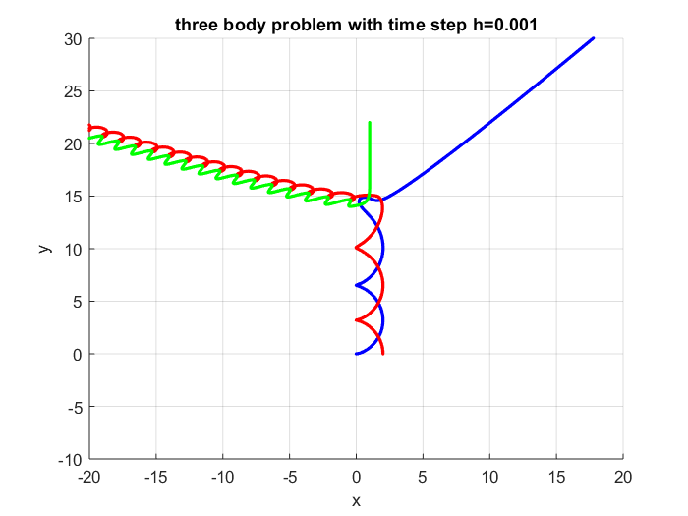
The parameter value of b=23.5 produces the result of
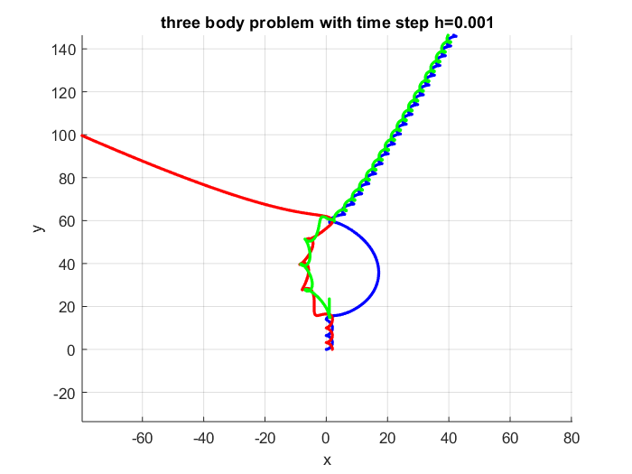
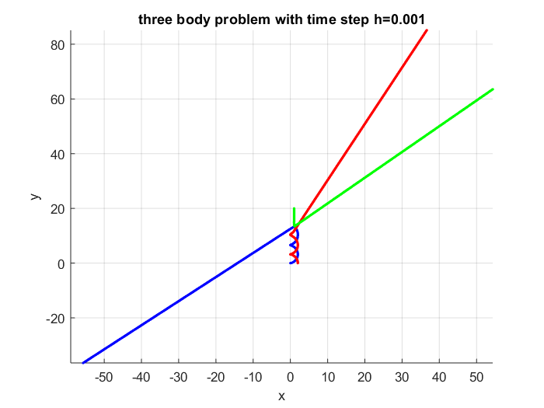
The interaction has a property of changing the orbit pairings twice before the three planets diverge. One issue with the computation is perturbation of the the time-step causes different results. One example is for the parameter b=20 there is a difference of behavior between the timestep h=0.001 and h=0.0001.
