Dmitriy Tarasov
CSCI 4446
HW 2
The bifurcation diagram of the logistic map for the values of is
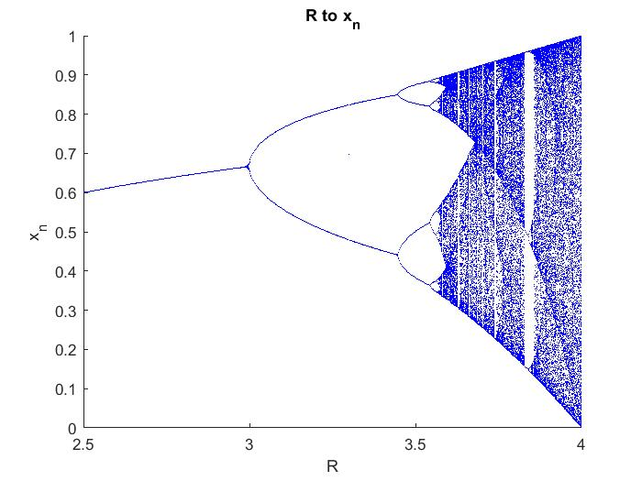
The experimental values for the bifurcation points are
with the experimental Feigenbaum numbers approximations are

The Henon map is defined as
The Henon map has the bifurcation diagram of for b=0.3 and
The values of a with the bifurcation are with the experimental Feigenbaum number of
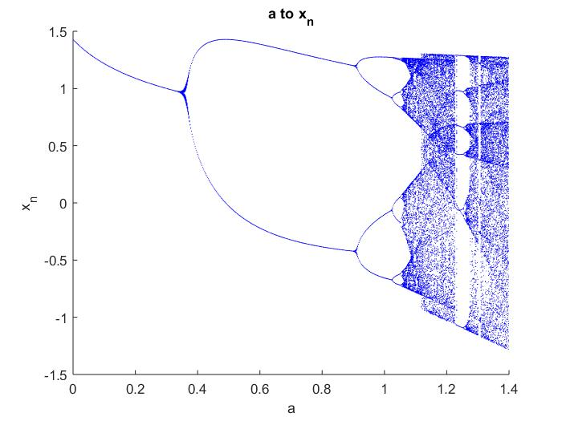
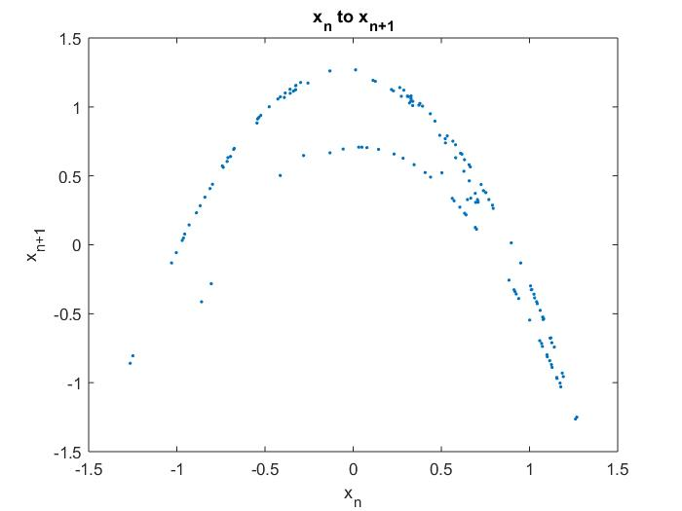
The result is unexpected as with a static b=0.3 the Henon map reduces to doesn't reduce into a unimodal map with f( 0 ) = f( 1 ) = 0. The theory of unimodal maps having the same Feigenbaum constant and U-Sequence doesn't hold for the Henon map. Plus the inaccuracy of measuring the result is a factor in the inaccuracy of experimentally measured Feigenbaum constant.

