Dmitriy Tarasov
HW 3

For the fractal tree the immediate though was about matrix transformations in homogeneous coordinates as that is a proper way in finding the rotation and position of line segments. The algorithm I had has the angle zero being measured from back into the line segment. So to have it would need to be input as
Fractal tree for and
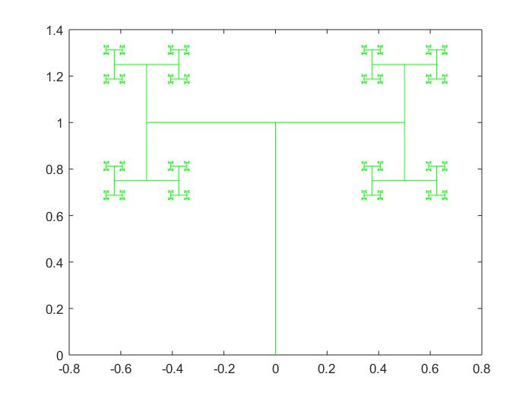
The change of the length parameter results in the quicker convergence of line segments. If the length is greater than then the segments begin to overlap. For length of one, the fractal tree becomes a square grid.

Fractal tree with length of and angles of andrespectively
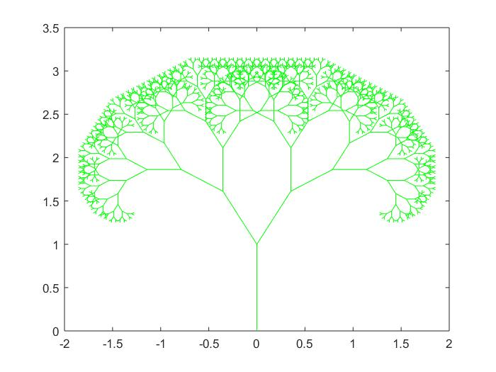
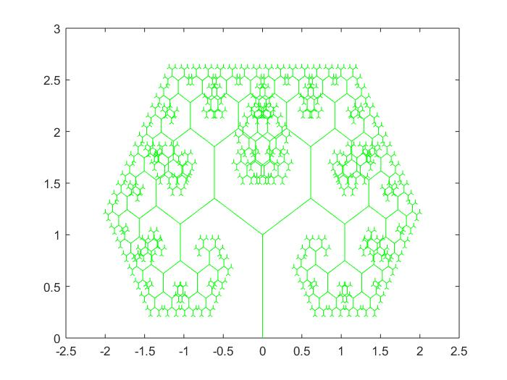

For the angle of , the tree collapses on itself which also happens at
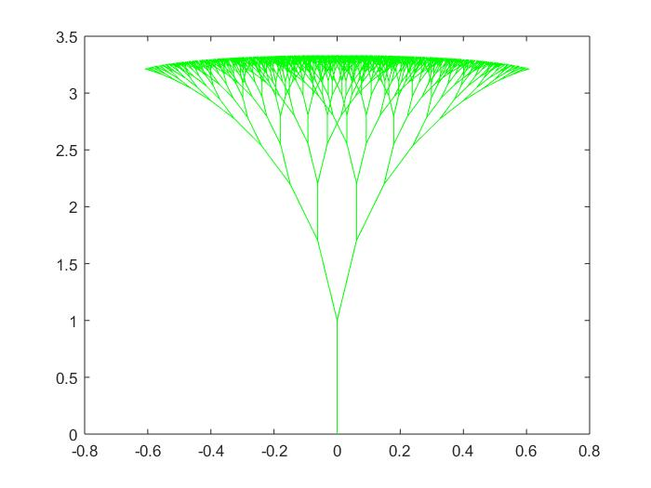
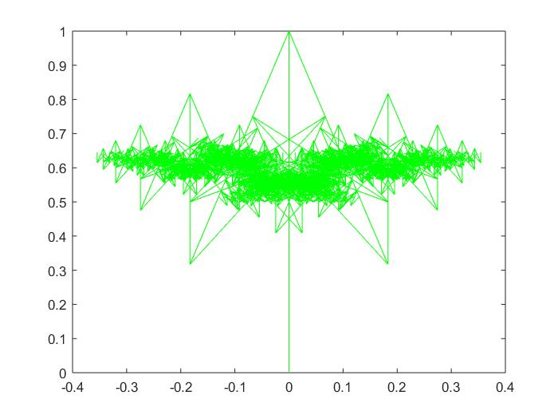
Thus the angle of fractal tree has a unimodal function behavior on the box dimension of the system with the maximum at . While the parameter of the length has monotone influence on the box dimension of the system as the dimension increases when the length proportion increases.

