Dmitriy Tarasov
CSCI 4446
Homework 4

2) a)
for the conditions of which means the pendulum system has neither damping nor driving force. The initial conditions of the system are andwith the numerical parameters of and 400 steps of Runge-Kutta four.
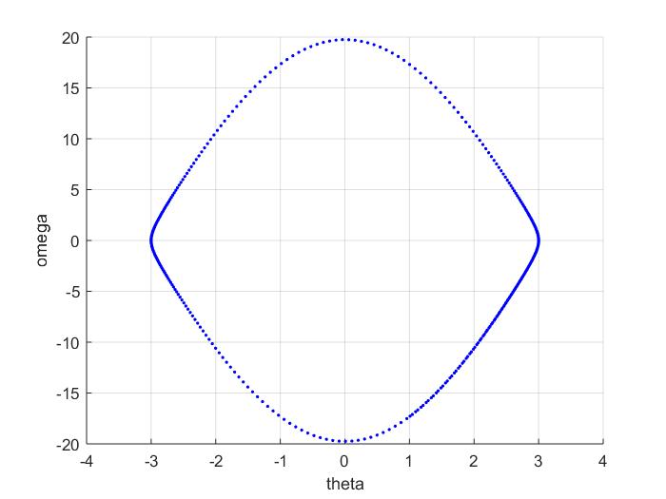
b) for the same parameters but the initial conditions of and
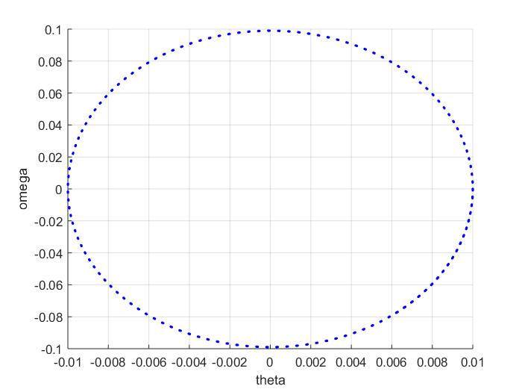
The reason why the system resembles an ellipse is because of the model of the system can be approximated as for small angles which has the analytic solution of perfect centers. The ellipse form is the difference in error for the low energy system. Also the numerical map of the RK4 algorithm is able to correctly predict the conservative nature of the system.

- The behavior of the phase space has two different sets of behaviors separated by the heteroclinic orbit which would mean that the conditions are ideal with measure zero to reach the unstable fixed point. If the energy is above then the pendulum goes over the top and if below then the pendulum will swing back and forth. The three points that were chosen for the system are which has the resulting state space plot.
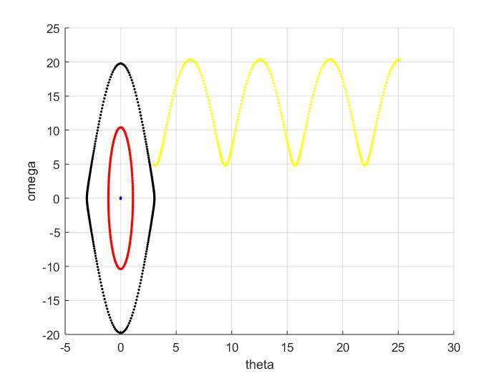
- The addition of a damping coefficient with the same points as without damping gives the following graph.
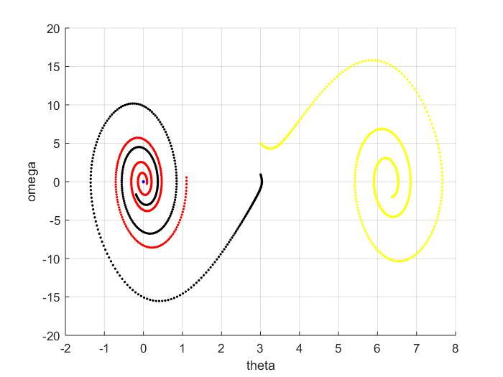
The graph makes sense to the pendulum as the oscillation should decrease due to the damping. The energy of the system should decrease until the pendulum gets stuck rotating around one of the fixed points located at every and converge to one like the system that goes over the top and then converges around the stable fixed point . Since the conservative system is correctly represented in the undamped case would mean that any damping coefficient would cause the system to converge as long as there isn't a floating point issue. The damping coefficient would just determine how quickly the system converges to the stable fixed point at every .

- When taking the modulo of the system the phase portrait becomes the following
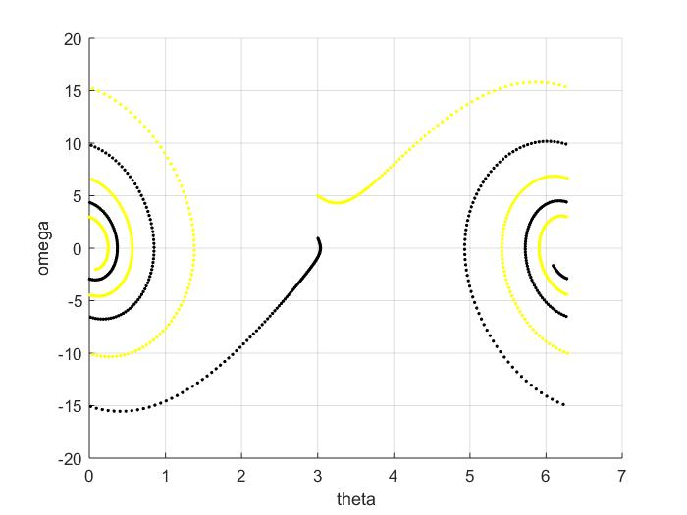
thus the problem has that each wraps around itself. Thus there are only two fixed points where 0,is the stable one and is unstable.

- Adding the driving force to the system with the driving frequency of ¾ of the natural frequency and the driving amplitude of and A=0.9. For the initial conditions of (0,0) results in the chaotic orbit after 5000 steps with a time-step of h=0.005.
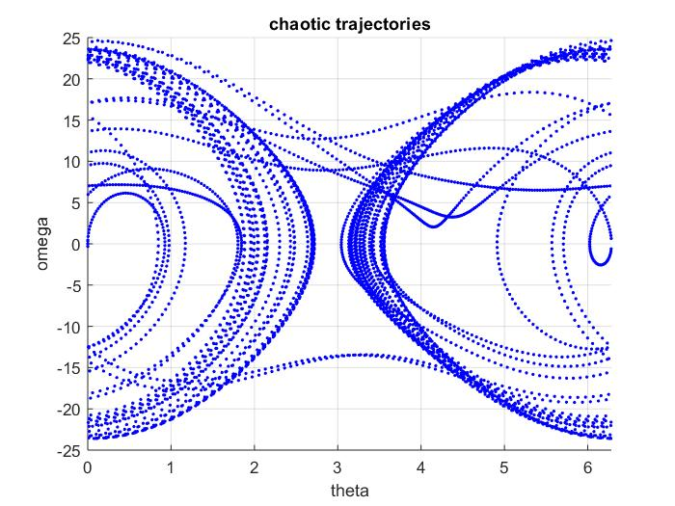
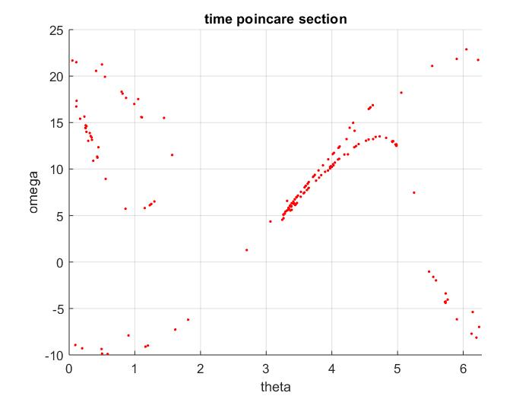
Where the temporal Poincare sections with the period of the pendulum shows that the system is chaotic as a Poincare section with the time sampling of the pendulum period would have the result of being a single point.

- Back to the normal pendulum without driving or damping. The time-steps that I have used were h=0.01,0.02,0.05,0.1 with the initial conditions of (0.5,0.2)
The behavior notes that a large time-step results in an acceleration of the energy gain to the point where the pendulum goes over the top. A large time step results in the system to gain energy faster which results in the system to go beyond the heteroclinic orbit boundary faster.
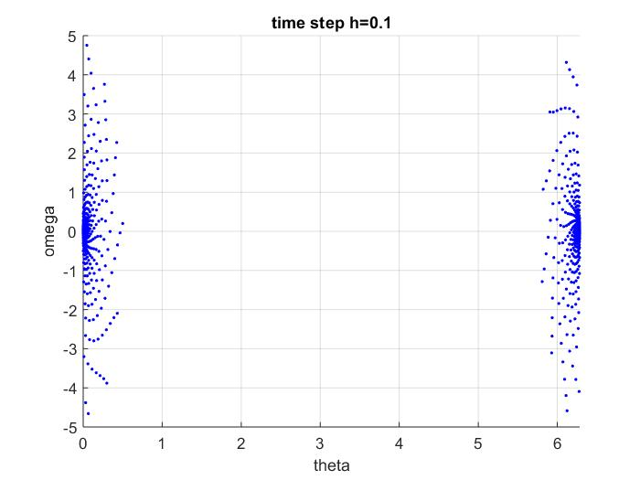
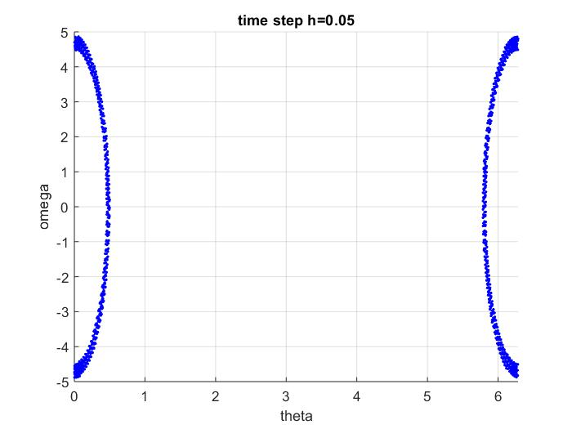
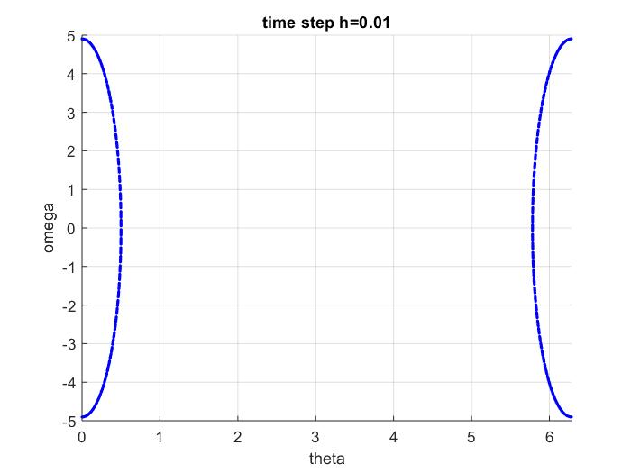
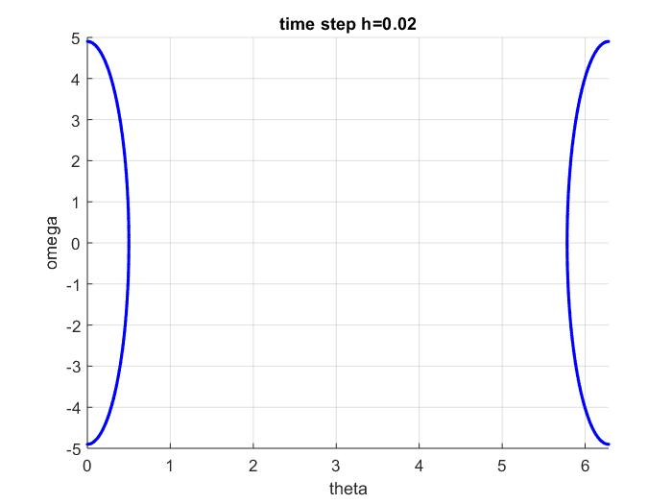
Which notes that as the time-step becomes large, the numerical map ceases to represent the dynamical system. Since the numerical map is a function of the dynamical system and the numerical parameters means that the Runge-Kutta might have results that don't resemble a model. In this case a large time-step results in a bifurcations of the map to converge to a fixed point rather than have a property of being a conservative system.

