Dmtiriy Tarasov
CSCI 4446
Assignment 5: Adaptive Runge-Kutta
The Lorenz system is defined by the equations

with the parameters a, r , and b. The first fixed point of the system is at and at the points which is defined as C+ and C-. The origin fixed point is stable for 0<r<1 while the C+ and C- are stable only for 1<r<. The Lorenz system is also dissipative. Thus with the known properties of the Lorenz equation it would be possible to have some measure of how correct the numerical map is to the actual Lorenz system flow.

The algorithm that I have used for the adaptive RK4 uses the euclidean norm to measure the error between the two points. Also if the error is more than the tolerance or a bigger time step is acceptable then the time-step is changed by a factor of two.

- a) The Lorenz system under the initial conditions of x0=(-13, -12, 52) and the parameters of a=16, r=45, and b=4. The numerical variable are restricted by the tolerance of 0.001, initial time-step of 0.001 and 200 steps. The result of the graph with the parameters is the following.
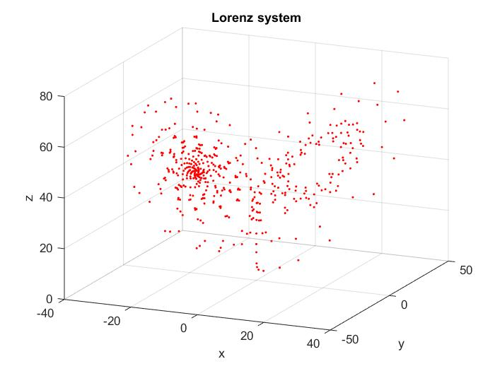
The behavior of the system shows that there is an unstable saddle cycle around the points C+ and C-. The result is the expected from the dynamics of the system since the C+ and C- are both unstable fixed points and the system is dissipative. This means that the trajectory leads out from the fixed points and yet is confined in a finite space.

b) Now the difference of the fixed time-step and the adaptive time-step Runge-Kutta is shown on the following graph.
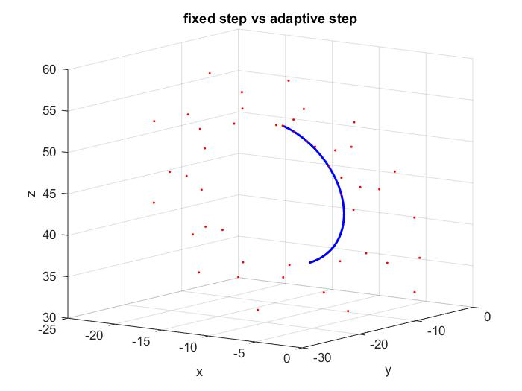
The adaptive RK4(red) doesn't have equally spaced points which allows the adaptive RK4 to explore more of the dynamics space compared to the fixed size time-step RK4(blue). The adaptive Runge-Kutta is has a higher time-step most of the time that the system stays around the points C+ and C-. When the system switched over between the two fixed points is when the system lowers the time-step due to error being too high. The divergence of the adaptive and fixed Runge-Kutta happens due to the dynamical error of both systems as each truncation of the the Taylor series is added back in each step of Runge-Kutta. The dynamic error causes the two paths to diverge which wouldn't happen if the Taylor series wasn't truncated to the fourth order.

c) The parameter that is changing is the parameter r, while the rest of the parameters remain the same as conditions. The initial conditions of x0=(-13, -12, 52) and the parameters of a=16, and b=4. The numerical variable are restricted by the tolerance of 0.001, initial time-step of 0.001.

For the parameter r=0.5 and initial condition x0=(1,0,1), The system converges to the origin. This makes sense as the model has the fixed point at the origin for 0<r<1.
For the parameter r=13.5 and the initial condition of x0=(-10,2,5.5), The numerical map converges to the predicted C+ or C- fixed points which is predicted to emerge in a pitchfork bifurcation at r=1.
For the parameter r=14 and the initial condition of x0=(0.1,-0.001,0.2), the system still converges to the fixed point C- or C+.
For the parameter r=23 and the initial condition of x0=(3,3,-3), the system showed signs of transient chaos as the RK4 went to start cycling around C+ and then converged at C-.
For the parameter r=25 and the initial condition of x0-(2,-4,1), the system again showed transient chaos but it converged around C+ instead of C- at these initial conditions.
For the parameter r=28 and the initial condition of x0=(2,-4,1), the system still converges to the C- fixed point. Changing the initial condition to x0=(0.1,-0.01,0.001) just changes the convergence from C- to C+.
At r=40,the system is chaotic which means there is a bifurcation where the C- and C+ become unstable but the system doesn't diverge into infinity.

- The Rossler system is defined by the equations

where a,b,c are parameters of the system. The conditions of the Rossler system are defined as
a=.398, b=2, c=4. The initial conditions of the system are . The numerical parameters of the system are the tolerance of 0.0001 and initial time-step of 0.001. After taking 1000 steps the Rossler system has the following graph.
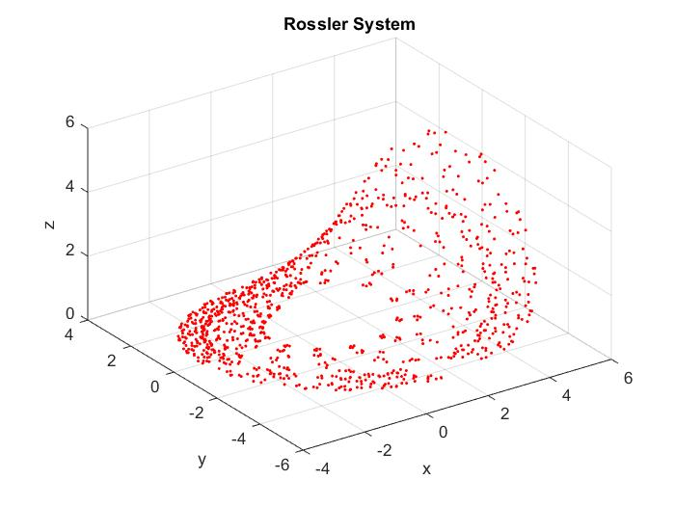
The Rossler system has a global fixed point at the origin which is unstable at the given parameters. The Eigenvalues of the Rossler system around the origin are {λ->-4.},{λ->0.199 -0.979999 i},{λ->0.199 +0.979999 I} which notes that there is a saddle cycle with an unstable limit cycle and a stable manifold in the linearization around the origin. The Rossler system demonstrates behavior alike the linearization as the system diverges on the x-y plane and then converges back closer to the center after some time in the z plane.

- The Lorenz system with the same parameters given in part 2 has the following properties when the tolerance of the system is allowed to be loosened. The tolerances that were specified were
0.01, 0.02, 0.04, 0.05 in which the numerical system diverges to infinity.
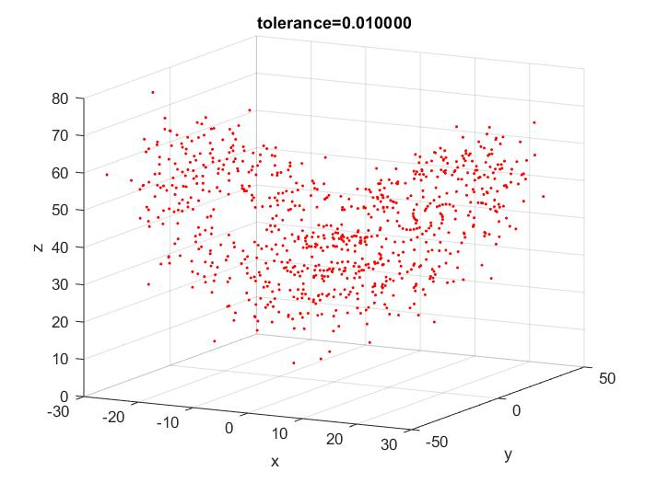
For the tolerance of 0.01, the system remains stable for 800 steps.
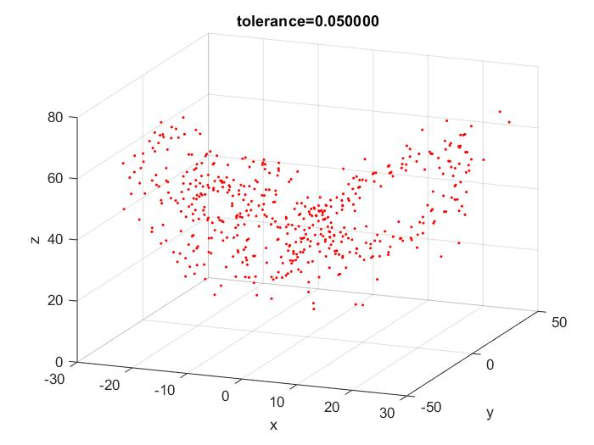
For the tolerance of 0.05, the system remains stable after 500 steps. The numerical system has a change of how the points jump from the two saddle cycles of C+ and C-. The results of how the numerical system spirals around the points C+ and C- means that there can't be sufficient accuracy to predict the behavior of the model in the long term using numerical methods. The sensitivity to initial conditions is emphasized as each iteration of the numerical algorithm will further diverge from the actual model. Thus after some time, the numerical model will be nowhere near the actual model.

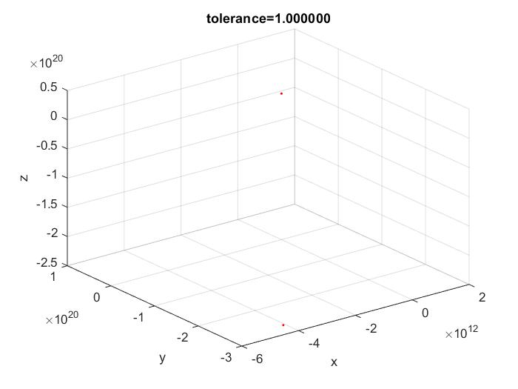

For the tolerance of 1, The numerical map ceased to have any resemblance to the Lorenz system. The numerical map had even ceased to have the dissipative property of the Lorenz system as noted by the divergence of the map. The tolerance relates to the time-step issue In the fixed step RK4 as the time-steps are controlled by the tolerance. Having the tolerance set too high would produce a time step that is too large and the numerical map ceases to resemble the actual system.

