Dmitriy Tarasov
CSCI 4446
Assignment 6: Poincare Sections
the RK4 algorithm that is used for the pendulum system takes the modulo of for theta to collapse every fixed point into either the fixed pointor . The RK4 algorithm is a fixed step one to match the results of previous problem.

1) temporal sections simple algorithm
a) The expectation of what would be seen was that the trajectory would be in the same place excluding the fuzziness caused by using a point not exactly on the plane and that breaks down for large angles. Though since the starting angle of 0.01 radians is so small the issue should be negligible under the linearization approximation. The time-step was h=0.001 and the to plot a point is at every where the blue is the trajectory and red is the Poincare section.
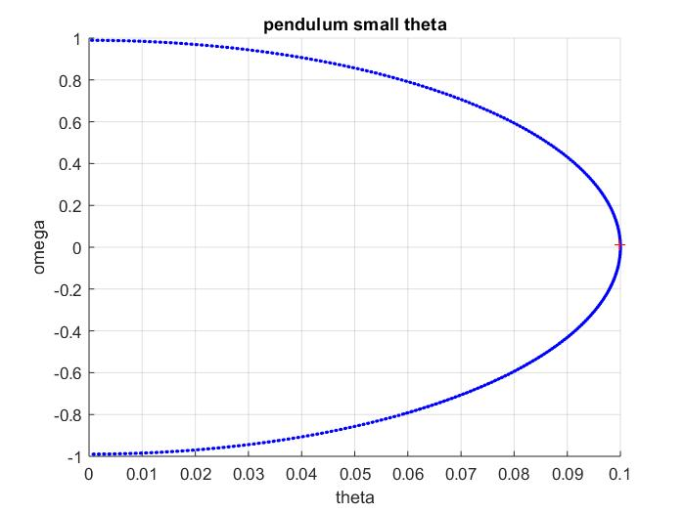
b) For a time section that isn't rationally related to to the natural period produces the result of having the entire range of the pendulum displayed. The time section that was taken was every had the result of.
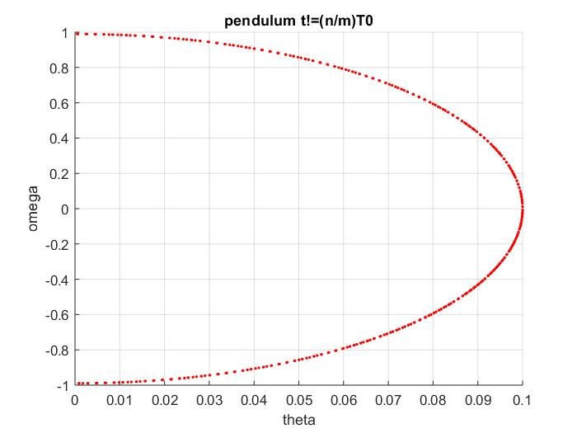
due to the time section being unrelated to the natural frequency of the pendulum gives the result of having the entire system being in the temporal Poincare section.

- The conditions of the system were where is the natural frequency of the pendulum. The driver amplitude was set as with the initial conditions and taking 300000 steps with a time-step of h=0.005 gives the following temporal Poincare section
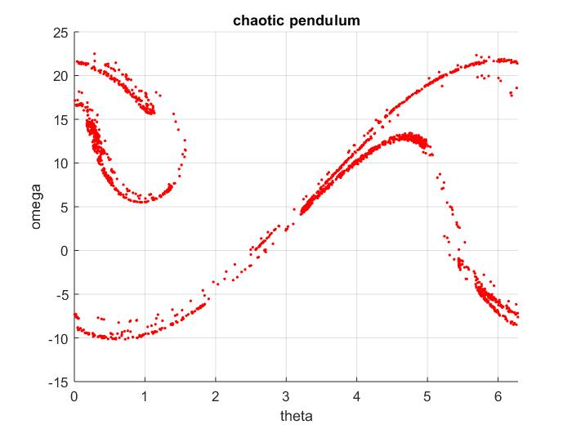
- increasing the step-size to h=0.01 produces the result
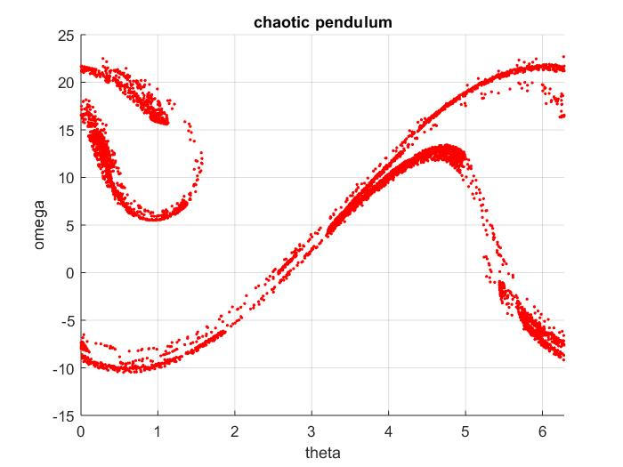
The increase of the time-step resulted in the increase of points that cross the inexact Poincare section. One explanation for the phenomenon is that the longer interval allows for more points to actually cross the section criterion where otherwise it would have been instead close to the section plane.

2) The algorithm that I used for improving the Poincare section is linear interpolation between the two points by taking the fraction of time between times and n*T, then computing the weighted average between the two points and the average vector . The algorithm takes the first section and waits till its been crossed and then iterates n by one after a crossing was detected.

The Poincare section of the taking 300000 steps with the time-step of h=0.005 has the result
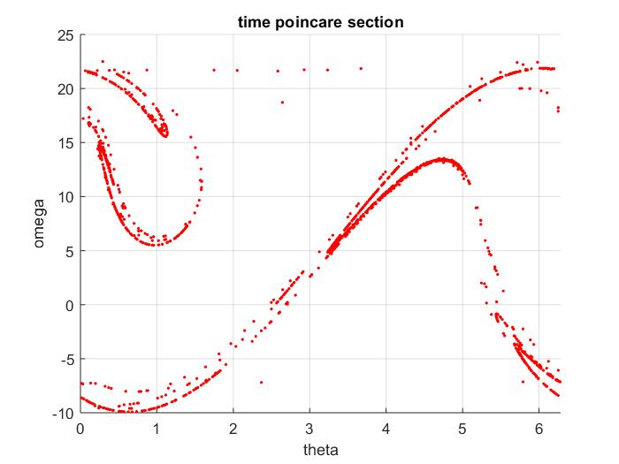

while the Poincare section of the taking 300000 steps with the interval of h=0.01 has the result
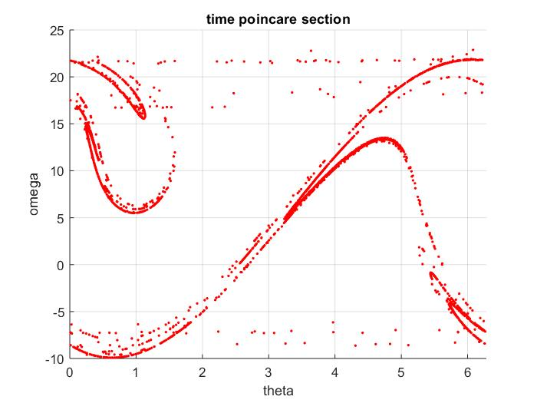

The problem of decreasing precision is lowered by taking the linear interpolation of the
The points vanish when a smaller time-step of h=0.001 is used
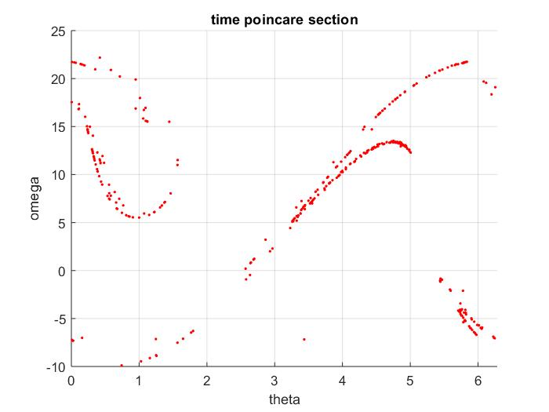
Appendix
to test the correctness of the algorithm , this paper was used
A computer controlled pendulum with position readout
H. Hauptfleisch2, T. Gasenzer1, K. Meier2, O. Nachtmann1, and J. Schemmel2
1
Institut f ̈ur Theoretische Physik, Universit ̈at Heidelberg, Philosophenweg 16, 69120 Heidelberg, Germany2
Kirchhoff-Institut f ̈ur Physik, Universit ̈at Heidelberg,
INF 227, 69120 Heidelberg, Germany
(Dated: May 14, 2009)
which has a more concise results on the website
http://www.thphys.uni-heidelberg.de/~gasenzer/index.php?n1=teaching&n2=chaos
Thus I put the initial conditions of control parameters where beta is the damping coefficient, alpha is the frequency of the driver, g/L is the gravity vs length, and B/m is the driving force amplitude. The Poincare section time-step was
which brought the result of with the variableand the initial conditions of with a fixed time-step h=0.005 of which results in the following graph.
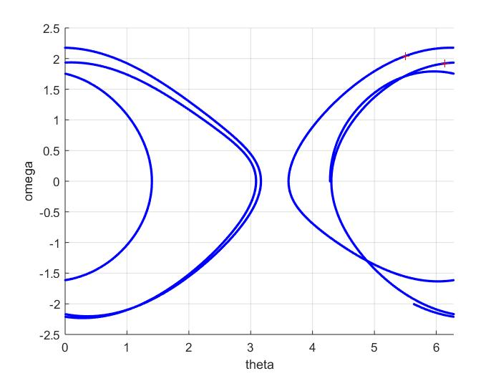
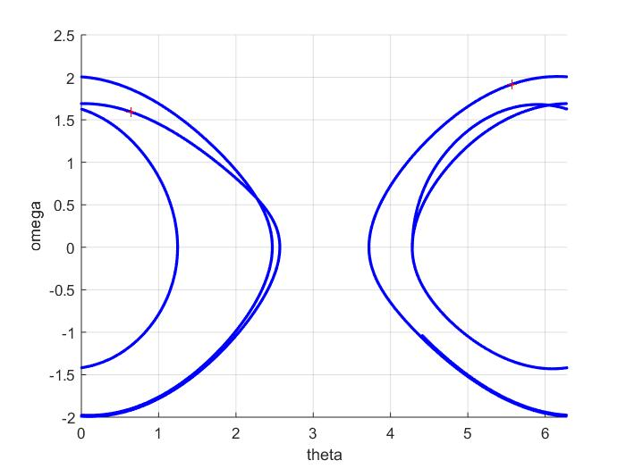
which the trajectory matches the paper which means the ode solver is working as intended. The Poincare section for the second plot includes a second point that shouldn't be there. Decreasing the time-step gives the result of removing the point.
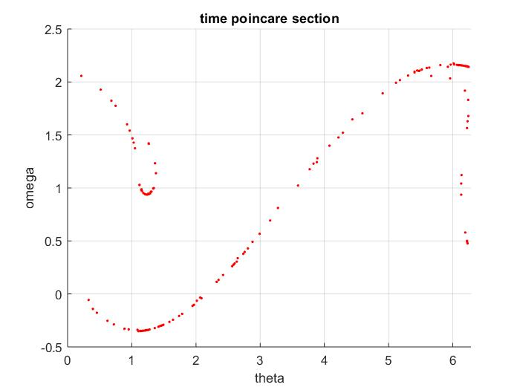
Also the Poincare section of the system has the expected result of mathworks which demonstrates the algorithm is working as intended.

