Dmitriy Tarasov
CSCI 4446
Assignment 9: Wolf Algorithm

- The Lorenz system is defined with the parameters r=45,a=16, and b=4. The initial conditions of the system are x0=(-20,-20,50). The numerical parameters are h=0.001, 50,000 time-steps and taking out the first 10000 transients. The Wolf algorithm is run with a tolerance of 4.0 and the first point being t0=15,000. The Lyaponov exponent of the system was .

Keeping the parameters the same except changing the r parameter to r=20 produces the Lyaponov exponent of . The result means that there should be a limit cycle but the result is incorrect as the dynamic of the system points out that the system should converge to a fixed point. Thus the Lyaponov exponent should be negative.

- Given a time series of the Lorenz equation with only the x state variable with data samples at h=0.001 and 100,000 data points. The embedding dimension parameters chosen were m=120
as that was the first minimum of mutual. The graphs of the mutual information for the dataset is
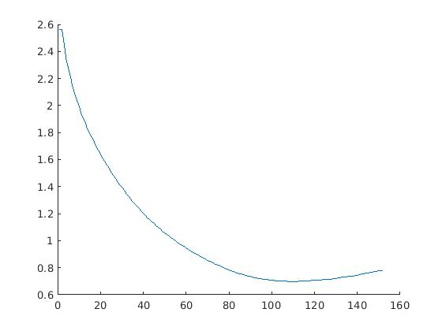
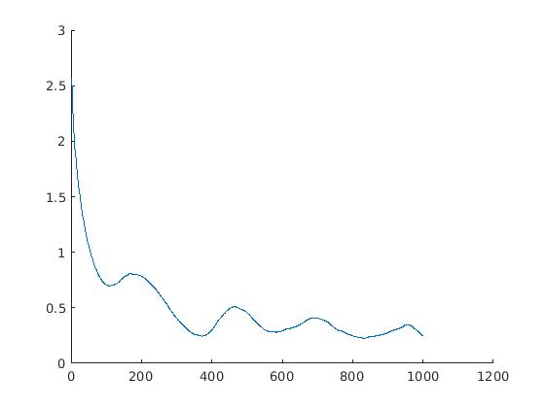
for the dimension of the problem the pick was k=7 which satisfies Taken's theorem to ensure the embedding the topologically the same as the actual Lorenz system and thus would preserve the property of the Lyaponov exponents. The graph of the dimension 1 though 10 for the m=110 is

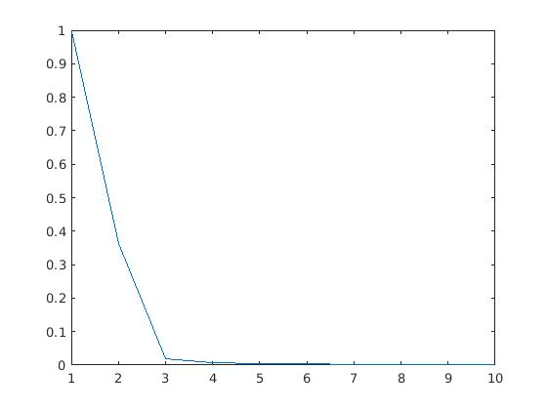
The resulting embedded system is the following graph which is on the edge of folding over itself. The data set was taken with a down sampling of every tenth point in the data set.
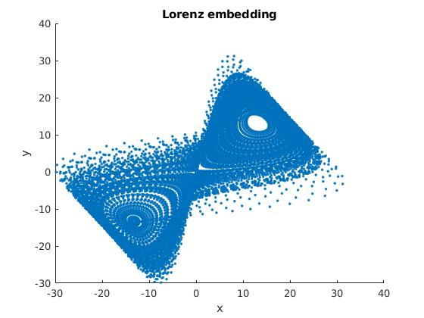
The lyap_k tisean command that was run was:
system([tiseanpath,'lyap_k timeseries -m7 -M7 -d110 -o lyaponovexp -x50000 '])
The plot that I looked at was for the tolerance of epsilon=.1088884 which was the second epsilon that lyap_k computed. The plot of the lyap_k is the following
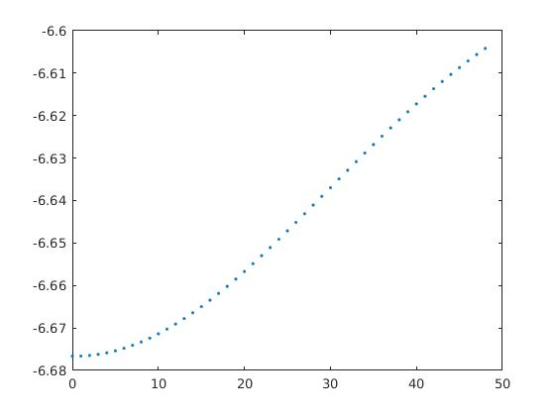
The slope of the lyap_k algorithm was 0.0019 which is the Lyaponov exponent when the average slope from points 30 and 20 was taken. This resembles closely to the result of the Wolf algorithm of 0.0018.

- a) The variational equation of the Lorenz system is defined as.

where each delta is the
The initial conditions of the system is x0=(-20,-20,50) with the parameter conditions of r=45,a=16,b=4. The Runge-Kutta four parameters are h=0.001 with 10,000 time-steps.
Taking the 10,000th point the variational equation has the result of the matrix

which has the eigenvalues of

by taking the equation The Lyaponov exponents of the system are approximated as (0.0014,0.0001,-0.0020) by taking the 10,000th point. The Lyaponov exponents makes sense concerning the dynamics as the Lyaponov exponents note that the system is dissipative because the negative Lyaponov exponent has the largest magnitude which means the unstable manifold is becoming flat faster than the other two Lyaponov exponents. The largest Lyaponov exponent notes that the Lorenz system doesn't converge to a fixed point. This notes the behavior of the Lorenz system trajectory of a strange attractor.

