class04.R

dylanmullaney

2025-01-16

x <- 1:50  
plot(x, sin(x))

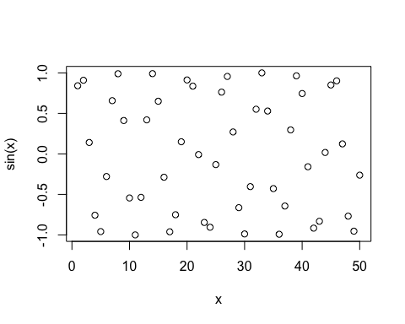

# Make more sense of the graph  
plot(x, sin(x), col='blue', type="l", lwd=3)

