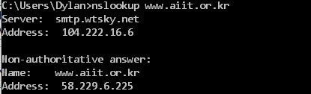1

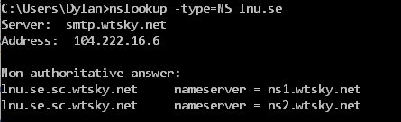2.

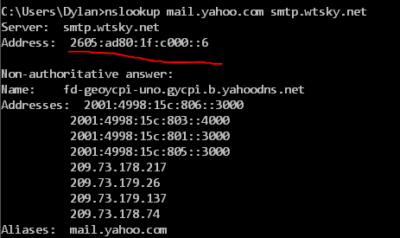3

4. udp

5. 53 for both

6. 104.222.16.6, which is one of my DNS ips

7. A, no

1. 2 answers with host name, type, class, TTL, length and IP
2. Yes, first ip in dns response message
3. No
4. 53 for both
5. 104.222.16.6, yes
6. A
7. One answer with host name, type, class, ttl, length, IP
8. 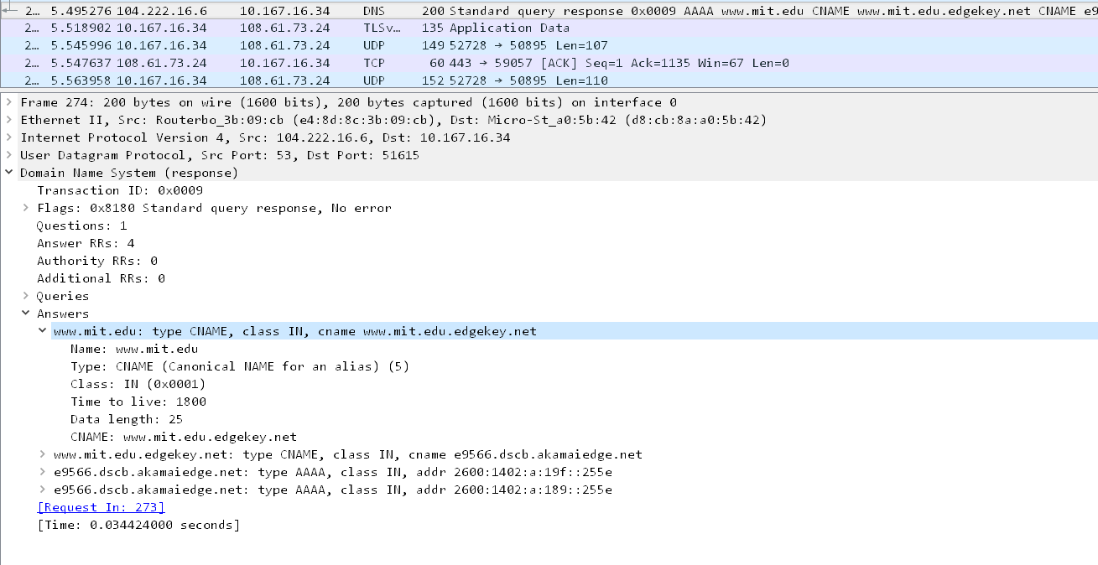
9. 104.222.16.6, yes
10. NS, no answers
11. 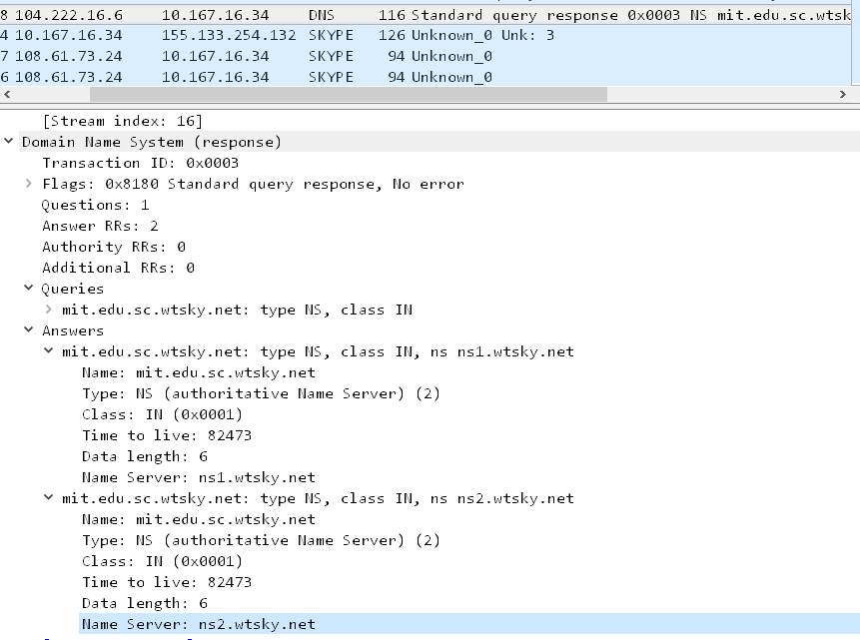Ns1.wtsky.net, ns2.wtsky.net. cant find IP addresses.
12. .
13. Timeout
14. Timeout
15. Timeout
16. Timeout