Possible relationships:

* Sales and social media buzz
  + Artist social media pages
  + Critical acclaim
  + Tours
* Critical acclaim and
* Growth of popularity
* Spatial?
* Greatest of all times :

Sources:

* Rate Your Music
* **Spotify**
  + Access popularity, characteristics
* **Billboard**
  + 1950 – genres
  + Persistent
  + https://data.world/typhon/billboard-hot-100-songs-2000-2018-w-spotify-data-lyrics
* Awards
* Wikipedia
* Ticketmaster
* 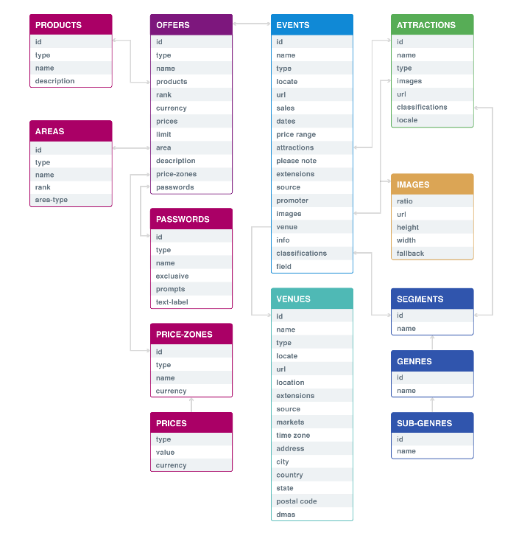

Visualization:

Models:

11.2.18 Lecture Notes:

* Poster session uploaded online
* GitHub:
  + Expect Have data set and scripts available for TA and Professor to use
  + Use “wiki” to document process from start to finish
  + Consider hosting data on student public html account
* Poster advice:
  + Center piece be key, eye-popping results. Information around it.
  + Title and names of members – Not professor
  + Course name and Semester
  + Legibility from afar
* Finish by Sunday, December 2nd
  + Turn in poster early Monday morning
  + Less than $10 for poster from CCIT