**Visualizing tabular data on D3.js**

The objective of this assignment is to implement common visualization techniques to represent tabular data in D3.js

Submission – **On Canvas**Deadline **– 10/18/2020**

**Deliverables:** – a pdf containing:

* A figure for each image requested in this document
* A link to each ObservableHQ notebook as requested in this document

**Step 1 – Update existing visualization**

We have played with streamgraphs in class to organize the classic streamgraph visualization. Streamgraphs are extremely eye catchy visualizations even though they are not super easy to read. Moreover, they are affected by the aspect ratio used to visualize them. In class we used a 1:1 aspect ratio. The objective of this first step is to familiarize with the code we have written and learn how to change an existing visualization with small updates.

Visit the shared notebook (https://observablehq.com/d/28297cc70ff54f37)

Click on Fork

Starting the provided code, change your code so to obtain the following updates

* Change the aspect ratio of your graph so to squeeze the height. (Using an aspect ratio of 3:1 will probably work best.). Now the graph looks a bit better in the sense that it stresses its horizontal flow.

A streamgraph uses both negative and positive values to organize the streams. We can change that and easily convert our stream graph to an area graph.

* Change the way information are stacked removing the offset that produces the stream graph.

Now you should have obtained an area graph that is no longer aligned with your axis. While we fix this let’s play with the overall design. From Lecture 3 (*Design principles*), we studied how reducing the amount of ink dedicated to axis and labels can improve the readability of our graph. Let’s take this principle to its extreme:

* Translate the area graph in order to align it close to the axis ticks.
* Change the ticks color to white.

The result is not too bad. We have maintained the scope of the ticks (i.e., indicating where each year is) without adding black ink to the graph. Also, this way the ticks looks like the are ending with the area graph leaving much more white space for data annotations.

|  |  |
| --- | --- |
| This should be your starting figure | This should be the graph you will obtain at the end |
|  |  |

* Add here the final image you have obtained and the link to your notebook (remember to activate the sharable link option from your noteboook)

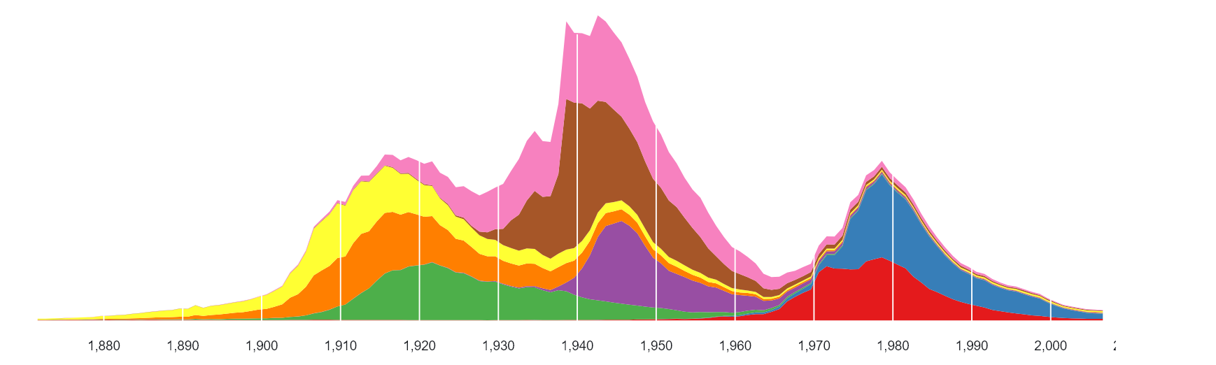

**https://observablehq.com/@dmumm/my-first-streamgraph**

**Step 2 – Creating a bar chart from scratch**

* Visit the shared notebook (https://observablehq.com/d/95aa73249946a45c)
* Click on Fork
* Follow the instructions found in the notebook
* If everything goes well you will obtain the following images

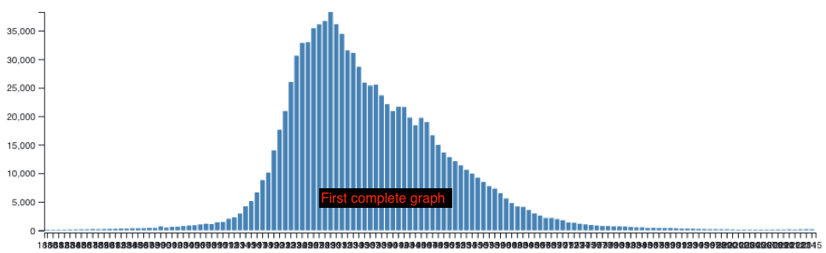

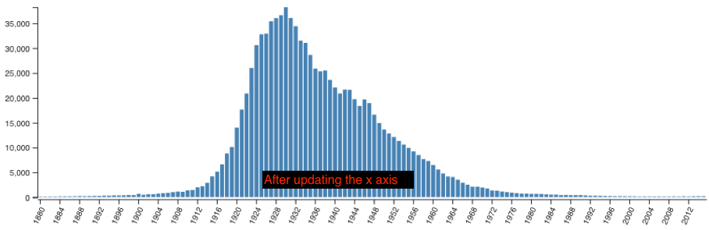

* Add here the final image you have obtained and the link to your notebook (remember to activate the sharable link option from your noteboook)

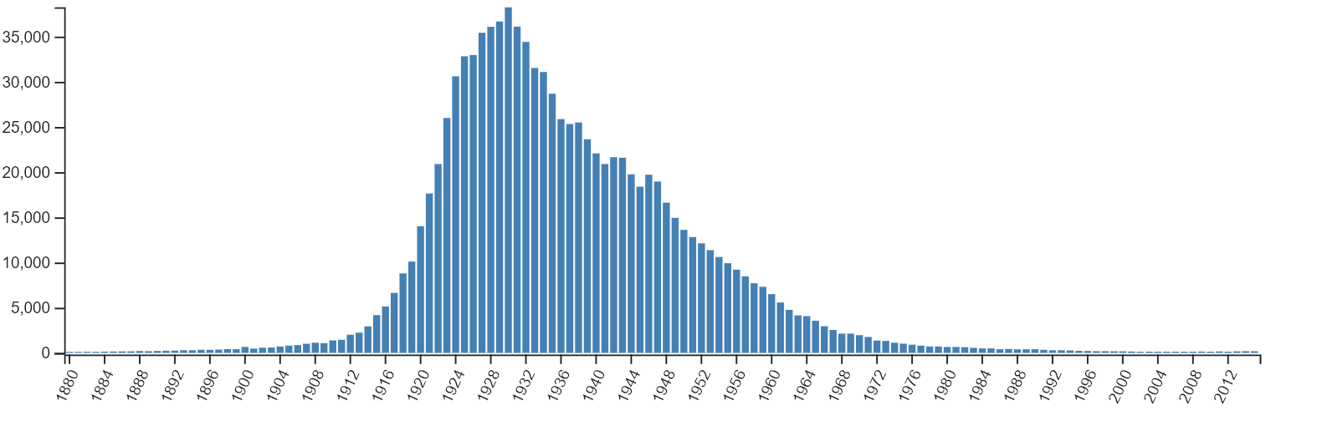

<https://observablehq.com/d/16efeb471507d6d5>