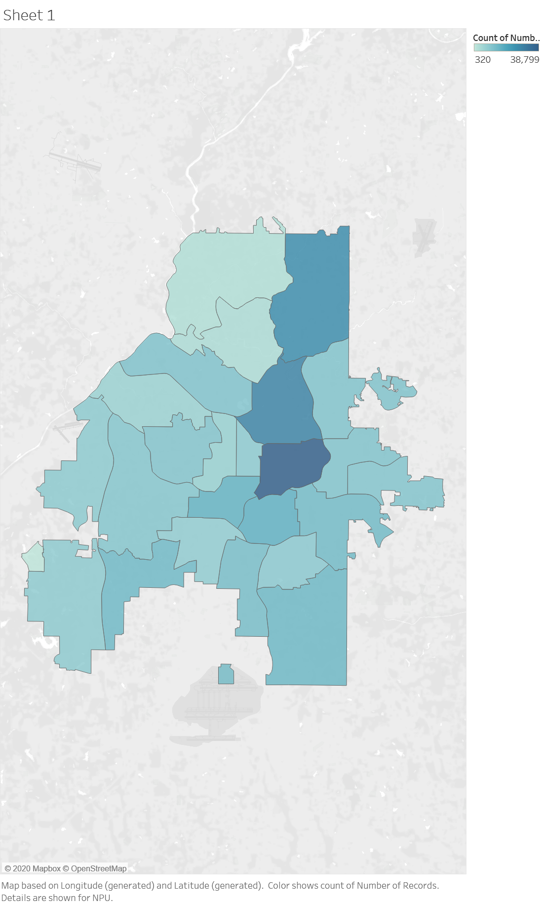

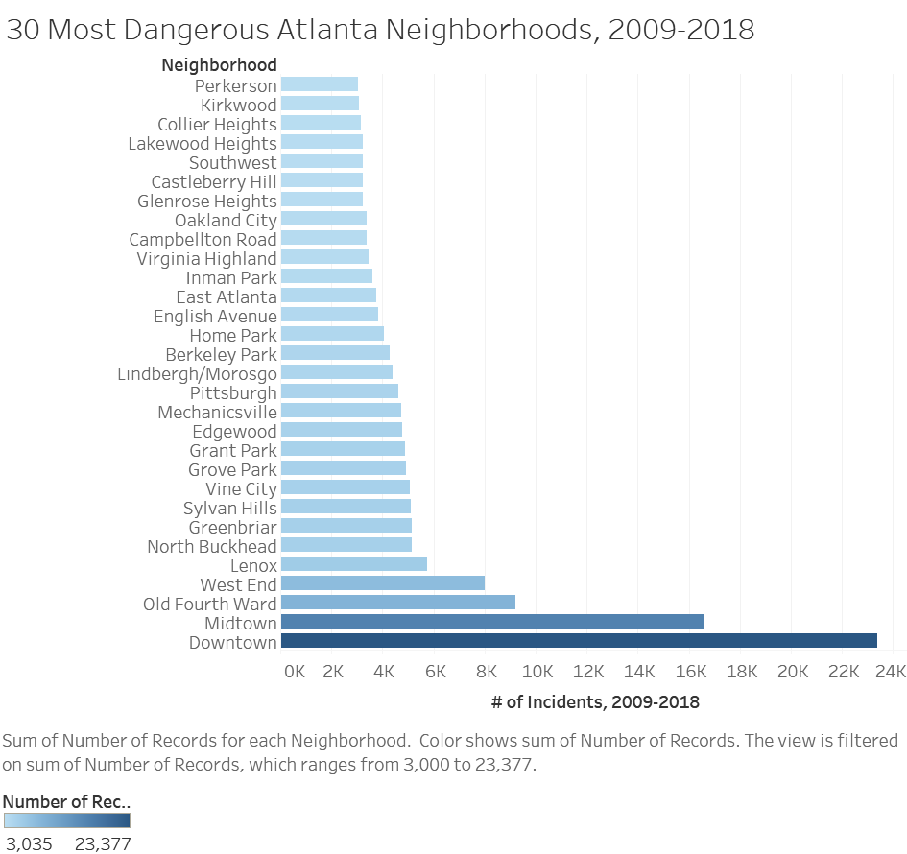

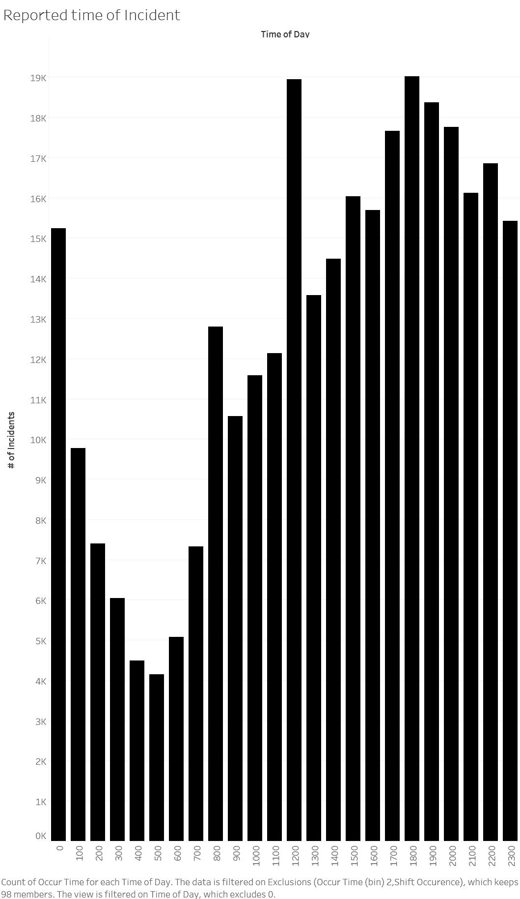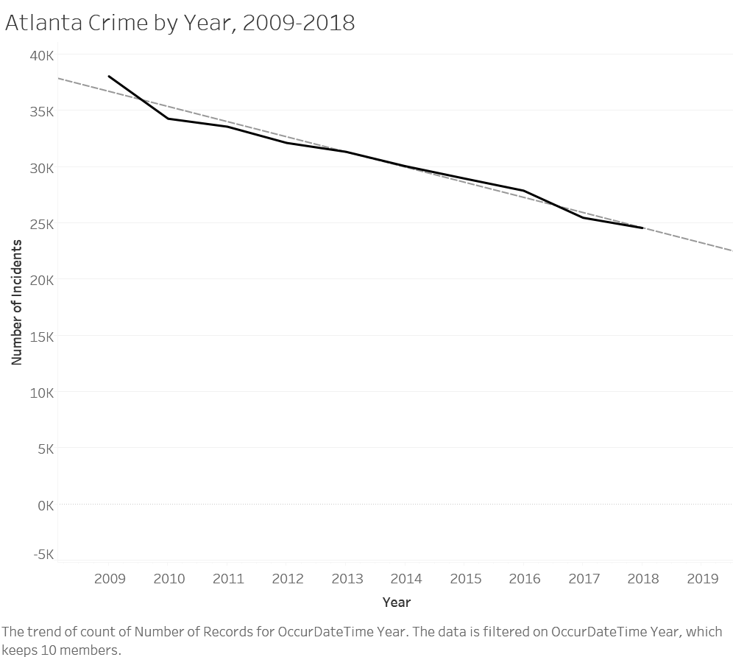

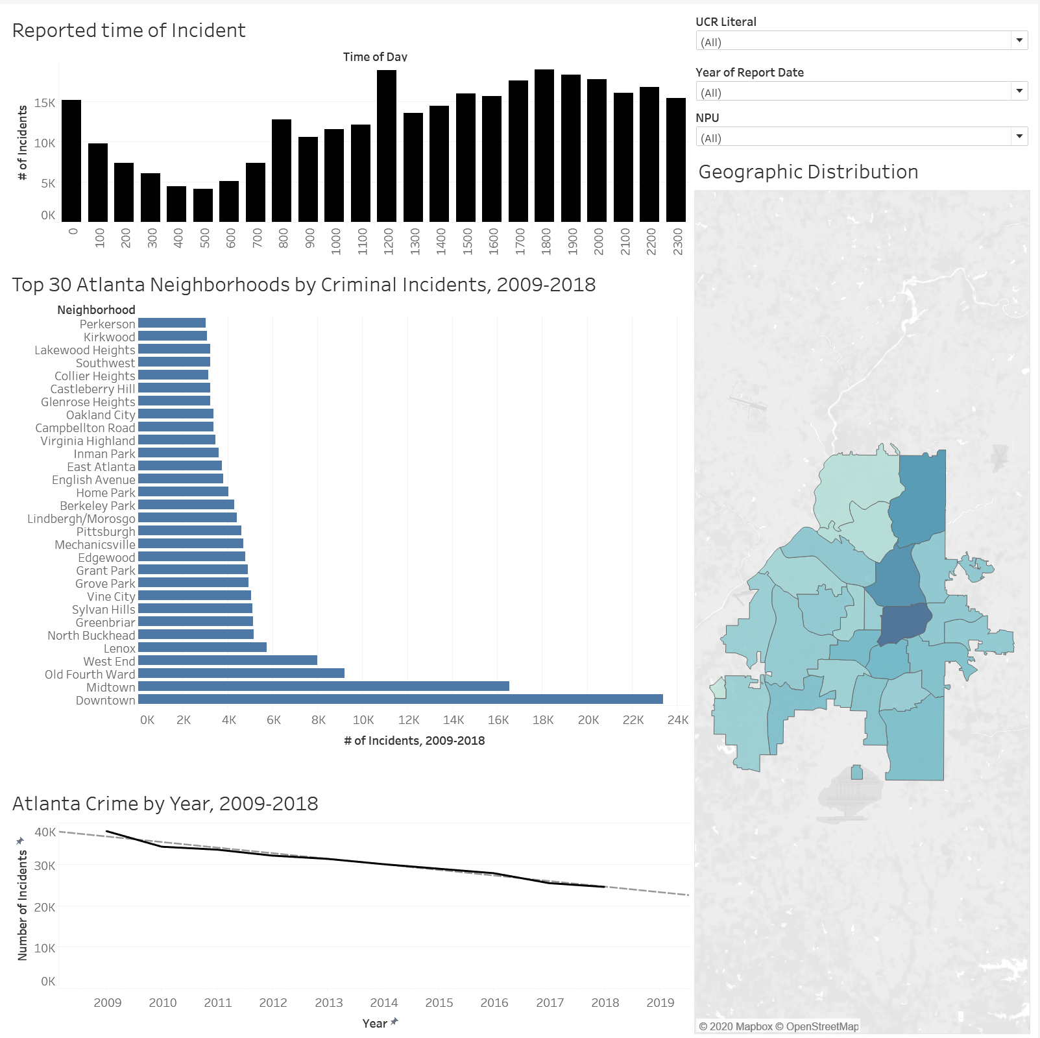

Filters:

* UCR Literal (Type of crime reported
* NPU (What area crime was in)
* Year (When incident took place

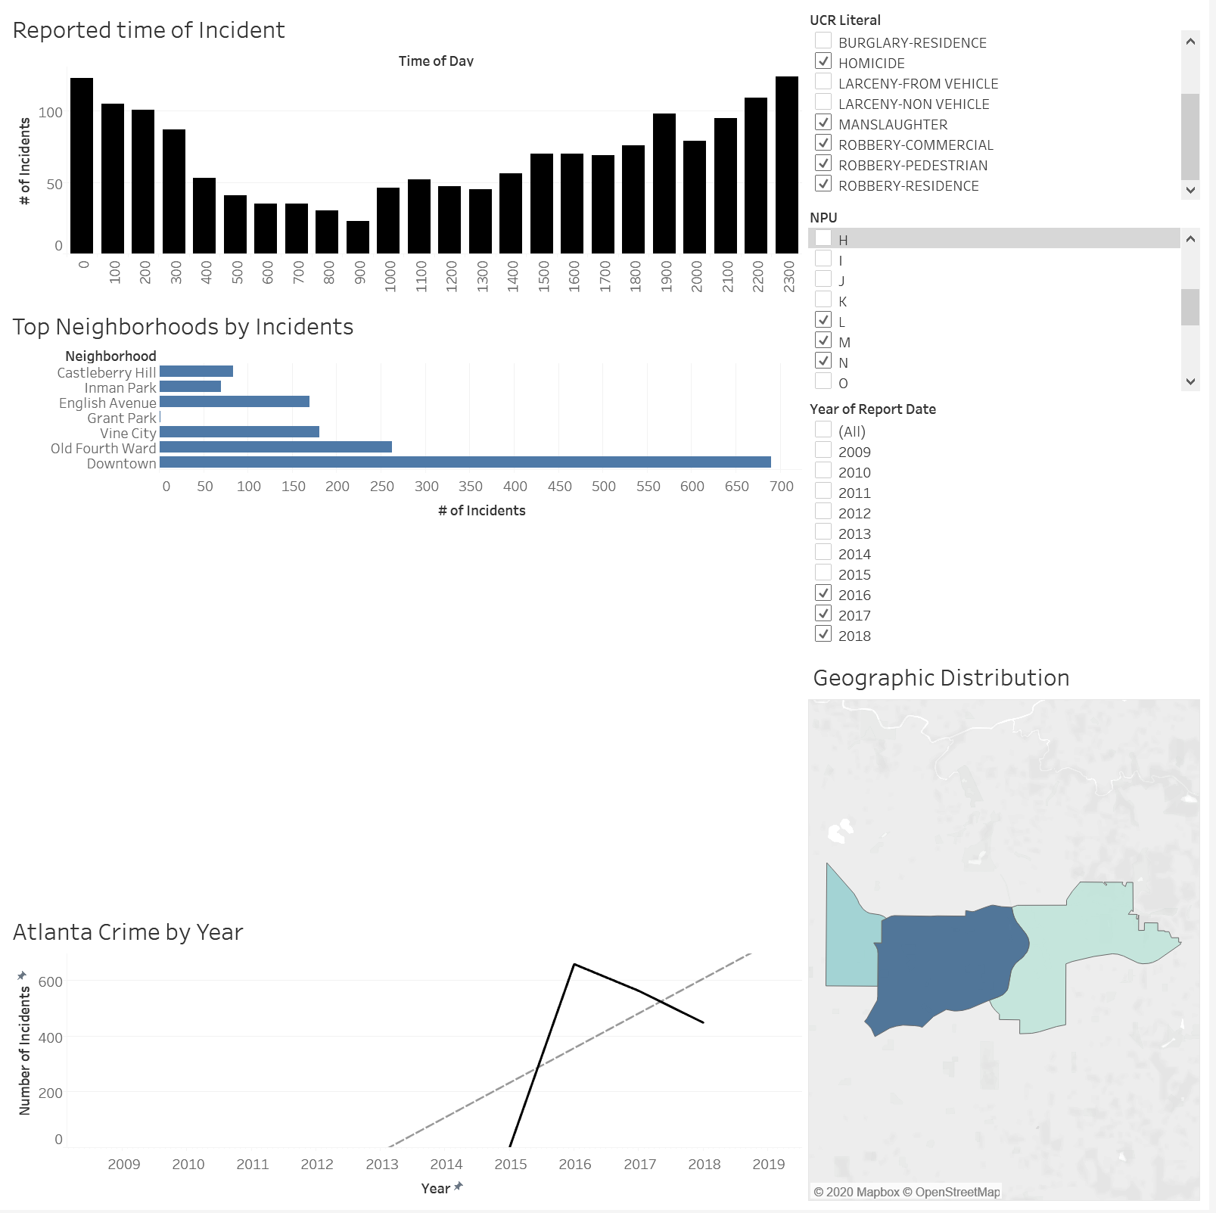

<https://drive.google.com/drive/folders/1E2-tTiWwBDC9yDCr4oV5a6qeZpWRdTjs?usp=sharing>