Intel® Core i5-7500

3.40 GHz, 4 logical threads

|  |  |  |  |
| --- | --- | --- | --- |
| Execution time, seconds | | | |
| Threads | **Pi** | **Log(2)** | **Gamma** |
| 1 | 11.568 | 32 | 296.868 |
| 2 | 4.266 | 11.424 | 105.919 |
| 3 | 4.039 | 11.135 | 102.955 |
| 4 | 3.414 | 9 | 85.941 |

15 GB available physical memory

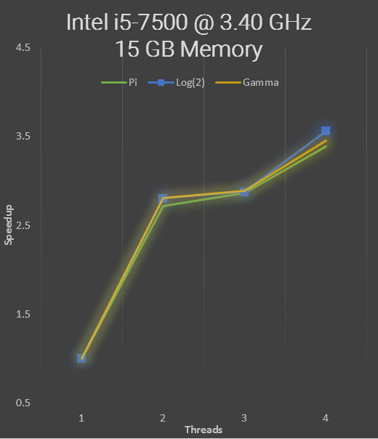

Intel® Core i7-4770

3.40 GHz, 8 logical threads

14 GB available physical memory

|  |  |  |  |
| --- | --- | --- | --- |
| Execution time, seconds | | | |
| Threads | **Pi** | **Log(2)** | **Gamma** |
| 1 | 14.731 | 40.635 | 371.993 |
| 2 | 5.633 | 16.327 | 142.402 |
| 3 | 5.431 | 15.133 | 136.755 |
| 4 | 4.19 | 11.496 | 104.852 |
| 5 | 4.246 | 11.613 | 106.122 |
| 6 | 4.136 | 11.327 | 102.690 |
| 7 | 4.039 | 11.125 | 102.329 |
| 8 | 3.962 | 10.755 | 98.604 |

