1.

course:class = one-to-many

class:enroll = one-to-many

enroll:student = many-to-one

2. 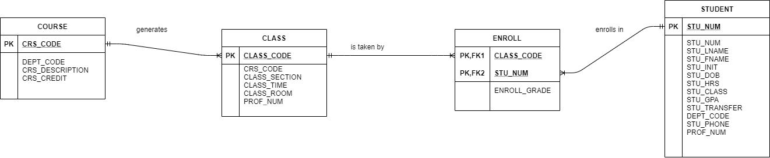

3.

