1.

|  |  |  |
| --- | --- | --- |
| TABLE | PRIMARY KEY | FOREIGN KEY(S) |
| EMPLOYEE | EMP_CODE | JOB_CODE |
| BENEFIT | EMP_CODE+PLAN_CODE | EMP_CODE, PLAN_CODE |
| JOB | JOB_CODE | None |
| PLAN | PLAN_CODE | None |

2.

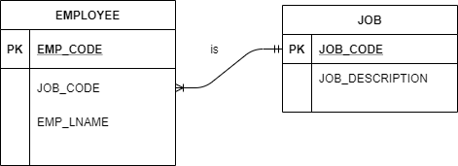

3.

|  |  |  |
| --- | --- | --- |
| TABLE | ENTITY INTEGRITY | EXPLANATION |
| EMPLOYEE | Yes | All keys unique, none null |
| BENEFIT | Yes | Each row unique composite key, none null |
| JOB | Yes | All keys unique, none null |
| PLAN | Yes | All keys unique, none null |

4.

|  |  |  |
| --- | --- | --- |
| TABLE | REFERENTIAL INTEGRITY | EXPLANATION |
| EMPLOYEE | No | Rudell / EMP_CODE 14 not listed under BENEFIT |
| BENEFIT | Yes | Each foreign key refers to valid primary k |
| JOB | Yes | No foreign keys |
| PLAN | Yes | No foreign keys |

5.

