**Case Study – 8  
(50 points)**

**Name: Dylan Mumm**

**Clemson ID: C18070517**

**Submission**: Save this Word document with your answers as a PDF file and upload the PDF file to Canvas.

(40 pts) Create 4 UI Mockups/Wireframes for the EVCSS Project with data validation constraints indicated. These **must** be more than simple logon screens! You can use one of the diagramming tools identified on the “External Tools Page” in Canvas or one of your own choosing.

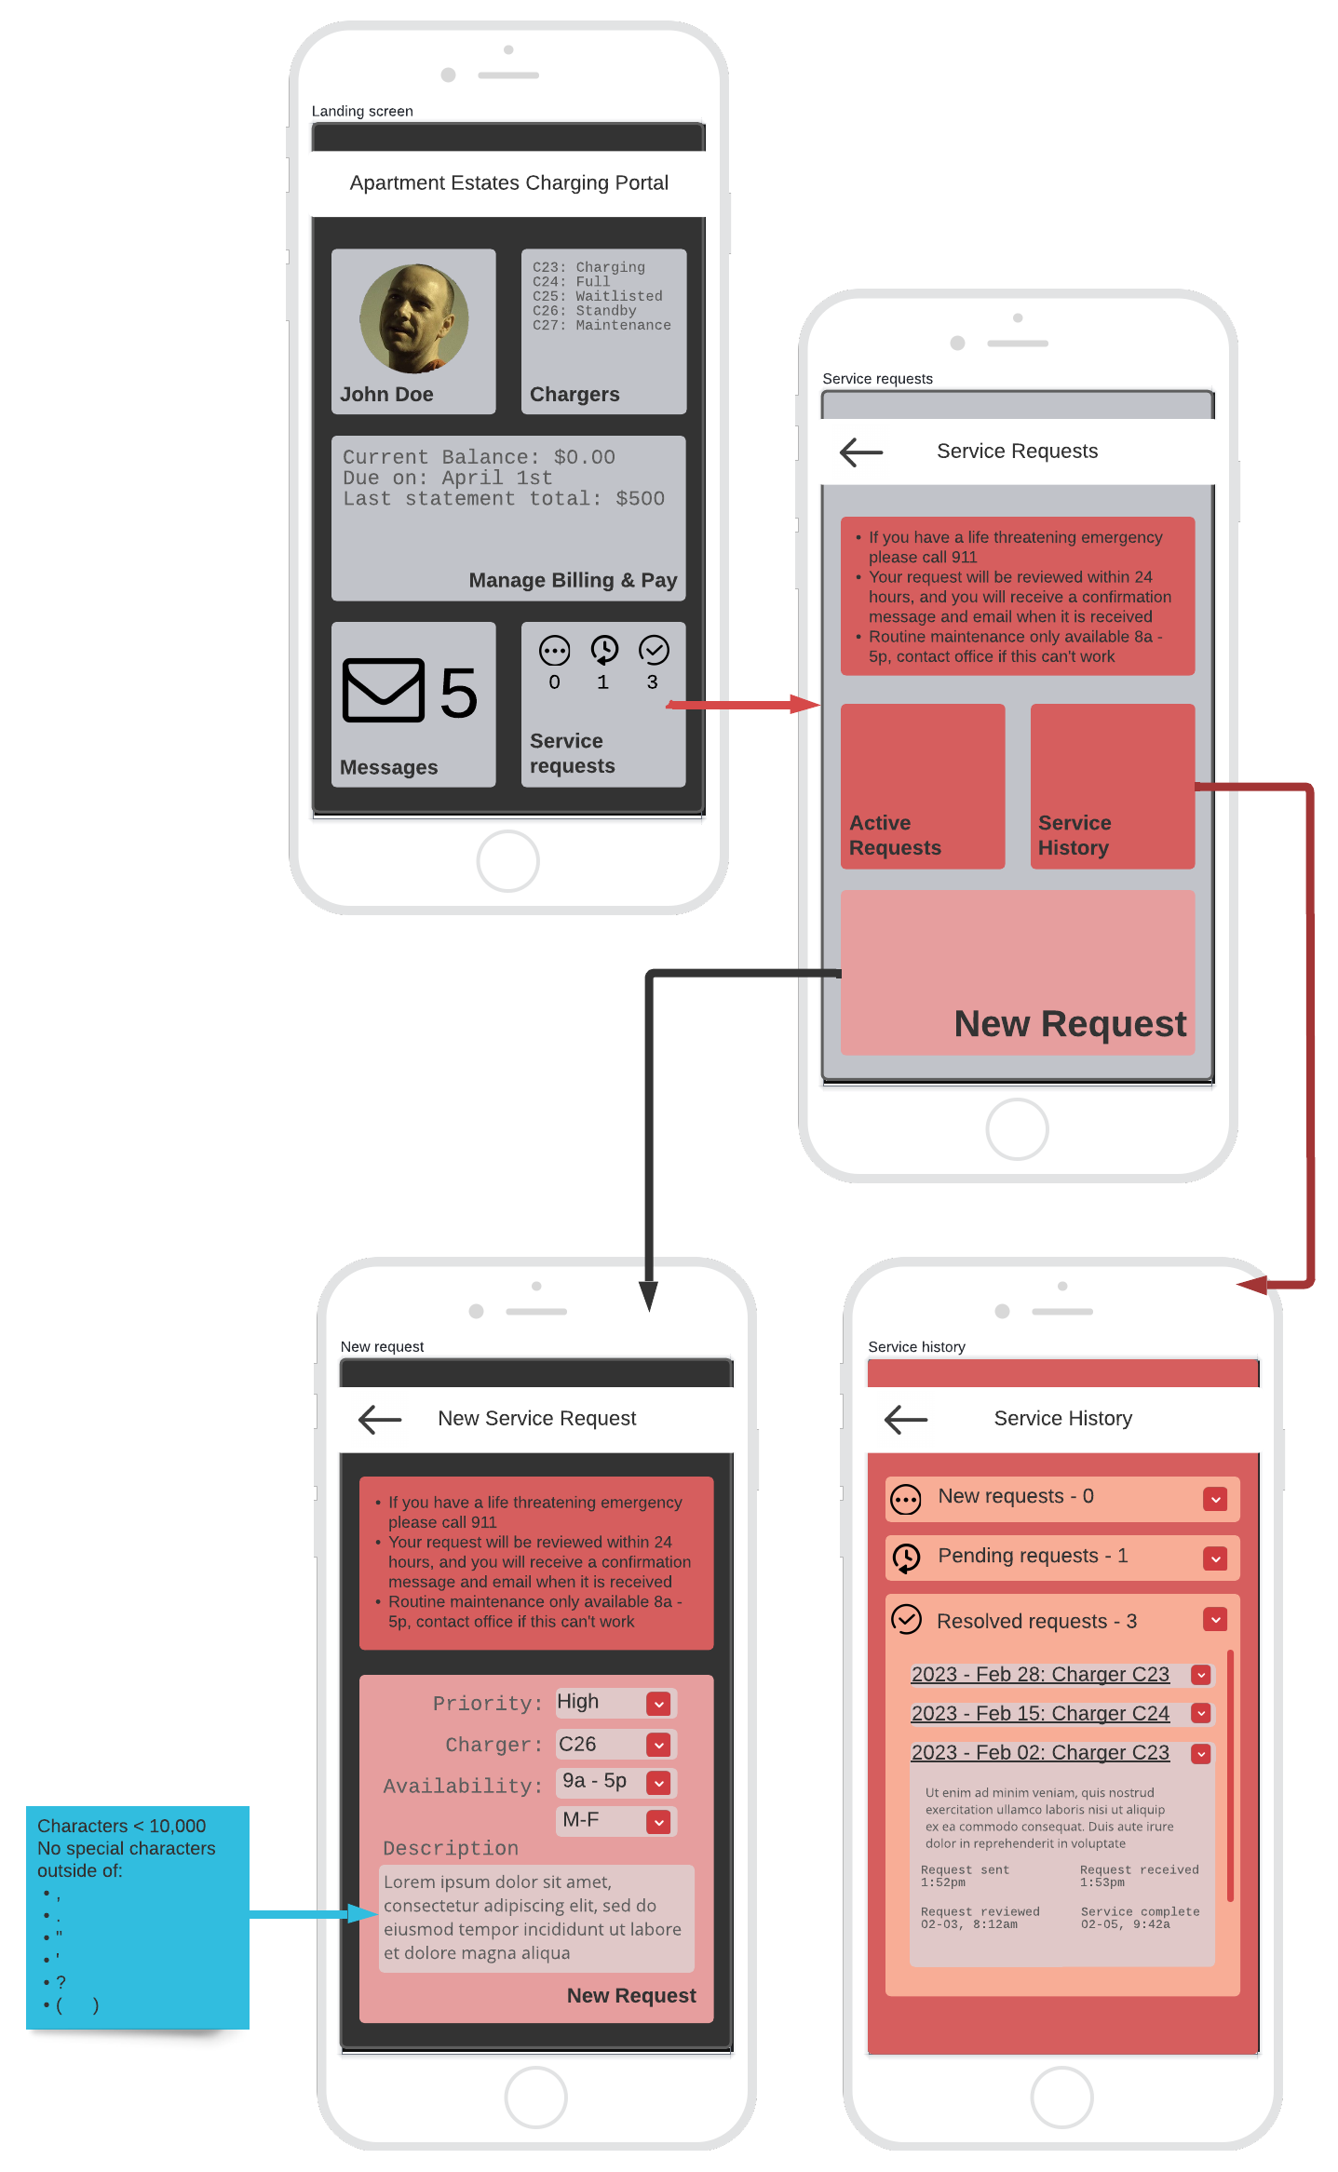

(10 pts) Create 2 report mockups for the EVCSS Project related to profitability, keeping in mind the guidance in Fig 8.14. Use one of the diagramming tools identified on the “External Tools Page” in Canvas. The client and the management users will be closely monitoring to financial performance of the system.

