PCA Covid19 América

Daniel Munera y Cristian Londoño

04/04/2021

## ACP para datos de Covid19 en el continente americano

En el presente trabajo se analizarán las principales variables relacionadas con la propagación del Covid-19 en el continente americano, considerando países tanto de Sur-América, Centro América y Norte América. Para el análisis se utilizará la técnica de análisis de componentes principales(ACP) y representaciones Biplot.

Para el análisis se utilizarán datos de la publicación de la Universidad de Oxford OurWorldInData actualizados hasta el 03 de abril del 2021. La descripción de las variables a utilizar se presentan a continuación:

## column description  
## 1 iso_code ISO 3166-1 alpha-3 â\200“ three-letter country codes  
## 2 continent Continent of the geographical location  
## 3 location Geographical location  
## 4 date Date of observation  
## 5 total_cases Total confirmed cases of COVID-19  
## 6 new_cases New confirmed cases of COVID-19

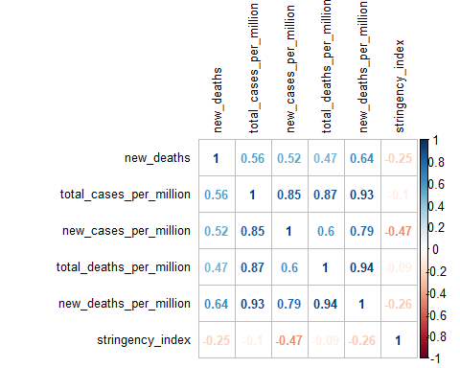

## new_deaths total_cases_per_million  
## new_deaths 1.0000000 0.55732813  
## total_cases_per_million 0.5573281 1.00000000  
## new_cases_per_million 0.5174538 0.84699045  
## total_deaths_per_million 0.4670806 0.86592875  
## new_deaths_per_million 0.6423831 0.92642938  
## stringency_index -0.2453874 -0.09960535  
## new_cases_per_million total_deaths_per_million  
## new_deaths 0.5174538 0.46708063  
## total_cases_per_million 0.8469905 0.86592875  
## new_cases_per_million 1.0000000 0.60435628  
## total_deaths_per_million 0.6043563 1.00000000  
## new_deaths_per_million 0.7940130 0.94230102  
## stringency_index -0.4681227 -0.09310179  
## new_deaths_per_million stringency_index  
## new_deaths 0.6423831 -0.24538739  
## total_cases_per_million 0.9264294 -0.09960535  
## new_cases_per_million 0.7940130 -0.46812272  
## total_deaths_per_million 0.9423010 -0.09310179  
## new_deaths_per_million 1.0000000 -0.26186661  
## stringency_index -0.2618666 1.00000000

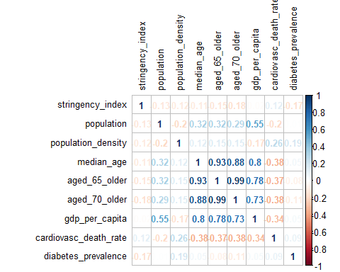

## stringency_index population population_density  
## stringency_index 1.00000000 -0.133789442 -0.1177845  
## population -0.13378944 1.000000000 -0.2028564  
## population_density -0.11778452 -0.202856441 1.0000000  
## median_age -0.11297284 0.323557868 0.1206966  
## aged_65_older -0.14709591 0.320949208 0.1479701  
## aged_70_older -0.17585544 0.292907980 0.1464550  
## gdp_per_capita -0.01500453 0.548718498 -0.1702402  
## cardiovasc_death_rate 0.11750146 -0.199109161 0.2617352  
## diabetes_prevalence -0.17487528 0.005672343 0.1860132  
## median_age aged_65_older aged_70_older gdp_per_capita  
## stringency_index -0.11297284 -0.14709591 -0.1758554 -0.01500453  
## population 0.32355787 0.32094921 0.2929080 0.54871850  
## population_density 0.12069655 0.14797006 0.1464550 -0.17024024  
## median_age 1.00000000 0.92578063 0.8800477 0.79528911  
## aged_65_older 0.92578063 1.00000000 0.9916389 0.77968387  
## aged_70_older 0.88004767 0.99163890 1.0000000 0.73414827  
## gdp_per_capita 0.79528911 0.77968387 0.7341483 1.00000000  
## cardiovasc_death_rate -0.38224426 -0.37494792 -0.3837827 -0.33582141  
## diabetes_prevalence 0.05375998 -0.07759379 -0.1074988 0.04758725  
## cardiovasc_death_rate diabetes_prevalence  
## stringency_index 0.11750146 -0.174875278  
## population -0.19910916 0.005672343  
## population_density 0.26173524 0.186013227  
## median_age -0.38224426 0.053759980  
## aged_65_older -0.37494792 -0.077593788  
## aged_70_older -0.38378269 -0.107498791  
## gdp_per_capita -0.33582141 0.047587248  
## cardiovasc_death_rate 1.00000000 0.090435323  
## diabetes_prevalence 0.09043532 1.000000000

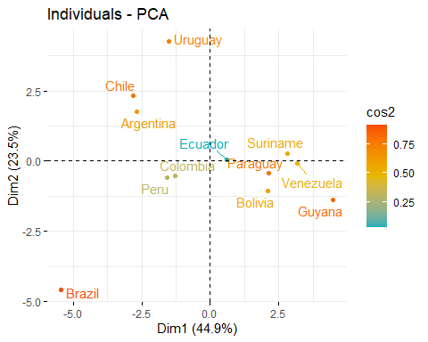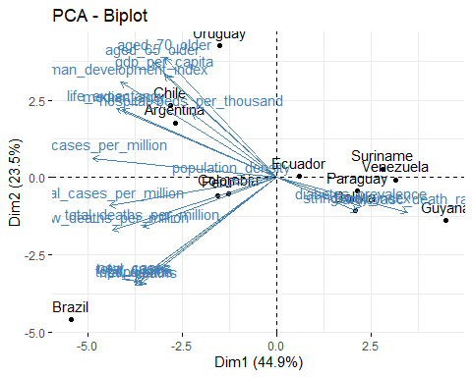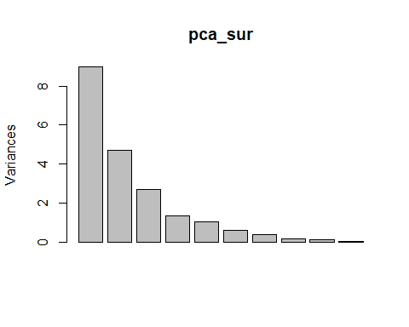

## Warning: ggrepel: 2 unlabeled data points (too many overlaps). Consider  
## increasing max.overlaps

