CS 255 System Design Document

UML Diagrams

UML Use Case Diagram

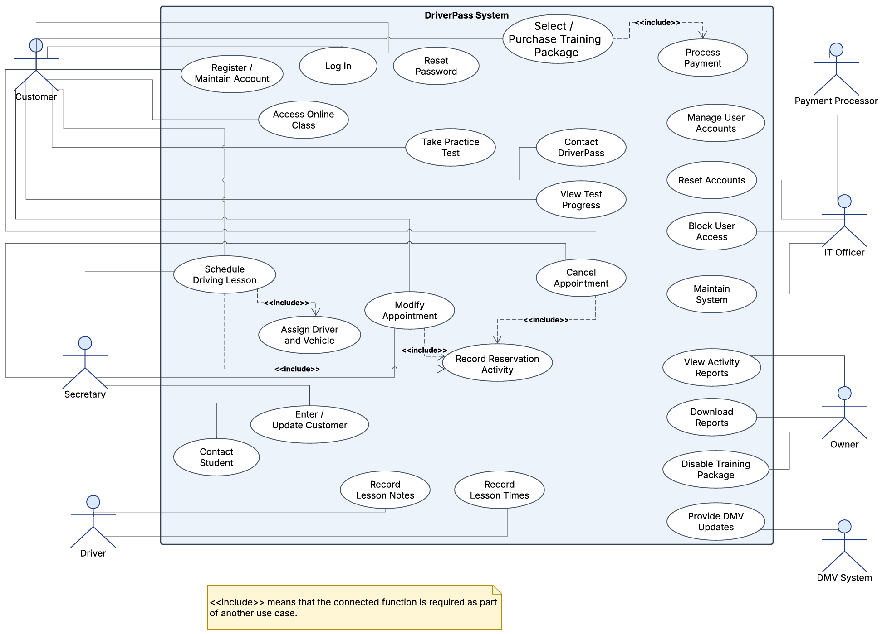

UML Activity Diagrams

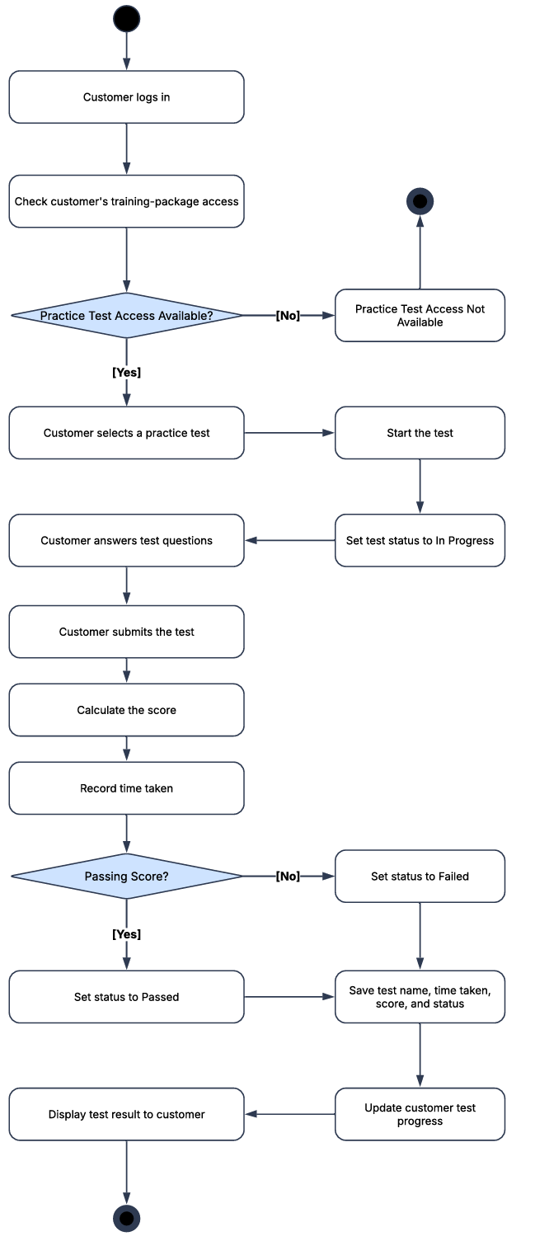 | 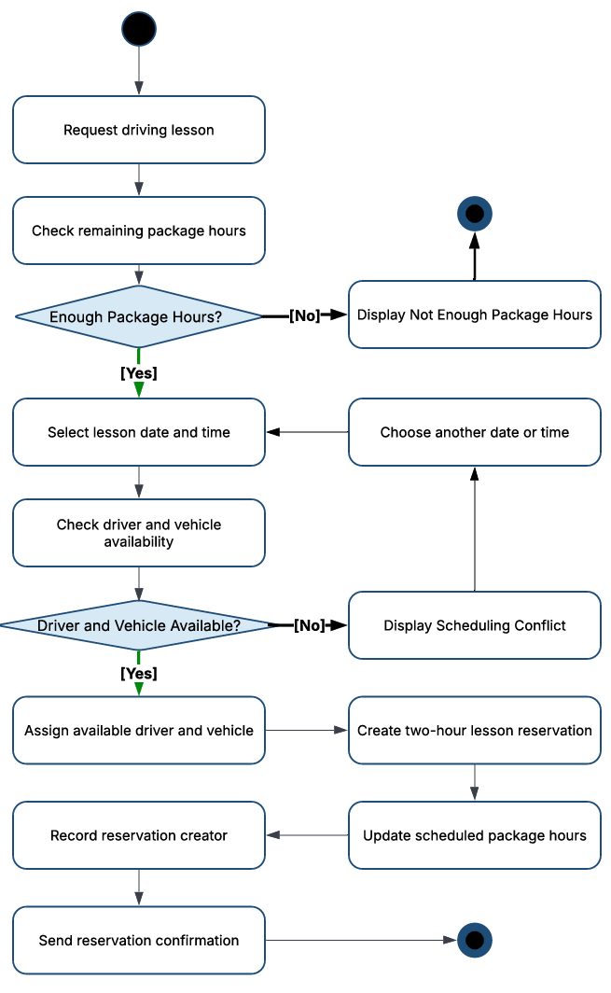

UML Sequence Diagram

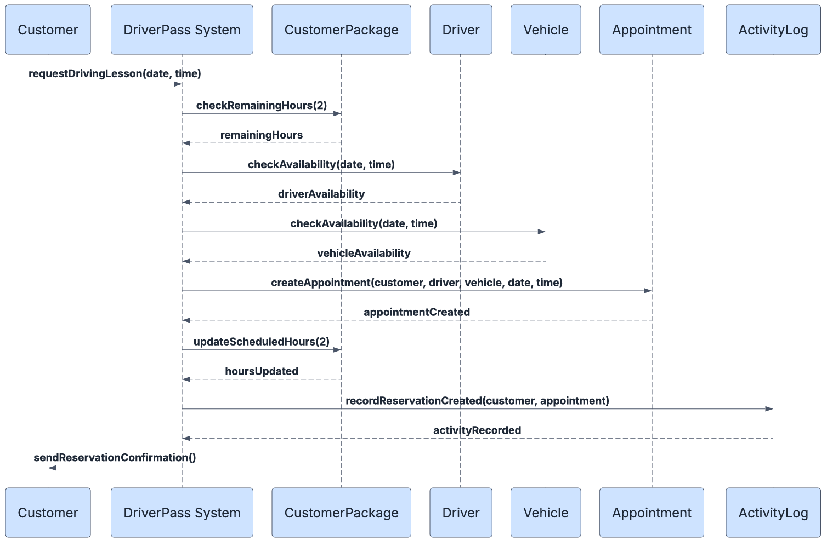

UML Class Diagram

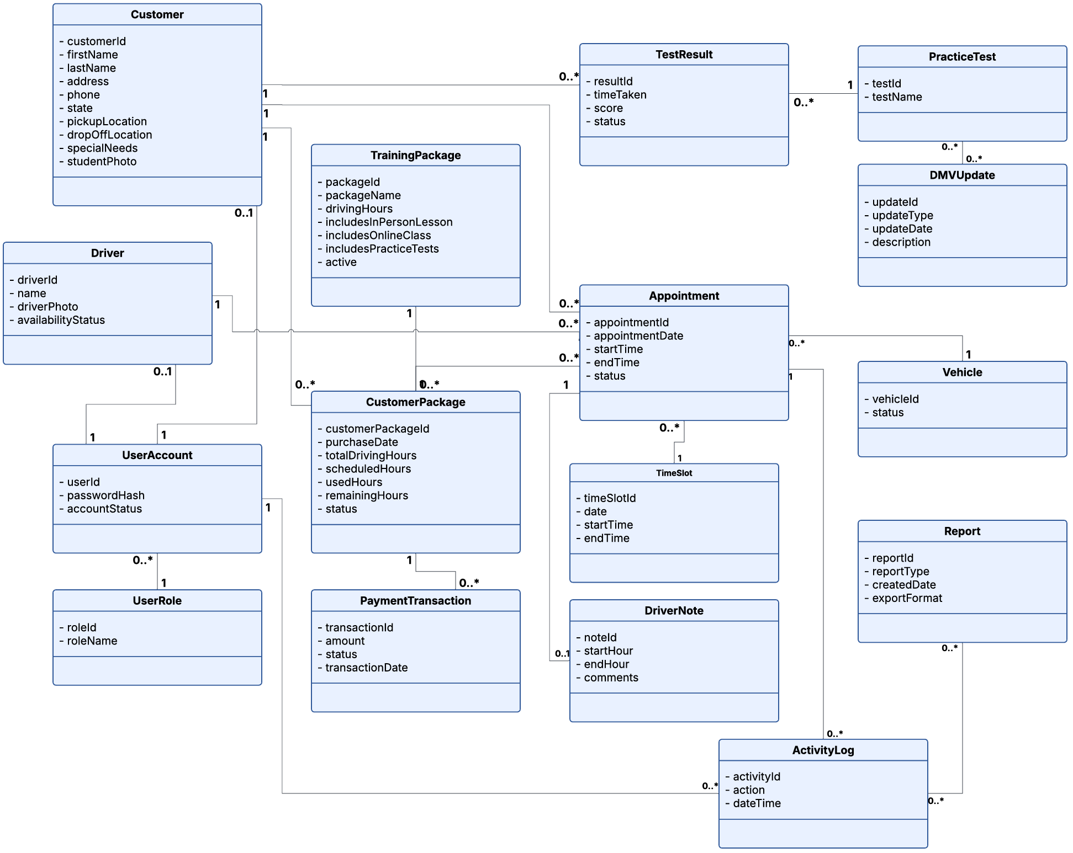

Technical Requirements

The DriverPass system will be a web-based application, so users will need a computer, tablet, or phone with internet access and a web browser. The system should be hosted in the cloud, so DriverPass does not need to maintain its own physical server. The cloud service should also provide backups and basic security.
The system will need a database to store customer accounts, training packages, appointments, drivers, vehicles, test results, notes, payments, and activity records. It should use role-based access, so customers and employees only see the functions they need. Passwords and payment information should be protected, and the website should use HTTPS.
The system should also connect to a payment service and have a way to receive DMV updates. Reports should be downloadable for use in Excel. Development tools will be needed for coding, testing, source control, and updating the system design. The system should also prevent scheduling conflicts and keep a record of who creates, changes, or cancels appointments.

