Adjudicating the viral auxiliary metabolic gene record: disputed families cancel in comparisons and persist in descriptions
Daniel Murphy Undergraduate, Biochemistry. Independent research.
Status: draft, 8 August 2026. Numbers are final; prose is not. All analysis code and intermediate results: https://github.com/dmurfy06/amg-annotation-audit

Abstract
Viruses of bacteria carry genes that resemble host metabolic enzymes. These are routinely catalogued as auxiliary metabolic genes (AMGs) and read as evidence that viruses reprogram host metabolism. A 2025 Nature Microbiology review argued that several of the most frequently counted categories are more plausibly performing viral functions — genome protection, nucleotide provisioning, receptor modification — named specific suspects without quantifying them, and proposed retiring "AMG" in favour of the broader "auxiliary viral gene" (AVG). We quantify the suspects.
We harmonised three published AMG catalogues spanning ocean, soil and wastewater (93,413 calls, three annotation pipelines, three independent research groups), matched gene families by database accession rather than free text, and adjudicated 35 gene families against a pre-registered two-part rule with a six-tier evidence hierarchy. The rule was deliberately biased against our own hypothesis: families default to counting, and chemical plausibility alone can never rule one out.
Twenty-eight of 35 families survive adjudication. Four are ruled out and three are unresolvable. Eight of 35 have no phage-specific experimental evidence of any kind, yet support published claims. Under the strictest pre-registered rule, 28.5% of the curated ocean AMG record, 11.9% of soil and 37.7% of wastewater falls in families that do not support the inference drawn from them — but this figure is carried almost entirely by families that are unresolvable rather than refuted, and in the ocean the strict-rule result reduces to a single family (dcm, 99.6% of excluded calls).
Testing the consequence on published claims, the effect is strongly claim-dependent. A wastewater catalogue's headline compositional claim does not survive: the genes it names as most common are the disputed family. An ocean prevalence estimate moves modestly (19% to 16.9%). A soil comparative claim across a contamination gradient is entirely unaffected. Disputed families cancel in comparisons and persist in descriptions. Comparative AMG claims are largely robust; the more specific a descriptive claim, the more of it rests on families the current evidence cannot adjudicate.
Two limitations are stated rather than buried. Abundance weighting is impossible for 95% of the record, because the ocean catalogue publishes no abundance table. And every family carrying the headline was, by the protocol's own advance declaration, adjudicated with its abundance already publicly known: over the 30 families that entered genuinely blind, the adjudication ruled out none. That bounds the problem usefully — the record's exposure is concentrated in a small, already-named set rather than diffuse and awaiting discovery.
None of the three catalogues did anything the field would regard as incorrect. They applied the standard category. The problem is in the category — which is an argument for Martin et al.'s proposed reframing, on narrower grounds than they give for it.

1. Introduction
Bacteriophages carry genes with unmistakable homology to bacterial metabolic enzymes. The canonical example is psbA, encoding the photosystem II reaction centre protein D1. Mann et al. (2003) found it in a cyanophage genome (doi:10.1038/424741a); Lindell et al. (2005) showed the phage copy is transcribed during infection of Prochlorococcus, co-transcribed with essential phage capsid genes, with phage D1 protein accumulating through the infective period while host photosynthesis gene expression declines (doi:10.1038/nature04111); and Sullivan et al. (2006) found psbA in 88% of surveyed cyanophage genomes, and both psbA and psbD in 50% (doi:10.1371/journal.pbio.0040234). Such genes are interpreted as auxiliary metabolic genes: virus-encoded functions that sustain or redirect host metabolism through infection, with consequences that scale to biogeochemical cycling.
For psbA the interpretation is well supported — and the standard of evidence behind it is worth stating, because very little else in the record meets it: expression measured across infection, protein quantified, and phage genome replication shown to depend on photosynthesis. A phage that keeps photosynthesis running in a cell it is consuming is doing something the host would recognise as its own metabolism, and the fitness rationale — maintaining the energy supply the phage is drawing on — is clear. psbA and psbD serve as this study's positive controls for precisely that reason.
The inference has since been generalised well beyond that case. Annotation pipelines assign AMG status semi-automatically; catalogues are published at the scale of tens of thousands of calls; and those counts underwrite claims about viral contributions to carbon, nitrogen, sulfur and phosphorus cycling across every sampled environment. The category has become infrastructure.
Martin et al. (2025, Nature Microbiology, doi:10.1038/s41564-025-02095-4) argue that a substantial part of what the infrastructure has accumulated is misread. Several of the most frequently counted families have direct, well-documented viral functions:
- DNA cytosine methyltransferases (dcm) modify the phage's own genome, evading host restriction — genome protection, not host metabolism.
- Queuosine biosynthesis enzymes make 7-deazaguanine derivatives that have been detected in phage DNA, where the attributed function is protection from host endonucleases (Thiaville et al. 2016, doi:10.1073/pnas.1518570113; Hutinet et al. 2016, doi:10.1080/15476286.2016.1265200).
- Glycoside hydrolases include virion-associated lysins that breach the cell wall during entry; one was found bound to the phage baseplate and proposed to facilitate genome injection (Yuan & Gao 2016, doi:10.3389/fmicb.2016.00745).
- Folate and one-carbon enzymes feed nucleotide biosynthesis, which during infection is supplying the phage genome.
The general form of the objection is that a gene can act on a host molecule and still be performing a discrete step of the viral lifecycle rather than sustaining host metabolism — and that the AMG category, as applied, does not distinguish the two.
Their proposed remedy is terminological: retire "auxiliary metabolic gene" in favour of "auxiliary viral gene" (AVG), an expanded category covering all genes auxiliary to core viral functions, together with an eco-evolutionary framework for the analyses needed to support claims made about them. The rename is motivated by the misannotation problem, but its scope is the whole category.
Martin et al. name the suspects. They do not count them — so how much of the record the rename is needed for is unknown, and that is a question their own argument cannot answer.
The concern is not new. Pratama et al. (2021, doi:10.7717/peerj.11447) benchmarked viromics workflows, showed that fragmented assemblies lead to erroneous identification of AMGs, and set out a best-practice workflow for curating candidate AMGs. But that work addresses how to curate a candidate correctly going forward; it does not quantify how much of the already-published record rests on families whose interpretation is contested. That has never been measured.
That is the gap. It matters because the answer is not obvious in either direction: the contested families could be a rounding error, or they could be most of the record, and the published literature is compatible with both. It also matters that the question is answerable without new experiments — the catalogues, the annotations and the primary phage literature are all public.
This study asks three questions in order:
- How much of the published record sits in contested families? We harmonise three independent catalogues and match families by database accession rather than free text (§2.2, §3.1).
- Do the catalogues apply their own stated inclusion criteria? This is deliberately independent of Martin et al.'s rubric, and so cannot be dismissed as choosing a convenient standard (§3.2).
- Which families withstand scrutiny on the published evidence, and does removing the rest change anything anyone has claimed? (§3.3–3.6).
The third question is the one that determines whether any of this matters. A labelling problem that changes no published conclusion is a curiosity; one that changes conclusions selectively, in a predictable direction, is a methodological finding. We find the latter.
A note on what this study is and is not. Every verdict here is a judgement about the most parsimonious reading of a gene family on currently published evidence. It is defeasible, it is not a claim about any individual gene call, and it is not a claim that anyone's annotation is incorrect. The protocol was pre-registered, deliberately biased against the hypothesis motivating the study, and its abundance data sealed before any verdict existed, precisely because the author had an obvious interest in a particular answer.

2. Methods

2.1 Catalogues
Three published AMG catalogues, chosen for independence of environment, pipeline and research group:
Catalogue | Environment | Pipeline | Calls | KO-assigned
Microbiome 2024 | Global ocean (Tara) | DRAM-v | 88,729 | 31,772
ISME J 2022 | Soil, organochlorine gradient | VIBRANT + DRAM-v | 4,583 | 1,151
ES&T 2023 | Wastewater activated sludge | kofamscan + hmmsearch | 101 | 77

The ocean catalogue is additionally available pre-curation (255,859 calls), which permits a direct test of whether curation enriches or depletes contested families.
Reconciliation with the published count. Tian et al. report 86,913 AMGs; our harmonised table holds 88,729 ocean rows. These agree exactly: the table carries 86,913 distinct gene identifiers, and the 1,816 surplus rows are genes bearing more than one annotation. We count calls (rows) by default because that is what a catalogue's composition is made of, and report per-gene figures alongside wherever the two differ materially. Recovering the published figure to the digit is the check that the harmonisation is faithful.

2.2 Accession-based family matching (Amendment 1)
Gene families were initially identified by text-matching annotation descriptions. This was wrong and the results it produced are void. Databases spell the same function differently ("glycosyltransferase" vs "Glycosyl transferases group 1"), so text matching under-counted by up to ninefold in the soil catalogue.
All matching is now by database accession (KEGG KO, Pfam PF), which cannot be misspelled. The frozen accession list is data/family_accessions.tsv. Every accession was reviewed by hand and carries a status:
- INCLUDED (72) — the accession denotes the family's activity.
- AMBIGUOUS (6) — folE, folE2, queD and relatives sit at the branch point shared by folate and queuosine biosynthesis. Reported both ways throughout; this single ambiguity moves the wastewater result by 18 percentage points.
- EXCLUDED (2) — matched in error and removed.
The two exclusions matter enough to state explicitly:
- `PF13385` — "Concanavalin A-like lectin/glucanases superfamily" — is a structural fold, not an activity. Concanavalin A binds sugars; it does not hydrolyse them. It was matched solely on the substring "glucanases", and it was 9,237 of the 9,258 glycoside hydrolase calls in the curated ocean catalogue (99.8%) — 21,567 of 21,690 (99.4%) if the pre-curation ocean release is counted alongside the curated one, as the frozen accession table does.
- `K14652` (ribBA) is GTP cyclohydrolase II — riboflavin biosynthesis. Folate and queuosine use GTP cyclohydrolase I. Matched on the shared string "GTP cyclohydrolase".
Both errors inflated our own hypothesis. Removing them reduced the headline. We report this because the direction is informative: the largest single correction in this study made the result smaller.

2.3 The adjudication rule (pre-registered)
Full protocol: 08_adjudication_protocol.md, committed before any verdict existed.
A family counts as an AMG only if both:
- Substrate — the gene product acts on a host molecule; and
- Consequence — the effect is to sustain or redirect host metabolism, rather than to serve a discrete step of the viral lifecycle (entry, genome protection, replication, assembly, egress).
Three design choices deliberately bias the protocol against the hypothesis this study exists to test:
- The default verdict is COUNTS. A family leaves the record only on positive evidence.
- Tier 6 evidence (chemical plausibility alone) can never rule a family out. Tier 6 is essentially what Martin et al. offer; permitting it to decide would restate their argument rather than test it.
- UNRESOLVABLE requires naming the experiment that would settle it. A family with no evidence at all is unresearched, not unresolvable, and defaults to COUNTS. Collapsing those two states would inflate the disputed share on the basis of nobody having done an experiment — the exact information loss this paper criticises.
Evidence tiers. 1: gene knocked out of a phage and effect measured. 2: the phage's own protein purified or structured and substrate shown. 3: expression timing across infection. 4: consistent genomic context among structural/replication genes. 5: informative divergence from host copies. 6: chemistry alone.
Family selection. A family was adjudicated if it accounted for ≥1% of KO-assigned AMG calls and ≥10 calls in any catalogue, or was named by Martin et al. The ≥10 floor (Amendment 2) prevents the percentage threshold from becoming degenerate in the 77-call wastewater catalogue; it removes 18 families accounting for 3.1 percentage points, which are counted in aggregate as COUNTS. No control was removed by this amendment.
Controls. Four families are designated controls: psbA/psbD (positive) must return COUNTS, and xtmA/xtmB (negative) must return DOES NOT COUNT. All four returned correctly. dcm is not a control but a worked example — the protocol's own table of the rule's behaviour states its verdict in advance — so its result is also pre-specified, and we treat it as such throughout. None of these are blind: the protocol names them all. They test whether the rule, faithfully applied, reproduces distinctions the field already accepts. They do not test rater impartiality, and we do not claim they do.
Sealed counts, and what the seal does not cover. Per-family abundance was computed and committed to data/adjudication_counts_SEALED.tsv before any verdict existed, and opened only after all 35 verdicts were recorded and the controls checked.
The seal is not blanket blinding, and the protocol says so explicitly. *Five families — `dcm`, `queuosine`, `glycoside_hydrolase`, `folate` and `dsrC_tusE` — were named by Martin et al., so their approximate abundance was public knowledge before this study began and could not be unknown. The protocol labels these seen*, declares their verdicts "protocol-guided but not blind", and commits to reporting the disputed share twice: over all families, and over blind-only families. That analysis is §3.7, and it matters more than we expected.
For the 30 blind families, no verdict can have been fitted to counts the rater did not have.

2.4 Reporting rules (pre-registered)
The disputed share is reported under four rules, always together:
Rule | Treatment
Inclusive | Current field practice; nothing excluded
Strict | DOES NOT COUNT excluded; UNRESOLVABLE retained
Maximally strict | DOES NOT COUNT and UNRESOLVABLE excluded
Confidence-limited | Only high-confidence DOES NOT COUNT excluded

All proportions carry Wilson score intervals. The spread between rules is a headline result, not a footnote: no reader has to accept our verdicts to use our numbers.

2.5 Rater independence — a limitation stated in the methods, not the discussion
The first adjudication pass was produced with AI assistance (Claude, Anthropic). A second pass was then conducted by the author on the 12 families where evidentiary judgement was actually required; the remaining 23 were resolved mechanically by the protocol (no Tier 1–5 evidence exists, so the family cannot be ruled out), where two raters must agree by construction and measuring agreement would inflate the figure while testing nothing.
The second pass worked from evidence extracts with all verdicts, tier assessments and resolving experiments programmatically removed (build script and leak checks: scripts/build_blind_concordance_sheet.py).
Agreement: 12/12 verdict, 12/12 confidence, 11/12 evidence tier.
Independence could not be verified. The first-pass file remained accessible to the second rater during rating, contrary to protocol. Text-similarity analysis does not indicate copying — every content word in the second rater's free text appears in the supplied evidence extracts, which is sufficient to explain the overlap, and the single tier disagreement is not consistent with transcription. We nonetheless report this as a rubric-application check with independence unverified, and do not present κ as an inter-rater reliability statistic for this study. A genuine reliability figure requires a second human rater working from the blind materials alone, and we did not obtain one.

3. Results

3.1 A DRAM-v flag that looked like a fatal objection, and was not
Pratama et al. (2021) showed that fragmented assemblies produce erroneous AMG identifications, which makes assembly quality the first thing to check before any of what follows means anything.
68% of dcm calls — the largest contested family — carry DRAM-v's F flag. We established from the DRAM-v source (annotate_vgfs.py::get_metabolic_flags, length_from_end=5000) that F means the gene lies within 5,000 bp of a contig end: a positional property, not a biological one, and exactly the marker of fragmented assembly Pratama et al. warn about.
The obvious objection follows immediately — that contested families are assembly artefacts. They are not.
Stratum | n | % F-flagged [95% CI]
Baseline — all AMG calls | 88,729 | 79.1% [78.9–79.4]
Baseline — KO-assigned only | 31,772 | 75.8% [75.3–76.3]
dcm | 5,797 | 68.0% [66.8–69.2]
Queuosine biosynthesis | 2,156 | 74.8% [72.9–76.6]
All contested families combined | 7,969 | 69.9% [68.8–70.9]

Contested families are better placed than the catalogue average, with non-overlapping intervals. A proportion without its denominator is not a finding; computing the baseline converted a threat into a ruled-out confounder.
Two further flags are worth reporting: V (viral replication/structure category) and T (transposon) occur zero times in the curated catalogue, confirming the published exclusions were applied.

3.2 The catalogues mostly cannot break their own rules
We tested each catalogue against its own stated inclusion criteria, using its own annotation database. Martin et al. are not used in this analysis at all. This defeats the objection that we simply selected a rubric that produces the answer we wanted.
Ocean — the rule is enforceable, and enforced. The catalogue states it excludes AMGs on contigs carrying lipopolysaccharide-island genes including glycosyltransferases. Between the permissive and conservative releases, glycosyltransferase calls fall from 30,483 to 2 (99.993% removed) and all 762 transposon-flagged calls are removed. This is a negative result for our pre-registered hypothesis, and it is what makes the positive result credible: the test can pass.
Wastewater — the rule cannot be applied deterministically. The catalogue states that genes "directly involved in viral replication (e.g., replication, repair, nucleotide transport, and metabolism) were not included". Using the authors' own KEGG annotation, 13.0% [7.2–22.3] of KO-assigned calls sit in a category the rule excludes — but 0.0% [0.0–4.8] sit in such a category exclusively. Every one is dual-classified: purA is both nucleotide metabolism (excluded) and amino acid metabolism (permitted); prsA is both nucleotide (excluded) and carbohydrate metabolism (permitted), and the authors present it as a carbon gene.
A rule that does not decide is not being enforced. It is being interpreted case by case, invisibly, and no reader can reconstruct which reading was applied to which gene.
Soil — the rule is not mechanically testable. "Proteins involved in nutrient transformation and pollutant degradation were defined as auxiliary metabolic genes" is a positive definition in ordinary English. Deciding whether cell-surface polysaccharide biosynthesis counts as "nutrient transformation" requires our judgement, so this is not an internal-inconsistency result and we do not claim it as one.
A pre-registered prediction that failed. We predicted the queuosine genes would violate the wastewater rule, since the authors themselves note those genes "could also participate in tRNA biogenesis". They do not trip the test: KEGG files queuosine biosynthesis under folate biosynthesis (09108, cofactors and vitamins), not nucleotide metabolism. The genes that trip it are purA and prsA, and neither trips it cleanly. Reported as a failed prediction rather than quietly dropped.
So: of three catalogues, one states a rule it can and does enforce, one states a rule that cannot be enforced, and one states no mechanically testable rule at all. AMG inclusion criteria are mostly not the kind of thing anyone can check — which is precisely why the record drifts.

3.3 Adjudication: most families survive
Of 35 families adjudicated:
Verdict | n | Families
COUNTS | 28 | incl. psbA, psbD, phoH, TALDO1, nrdH, dut, NAMPT, all nucleotide-sugar precursors
DOES NOT COUNT | 4 | dcm, glycoside_hydrolase, xtmA, xtmB
UNRESOLVABLE | 3 | dsrC_tusE, folate, queuosine

The headline finding is not that the record is full of miscounted genes. Four families in 35 are ruled out, three of which are protocol controls or near-zero in abundance. The adjudication mostly vindicates the field's assignments at the family level.
Eight of the 35 families have no phage-specific experimental evidence of any kind. Nobody has tested what the phage version of those genes does, in any system. Published claims rest on them regardless. This is independent of any verdict and, we suggest, the most immediately actionable result here: it is a research agenda, not a criticism.
dsrC_tusE deserves specific mention because it is an annotation failure rather than a biological one. KEGG merges two functionally distinct proteins into one orthology group literally named tusE, dsrC — one feeds tRNA thiolation, the other dissimilatory sulfite reduction. Nothing in environmental data distinguishes them. The field's strongest phage-sulfur paper writes dsrC/tusE, with a slash, inheriting the ambiguity in its own notation.

3.4 The disputed share, and what carries it
Rule | Ocean (curated) | Soil | Wastewater
Inclusive | 0% | 0% | 0%
Strict | 18.31% [17.89–18.74] | 0.87% [0.47–1.59] | 0.00% [0.00–4.75]
Maximally strict | 28.47% [27.98–28.97] | 11.90% [10.16–13.90] | 37.66% [27.67–48.83]
Confidence-limited | 18.31% | 0.87% | 0.00%

Two features of this table matter more than the point estimates.
The confidence-limited rule is degenerate. All four DOES NOT COUNT verdicts were recorded at high confidence, making it identical to strict. A pre-registered analysis that turns out degenerate is still reported; its degeneracy is a fact about the evidence base.
The ocean strict result is one gene family. dcm supplies 5,797 of 5,818 excluded ocean calls (99.6%). Leave-one-out across all 35 families:
Family held as COUNTS | Ocean strict becomes | Swing
dcm | 0.07% | 18.25 pp
glycoside_hydrolase | 18.25% | 0.07 pp
xtmA, xtmB | 18.31% | 0.00 pp

Removing dcm collapses the strict result from 18.31% to 0.07%. Moreover, dcm is one of the protocol's pre-specified worked examples: its verdict was fixed when the rules were written, not when the evidence was weighed. The ocean strict figure is therefore not an output of the adjudication in the way the maximally-strict figure is, and we do not present it as one.
The defensible headline is the maximally-strict row, where the load is distributed — dcm 18.25 pp, queuosine 6.79 pp, folate 3.35 pp — and where the families doing the work are unresolvable rather than refuted. The honest statement of this study's central result is:
The disputed mass of the AMG record sits in families that the current evidence base cannot adjudicate in either direction.

3.5 Abundance weighting covers only 5% of the record
The pre-registration commits to reporting call-weighted and abundance-weighted shares wherever per-sample abundance exists. It exists for soil (9 samples, relative abundance) and wastewater (RPKM per genome). It does not exist for the ocean catalogue, which publishes annotations without the abundance table behind them — 88,729 of 93,413 calls, and the catalogue carrying the strict-rule result. Abundance weighting is therefore impossible for 95% of this study.
Where it is possible, two analytical traps must be avoided, both of which produced incorrect results in our first attempt:
Abundance is published per virus, not per gene. A virus carrying 27 AMGs repeats its abundance on 27 rows. Naive summation over calls double-counts, and unevenly — it inflates whichever group sits on gene-dense genomes. This artefact alone produced an apparent strict-rule depletion of 0.58×, which disappears entirely (0.99–1.01×) when each virus is counted once. There was no effect.
Aggregate ratios are not family properties. Under the maximally-strict rule the abundance-weighted share genuinely is lower than the call-weighted share (soil 0.47–0.49×, wastewater 0.36–0.37×). But the viruses carrying folate and queuosine sit at 0.92× and 0.90× of the overall median abundance — that is, entirely typical. The aggregate gap is driven by the heavy right skew of viral abundance: a small number of very abundant viruses happen to carry nothing disputed, out of 539.
We therefore state only the narrow result: abundance weighting lowers the disputed share in both catalogues where it can be computed, but the families driving the dispute are carried by viruses of ordinary abundance. The stronger and more interesting claim — that disputed genes sit preferentially on rare viruses — is not supported.
Direction of effect, declared: this cuts against our hypothesis.

3.6 Does any of this change a published claim?
One claim was taken from each catalogue's own abstract. All three were fixed before any was recomputed.
Wastewater — the claim does not survive. The abstract states that of 101 vAMGs, "the most common of which were the queuosine biosynthesis genes folE, queD, and queE and the sulfur metabolism gene cysH". Those genes are the disputed family. Under the maximally-strict rule 29 of 101 vAMGs (28.7%) are removed, the named genes disappear entirely, and cysH inherits the top of the list. We note additionally that the claim holds only in aggregate: no single queuosine gene exceeds cysH's 12 calls; the pathway reaches 27 only when its genes are summed.
Ocean — the claim moves modestly. "We estimate that ~19% of ocean virus populations carry at least one AMG" becomes 17.4% (strict) or 16.9% (maximally strict), a relative fall of about 11%. Of 60,471 virus contigs carrying at least one AMG call, 4,945 qualify on the strength of `dcm` alone.
Soil — the claim is unaffected. "The diversity and relative abundance of AMGs significantly increased along with the severity of pesticide contamination" holds under every rule:
Rule | Abundance Heavy/Clean | Richness Heavy/Clean
As published | 1.25× | 2.54×
Strict | 1.25× | 2.54×
Maximally strict | 1.25× | 2.55×

The pattern is the result. Disputed families are a roughly constant fraction across a gradient, so they cancel in comparisons and persist in descriptions. A study asking "does AMG content differ between conditions?" is largely robust to everything in this paper. A study asking "what are these viruses doing?" is answering with families the evidence cannot resolve — and the more specific the answer, the more of it rests on them.
Every recomputation reduces the published figure. None of the three claims is strengthened.

3.7 The pre-registered blind-only analysis, and what it shows
The protocol commits to reporting the disputed share twice — over all families, and over the 30 families that entered blind — because five families (dcm, queuosine, glycoside_hydrolase, folate, dsrC_tusE) had publicly known abundance before this study started, having been named by Martin et al. (§2.3).
Rule | Family set | Ocean | Soil | Wastewater
Strict | all 35 | 18.31% | 0.87% | 0.00%
Strict | blind-only (30) | 0.00% | 0.35% [0.14–0.89] | 0.00%
Maximally strict | all 35 | 28.47% | 11.90% | 37.66%
Maximally strict | blind-only (30) | 0.00% | 0.35% [0.14–0.89] | 0.00%

Every family carrying the headline was adjudicated non-blind. Of the seven families that leave the record under either rule, five are the seen set and the remaining two are the negative controls xtmA/xtmB (4 soil calls between them). The blind-only disputed share is indistinguishable from zero in two of three catalogues.
This requires care to interpret, in both directions.
It is not evidence that the verdicts are biased. The seen families are seen because Martin et al. named them; their abundance was public before this project existed and could not have been unknown by any design. The declaration was made in advance precisely so this could be checked rather than discovered later.
But the honest reading is a real constraint on the result. Every quantitative claim in §3.4 rests on verdicts made with the counts already known. A reader who distrusts those five verdicts is left with essentially no disputed share at all, and we would rather state that plainly than have it inferred.
And there is a genuine positive finding here that we did not anticipate. Thirty families entered blind, and the adjudication ruled out none of them. No contested family was discovered beyond those the field had already flagged. That bounds the problem usefully: the AMG record's exposure is not diffuse contamination awaiting discovery, it is concentrated in a small, already-named set. The default-COUNTS rule did what it was designed to do — on genuinely blind families, it almost never fired.

4. Discussion

4.1 The record is not broken, but it is unevenly load-bearing
Twenty-eight of 35 families survive adjudication under a protocol explicitly designed to make exclusion difficult. Anyone expecting this study to show that the AMG literature is largely artefact should read that as the primary result. At the level of families, the field's assignments mostly hold.
What does not hold is the assumption that the record is uniformly reliable. Its exposure is concentrated in a small number of families that happen to be very abundant, and — importantly — those families are mostly unresolvable rather than refuted. folate and queuosine carry the maximally-strict result in every catalogue. Neither can currently be assigned in either direction: the queuosine pathway demonstrably serves tRNA modification and has been detected modifying phage DNA, and the same enzymes do both. folE sits at the branch point feeding both pathways, and which branch it feeds moves the wastewater result by 18 percentage points.
This is a different and more tractable problem than "the record is wrong". It localises the uncertainty to a handful of specific, nameable biochemical questions.

4.2 Why the effect is claim-dependent, and how to use that
The most useful generalisation this study supports is structural rather than numerical:
Disputed families cancel in comparisons and persist in descriptions.
The mechanism is straightforward. Contested families occur at a roughly constant rate across the conditions a study compares, so they appear in both numerator and denominator of a ratio and largely drop out. The soil contamination gradient is unchanged to two decimal places under every rule. But those same families remain in any statement about what the record is — what the most common vAMG is, what fraction of viruses carry one, which pathways viruses target — because there is no second term for them to cancel against.
This gives readers a usable heuristic. A study comparing AMG content between treatments, sites, depths or timepoints is largely robust to everything in this paper. A study describing what viruses in an environment are doing is not, and the more specific the description, the less robust it is. The wastewater case is the limiting example: a claim naming the queuosine genes as the most common vAMGs cannot survive those genes being contested, because the claim's subject and the contested family are the same object.

4.3 The criteria problem is upstream of the counting problem
Section 3.2 is, on reflection, the more uncomfortable result. Of three catalogues, one states a mechanical exclusion and enforces it almost perfectly; one states an exclusion that cannot be applied deterministically, because in the authors' own annotation database the same gene simultaneously satisfies and violates it depending on which KEGG category one reads; and one states its criterion in ordinary English, which cannot be checked at all without importing the checker's judgement.
A rule that does not decide is not being enforced — it is being interpreted, case by case, invisibly, and no reader can reconstruct which reading was applied to which gene. This is not a failure of care by any author. It is a convention that has never required inclusion criteria to be machine-checkable, and the drift documented in this paper is what that convention produces at scale.
We think this is the finding with the clearest remedy, and it does not depend on accepting a single one of our verdicts.

4.4 Eight families, no evidence
Eight of 35 families have no phage-specific experimental evidence of any kind. Not weak evidence: none. Nobody has tested what the phage copy of those genes does, in any system, and published claims rest on them anyway.
Under our protocol these families default to COUNTS, because a family with no evidence is unresearched, not unresolvable, and we refuse to let absence of evidence inflate the disputed share. That is the conservative choice and it works against our own hypothesis. But it should not obscure what the number means: for roughly a quarter of the families examined, the question this entire literature turns on has never been asked experimentally.
Each unresolvable verdict in this study names the specific experiment that would settle it (Appendix A). We suggest that list is the most immediately actionable output here.

4.5 What we are not claiming
Not that the annotations are wrong: these sequences really do encode glycosyltransferases and methyltransferases. We challenge the inference drawn from the annotation, not the identification — the misannotation is not in the database, it is in the sentence written afterwards.
Not that any author was careless. Section 3.2 shows one team applying its own stated exclusions to 99.993%. People following reasonable rules can still produce a record that overstates, because the rules underdetermine.
Not anything about any individual gene call. We cannot know what one phage in one water sample was doing with its copy of galE. These are claims about the most parsimonious reading of a family, applied to every call in it.
And emphatically not that AMGs are not real. psbA is real, phoH's distribution (present in ~40% of marine phage genomes and 4% of non-marine ones; Goldsmith et al. 2011, doi:10.1128/AEM.05531-11) is about as good as ecological evidence gets, and transaldolase measurably doubles the host NADPH/NADP ratio (Thompson et al. 2011, doi:10.1073/pnas.1102164108). The question is only how much of the record rests on families that do not support the claim drawn from them.

4.6 On dcm, and on reporting one's own fragilities
That a single family supplies 99.6% of the ocean strict-rule result is a fragility, and we report it as one rather than leaving it for a reviewer. It is also informative in two ways. First, dcm is the least contested case in the whole record — a restriction–modification function nobody seriously argues is host metabolism — so the exposure is concentrated in the clearest case rather than a marginal one. Second, dcm's verdict was fixed by the protocol as a worked example before any evidence was weighed, which means the ocean strict figure is substantially a restatement of the protocol rather than a finding produced by applying it. We therefore rest nothing on it.

4.7 On the proposed rename to "auxiliary viral genes"
Martin et al. propose replacing AMG with the broader AVG. Our data bear on the scope of that proposal, and support it on narrower grounds than they give.
The case for a category-wide rename is strongest if misannotation is diffuse. It is not. Of 35 families, 28 survive adjudication; of the 30 that entered blind, none was ruled out; and the entire disputed mass sits in a handful of families the field had already identified. A rename justified by "many AMGs are not what they appear" is justified by less than that phrase implies.
But there is a better argument for it in our §3.2 result, which is not about misannotation at all. The problem is not principally that genes are wrongly identified — the sequences really do encode what the databases say. It is that the category's inclusion criteria are mostly not checkable: two of three catalogues state rules that cannot be applied deterministically. A term whose boundary cannot be enforced will drift regardless of how good the annotations are, and "auxiliary viral gene" is a wider boundary requiring a weaker commitment — which is exactly why it is more defensible.
So: we support the reframing, for the criteria reason rather than the misannotation reason, and we note that adopting it should not be taken to imply that a large fraction of published AMG calls are wrong. On the evidence here, most are not.

4.8 What the field could do
- Report AMG counts under more than one rule. The spread between inclusive and maximally strict reaches 28.5 percentage points within a single catalogue. A single number conceals a choice that a reader cannot see or reverse.
- State inclusion criteria mechanically enough to be checked. If a criterion cannot be applied deterministically using the annotation database the study itself used, it is not functioning as a criterion.
- Report the namespace and the unit. KEGG and Pfam disagree by up to threefold on the same catalogue, and in opposite directions in different environments; genes and calls are not interchangeable.
- Do the named experiments. Three unresolvable families, three specified experiments, and eight families with no phage-specific evidence at all.

4.9 A note on method
Three headline numbers in this study were killed by checks built into it beforehand: a family that turned out to be 99.4% a protein fold rather than an activity; an apparent abundance depletion that was per-virus values summed over per-gene rows; and an inter-rater agreement figure whose independence could not be verified. Each was caught by something set up in advance — a frozen accession list with a status column, a pre-registered commitment to report both weightings, a sealed counts file, a routine text comparison.
We report them because a study arguing that a field's conventions permit undetected drift is obliged to demonstrate that its own conventions detect it.

5. Limitations
- Every family carrying the headline was adjudicated non-blind (§2.3, §3.7). The five families driving the result had publicly known abundance because Martin et al. named them. This was declared in the protocol in advance and the blind-only analysis is reported, but it is the single largest constraint on how much weight §3.4 can bear.
- Independence of the second adjudication pass is unverified (§2.5). No inter-rater reliability statistic is claimed.
- No control in this study is blind. The protocol names all four, plus the dcm worked example.
- Abundance weighting covers 5% of the record (§3.5).
- 35 families, not all families. 18 further families were removed by Amendment 2 and counted in aggregate as COUNTS, accounting for 3.1 percentage points.
- Family-level verdicts are applied to every call in the family. No claim is made about any individual gene call, which cannot be adjudicated from catalogue data.
- Adjudication is defeasible. Verdicts reflect the best reading of current evidence, not settled fact — which is why confidence is recorded separately and why Tier 6 alone cannot rule a family out.

6. Data and code availability
All code, intermediate results, the frozen accession list, the pre-registered protocol with amendments, the sealed abundance counts with their commit history, and both adjudication passes: https://github.com/dmurfy06/amg-annotation-audit
Source catalogues are the published supplementary files of the three cited studies and are not redistributed here.

7. References
All entries below were retrieved and verified via PubMed. The primary phage literature underpinning individual family verdicts is cited inline in Appendix A and in results/chunk5_evidence_dossiers.md, and is not repeated here.
The three source catalogues
- Tian F, Wainaina JM, Howard-Varona C, Domínguez-Huerta G, Bolduc B, Gazitúa MC, Smith G, Gittrich MR, Zablocki O, Cronin DR, Eveillard D, Hallam SJ, Sullivan MB (2024). Prokaryotic-virus-encoded auxiliary metabolic genes throughout the global oceans. Microbiome 12(1):159. doi:10.1186/s40168-024-01876-z
- Zheng X, Jahn MT, Sun M, Friman V-P, Balcazar JL, Wang J, Shi Y, Gong X, Hu F, Zhu Y-G (2022). Organochlorine contamination enriches virus-encoded metabolism and pesticide degradation associated auxiliary genes in soil microbiomes. ISME J 16(5):1397–1408. doi:10.1038/s41396-022-01188-w
- Yuan L, Ju F (2023). Potential auxiliary metabolic capabilities and activities reveal biochemical impacts of viruses in municipal wastewater treatment plants. Environ Sci Technol 57(13):5485–5498. doi:10.1021/acs.est.2c07800
The critique and the standards this study responds to
- Martin C, Emerson JB, Roux S, Anantharaman K (2025). A call for caution in the biological interpretation of viral auxiliary metabolic genes. Nature Microbiology 10(9):2122–2129. doi:10.1038/s41564-025-02095-4
- Pratama AA, Bolduc B, Zayed AA, Zhong Z-P, Guo J, Vik DR, Gazitúa MC, Wainaina JM, Roux S, Sullivan MB (2021). Expanding standards in viromics: in silico evaluation of dsDNA viral genome identification, classification, and auxiliary metabolic gene curation. PeerJ 9:e11447. doi:10.7717/peerj.11447
The `psbA` evidence chain (positive controls, §1)
- Mann NH, Cook A, Millard A, Bailey S, Clokie M (2003). Marine ecosystems: bacterial photosynthesis genes in a virus. Nature 424(6950):741. doi:10.1038/424741a
- Lindell D, Jaffe JD, Johnson ZI, Church GM, Chisholm SW (2005). Photosynthesis genes in marine viruses yield proteins during host infection. Nature 438(7064):86–89. doi:10.1038/nature04111
- Sullivan MB, Lindell D, Lee JA, Thompson LR, Bielawski JP, Chisholm SW (2006). Prevalence and evolution of core photosystem II genes in marine cyanobacterial viruses and their hosts. PLoS Biology 4(8):e234. doi:10.1371/journal.pbio.0040234
A note on overlapping authorship, stated for transparency. Sullivan is an author on the ocean catalogue (1), the standards paper (5) and the psbA prevalence survey (8); Roux is an author on the critique (4) and the standards paper (5). This is a small field. Nothing here is a criticism of any individual, and the analysis in §3.2 was constructed to be independent of whose rubric is applied precisely because that is unavoidable.

8. Acknowledgements
Analysis code was written with Claude (Anthropic), and the first adjudication pass was AI-produced; see §2.5 for what that means for the reliability claims in this paper. Scientific judgement, verdicts, and all decisions about what to report are the author's.

Appendix A — the 35 adjudicated families
Complete: `manuscript/appendix_a_families.md`. Verdict, evidence tier, confidence, per-catalogue counts, basis for inclusion and full accession list for all 35 families, plus the named resolving experiment for each unresolvable verdict. Generated directly from the adjudication record by scripts/build_appendix_a.py rather than transcribed, so it cannot drift from the underlying verdicts.

Figures
Built by scripts/build_figures.py from the sealed counts and the adjudication record (Figures 1, 2, 4) and from the chunk 7 outputs (Figure 3), so no value is transcribed by hand. PNG and vector PDF in manuscript/figures/. Palette is Okabe–Ito and legible in greyscale.
Figure 1 — Excluded share depends on which pre-registered rule is applied. fig1_four_rule_spread · cited in §3.4 Excluded share of the KO-assigned AMG record under three of the four pre-registered rules, for each catalogue, with Wilson 95% intervals. The confidence-limited rule is identical to strict — all four DOES NOT COUNT verdicts were recorded at high confidence — and is not plotted separately. The spread between rules is the result; no single bar is the headline.
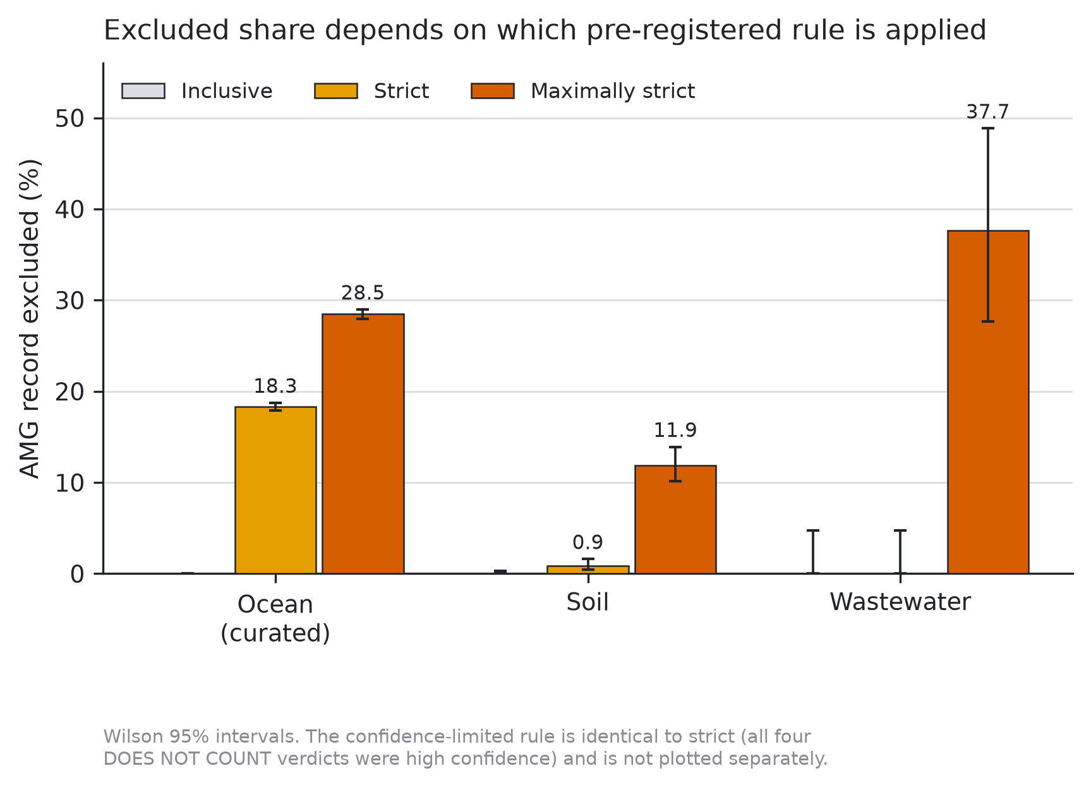
Figure 2 — One family carries the strict result; the maximally-strict result is distributed. fig2_leave_one_out · cited in §3.4 Leave-one-out for the ocean catalogue: each bar is the excluded share when that family alone is held at COUNTS, against the dashed baseline. Under the strict rule, removing dcm collapses the result from 18.31% to 0.07%. Under the maximally-strict rule the load is distributed across dcm, queuosine and folate. dcm is highlighted because it is also a protocol worked example, so its verdict was fixed before evidence was weighed.
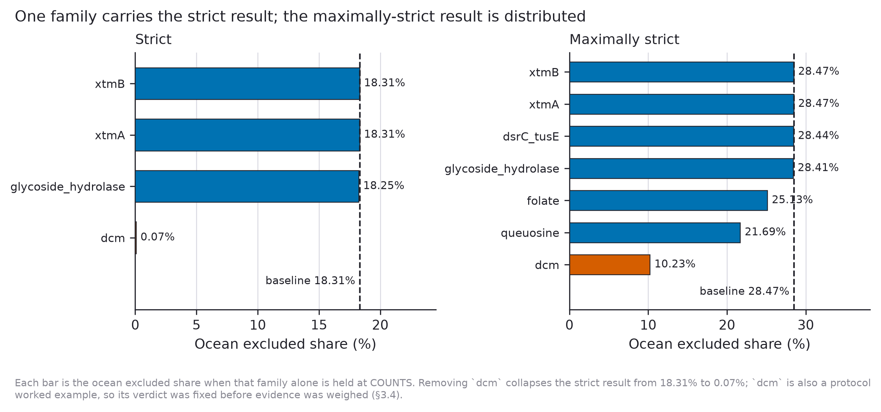
Figure 3 — Disputed families cancel in comparisons and persist in descriptions. fig3_published_claims · cited in §3.6 · the paper's key figure One claim from each catalogue's own abstract, all three fixed before any was recomputed. Left: the wastewater catalogue's 101 vAMGs, with the queuosine-pathway genes its abstract names as most common highlighted — under the maximally-strict rule those genes disappear and 29 vAMGs go with them. Centre: the ocean prevalence estimate falls from 19% to 16.9%. Right: the soil contamination gradient is unchanged under every rule, for both abundance and richness.
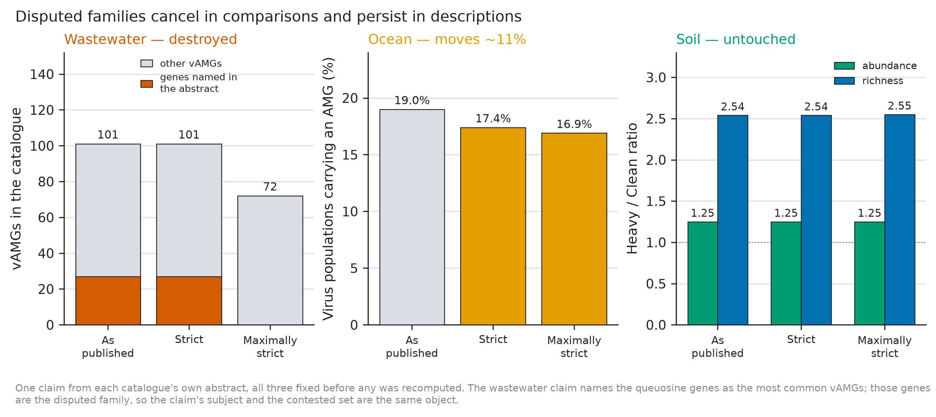
Figure 4 — Half the adjudicated families rest on chemical plausibility alone. fig4_evidence_tiers · cited in §3.3 Highest tier of phage-specific evidence found for each of the 35 families, stacked by verdict. Seventeen families reach only Tier 6, where the protocol forbids ruling a family out, so they default to counting. Eight have no phage-specific evidence of any kind. Tiers are from the first-pass record; the second pass disagreed on one family (rfbC, Tier 2 vs 6; §2.5).
