In-Class Data File Practice

**Group: shredder shirts**

1. The R-code you used to read each of the three data files. Do not use file.choose()!

Answer:

require(here)

dat_catrate <- read.csv(here("data”, “catrate.csv"))

dat_delomys <- read.csv(here("data”, “delomys.csv"))

dat_rope <- read.csv(here("data”, “rope.csv"))

1. A plot (of any type) from each group member.
   * You must add a custom title containing your name to your plot (using the *main =* argument).

Ednita:

require(here)

dat_catrate <- read.csv("catrate.csv")

dat_delomys <- read.csv("delomys.csv")

dat_rope <- read.csv("delomys.csv")

head(dat_catrate)

head(dat_delomys)

head(dat_rope)

plot(pond ~ cat.rate, data = dat_catrate, xlab = "Rate", ylab = "Pond", main = "Ednita Pond vs Rate" )

boxplot(observation ~ sex, body_mass ~ body_length, data = dat_rope,

main = "Ednita's Observation of Sex",

xlab = "Sex",

ylab = "Observation")

hist(dat_rope$body_length, dat_rope$agea, main = "Ednita's Body Length", xlab = "Body Length")

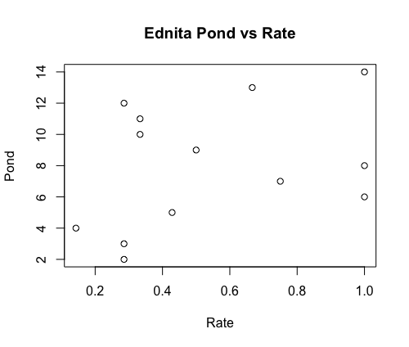

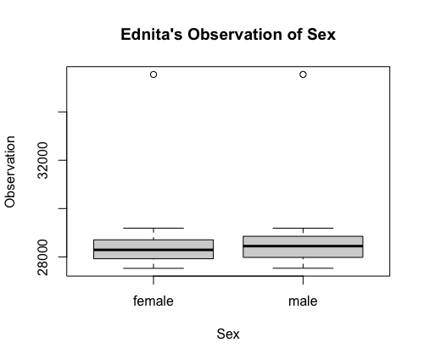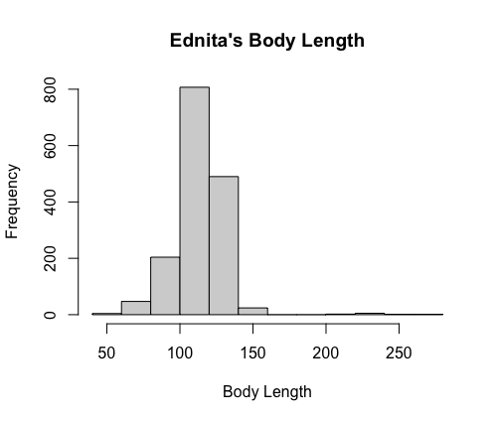

Q1: I found it difficult to make a histogram but

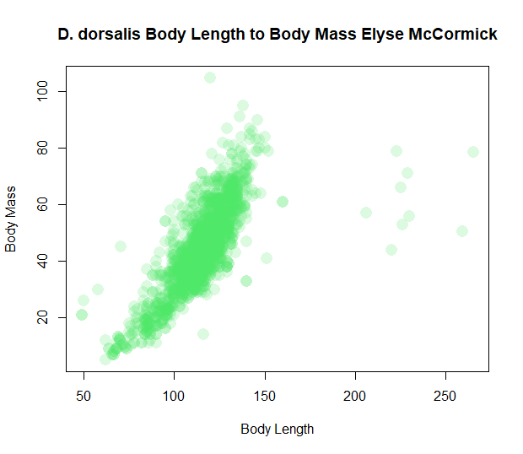

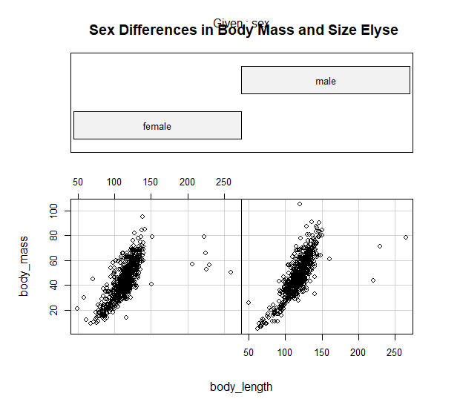

Elyse:

dat_catrate = read.csv( here("data", "catrate.csv"))

head(dat_catrate)

dat_delomys = read.csv( here("data", "delomys.csv"))

head(dat_delomys)

dat_rope = read.csv( here("data", "rope.csv"))

head(dat_rope)

Kato:

rope <- read.csv(here("data", "rope.csv"))

delomys <- read.csv(here("data", "delomys.csv"))

catrate <- read.csv(here("data", "catrate.csv"))

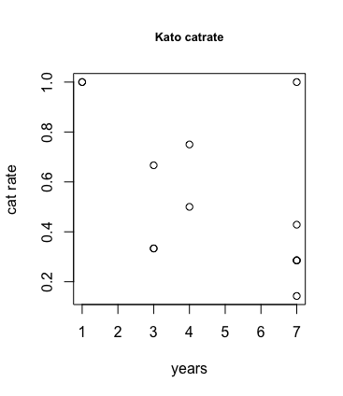

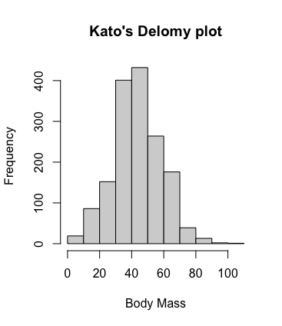

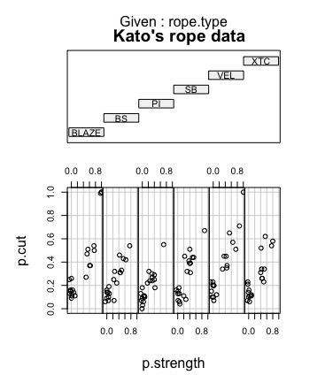

1. One question or difficulty that your group encountered.

Answer: the function here() was a little confuse in the begin of the course, but I now is easier to understand.

Getting a title on the coplot was tricky.

Trying to make a title have italics was tricky, I didn’t figure it out

Matthew:

dat_catrate <- read.csv(here("data", "catrate.csv"))

dat_delomys <- read.csv(here("data", "delomys.csv"))

dat_rope <- read.csv(here("data", "rope.csv"))

head(dat_catrate)

head(dat_delomys)

head(dat_rope)

boxplot(body_length ~ status, data = dat_delomys,

main = "Matthew's Plot of Delomys Body Length in Living and Dead Subjects",

ylab = "Body Length", col = "orange")

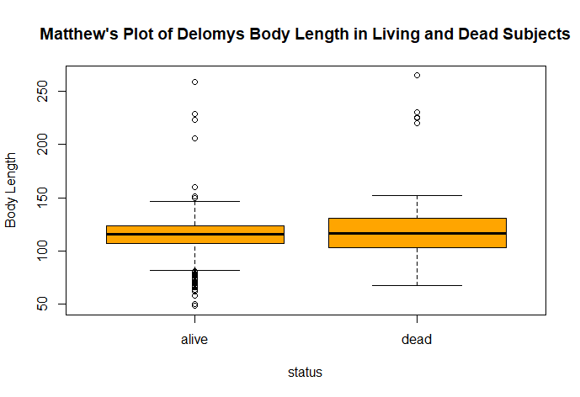

The most challenging part was attempting to do two variables, adding the status variable to the plot

Jackie Stephens

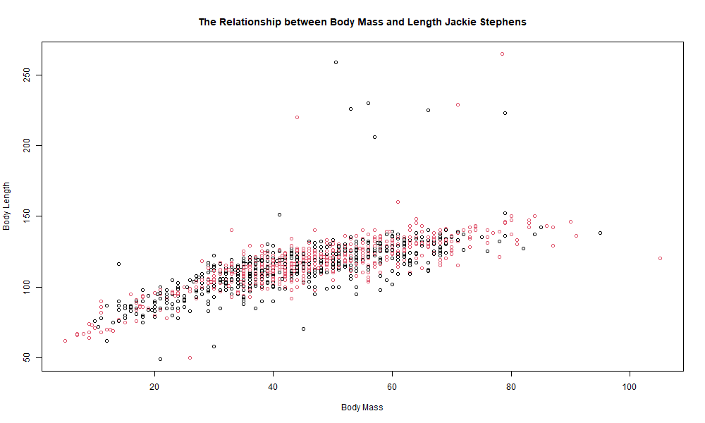

With females shown in black and males in red

One difficulty I came across was figuring out the difference between the coplots used last in class activity and creating a graph that differentiates between sex.