Table of Contents
About Homeopathy 3
Taking Cases 4
Finding More Information 4
Homeopathic Literature 5
Pharmacies and Bookstores 5
Organizations 5
Overview and Quick Start Instructions 6
What's New 12
Detailed Instructions 14
Main Form 14
The File Menu 14
New Case File command (File menu, main screen) 14
Open Case File command (File menu, main screen) 14
Close Case File command (File menu, main screen) 14
Save Case File command (File menu, main screen) 15
Save Case File As command (File menu, main screen) 15
New Quest. File command (File menu, main screen File menu, Questionnaire) 16
Open Quest. File command (File menu, main screen and each questionnaire page) 16
Close Quest. File command (File menu, main screen and each questionnaire page) 16
Save Quest. File command (File menu, main screen and each questionnaire page) 17
Save Quest. File As command (File menu, main screen and each questionnaire page) 17
Print command (File menu, main screen) 17
Print Preview command (File menu) 18
Exit command (File menu) 18
OPTIONS Menu 19
Toolbar 21
Title Bar 22
Main Form Optional Settings 22
Minimum Number Box 22
Default Scheme (Prescribing Schemes section) 23
Equal Weight Scheme (Prescribing Schemes section) 24
Straight Count Scheme (Prescribing Schemes section) 24
Normalize Option (Prescribing Schemes section) 24
Weight (Set Weight section) 25
Holistic Option (Set Weight section) 26
The “Show Similar Symptoms” button 26
The “Find” button 27
The "Grid Search" Button 29
Repertory-Style (symptom search) button 31
HELP Menu Commands 33
Help Contents command (Help menu) 33
User Manual command (Help menu) 33
About command (Help menu) 33
Lists and Buttons 33
The Symptom List 34
Using the Scroll Bars 34
Selecting Symptoms 34
The “Must Use” Button and Box 34
The “Select” Button and “Selected Symptoms” List 35
Symptom Weights 35
The “Find” and "Grid" Buttons 36
The “Weight” Box 36
The “Delete Must” Button 36
The “Delete Sel” Button 37
The “Prescribe” Button 37
The Prescribed Remedies List 37
The “Remedies” Button and Lists 39
The "Questionnaire" Button and forms 40
File Formats 48
Symptom Files 48
Questionnaire Files 48
In Case Of Difficulty 49

About Homeopathy
The branch of medicine known as Homeopathy was invented by Dr. Samuel Hahnemann of Germany (1755 - 1843). Homeopathy seeks to cure illnesses with the minimum necessary dose of medicine. The key principle of Homeopathy is the Law of Similars. This law states that any substance which causes a given set of symptoms in healthy people can cure the same symptoms in a sick person.

Homeopathic medicines are prepared by progressively diluting the original substance in alcohol, distilled water, or lactose, usually using 9, 99, or 999 parts of the diluting substance to one part of the original. This dilution is then "succussed", which involves hitting the container of solution against a table, hand, etc. a number of times to mix the solution. This process is repeated a number of times to obtain the desired potency. Solutions prepared in this manner are called "Remedies", and are said to be "Potentized". The strength is abbreviated by a number which indicates the number of times the remedy was diluted, and a Roman numberal X, C, or M indicates a 1/10, 1/100, or 1/1000 dilution at each stage. Common dilutions are 6X, 6C, 12X, 12C, 30X, and 30C. Surprisingly, the higher the number of dilutions, the stronger the remedy appears to act. Potencies above 30X and 30C, and the "M" potencies, should only be used when prescribed by a physician.

Homeopathic remedies are made from many different substances. The majority of these are derived from various parts of plants. Others come from animals or chemical sources. Plants and soluble substances are dissolved in alcohol or distilled water, and are referred to as a "tincture" before being diluted. Non-soluble substances are mixed with lactose and referred to as a trituration. These are then made into either tablets or pellets.

Homeopathic remedies are believed to be relatively safe, with few or no known side effects. However for them to be effective, certain practices must be followed. You should avoid fluoride, caffiene, and mint when taking Homeopathic remedies. Even small amounts of fluoride can counteract Homeopathic remedies and make them useless. For this reason, if your water contains fluoride, you should drink steam-distilled or properly filtered water (this is probably a good idea anyway). Special toothpastes are available through health-food stores or in many grocery stores and pharmacies which do not contain mint or fluoride; common brands are Toms and Burts Bees. Remedies should not be taken with food. See the individual remedy containers and Homeopathic literature for specific instructions and dosage recommendations.

You will want to observe certain practices to maintain the potencies of your remedies. They should be stored at room temperature, out of direct sunlight. You should also keep them away from strong-smelling substances such as spices, and from electro-magnetic fields (motors, TV's, microwaves). In addition, you should success them once per week.

It is strongly recommended you obtain a good Materia Medica to use in conjunction with this program. These contain lists of remedies with their associated symptoms. Many of them also contain a Repertory, which is an abbreviated list of symptoms with a cross-reference to remedies. Two of the best Materia Medicas are "Pocket Manual of Materia Medica with Repertory" by William Boericke, M.D.. and "Lectures on Homeopathic Materia Medica" by James T. Kent, M.D. It will also be very helpful to have a good medical dictionary. Probably the best one for Homeopathy is the "Dictionary of Homeopathic Medical Terminology" by Jay Yasgur, RPh., M.Sc. These books are available at many health-food stores or online. One good source is Homeopathic Educational Services (homeopathic.com). See the Bibliography section for mail-order addresses and additional titles.

When starting to take a new remedy, you should always start with a lower potency. In general, you will want to use a 6X or 6C, but you should consult a Materia Medica for specific dose recommendations, especially for the less common remedies. You can then work up to higher potencies with time, if necessary.

When taking Homeopathic remedies, as with any medicine, you should never try to "play doctor". If your symptoms persist more than a few days, it is important to see a physician for proper diagnosis and treatment. Many diseases may be contagious or can get worse with time, and require proper diagnosis by trained professionals.

Taking Cases
In order to prescribe a Homeopathic remedy, it is necessary to gather as much information about the patient as possible. This can include such things as physical and psychological characteristics, medical history, modalities (what makes the condition worse or better), and specific names of illnesses, if known. This collected information is known as a "case". In Homeopathic medicine, a remedy that cures one person's flu, for example, may not work for another person, due to differences in their characteristics. For this reason, it is important to note as many distinguishing factors as possible to improve the accuracy of the prescribing process. You may want to browse through the symptom list in Dr. Hahnemann's Assistant or a good Materia Medica to get a feel for the types of things to look for when making up your case. Also note which symptoms appear stronger or more important.

You will also want to take note of the stage of the illness. Many remedies are optimal for the beginning, middle, or end of a fever, for example; this means you may want to switch to different remedies as such an illness takes its course. The notes in the Materia Medica can help you determine if you are dealing with an illness which requires switching remedies, and when you need to make the switch. You will then want to revise your case and have Dr. Hahnemann's Assistant make another recommendation.

You will note that many of the symptoms in the list are names of diseases. You should use these only after being properly diagnosed by a trained professional. Never assume you have the "flu" or a "cold", for example; it could be allergies. Also, many diseases such as cancer, heart disease, etc. can be life-threatening. Always seek the care of a qualified professional when dealing with these diseases.

For a good description of taking cases, see "Everybody"s Guide to Homeopathic Medicines" by Stephen Cummings, M.D. and Dana Ullman, M.P.H.

Finding More Information
Many good books on Homeopathy are available through bookstores and health-food stores, online, and at local libraries. Also, several organizations exist for training, research, and advancement of the field of Homeopathy. Below is a small list of books, companies, and organizations which deal with Homeopathics, to get you started. There is a wealth of information about Homeopathy on the Internet; for the most current information, and to find homeopathic pharmacies in your part of the world, it is suggested you do an Internet search for “Homeopathic”.

Homeopathic Literature
"A Dictionary of Homeopathic Medical Terminology" by Jay Yasgur, R.Ph., M. Sc., Van Hoy Publishers, PO Box 925, Greensville, PA 16125

"Divided Legacy: A History of the Schism in Medical Thought", Harris Coulter, PhD (3 volumes)

"A Doctor's Guide to Helping Yourself with Homeopathic Remedies" by James H. Stephenson, M.D. West Nyak, N.Y.: Parker Pub. Co. 1976.

"Everybody's Guide to Homeopathic Medicines", by Stephen Cummings, M.D. and Dana Ullman, M.P.H. Jeremy P. Tarcher, Inc., 5858 Wilshire Blvd., Suite 200, Los Angeles, CA 90036

"Lectures on Homeopathic Materia Medica" by James T. Kent, M.D.

"Pocket Manual of Materia Medica with Repertory" by William Boericke, M.D.

"Vibrational Medicine", by Richard Gerber, M.D., Bear & Co., Santa Fe, NM 87504 - good survey of various forms of alternative medicine, including theories explaining Homeopathics and the Interro

Pharmacies and Bookstores
Boericks & Runyon, Div. (Boericke and Tafel), http://www.boerickeandtafel.com

Homeopathic Educational Services, (homeopathic.com) - remedies, books, software, research literature, lists of Homeopathic physicians

Kiehl's Pharmacy, https://stores.kiehls.com/ny/new-york/109-3rd-ave.html

Smallflower Pharmacy, https://www.smallflower.com/

Sion et Nature, https://www.soin-et-nature.com/en/

Washington Homeopathic Pharmacy (WHP), https://www.homeopathyworks.com

Organizations
American Institute of Homeopathy, https://homeopathyusa.org/

National Center for Homeopathy, https://homeopathycenter.org/

Overview and Quick Start Instructions
When you first start Dr. Hahnemann's Assistant, the following form will come up:

File, Options, and Help menus Names of your current files
symptom text display toolbar provides shortcuts

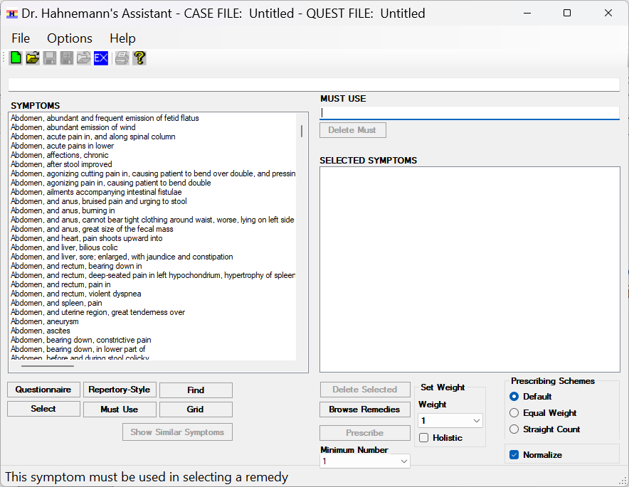
this dropdown assigns weight to symptoms
use these buttons to search for symptoms
select symptoms from this list with these buttons selected symptoms appear in these boxes

Figure 1 – Main Form

The concept behind Dr. Hahnemann’s Assistant is relatively simple. It contains a list of over 20000 symptoms, which you choose from to make up your “case”. You have the option to view this list in several formats, including a complete alphabetical list of symptoms, a series of pop-up lists broken into phrases similar to the way they appear in a repertory, phrase search functions, and a case-style questionnaire. The symptoms are taken from several Materia Medica. Each symptom is associated with one or more Homeopathic remedies.

When you are done selecting all the symptoms which describe your case, you are ready to prescribe the remedy. Several symptom weighting options are available, as well as an option to limit the number of remedies considered by requiring more than one selected symptom per remedy. Dr. Hahnemann’s Assistant uses your Symptom List and weighting criteria to search its table of remedies and generate a ranked list of remedies for your case. This list is sorted in order of indication, with the most strongly-indicated remedy at the top. There are also options to view Symptom Lists for individual remedies, and to print the case symptoms, prescribed remedy list, individual remedy Symptom Lists, and questionnaire.

The following paragraphs take you through inputting a case and prescribing a remedy. For a detailed description of an individual function such as searching the Symptom List, see the section under that particular function.

Begin by making up your case from the list of symptoms on the left side of the screen (see Figure 1). To navigate through the list of symptoms, you can use the scroll bar to the right of the list or the “Find” or “Grid” buttons. The “Find” button brings up a dialog which allows you to specify the string to search for, as well as to tailor the search to make it easier to find your symptom. The “Grid” button brings up a dialog similar to the one for the “Find” button, but you can enter multiple search words in a grid and have the ability to logically AND and OR them together. When you locate the desired symptom in a list, click on it to highlight it. Note that any number of symptoms in the view may be highlighted. If you accidently click on the wrong symptom, click on it again to un-highlight it. To complete the symptom selection, you must click either the “Select” or the “Must Use” button.

If you find the Symptom List is a bit long and tedious to search, you may want to try the Repertory-Style search. To bring up this option, click the “Repertory-Style” button above the Symptom List. This button brings up an abbreviated-format Symptom List which presents only the first phrases of symptoms, with those having identical first phrases combined. Use the scroll bar just like the one on the Symptom List, or begin typing a phrase in the box above the list to quickly go to it. If the phrase ends in an ellipsis ("..."), clicking on it will bring up a second list containing the next phrase of all symptoms which start with that phrase. Continue in this manner to complete the symptom phrase. When a symptom is complete, clicking on it will enable the buttons at the bottom of the box. Use these buttons just like the ones on the main form to select your symptom or assign it to the "Must Use" box, and assign it a weight. When you are done selecting your symptom, click on the Close button to go to the previous box and continue selecting symptoms, or the Done button to start on a new symptom phrase or to stop selecting symptoms.
access questionnaire files and print questionnaires from this menu navigate pages with these tabs
type in descriptive answers here and select qualifiers here (if available) scroll tabs

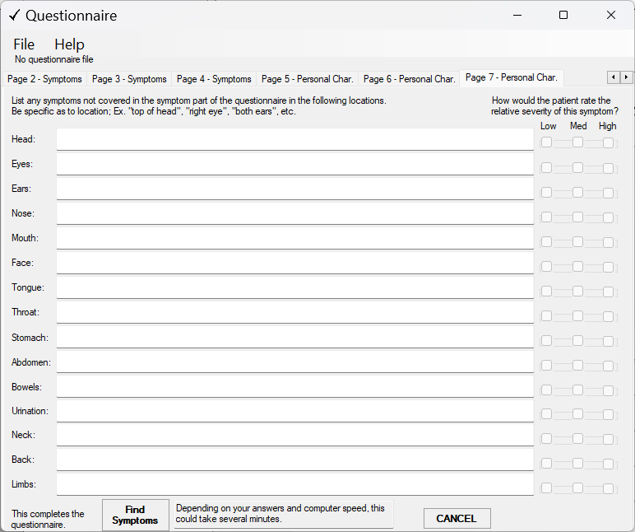
use this button to generate an initial
symptom list from your answers (available only on the last page)

Figure 2 – Questionnaire Form

Another useful feature is the Questionnaire. As with the repertory-style search option, this feature is not required to complete your case, but can make it easier to track progress of your case and to select the initial group of symptoms. Click the “Questionnaire” button above the Symptom List on the main form to bring up the first questionnaire page (Figure 2 is showing Page 7). Fill in the patient information just as you would on a form when taking a case. Use the “Continue” button and Page tabs to navigate between pages. The first 4 pages are for individual symptoms, and the last 3 pages are for general information. To add additional symptoms, use the “Add a Symptom” button on page 4. You can then use the “Prev” and “Next” buttons to navigate between symptoms. Use the File menu at the top of any of the questionnaire pages to save or retrieve your questionnaire to/from a file (this file is separate from a case file). The “Print” menu allows you to print your completed questionnaire. Click the “Find Symptoms” button at the bottom of page 7 to bring up a list of symptoms suggested by your answers in the questionnaire. You can then use this list just like the Symptom List on the main form to select symptoms and assign symptom weights. When you are done with the questionnaire, click the Cancel button on any page.

Continuing on the Main Form, the “Must Use” button will copy a single highlighted symptom to the “Must Use” box at the upper right of the screen. When prescribing, only remedies associated with this symptom will be considered. The “Must Use” box can contain a maximum of one symptom. Due to this fact, it will greatly limit your list of prescribed remedies. It is not necessary to use the “Must Use” box for your case.

Use the “Select” button to select the list of symptoms for your case. When you click on this button, all highlighted symptoms (with the exception of the “Must Use” symptom and any previously-selected symptoms that may appear on the display) will be copied to the “Selected Symptoms” list on the right side of the screen. Symptoms in this list are sorted in alphabetical order (ignoring the preceding weight number). The number in the “Weight” drop-down will initially appear to the left of the symptom. This is a weighting factor which you can assign (see below); these numbers range from 1 to 6.

After you have selected a symptom for either the “Must Use” box or the “Selected Symptoms” list, you may decide to remove it from the list, perhaps because another symptom is more appropriate. To remove a symptom from the “Must Use” box, click on the “Delete Must” button. This will bring up a dialog which allows you to either move it to the “Selected Symptoms” list, or to un-select it. To remove a symptom from the “Selected Symptoms” list, highlight the symptom (it may be necessary to scroll the list to bring the symptom into view), and click on the “Delete Sel” button.

Symptom weights are used to improve the accuracy of the remedy prediction. A symptom with a weight of 3 will count 3 times as much as a symptom with a weight of 1 when choosing a remedy, a weight of 6 will count twice as much as a 3, and so on. One scheme of weights suggests assigning a strength of 1 to 3 to the symptom, with 1 being the weakest and 3 the strongest. To this number, add 1 for specific physical symptoms, add 2 for general symptoms, or add 3 for mind symptoms. As you become more experienced with Homeopathics, you may want to experiment with other weighting schemes.

To change the weight of a symptom that is already selected, highlight the selected symptom in either the “Must Use” box or “Selected Symptoms” list, and select the desired weight in the “Weight” drop-down. The number to the left of the highlighted symptom will change to that of the weight you select. If you want to keep the original weight, you do not need to do anything. Hint: an easy way to choose weights is to select one symptom at a time, then select the desired “Weight” drop-down value while the symptom is still highlighted in the “Must Use” or “Selected Symptoms” box.

You will probably want to save your case to disk for future reference. To save a case, click on the “File” item at the top of the screen (or hold down the <Alt> key and type an F), to pop-up the “File” menu. This menu allows you to load and save files, print, and exit the program. At any time, all available file options will show in black; unavailable options will be “grayed out”. If you select “Save Case File”, your file will be saved by the name shown at the bar at the top of the window after the words "CASE FILE:". If you want to choose your own file name (this is a good idea, as you will accumulate many cases over time), select the “Save Case File As” option. This will bring up a dialog box which allows you to choose the disk, folder, and file name to save your case under. Use the standard Windows file naming conventions. The default extension is “.CSE”. Once the file has been saved, you have a permanent copy of your case which you can refer to in the future. To start a new case file, select “New Case File”.

The “File” menu also contains print options. For a full explanation of these options, see the detailed discussion for each item. The “Print Preview” and “Print” options will preview / print your case Symptom List as it appears in the “Must Use” box and “Selected Symptoms” list.

Once your symptoms are selected, you will want to consider a prescribing scheme for your symptoms. The default scheme should be acceptable in most cases. However, due to different needs and theories of Homeopathy, three schemes are provided. See the discussion of the Main Form Optional Settings for a detailed description of the math used by the various prescribing schemes.

To select a prescribing scheme, use the radio buttons in the “Prescribing Schemes” box.

The “Default” scheme uses a weighted percentage; it takes into account that some symptoms are stronger indicators for a certain remedy than others. This indicator is called the “remedy weight”; symptoms with stronger indicators have a “*” or “**” after them in the Symptom List. The percentage of symptoms chosen for each remedy (out of the total number of symptoms given for that remedy), with the remedy weight and symptom weight taken into account, are used to determine the strength of indication for that remedy.

The “Equal Weight” scheme is similar to the “Default” scheme, except that it doesn’t use the remedy weights. Symptom weights are still used, and the indications are given as percentages of the total number of symptoms for each remedy, with the symptom weight factored in.

The “Straight Count” scheme is a simple count of symptoms selected for each remedy. As in the “Default” and “Equal Weight” schemes, symptom weights are factored in.

In the three prescribing schemes, the percentages or counts for each individual symptom are multiplied by the symptom weight. For this reason, if symptom weights other than “1” are used, the final number could be greater than 100 for the percentages, or greater than the number of symptoms for a remedy if the “Straight Count” method is used.

Use the “Minimum Number” dropdown below the “Prescribe” button to select the minimum number of symptoms you must select from a given remedy for that remedy name to be displayed when you prescribe. To select a number, click on it; the check mark indicates the selected number. When you prescribe, depending on the scheme you use, you may find the list contains a large number of remedies, and that some of the remedies with higher percentage rankings have only one or two of your symptoms but generate a high ranking due to a small number of symptoms for that remedy. This may be all right if the remedy contains key symptoms for your case; on the other hand, the remedy may not address several important symptoms, or there may be an excessive number of these “small Symptom List” remedies. By using a minimum number of 2 or more, you can easily eliminate these remedies from the prescribe list. When using the “Must Use” box, you will probably want to set the “Minimum Number” to 1; using a higher number may result in no remedies being selected for your case.

After you have selected the symptoms and weights for your case and chosen the prescribing scheme, you are ready to begin prescribing remedies. When you click the “Prescribe” button, Dr. Hahnemann’s Assistant searches its remedy table to find and rank remedies for your case. The result is displayed in a pop-up list box, sorted with the highest-ranked remedy at the top. The remedy names are listed in three forms on each line, separated by commas. The first part, in CAPS, is the common abbreviation used for that remedy. The second part is the Latin name, and the third is the English equivalent. It may be necessary to scroll this list to see all the remedy names. You can print just this list using its “Print” button, or print the list along with symptoms and optionally the Questionnaire using the Main Form File / Print menu option.

If you want to investigate a particular remedy, you can double-click on the line which contains its name. This will bring up another list box which contains a list of symptoms for that remedy. This list also has a “Print” button, and can be scrolled. When done viewing the remedy, click the “Done” button to remove the pop-up. Similarly, click the “Done” button on the Prescribed Remedy list to remove that list.

Another way to view a particular remedy Symptom List is through the “Remedies” button on the Main Form. When you click this button, you bring up a list of remedies alphabetized by their Latin names. Use this list to browse the remedy Symptom Lists for any remedy in the database. To bring up the remedy Symptom List, scroll to the desired remedy, then either double-click on its line or single-click it to select it, then click on the “View Remedy” button. To remove this pop-up, click on its “Done” button.

If you want to take another case, you can remove your selected symptoms from the screen by selecting the “Close” option from the “File” menu. This will delete all symptoms from the “Must Use” box and “Selected Symptoms” list, and return the “Symptoms” list to the top. Another way to do this is to select the “New” option from the “File” menu. This will give you a default file name and prepare you for saving the file. If you want to re-visit a case you have saved previously, select the “Open” option. This will bring up a dialog which allows you to select a previously-saved case file.

To make case taking simpler for future cases, you might want to generate a “core” case for each person you will be prescribing for, which you can use as a starting point for future symptoms for that person. Besides illnesses, case “symptoms” can also be personality and physical traits, age, etc. You may also want to add chronic symptoms to your “core” case files. You will generally want to assign lower symptom weights to these traits. Later, you can add to these Symptom Lists the symptoms for a particular illness, and use the “Save As” feature to save them under a symptom-specific name. In general, you will want to give these added symptoms a higher weight. Since in Homeopathy, a remedy which helps the flu for one person may not work on everyone, for example, doing this will make it easy to tailor remedies for each individual.

Dr. Hahnemann’s Assistant includes several features which make the program easier to use. These are “Key Accelerators”, the Toolbar, the Status Bar, ToolTips, and the Help menu (these should be familiar to Windows users). The Key Accelerators provide a way to select menu items with a keystroke instead of using the mouse. When a menu or selection contains an underlined letter, you can select that menu or selection by holding down the <ALT> key and typing the letter. Another fast way to select menu items is with the Toolbar. The Toolbar is the set of “Icons” which initially appears along the top of the screen, below the menu names. These icons contain descriptive pictures of their actions; for example, the file folder with the arrow pointing clockwise brings up the File menu “Open” dialog, the icon of the printer will print your case Symptom List, and the blue button with the letters “Ex” will exit the program. Icons which are “grayed out” are for options which are not currently available (for example, you can’t “Save” a file if no file is open). If an icon appears “pushed in”, it indicates that item is selected. See the detailed Toolbar discussion or the on-line Help for a description of each toolbar button.

Other helpful features are the Status Bar and ToolTips. The Status Bar is located at the bottom of the main screen and displays helpful messages as you drag the mouse cursor over various items (buttons, boxes, and lists) on the screen. ToolTips contain the same messages, but they pop-up near the item you are pointing to after a short delay. ToolTips are a good way to become familiar with the program. As you gain experience, you may want to turn them off. The Status Bar provides a less "intrusive" method to display tips.

To turn the Toolbar or ToolTips off, click the “Options” menu, select the "Set Preferences" item, then click the “Show Toolbar”, "Show Status Bar", or “ToolTips” item. You can also change fonts and font colors here. When you are done, click the "Apply" button.

The Help menu contains several features. The first item, “Contents”, brings up a list of topics which you can view by double-clicking on the desired topic. This entire instruction manual is available from this menu, as well as help on many Windows topics. You also have the option to search for a topic and print a hard-copy of any topic. For a detailed discussion on the Help feature, select the “Help” menu “Using Help” option. For help on specific items on the screen, you can also click on that item and type the F1 key.

What's New
Several features have been added to version 3.0 to make finding symptoms and taking cases easier.
- Version 3.0 uses a 64 bit compiler and is targeted for Windows 10 / 11. It is being released as free, public-domain Open Source software.
- The “File” handling menu options have been changed to match the file handling in OpenOffice Writer.
- Buttons used to select Weight and Minimum Number have been replaced with drop-down boxes.
- “Automatically Assign Weight” has been renamed “holistic” to make it more intuitive.
- Weighting scheme, Minimum Number, Prescribing Schemes and Normalize have been moved out of the “Options” menu and grouped with their corresponding functions on the Main Form to make them easier to find and make currently-selected options easily visible.
- The Grid Search function has been re-designed to make it more intuitive and to eliminate non-productive searches. It now allows you to select words from a list of only words that would result in positive results, and only if they will narrow down the symptoms found.
- A “Show Similar Symptoms” function has been added to suggest a list of symptoms similar to a selected symptom.
- The “Set Weight” function has been modified to make it easier to change weights either before or after a symptom has been selected.
- The Questionnaire pages have been implemented in a tabbed-page format to make them simpler to navigate.
- The Questionnaire “Find Symptoms” feature has been expanded to include more synonyms for matching symptoms, and an option is provided to tailor the word search.

Detailed Instructions

Main Form

The File Menu

New Case File command (File menu, main screen)
Use this command to create and open a new case file after you have already saved or closed a file or opened another case file. The default file name selected by the “New” menu is “Untitled.cse”. The new case file name will appear in the title bar at the top of the screen. You will have an opportunity to change the file name the first time you use the Save Case File command. If you have a file already open or have selected any symptoms, when you choose this option a dialog box will pop-up giving you a chance to save your current changes before opening the new file. When the new file opens, all symptom selections are cleared.

To open an existing case file, use the Open Case File command.

Shortcuts
Toolbar:
Keys: CTRL+N

Open Case File command (File menu, main screen)
Use this command to open an existing case file. If you have made changes in your Symptom List since last saving the case file a dialog box will pop-up allowing you to save your current changes before opening the case file. A File Explorer window will pop up. Below the File Explorer window is a box labeled “File Name” where the path of the selected file will appear. You can click the down-arrow on the right of this box to bring up a list of recently-selected files; if you want to open one of these, select it in this list and its path will appear in the box. To open a file not in the list, note that to the right of this box is another box with the text “Case Files (*.CSE)”. If the file you want to open is not of the type “.CSE”, click the down-arrow on the right to display all file types “All Files (*.*)”. Then navigate to the file you want to open and click on it; its name will appear in the “File Name” box. Once the desired file has been selected, click the “Open” button (or double-click on its name in the File Explorer window). If you change your mind, click the “Cancel” button. When the case file is opened, all Symptom Lists will be updated to reflect the contents of the file. The opened case file name will appear in the title bar at the top of the screen.

You can create new case files with the New Case File command.

Shortcuts
Toolbar:
Keys: CTRL+O

Close Case File command (File menu, main screen)
Use this command to close the active case file. After you close the file, the file name after "Case File:" in the title bar is replaced by the word “Untitled” to indicate there is no active case file. If you have made changes to your selected symptoms since last saving, Dr. Hahnemann’s Assistant pops-up a dialog box which allows you to save changes to your file before you close it. If you select “No” to the prompt, you lose all changes made since the last time you saved them.

Shortcuts
Toolbar:
Keys: CTRL+C

Save Case File command (File menu, main screen)
Use this command to save the active case file to its current name and directory. The first time you save a case file after you run Dr. Hahnemann's Assistant or after opening a new case file, the "Save As" dialog box will pop up to allow you to choose the file name (see below).

If you want to change the name and directory of an existing document that you have already saved, use the Save Case File As command.

Shortcuts
Toolbar:
Keys: CTRL+S

Save Case File As command (File menu, main screen)
Use this command to save the active case file under a new name. Dr. Hahnemann’s Assistant displays the Save As dialog box so you can name your document. This is also a convenient way to make a copy of an existing case file. The File Save As dialog box is similar to the File Open dialog box. It contains a File Explorer window so you can navigate to the desired path for your new file. In this window you can do anything you would do in a regular File Explorer window; for example select a folder, right-click on it, and select “New Folder” to create a folder below the selected folder. Below this window is a box labeled “File Name” which initially contains the path and name of the currently-opened file. If you want to save the file at the same path but under a different name, just edit the file name in this box. If you want to change the path, navigate to the desired path in the File Explorer box; the current file name (minus the path) will appear in the “File Name” box (but the selected path will be used to save the new file). As in saving at the same path, you can edit the file name if you want to change it. Below the “File Name” box is another box labeled “Save As Type” with the text “Case Files (*.CSE)”. If you want to save the file as a type other than “.CSE”, click the down-arrow on the right to display all file types “All Files (*.*)”, then edit the file type (“.CSE”) in the “File Name” box. The complete path where the file will be saved will be a combination of the path selected in the File Explorer window and the name in the “File Name” box. Click the “Save” button to create and save the new file. If you change your mind, use the “Cancel” button to quit the operation. The new file name will appear in the title bar at the top of the screen.

To save a case file with its existing name and directory, use the Save Case File command.

Shortcuts
Toolbar:
Keys: CTRL+A

New Quest. File command (File menu, main screen File menu, Questionnaire)
Use this command to create and open a new questionnaire file after you have already saved or closed a file or opened another questionnaire file. The default file name selected by the “New” menu is “Untitled.que”. The new questionnaire file name will appear in the title bar at the top of the Main Form screen. You will have an opportunity to change the file name the first time you use the Save Questionnaire File command. If you have a file already open or have modified the questionnaire, when you choose this option a dialog box will pop-up giving you a chance to save your current changes before opening the new file. When the new file opens, all questionnaire entries are cleared.

To open an existing questionnaire file, use the “Open Quest. File” command.

Open Quest. File command (File menu, main screen and each questionnaire page)
Use this command to open an existing questionnaire file. If you have made changes to the questionnaire since last saving the questionnaire file a dialog box will pop-up allowing you to save your current changes before opening the questionnaire file. A File Explorer window will pop up. Below the File Explorer window is a box labeled “File Name” where the path of the selected file will appear. You can click the down-arrow on the right of this box to bring up a list of recently-selected files; if you want to open one of these, select it in this list and its path will appear in the box. To open a file not in the list, note that to the right of this box is another box with the text “Questionnaire Files (*.QUE)”. If the file you want to open is not of the type “.QUE”, click the down-arrow on the right to display all file types “All Files (*.*)”. Then navigate to the file you want to open and click on it; its name will appear in the “File Name” box. Once the desired file has been selected, click the “Open” button (or double-click on its name in the File Explorer window). If you change your mind, click the “Cancel” button. When the questionnaire file is opened, all questionnaire data will be updated to reflect the contents of the file. The opened questionnaire file name will appear in the title bar at the top of the screen.

You can create new questionnaire files with the New Quest. File command.

Close Quest. File command (File menu, main screen and each questionnaire page)
Use this command to close the active questionnaire file. After you close the file, the file name after "Questionnaire File:" in the title bar is replaced by the word “Untitled” to indicate there is no active questionnaire file. If you have made changes to the questionnaire since last saving, Dr. Hahnemann’s Assistant pops-up a dialog box which allows you to save changes to your file before you close it. If you select “No” to the prompt, you lose all changes made since the last time you saved them.

Save Quest. File command (File menu, main screen and each questionnaire page)
Use this command to save the active questionnaire file to its current name and directory. The first time you save a questionnaire file after you run Dr. Hahnemann's Assistant or after opening a new questionnaire file, the "Save As" dialog box will pop up to allow you to choose the file name (see below).

Save Quest. File As command (File menu, main screen and each questionnaire page)
Use this command to save the active questionnaire file under a new name. Dr. Hahnemann’s Assistant displays the Save As dialog box so you can name your document. This is also a convenient way to make a copy of an existing questionnaire file. The File Save As dialog box is similar to the File Open dialog box. It contains a File Explorer window so you can navigate to the desired path for your new file. In this window you can do anything you would do in a regular File Explorer window; for example select a folder, right-click on it, and select “New Folder” to create a folder below the selected folder. Below this window is a box labeled “File Name” which initially contains the path and name of the currently-opened file. If you want to save the file at the same path but under a different name, just edit the file name in this box. If you want to change the path, navigate to the desired path in the File Explorer box; the current file name (minus the path) will appear in the “File Name” box (but the selected path will be used to save the new file). As in saving at the same path, you can edit the file name if you want to change it. Below the “File Name” box is another box labeled “Save As Type” with the text “Questionnaire Files (*.QUE)”. If you want to save the file as a type other than “.QUE”, click the down-arrow on the right to display all file types “All Files (*.*)”, then edit the file type (“.QUE”) in the “File Name” box. The complete path where the file will be saved will be a combination of the path selected in the File Explorer window and the name in the “File Name” box. Click the “Save” button to create and save the new file. If you change your mind, use the “Cancel” button to quit the operation. The new file name will appear in the title bar at the top of the screen.

To save a questionnaire file with its existing name and directory, use the Save Quest. File command.

Print command (File menu, main screen)
You can use the Print command in the file menu of the main screen to print your selected Symptom List, Questionnaire, Suggested Remedies, and Remedy Descriptions, or any combination of these, depending on which of these items are currently active (e.g. if the questionnaire contains entries, symptoms are selected, or the “Prescribe” button has been pressed). You can also use the Print command to select a printer, and set up the printer's properties.

If more than one item is active, a form will pop up with check boxes for you to choose which of the active items you want to print; there is also an option to print all the available (active) items. Printouts of more than one item will contain all items in a single printout, separated by blank lines. Selected items are printed in the following order (if selected): Questionnaire, Selected Symptom List, Suggested Remedies, and Remedy Descriptions for each of the Suggested Remedies.

When you select this command, the Windows Print Dialog pops up. If you have more than one printer driver installed or more than one printer connected to your system or network, click on the arrow to the right of the "Name:" box to pop-down a list of printers, then select the one you want. If you want to print to a file, click in the "Print to File" box. To change the setup for your printer, click the "Properties" button; the options this allows you to choose will depend on your printer model and driver.

In the "Print Range" section, you will normally want to leave the "All" option checked. The "Selection" option is used to print a portion of your document which you have highlighted.

To print more than one copy, click the arrows to the right of the "Number of Copies:" box to scroll to the number you want to print.

When you are satisfied with the print options you have selected, click the "OK" button to begin printing. If you do not desire to print, click the "Cancel" button. See your Windows documentation or Help topic for a full description of the Print Dialog.

Shortcuts
Toolbar:
Keys: CTRL+P

Print Preview command (File menu)
This command works the same as the “Print” command, except instead of printing to paper or a file, the print is displayed in a pop-up window on the screen. Items at the top of the window allow you to navigate the pages displayed; note that if you attempt to display a large number of pages, they may not display correctly (depending on the version of Windows). The “Printer” icon at the top of the window allows you to print the preview data, but only to the system default printer.

Exit command (File menu)
Use this command to end your Dr. Hahnemann’s Assistant session. Dr. Hahnemann’s Assistant prompts you to save any case file or questionnaire file with unsaved changes. To save your changes, select the "Yes" option, or select the “No” option to discard them. If you are saving the changes made to a "New" file for the first time, a dialog will pop-up which allows you to select a folder and name for the file. Clicking the Windows “X” at the top right of the Main Form has a similar action.

Shortcuts
Toolbar:
Keys: CTRL+X

OPTIONS Menu
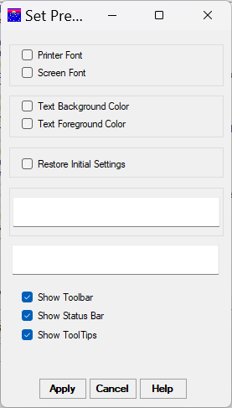
Figure 3 – Set Preferences Form

The Options Menu brings up the “Set Preferences” form (See Figure 3) which allows you to specify printer and screen fonts as well as text foreground and background (surrounding) color. You also have the option to set whether to show the toolbar, status bar, and ToolTips.

Click in the Printer Font check box to bring up the Windows font dialog and specify the font for printing. To select a font, you can either scroll the Font list and click on the font name you want, or type the name in the box under the "Font:" label. As you begin to type, the list will scroll to show font names beginning with the letters you have already typed, as an aid to selection. After you select a font, an example will appear in the "Sample" box. Use the “Style” box to select the desired style (normally you would want “Regular”). To the right of the "Font style" box is a box labeled "Size:". Use this to select the point size from those available for the font. Take care in selecting sizes; too small a size may be unreadable, while too large a size will not fit on the page. If the font you choose is a TrueType font, a message will appear at the bottom of the pop-up. The “Effects” box lets you choose either strikeout or underline. The "Script" box allows you to select a script appropriate to your language. When you are done setting your font, click the "OK" button to continue with your changes; the first box in the “Set Preferences” form will now show the message “Printer Sample” in the font you selected. If you click the "Cancel" button, you will revert to your old printer font. Note that the font you chose will not actually take effect until you click the "Apply" button on the "Set Preferences" form.

You can change the font used for the letters displayed on your screen (within the program) by clicking the Screen Font check box. This will bring up the Windows font dialog. See the description of the "Printer Font check box" above for instructions for using the font dialog. If you click the “OK” button, the second box in the “Set Preferences” form will show the message “Screen Sample” in the font you selected. As with the Printer Font, the font you chose will not take effect until you click the “Apply” button on the “Set Preferences” form.

Clicking the Text Background Color check box brings up the Windows color dialog. This dialog presents the colors available on your computer in the "Basic colors:" section. To select one of these colors, click on its square. If you want to define a color which doesn't appear in the "Basic colors" or “Custom colors” sections, click the "Define Custom Colors >>" button. This adds a section to the right of the color dialog which will allow you to create a custom color. The color you create appears in the "Color|Solid" box. You can set up your custom color by moving the cursors in the color boxes at the top, by typing in the numbers 0 - 255 in the Hue, Sat., and Lum. boxes, or by typing in the numbers 0 - 255 in the Red, Green, and Blue boxes. To move one of the cursors, click on the square or the column at the position you want, and the cursor will move where you point. Moving the cursor in the large square box right or left affects the hue value. Moving it up and down affects the Sat. value. Moving the cursor for the column to the right of this box affects the Lum. value. If you prefer to specify colors by the amount of red, green, and blue in the color, type the appropriate numbers in the Red, Green, and Blue boxes. A value of 0 will give none of a color, while a value of 255 gives the maximum amount of the color. When you are done setting up your custom color, click the "Add to Custom Colors" button; your new color will appear in the first unused box in the "Custom colors:" section. To use a custom color, click on its box. When you are done selecting your color, click the "OK" button to continue with your changes, or the "Cancel" button to revert to your old color. The color you chose will appear in the "SAMPLE" box, but will not actually take effect until you click the "Apply" button on the "Set Preferences" form. Note that this setting only affects the background color of boxes and lists containing text; the background color of forms is controlled by the Windows setting.

To change the color of the letters on your screen, click the Text Foreground Color check box. This will bring up the Windows color dialog. See the description of the "Text Background Color check box" above for instructions on using the color dialog. You should take care when choosing your screen colors that the foreground and background colors are not so similar (or identical) to each other that the text on the screen will not be readable.

Use the Restore Initial Settings check box to return your screen colors and printer and screen fonts to those when you originally installed Dr. Hahnemann's Assistant. When you click this box, a dialog will pop-up asking you if you are sure you want to restore the initial settings. To restore the settings, click "Yes"; to cancel your action, click "No". If you click "Yes", the initial settings for screen and printer font and screen background and foreground colors will be displayed in the two boxes. As with the font settings, these changes will not actually take effect until you click the “Apply” button on the “Set Preferences” form.

Once you have set up your fonts and/or colors, you may still discard your selections by clicking the "Cancel" button on the "Set Preferences" form. If you want to save your preferences, click the Apply button; this will immediately apply your new settings, pop-down the "Set Preferences" form, and store the preferences to the Windows Registry. To see font and color modifications, you will need to restart Dr. Hahnemann's Assistant.

The bottom portion of the "Set Preferences" dialog allows you to adjust helpful features to your preferences. Use the "Show Toolbar" option to display or hide the Toolbar, which contains buttons for some of the most common commands in Dr. Hahnemann’s Assistant, such as File Open. The "Show Status Bar" option displays a bar at the bottom of the main screen which contains short helpful messages relating to the item the mouse cursor is resting on. Use the "Show Tooltips" option to allow ToolTips to be displayed. ToolTips are the short descriptions which pop-up after a couple of seconds when you move the mouse over a button, box, or list.

When you are finished setting your preferences, click the “Apply” button to have them take effect. The Toolbar, Status Bar, and ToolTips settings will take effect immediately. As mentioned above, the font and color settings will require re-starting Dr. Hahnemann’s Assistant before they take effect. All preference settings will remain in effect every time you run the program, until you change them. If you decide not to use the preferences you have selected, click the “Cancel” button.

See “Toolbar” section for help on using the toolbar.

Toolbar
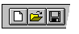

The toolbar is displayed across the top of the application window, below the menu bar. The toolbar provides quick mouse access to many tools used in Dr. Hahnemann’s Assistant,

To hide or display the Toolbar, choose "Set Preferences" from the "Options" menu, then select the "Show Toolbar" option.

Items on the toolbar can have 3 states: Selectable, Selected, or Disabled. An item which appears “grayed out” is Disabled; this means it is not currently available. An example of a Disabled button is the File Open item when a file is already open. Clicking on a Disabled items has no effect.

A Selected item appears “pushed in”; to indicate that it is selected. The Options Menu items all display their selected state this way. In addition, the three prescribing options act as “radio buttons”. When you click on an unselected item in this group, it becomes selected and the previously selected button “pops up”, like the station selector buttons on an old-style (non-digital) car radio. The Minimum Number items operate in a similar manner.

All toolbar items which are not Disabled or Selected are Selectable; you can click on them to choose that option.

Click To
Open a new case file.

Open an existing case file. Dr. Hahnemann’s Assistant displays the Open dialog box, in which you can locate and open the desired file.

Save the active document or template with its current name.

Save the active document under an optional different name. Dr. Hahnemann’s Assistant displays the Save As dialog box to allow you to enter a name and path.

Close the current file and clear the Selected Symptom Lists.

Exits Dr. Hahnemann’s Assistant.

Print the active case.

Brings up the help screen.

Title Bar
The title bar is located along the top of a window. The Main Form title bar contains the name of the application, along with the names of any open files. Title bars on other forms contain a descriptive name of the form's function. To move the window, drag the title bar. Note: You can also move dialog boxes by dragging their title bars.

Main Form Optional Settings

Minimum Number Box
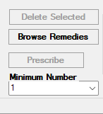
Figure 4 – Minimum Number box on Main Form

The “Minimum Number” box is located below the “Prescribe” button on the Main Form (See Figure 4). The box allows you to select the numbers 1 through 6 by clicking on the “˅” and selecting the desired number. The selected number will then appear in the box. These numbers are used to set the minimum number of symptoms for a remedy that you must have in your case before it will be considered in prescribing. This is a way of limiting the number of remedies which will be suggested. It is also a good way to show up lesser-known remedies which may have only two or three symptoms. The Minimum Number is initially set to 1 when you first run Dr. Hahnemann’s Assistant.

One way to point out lesser-known remedies would be to print out a prescribed remedy list with the Minimum Number set to 1, then to print it again with the number set to 3 or more; the list with the higher minimum number will tend to display only the Polychrest (multiple-symptom-type) remedies.

Using a minimum number of 1 tends to favor the lesser-known, (non-Polychrest) remedies, and can be useful in cases where Polychrests have been tried but failed to produce a cure.

Default Scheme (Prescribing Schemes section)
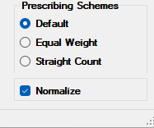
Figure 5 – Prescribing Schemes section on Main Form

You have the option to select one of three Prescribing Schemes via Radio Buttons (See Figure 5); “Default”, “Equal Weight”, or “Straight Count”. The Radio Button will appear dark next to the currently-selected scheme. The “Default” prescribing scheme bases its prediction on the number of symptoms which correspond to each remedy as a weighted percentage of that remedy’s total number of symptoms. For example, if a remedy has 8 “single weight” symptoms associated with it and you selected 4 of those symptoms in your case, its weighted percent would be 50 (100 * (4 / 8)). Symptoms which appear with a single asterisk after them in the remedy display are weighted double (this means they count as two symptoms when figuring the percent). Symptoms which appear with two asterisks after them are weighted by a factor of 4.

The “Default” scheme is a good general remedy selection scheme, in that it takes into account the fact that some remedies may have many symptoms while others have few. If used with “Minimum Numbers” higher than 1, it will tend to favor the Polychrests (remedies which have many different symptoms); these remedies tend to be more readily available due to their multiple uses. It also takes into account key symptoms which are important indicators for a remedy, and is generally the best scheme to start with on new cases.

The weighting scheme used by “Default” should not be confused with the case weights you assign with the Weight Buttons (or which the program assigns if you are using the Automatically Assign Weight option). These case weights are multiplied by the individual symptom percentages before adding them up for each remedy; for this reason, the “percentage” for a given remedy could well be greater than 100 if case weights greater than 1 are used (unless you have selected the Normalize option). This is perfectly legitimate, as the “percentages” are meant as a relative guideline, and not as absolute numbers.

The “Default” scheme works as follows: Certain symptoms are given greater weight in relation to other symptoms for a given remedy. Symptoms which have a “*” after their name on the Symptom List are counted as 2 symptoms. Other symptoms, noted by “**”, are considered determining factors in prescribing the remedy and count as 4 symptoms. These “remedy weights” of either 1, 2, or 4 are then multiplied by your assigned “symptom weight” (1-6), to determine the final weight of the symptom.

Equal Weight Scheme (Prescribing Schemes section)

The “equal weight” prescribing scheme is identical to the Default scheme, except that it doesn’t use the weight factors contained in the remedy Symptom Lists (remedy weights). The symptom weights which you assign with the Weight Buttons (or which the program assigns if you are using the Automatically Assign Weight option) are multiplied by the individual symptom percentage values. These numbers are than added up for each remedy as in the Default scheme. As with the Default option, it is possible for these numbers to add up to more than 100 if case weights greater than 1 are used (unless you have selected the “Normalize” option).

Straight Count Scheme (Prescribing Schemes section)

The Straight Count prescribing scheme uses a simple count of symptom “hits” per remedy when making selections. However, the symptom weights you assign (or which the program assigns if you are using the Automatically Assign Weight option) are used when adding up the symptoms for each remedy. This means that if you assign a case weight of 4 to a symptom, it will count as 4 “hits” for its remedy. To avoid using any weighting factor, turn off the "Automatically Assign Weight" option and leave the symptom weights at a value of "1" (the value the program initially gives them when you select symptoms).

Normalize Option (Prescribing Schemes section)

The “Normalize” option can be set for any of the three prescribing schemes. This option has different effects depending on which prescribing scheme is chosen. The square box to the left of the word “Normalize” will appear dark if this option is chosen.

If the Default method is set, the number which appears before each remedy represents the ratio of the un-normalized number you would get, to the maximum weighted number possible for that remedy. This maximum weighted number is the number you would get if you were to have all the symptoms for that remedy and were to rate them as your most important symptom. The formula used for this maximum weighted number is as follows: assign a strength of 1 to 3 to the symptom, with 1 being the weakest and 3 the strongest; to this number, add 1 for specific physical symptoms, add 2 for general symptoms, or add 3 for mind symptoms; next multiply this number by two for all symptoms followed by a single "*" and by four for those followed by "**". The sum of these numbers for all symptoms for the remedy will give the maximum weighted number used in the normalization formula.

If the Equal Weight method is set, the number which appears before each remedy represents the ratio of the un-normalized number you would get, to the maximum weighted number possible for that remedy with the Equal Weight option. This is similar to the method used for normalizing the Default option, with the difference that the maximum weighted number multiplies all symptom weights by one, including those symptoms followed by a single "*" or "**".

If the Straight Count method is set, the number which appears before each remedy is calculated as follows: multiply the number of symptoms chosen for each remedy (this is the number that would appear if the Normalize option were not used) by the number required to make the symptom count for the remedy with the highest number equal to 100.00. In other words, if you had two remedies, and the straight counts were 2 and 5, the Normalized version would be 40.00 and 100.00 (100 / 5 = 20 so the multiplier is 20; 2 * 20 = 40).

Weight (Set Weight section)

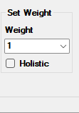
Figure 6 – Set Weight Section on Main Form

The “Weight” box in the “Set Weight” section allows you to manually choose a weight for your symptom(s) (See Figure 6). The box allows you to select the numbers 1 through 6 by clicking on the “˅” and selecting the desired number. A weight of “1” is the lowest (less-importance) weighted symptom, while a weight of “6” is the highest. The selected number will then appear in the box. To set symptom weights at the time the symptom(s) are being selected, set the desired weight in this box, then select one or more symptoms in the “Symptoms” list and click either the “Select” button to add one or more symptoms to the “Selected Symptoms” list or the “Must Use” button to add a single symptom it to that list. Setting the weight at symptom selection time allows you to easily set the same weight for a group of symptoms. The weight number will appear to the left of the symptom description in the “Selected Symptoms” list or “Must Use” box.

If you decide to change the weight of a symptom after it is selected, click on the symptom in either the “Selected Symptoms” list or “Must Use” box, then set the weight to the desired value in the “Weight” box. Note that once symptoms are selected you can only change the weight for one symptom at a time.

Holistic Option (Set Weight section)

The “Holistic” option ("Automatically Assign Weight" in earlier versions of Dr. Hahnemann's Assistant ) command is an aid to assigning weight to symptoms if you wish to use the common "holistic" model of symptom weighting. This model begins by assigning a strength of 1 to 3 to the symptom, with 1 being the weakest and 3 the strongest. To this number, add 1 for specific physical symptoms, add 2 for general symptoms, or add 3 for mind symptoms. If this option is turned on, the "Auto-Weight Severity" dialog box will pop up every time you select a symptom (see Figure 7). This box will display the symptom, with buttons below it which allow you to assign it a priority of High, Medium, or Low. Dr. Hahnemann's Assistant ranks the symptom as being physical, general, or mind, and adds the priority of the button you selected to this number to determine the symptom weight. Clicking the "High" button adds a 3, the "Medium" adds a 2, and the "Low" adds a 1. If Dr. Hahnemann's Assistant is unable to determine the symptom type, the “Auto Weight Type” box will pop up; this is similar to the “Auto-Weight Severity box” and allows you to assign the symptom as “PHYSICAL”, “GENERAL”, or “MIND”. When the symptom appears in the Select List or the Must Box, the calculated weight will appear in front of it. If you decide to change this weight later on, you can select the symptom in the Select List or Must Box by clicking on it, then click on the desired weight button. If you change your mind and decide not to select the symptom, click the "Cancel Symptom" button on the "Auto-Weight Severity" box to pop it down.

A check mark appears next to this item on the Main Form if it is currently selected.

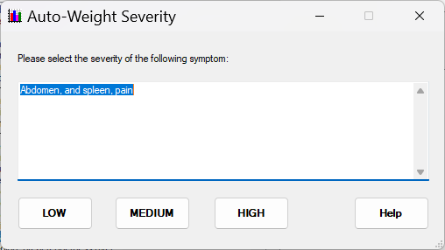
Figure 7 – Auto-Weight Severity Selection Pop-up

The “Show Similar Symptoms” button

Whenever you click on a symptom in the “SYMPTOMS LIST”, “MUST USE” box, or “SELECTED SYMPTOMS” list, its text will display in the text box just below the toolbar (or the menu options if the toolbar isn't displayed). If you would like to see a list of symptoms similar to the one in this text box, click the “Show Similar Symptoms” button. This will pop-up the “Find All” list (see Figure 9), which allows you to select one or more of these symptoms in a manner similar to that available on the front panel.

The “Find” button

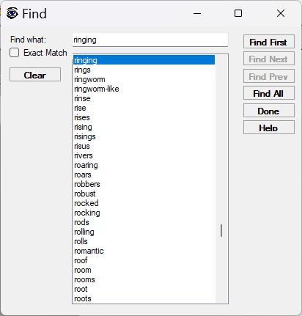
Figure 8 – Find Word Pop-up

Clicking the Find button brings up a form with a text box labeled "Find what:" for you to enter in the word you wish to search for (see Figure 8). To enter your text, click inside the box if the vertical flashing cursor is not already in it, and type the text. When you type the first letter or number of your word, a list of words will pop-up below your letter. This list contains all the words and numbers that you can search for in the Symptom List, in alphabetical order; the top word in this list will be the first word you can search for that begins with the letter you typed. If you continue typing letters of your word, the list will adjust itself so that the first occurrence of the letters you typed so far is on its top line. If you make a mistake, use the Backspace key to delete the last letter typed. Alternatively, you can click the "Clear" key to the left of the word list to clear your entire word. At any point in the process you may select a word from the list by clicking on it; if the word you want is not visible, use the scroll bar to the right of the list to scroll up or down until you see it. If you click on a word in the list, it will replace the word you typed in the text box. You can only search for words contained in the list; if you type in a word not in the list and try to search for it, a message will pop up informing you that the word you typed is not in the list.

Note that searches are not case-sensitive; all the words in the list begin with lower-case letters, but will search for matching words regardless of whether or not they are capitalized in the symptom.

To the left of the word list is an option button labeled "Exact Match". If this option is not selected (the button is blank), the search will look for words which match your search word, and also words which have extra letters at the end. For example, a search for the word "pain" would search for "pain", "painful", "painful/soreness", "painfully", "painfulness", "painless", "painlessness", and "pains". If the Exact Match option is selected, only the exact word you typed is searched for.

Once you have entered or selected your search word and set the desired "Exact Match" option, you are ready to begin the search. There are four search buttons which allow you to specify how to search the Symptom List. The Find First Button will find the first occurrence of your word in the Main Form Symptom List, regardless of where the list is currently positioned. When it finds your word, it scrolls the Symptom List so that the symptom containing your word is visible, usually (but not always) on the top line. The Find Next Button starts looking at the top line of the Symptom List currently displayed, and searches down for your word. If it reaches the end of the list, it asks you if you want to continue your search at the top; click "Yes" to continue or "No" to end your search. The Find Prev Button works exactly like the Find Next Button, except it searches up in the Symptom List.

The search dialog box has a “modeless” property, which means it stays displayed even after the search is finished, and you may work with the main form below it while it is displayed. This is done to allow you to continue your search for the same or another string. After the first string is found, you can use the “Find Next” button to continue your search. There is also a “Help” button which will bring up a brief help screen for the Search Dialog. When you are done searching, you can close the form by clicking on the “Done” button or typing the <Esc> key.

Helpful hints: When you first type a word in the box, the "Find First" and “Find All” buttons will be in dark text showing they are enabled. After the first match is found, the "Find Next" button text becomes dark, showing it is enabled (if there is another symptom containing the word). The “Find Prev” works in a similar manner. Also, you can pop down the "Find" box if it gets in the way by clicking the “Done” button, and it will remember your last search word when you pop it back up. If you want to search for a new word, you can use the "Clear" key to quickly clear the previous word from the box.

If you are interested in all symptoms which contain your word, searching the list one symptom at a time could get rather tedious, especially for a common word like "pain". You can bring up a list of all symptoms which contain your word by clicking the Find All Button. This button replaces the “Find” form with a form with a list of all symptoms which contain your word (see Figure 9).

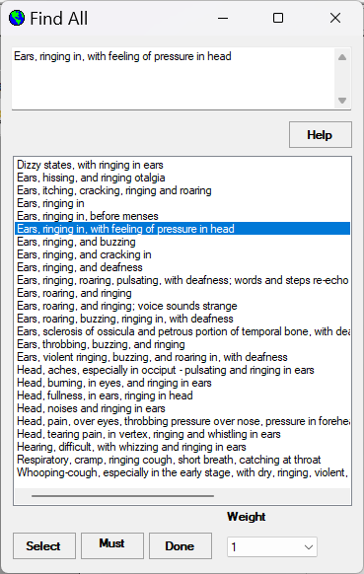
Figure 9 – Find All Pop-up

Both the “Find” and “Find All” forms have "Select" and "Must Use" buttons and a "Weight" box just like the Symptom List on the Main Form. You may select symptoms from the “Find” or “Find All” lists the same way you do with the Main Form Symptom List. When you are finished selecting from the list, click the "Done" button at the bottom to pop it down.

Shortcut
Keys: CTRL+F

The "Grid Search" Button

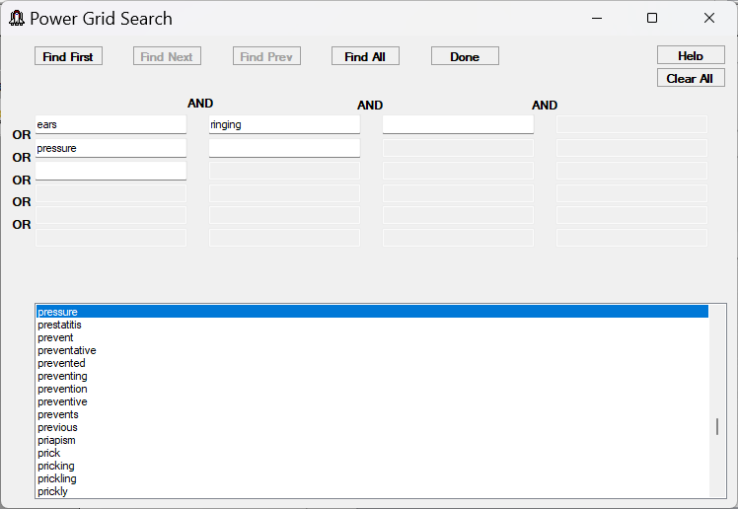
Figure 10 – Power Grid Search Pop-up

The button marked "Grid" below the "Find" button brings up the "Power Grid Search" form (see Figure 10). This form allows you to specify more than one search word. It functions in a manner similar to the "Find" form, but allows you to logically AND and OR search words together. You enter words similar to the way you do in the "Find" form. First click on a text box to select it, then begin typing letters for the word you want to add to your search. A list pops up below which contains only words that would result in selecting one or more symptoms, so no time is wasted entering words that would not find anything. To “select” the word, you need to click on it in the list, even if you have already typed the complete word; this prevents accidentally selecting words which are contained in other words, for example “ear” is contained in “hear”. Words entered in the same row are ANDed together; for example, if a row contained the words "pain" and "stomach", only the symptoms which contain both "pain" AND "stomach" would satisfy the search. As you add words, the next box to the right (if there is one) is enabled for you to add the next word; but if the result of a row of ANDed words would allow only a single symptom to be selected, even though less than 4 words are entered, the text box to the right is not enabled as it would be a waste of time to add more words. Words or groups of words entered in different rows are ORed together; if the words in the previous example were entered in separate rows, symptoms which contain either "pain" OR "stomach" would satisfy the search. This means that what is ORed is the result of the AND in each row. ORing words or groups of words allows you to search for several groups of symptoms at the same time. Since you select the words from the list, there is no “exact match” option. The rest of the buttons at the top of the screen have the same functions as the corresponding buttons in the "Find" form. The "Clear All" button can be used to conveniently clear all your words.

The Power Grid Search dialog box has a “modeless” property, which means it stays displayed even after the search is finished, and you may work with the main form below it while it is displayed. This is done to allow you to continue your search for the same or another string. After the first string is found, you can use the “Find Next” button to continue your search. There is also a “Help” button which will bring up a brief help screen for the Power Grid Search Dialog. When you are done searching, you can un-display the dialog by clicking on its “Cancel” button or typing the <Esc> key.

Helpful hints: When you first type a word or words in any box(s), the "Find First" button will be the "default" button (denoted by the black line which will surround it); you can select this button by typing the <Enter> key. After the first match is found, the "Find Next" button becomes the default. This allows you to do a sequential search without having to use the mouse. Also, you can pop down the "Power Grid Search" box if it gets in the way, and it will remember your last search words when you pop it back up. If you want to search for new words, you can use the "Clear" key to quickly clear the previous word(s) from the box. The <tab> key will move the cursor to the next text box, or the first box of the row below if it is in the last (or last enabled) box of a row. While you can use the Power Grid Search to search for single words just as you use the "Find" dialog box, it may be less convenient to use due to its large size.

Shortcut
Keys: CTRL+G

Repertory-Style (symptom search) button

Type search word(s) here Symptom phrase appears here
lists of phrases “Active” phrase list is yellow

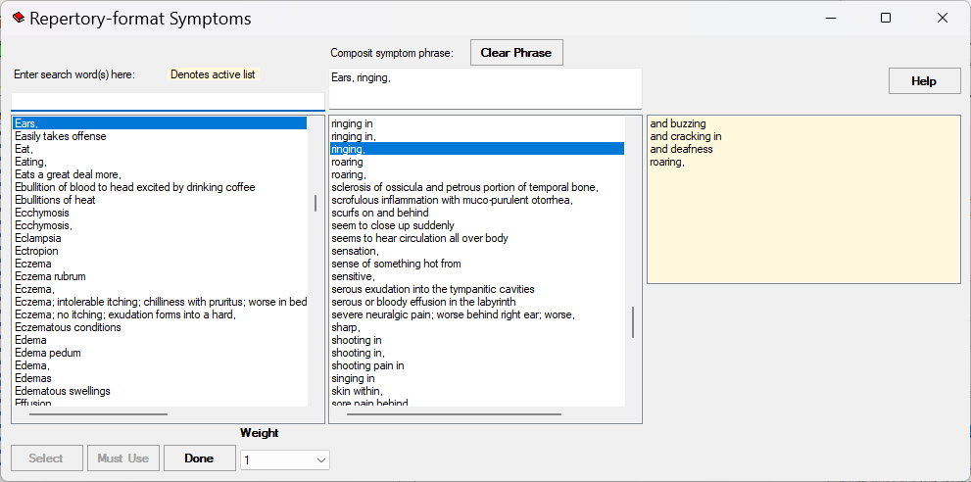
Figure 11 – Repertory-Style Search Pop-up

The "Repertory-Style" search button presents the Symptom List in a sequentially-detailed format, which makes it easier to search (see Figure 11). Instead of showing all symptoms in a single list, the symptoms are broken into phrases; those having identical phrases appear as a single item in the list. For example, all symptoms beginning with the word "Stomach," appear as the single item "Stomach," in the list. As with the “Symptoms” list on the main form, you can either scroll the list or begin typing the desired phrase in the box labeled “Enter search word(s) here:” to have the list scroll automatically to the phrase you typed (if it is in the list). When you select a phrase it appears in the “Composite symptom phrase:” box.

Symptoms which require additional phrases to complete them are indicated by the "," following the phrase; when you click on them another list becomes visible with one or more additional phrases, and the yellow background moves to this list indicating it is the “active” list. As you add phrases, they are appended to the “Composite symptom phrase:”. In the case where the next phrase is only used in one symptom (the next list that pops up contains only one phrase), it will behave as if you had selected the one phrase; if there are more phrases after the one phrase, the next list will pop up to allow you to select the next phrase (after the single phrase you didn't need to select); or if that is the final phrase, the entire symptom will appear in the “Composite symptom phrase:” box, just as if you had selected the final phrase. If a symptom has no more phrases, there is no “,” following the phrase; when you click on it, no additional list comes up, and you may change its weight by selecting a number (1 – 6) in the “Weight” box, and select it with the "Select" or "Must Use" buttons. These work just like the “Weight” box and buttons on the main form; the "Select" button copies the symptom to the main form “Selected Symptoms" list and the "Must Use" button copies it to the "Must Box".

If you want to re-use a phrase(s) in another symptom, you can select a new phrase in the list that contains the next phrase after the phrase(s) you want to re-use (the list doesn't need to have the yellow background); the new symptom phrases will appear in the “Composite symptom phrase:” box.

Note that you can only select one symptom or phrase at a time on these forms (unlike the “Symptoms” list on the main form). Clicking the "Clear Phrase" button closes all but the first phrase list so you can continue selecting phrases for another symptom. Clicking the "Done" button closes the “Repertory-format Symptoms” form.

Shortcut
Keys: ALT+R

HELP Menu Commands

Help Contents command (Help menu)

Use this command to display the opening screen of Help. From the opening screen, you can jump to step-by-step instructions for using Dr. Hahnemann’s Assistant and various types of reference information.

Once you open Help, you can click the Contents button whenever you want to return to the opening screen.

NOTE: Many of the forms contain a “Help” button which will display context-sensitive help for the form in your default web browser. To close the help page, click on the “X” at the top of the tab.

Shortcuts
Toolbar:
Keys: CTRL+H

User Manual command (Help menu)

Use this command to display the User Manual for the current version with your default .pdf viewer.

About command (Help menu)

Use this command to display the version number of your copy of Dr. Hahnemann’s Assistant.

Lists and Buttons

The Symptom List

The Symptom List contains an alphabetized list of symptoms, which correspond to the remedies in Dr. Hahnemann’s Assistant’s remedy database. Individual symptoms may point to more than one remedy, and each remedy corresponds to several symptoms. You make up your case by selecting one or more symptoms from this list and optionally assigning each one a Symptom Weight of 1 – 6.

Using the Scroll Bars

You use the scroll bar and Search buttons to navigate through this list. The scroll bar consists of a long rectangle with an arrow at each end. Inside the long rectangle is a square moveable “knob”. The position of this “knob” along the length of the scroll bar indicates the relative position of your view in the list. Clicking on the arrow at either end of a scroll bar moves your view of the list in the direction of the arrow, unless it is already scrolled as far as it can go in that direction. To move the list one line up or down, click once on the corresponding arrow on the scroll bar. If you want to scroll several lines at a time, click and hold on the arrow until the desired portion comes into view. To scroll one “page” at a time, click in the box area between the arrow and the movable scroll “knob” on the vertical scroll bar. You can “warp” the list several pages at a time by clicking and holding in this box area. To move long distances, click on the square “knob”, hold the left mouse button down, and “drag” the knob along the scroll bar. The list view will scroll to the position proportional to the new knob position.

Selecting Symptoms

Once a symptom is in view, you highlight it by clicking anywhere in its line of text. When you click a symptom, it appears in inverse video, with the text white and the background black (colors may vary depending on the preferences you have set). If you want to “unhighlight” a symptom you previously highlighted, click on it a second time. To highlight a group of symptoms, click on the first one in the group, then hold down the shift key and click on the last one in the group. You can highlight more than one non-contiguous symptoms at once by holding the <CTRL> key down while you click on additional symptoms. Highlighting symptoms gets them ready to copy to the “Must Use” or “Selected Symptoms” box.

To copy a highlighted symptom to the “Must Use” box, click on the “Must Use” button. If more than one symptom is highlighted, only the first one which is not already selected will be copied to the Must Use box. Similarly, to copy one or more highlighted symptoms to the “Selected Symptoms” list, click on the “Select” button. The “Select” button copies all highlighted symptoms that have not been previously copied. If you click on a highlighted symptom that is already in the “Must Use” box or “Select” list, a message box will pop-up explaining that you cannot “un-select” the symptom this way – you should use the appropriate “Delete” button; and the symptom will become highlighted again.

The “Must Use” Button and Box

The "Must Use" box allows you to specify a symptom which must be associated with all remedies produced by the "Prescribe" button. To copy a symptom to the “Must Use” list, click on the “Must Use” button. If more than one symptom is highlighted, the first highlighted symptom which is not already selected will be copied. If no symptoms are highlighted when you click this button, or if all highlighted symptoms are already selected, nothing will happen. Note that the “Must Use” box can only contain one item. If you click the “Must Use” button and there is already a symptom in the box, a dialog will pop up asking you if you want to move the current “Must Use” symptom to the “Selected Symptoms” list or delete it. When you click the desired button on this dialog, the symptom moves out of the box and the new “Must Use” symptom replaces it. If you elected to move it to the “Selected Symptoms” list, it is inserted into that list in alpha-numeric order; it will remain highlighted when scrolled into view in the “Symptoms” list. If you elected to delete it, it will not be highlighted when scrolled into view in the “Symptoms” list.

Shortcut
Keys: ALT+M

The “Select” Button and “Selected Symptoms” List

Clicking on the “Select” button copies all highlighted symptoms in the Symptoms list which are not already in the “Must Use” box or “Selected Symptoms” list to the “Selected Symptoms” list. If no symptoms are highlighted when you click this button, or if all highlighted symptoms are already selected, nothing will happen. Symptoms copied into the "Selected Symptoms" list are inserted in alphabetical order (ignoring the preceding weight number).

Shortcut
Keys: ALT+S

Symptom Weights

Items in the “Must Use” box and the “Selected Symptoms” list have a number in front of the symptom; this is the Symptom Weight, which is used in ranking the importance of the symptom and its associated remedy or remedies. Symptom weight can range from 1 – 6. When a symptom is first selected, this number will be the number in the “Weight” box (initially set to 1). To change this number, click the “˅” on the right side of the “Weight” box and select the desired number from the drop-down list. When a symptom is first selected, it remains highlighted in the "Must Use" box or "Selected Symptoms" list, so you will not need to click on it to change the weight. Also, clicking on a symptom in the "Selected Symptoms" list un-highlights a symptom in the "Must Use" box, and vice versa.

Symptoms in the “Selected Symptoms” list are arranged in alpha-numeric order. Because the Symptom Weight number appears first, they will be sorted in order by number, then alphabetically; for this reason the symptom will likely move in the list when you change the Symptom Weight. Note that if the “Selected Symptoms” list is not displaying the portion where your symptom will appear when you select it, the list scrolls so this portion is visible.

See the section on the “Weight” box below for a detailed discussion on assigning symptom weights.

The “Find” and "Grid" Buttons

The “Find” and "Grid" buttons are located to the right of the “Must Use” button, under the “Symptoms” list. See the section on the “Symptoms” list for a detailed discussion on using these buttons.

Shortcut
Keys: (Find) ALT+F
(Grid) ALT+G

The “Weight” Box

The box in the “Set Weight” section is used for assigning Symptom Weights. To change this number, click the “˅” on the right side of the “Weight” box and select the desired number from the drop-down list (numbers 1 – 6).

When you add symptoms to the “Must Use” box or “Selected Symptoms” list, they will initially be assigned the weight number in this box. This provides an easy way to set a number of symptoms to the same weight.

If you need to change symptom weight after a symptom is already in the “Must Use” box or the “Selected Symptoms” list, click on the symptom to select it, then select the desired weight in the “Weight” box. The “Must Use” box and “Select” list are linked together such that only one item can be highlighted at one time; if you click on an item in the “Selected Symptoms” list while the “Must Use” item is highlighted, the “Must Use” highlight goes away and “Moves” to the symptom you clicked on. A similar action takes place when you click on a symptom in the “Must Use” box. If an item in the “Selected Symptoms” list is highlighted and you click on another item, the highlight “moves” to the new item. Once the desired symptom is selected, set the number in the “weight” box to the desired number (1 – 6) to change the weight. When changing the weight of a symptom in the “Selected Symptoms” list, it will likely move it to a different position because the list is an alpha-numeric order.

The “Delete Must” Button

Directly below the “Must Use” box is the “Delete Must” button. Clicking on this button will allow you to delete an item in the “Must Use” box. If there is not a symptom in the “Must Use” box, this button is “grayed out”, indicating it is inactive. The “Must Use” symptom does not have to be highlighted to delete it. When you click this button, a box will pop-up with the question, “Move current must-use selection to selected list?” Clicking on “Yes” will move the symptom out of the “Must Use” box, and it will be inserted into the “Selected Symptoms” list. Clicking “No” deletes the symptom from the “Must Use” box; the symptom will no longer be considered in prescribing, and it will be un-highlighted if you move it into view in the “Symptoms” list. It is possible to re-select symptoms that have been deleted.

The “Delete Sel” Button

The “Delete Sel” button below the “Selected Symptoms” list is used to delete items from that list. Because the list can contain more than one item, you must highlight the item by clicking on it to indicate which symptom you want to delete before using this button (if you don't select any symptom, nothing will happen when you click the button). This may require scrolling the list to bring the desired item into view. As with the “Delete Must” button, this button will be inactive (grayed out) if there are no items in the “Selected Symptoms” list. Deleted symptoms will no longer be considered in prescribing, and will be un-highlighted if you move them into view in the “Symptom” list. It is possible to re-select symptoms that have been deleted.

The “Prescribe” Button

When you are finished selecting your symptoms, use the “Prescribe” button to suggest a list of remedies. There must be at least one symptom selected for this button to be enabled; the “Prescribe” button will be “grayed out”, indicating it is inactive, if neither the “Must Use” box nor the “Selected Symptoms” list contain any items. When you click on the “Prescribe” button, Dr. Hahnemann’s Assistant searches its database for all remedies associated with your selected symptoms. It then assigns them a number, based on the number of symptoms selected for that remedy, your prescribing scheme, the symptom weights you assigned, and optionally the remedy weights. See the section on the Options Menu commands for a detailed discussion of prescribing schemes. If you selected a “Minimum Number” greater than “1”, remedies will only be displayed if they are associated with at least that number of symptoms in your case. If you selected a “Must Use” symptom, only remedies which contain that symptom will be displayed. Remedies are displayed in order of highest ranking to lowest; this means that the remedy which Dr. Hahnemann’s Assistant predicts most likely to succeed will appear at the top of the list. The remedy list is limited to 1000 remedies.

The Prescribed Remedies List

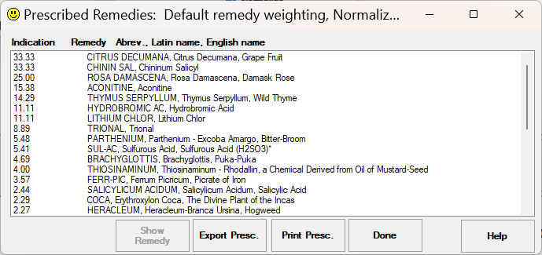

Figure 12 – Prescribed Remedies Pop-up

Clicking the Prescribe button brings up the Prescribed Remedies list (see Figure 12). This list is in the form of a list box, similar to the “Symptoms” and “Selected Symptoms” lists. See the discussion on the “Symptoms” list for a detailed description on using the scroll bars. The Prescribed Remedies list contains the numbers by which the Prescriber ranked the remedies, followed by the remedy name abbreviation (in CAPS), the Latin name, and the English name for each remedy. For lesser-known remedies, the Latin and English names may be the same. Some remedy names may be followed by a “*”; this indicates more commonly-available remedies, which can be obtained locally many health-food / vitamin stores.

Below the list are four buttons. The “Show Remedy” button will only be enabled if a symptom is selected. It will bring up the “Remedy & Associated Symptoms” form with the information for the selected remedy (See Figure 14 below). The "Export Presc." button allows you to export the Prescribed Remedies list to a tab-delimited file, suitable for import into a spreadsheet for graphing, etc. When you click it, a "Save File" dialog pops up which allows you to choose a folder and file name; the default extension for this file is ".PRE", but you may change the extension if you wish. If the file name you enter already exists in the folder you select, a warning dialog will pop-up and you will have the option to change the file name or overwrite the existing file. The “Print Presc.” button works in a manner similar to the “Print” option of the File menu, except that it is used to print the Prescribed Remedies list. No “Print Preview” option is available for this list. The “Print” button brings up the Windows Print dialog, which allows you to limit the number of pages printed. Lines longer than the page width are wrapped around to the next line on the page. If you want to combine the “Presc” report with others such as the list of symptoms, use the File menu “Print” option while the “Prescribed Remedies” form is popped up.

To view more detail for a particular remedy, highlight its name in the list; this enables the “Show Remedy” button, which will bring up a complete list of symptoms for that particular remedy (see Figure 14). Alternatively, you can double-click on the remedy name in the list. For a detailed discussion of the remedy Symptom List, see the description of the “Remedies” button below.

The “Done” button “pops down” the list and returns you to the main screen.

The “Remedies” Button and Lists

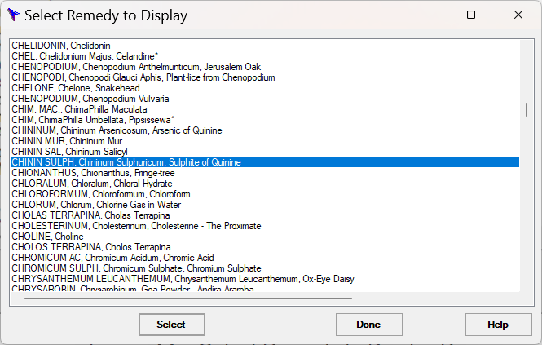
Figure 13 – Select Remedy to Display Pop-up

The “Browse Remedies” button brings up a scrollable list of remedy names (see Figure 13). This list contains a name for every remedy in the database of Dr. Hahnemann’s Assistant, and is used to select individual remedy Symptom Lists to view. This list is in alphabetical order by remedy Latin names. Scroll the list until the desired remedy is in view, then highlight the desired remedy name in the list; this enables the “Select” button, which will bring up a complete list of symptoms for that particular remedy. Alternatively, you can double-click on the remedy name in the list. See the section on the “Symptoms” list for a detailed discussion on using the scroll bars. To “pop-down” the remedy list without selecting a remedy, click on the “Done” button.

When you select a remedy to display, either by using the “Select” button or double-clicking the remedy name, the list of symptoms for that remedy pops-up (see Figure 14). This is the same list you can view from the Prescribe list. The first line contains the remedy name, in the usual format. This line may be followed by the word “COMPARE:”. The COMPARE line lists the abbreviated names for one or more remedies which have at least some symptoms similar to that remedy; you may want to view these remedies to see if the symptoms may also provide a good “fit” for your case. Following the optional COMPARE line is a list of symptoms for that remedy, in alphabetical order. Symptoms are indented under main headings, to avoid repetition. Symptoms which are especially prominent for that remedy are followed by a “*”. If a remedy has symptoms which are almost “sure” indicators for it, these are followed by “**”. A ">>>" in front of a symptom indicates that symptom is selected for the current case; note that the wording may differ from the case symptom, but the meaning will be synonymous. Symptom lines which are too wide to fit on the screen are wrapped in this list; wrapped lines are indicated by a “+” at the beginning of the line. If this list is too large to fit on the screen, use the scroll bars to view the rest of it. See the section on the “Symptoms” list for a detailed discussion on using the scroll bars.

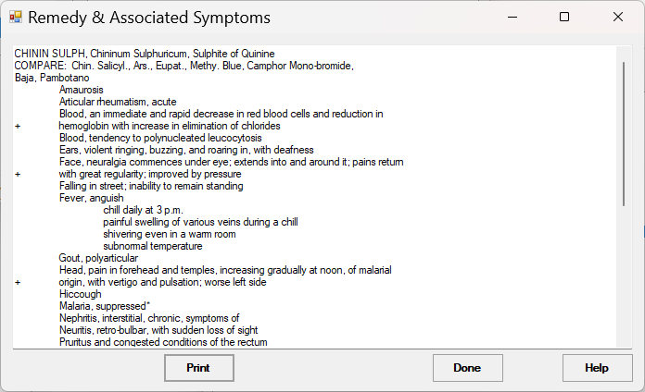
Figure 14 – Remedy & Associated Symptoms Pop-up

The “Remedy” display has a “Print” button, which works in a manner similar to that of the “Print” option on the File menu. Clicking on the “Print” button brings up the Windows print dialog, which allows you to select the number of pages to print. The remedy display will be printed in a format similar to that displayed on the screen. Any lines too long to fit on the page are wrapped to the next line. There is no “Print Preview” option for this display.

To “pop-down” the remedy display, click the “Done” button.

Shortcut
Keys: ALT+B

The "Questionnaire" Button and forms

To facilitate entering and archiving cases, Dr. Hahnemann's Assistant provides a case "Questionnaire" which can be used to enter and track patient cases. This questionnaire consists of 7 pages, which allow entry of most items commonly contained in a patient case history. The first four pages contain specific symptom-related questions; this group of pages is used repeatedly for each symptom, for as many symptoms as necessary to describe the case. The last three pages contain more general questions relating to the patient. The data in the questionnaire may be saved to and read back from a file, so that the case may be archived and updated. You also have the option to print the questionnaire case. After the questionnaire is filled out, you can optionally have it generate a list of symptoms based on your answers, as a start on your Symptom List.

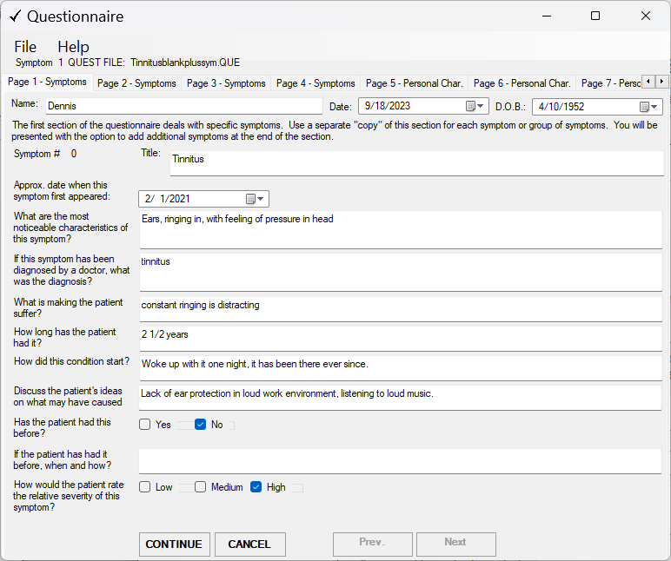
Figure 15 – Questionnaire opened to first page

To bring up the Questionnaire, click on the "Questionnaire" button below the "Symptoms" list. The questionnaire will pop up, opened to the first page (see Figure 15). This page has boxes for you to enter the patient name, the current date, and the patient date of birth (they initially display the current date). As you enter text, you can use the <TAB> key to move the cursor to the next field or <SHIFT><TAB> to move to the previous field; you can also move to a field by clicking in it. There is no restriction on the text you enter in the boxes. Some questions have check boxes that you click to give an answer. You can only check one of these per question; if another check box for that question was already checked, the check will move to the box you clicked. You are not required to answer all the questions, but the more you answer, the more complete your case will be.

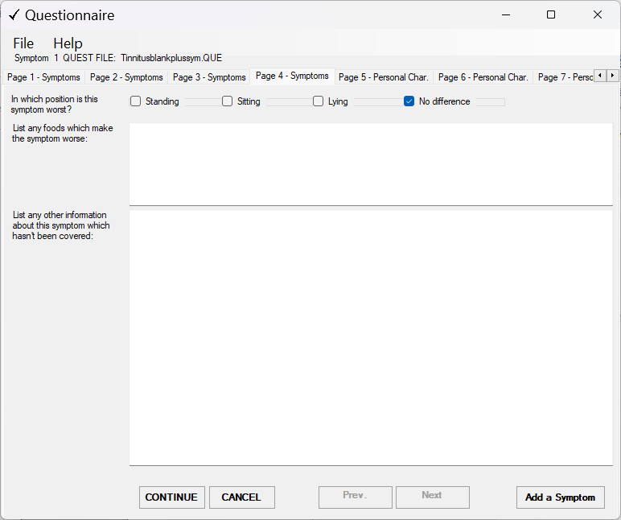
Figure 16 – Questionnaire opened to page 4

When you have completed a page, click on the "Continue" button at the bottom of the page to bring up the next one. You can also click on the tab for the desired page (the title in the selected (light-background) tab indicates which page is displayed). If the tab for the page you want is not displayed, click on the left or right arrow to the right of the tabs to scroll the tabs until the desired tab appears. Continue filling out the forms for the symptom you specified on Page 1. When you finish page 4, you have the option to add another symptom by clicking the “Add Symptom” button (see Figure 16). This button will return you to page 1, but the page will be blank, so you can begin entering your next symptom; also, the “symptom #” to the left of the “Title” box will increment to the new symptom number. When you finish entering your last symptom, click the "Continue" button on page 4; this will bring up page 5, which allows you to enter more general information such as patient likes and dislikes, attributes, etc. When you are done with page 7, you may have Dr. Hahnemann's Assistant try to match your questionnaire answers to symptoms from its symptom database by clicking the “Find Symptoms” button on Page 7 (see Figure 17). Note that if you have more than one patient symptom in your questionnaire, it will show the titles of all the symptoms in a list and allow you to select the symptom to use for matches.

“Find Symptoms” button
Figure 17 – Questionnaire opened to page 7

The Find Symptoms Dialog will open (see Figure 18).

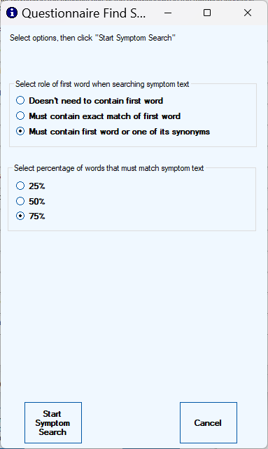
Figure 18 – Questionnaire Find Symptoms Dialog

This dialog allows you to tailor how the symptom matching is performed. Each questionnaire text box, and a pre-defined text description for each questionnaire check box is considered separately when looking for a symptom match. This dialog allows you to select the treatment of the first word in the text when searching the symptom list (default is “Must contain first word or one of its synonyms”). You are also allowed to select the percentage of words in the text which must match words in the symptom (default is 75%). If you find you are generating too many symptoms you may want to try again and select “Must contain an exact match of first word” and/or select a higher percentage of words which must match. Conversely if you are generating too few symptoms or want your search to return more thorough results, try selecting “Doesn't need to contain first word” and/or select a lower percentage. When you are done, click the “Start Symptom Search” button. Note that this search could take several minutes, depending on your answers and the speed of your computer; a progress bar will display and a message will show the page and question # being processed. When the search completes, the "Find All" list will pop up (see Figure 19), showing all symptoms that may provide a match to your questionnaire answers. In front of each symptom description will be a group of numbers which indicate the first question used to pick the symptom. The first number is the page, followed by a "/" and the symptom number for pages 1 – 4; or a blank for pages 5 – 7 because these are patient data, which is not associated with any particular symptom. The next number is the question on the page, numbering consecutively from the top as question #1. Following this is the symptom weight (based on your questionnaire input), then the description. The text in front of the symptom description is for informational purposes only. You will still need to select the weight using the normal method for symptoms you select. You select symptoms and assign weights just like you do in the main form. To view the portion of a symptom which extends past the right side of the list, click the symptom; the complete symptom will appear in the box above the Symptom List. When you are done selecting symptoms, click the "Done" button below the list.

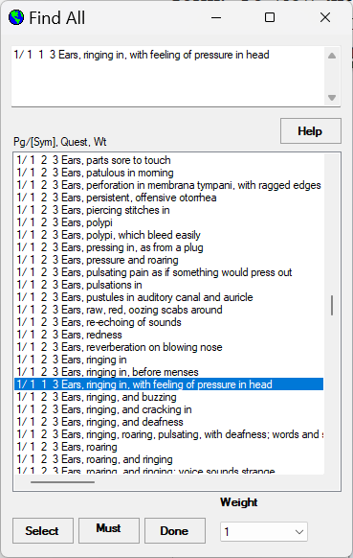
Figure 19 – Questionnaire “Find All” List

Questionnaires are stored in files, similar to the manner in which cases are stored. The default extension for questionnaire files is ".QUE". To load and save questionnaire files, you can use the "File" menu at the top of the questionnaire form. These options are identical to the Questionnaire File options available in the main form “File” menu. To archive individual cases, you may want to use a descriptive file name such as the patient's name, followed by a number or date. Then when you are ready to add to the case, you can open the latest questionnaire file for the patient, make your updates to the questionnaire, and save the file with the same name but a new number or date; in this way you will have a running record for each patient.

The Questionnaire “File” menu has “Print Preview” and “Print Questionnaire” options. The "Print Questionnaire" option will print out a formatted report of the questionnaire, displaying the questions with your answers. The “Print Preview” option shows a preview of the printout of the questionnaire; it works similar to the “Print Preview” on the main form “File” menu. If you want to combine the Questionnaire printout with others such as the list of symptoms, use the File menu “Print” option in the main form.

The questionnaire pages contain buttons at the bottom of the page and tabs at the top which make it easy to navigate between questionnaire pages and symptoms. Note that some buttons are not included on all pages, as they would not be appropriate. The "Next" and "Prev." buttons on pages 1 – 4 allow you to go to the next and previous symptom, respectively. The “Continue” button will take you to the next page. Use the "Cancel" button to pop-down the questionnaire; if you have any unsaved changes, Dr. Hahnemann's Assistant will ask if you want to save them.

If you plan to use the questionnaire to generate an initial list of symptoms, you will want to tailor the syntax of your answers to optimize the symptom selection process. To match up symptoms, significant words from each answer are used to produce a list of synonyms. There is also options to require that the symptom contain the first word (or optionally its synonyms) from your answers; if you plan to use these options, you should phrase your answers so they begin with the area affected (for example “eyes”), similar to the way the symptom list items are phrased. Accuracy will also be improved if you stick to words commonly found in the Materia Medica (and therefore in the Symptom List).

In addition to the shortcuts mentioned in this manual, Windows shortcuts are available as an aid to filling out the questionnaire. If you need to copy a phrase to another box, first select it, then type CTRL+C to copy it to the clipboard; next click on the box you want to copy to (the cursor appears in the box), then click CTRL+V to paste the clipboard into that box. Another useful shortcut is ALT+TAB to quickly switch back to the main form to view symptoms, etc.; then type ALT+TAB again to return to the questionnaire (be careful to type TAB only once, otherwise it will cycle through other forms and windows you may have open).

File Formats

Symptom Files

Case files have type “.cse” by default and are in text format. They can be edited by any text editor such as Notepad.

The first line contains the Dr. Hahnemann's Assistant version number from which it was saved, in “integer” format; for example version 3.0 would appear as “30”.

The second line contains the “symptom ID” <space> “weight” of any symptom in the “Must Use” box; if this box does not contain a symptom, it will contain “0 0”.

All lines below this contain the “symptom ID” <space> “weight” for all remaining symptoms in the case, one symptom per line in order by symptom ID.

Questionnaire Files

Questionnaire files have type .”que” by default and are in text format. They can be edited by any text editor such as Notepad.

The first line contains the number of symptoms in the file.
The following lines contain the information for the first symptom, 1 item per line:
Symptom Date
Symptom Title
The rest of page 1 items
page 2 items
page 3 items
page 4 items
(if more than one symptom, the next symptom starts on the next line)
…
After page 4 of the last symptom:
Name
Date of questionnaire
DOB
page 5 items
page 6 items
page 7 items

In Case Of Difficulty

Problem:
Program generates a repeatable error message with a number and a message that a certain function will not be available or "Hahnemann's Assistant is exiting".

Solution:
This is usually caused by a missing file. This could also be caused by a corrupted data file, or insufficient disk space. Refer to the file list in the Readme.txt file and check that all files are present in the directory that contains the Dr. Hahnemann's Assistant executable. If all files are present, check to see that you have a couple of Mbytes of free disk space for writing case files. Although these files are relatively small, a large number of them could cause problems if disk space is limited. Also, windows uses a portion of your hard disk for temporary swap space; if this is excessively limited, slow or erratic program execution can result. If this does not remedy the problem and you are using a downloaded version, your data files may have been garbled in the download; you may want to try another download. If these procedures do not remedy the problem, note down the number in the error messages and contact the author for assistance.

Problem:
Printouts are coming out the long way on the paper (landscape mode).

Solution:
Click on the "Setup" button in the print dialog. This is the box that pops up when you select the print option from the "File" menu. Click on the "Portrait" option for paper orientation. You do not need to print in "landscape" mode, as long lines are automatically wrapped.

