Student Name: _______________________________________

Activity 1
Directions: For each joint listed in the table below, identify the structural type, subtype, and functional type. When finished, compare your answers with a neighbor. Classify joints based on:
- Structural type (fibrous, cartilaginous, synovial)
- Subtype (suture, gomphosis, syndesmosis, synostosis, symphysis)
- Functional type (synarthrosis, amphiarthrosis, diarthrosis

Joint | Structural Type | Subtype | Functional Type
Joint between cranial bones
Tooth in socket
Distal tibiofibular joint
Epiphyseal plate (growing)
Joint between the pubis of the ox coxae
Skull suture in mature adult
Manubriosternal joint
Intervertebral discs
Hip joint
Carpal-metacarpal

Activity 2

Directions: Label the synovial joint diagram using the structures listed in the table below. Then write a one-sentence function for each structure. You may work with a partner or group.
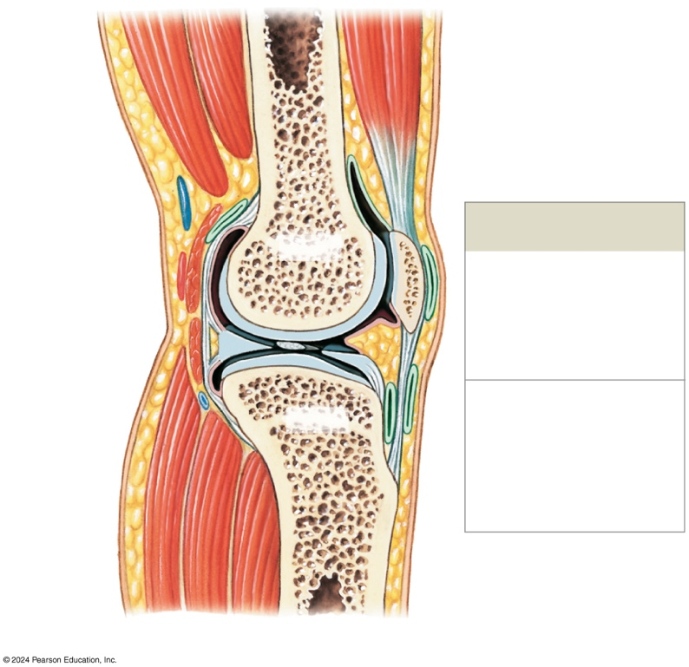

Structure | Function
Articular cartilage

Joint capsule (fibrous layer)

Synovial membrane

Joint cavity

Ligaments (extracapsular)

Ligaments (intracapsular)

Bursa

Fat pad

