Chapter 16-1
Autonomic Nervous System I
Sections 16.1 – 16.6
Flipped Lecture Activities

1. Building the ANS Pathways
Bloom’s Levels: 1–2 (Remember → Understand)
Time: ~20 minutes
Grouping: Rows as small groups (4–6 students)

Activity Description
You read aloud a series of short prompts, and groups work to diagram or list what you ask for on their mini whiteboard.

Student-Facing Slide Text
As a group (4–6 students):
- Listen to each question about the anatomy of the ANS
- Write your answer on your board
- When your group is ready, hold your board up

Questions
- What is the overall function of the ANS?
- What is the basic pathway of information in the ANS?
- Which neurotransmitter is always released by preganglionic neurons?
- Which neurotransmitter do sympathetic postganglionic neurons release?
- Which neurotransmitter do parasympathetic postganglionic neurons release?
- Write which synapses are cholinergic vs. adrenergic.
- Nicotinic receptors are found where along the ANS pathway?
- Muscarinic receptors are found in which ANS division?

Model Answers
- ANS function: Maintain homeostasis by regulating involuntary effectors (smooth muscle, cardiac muscle, glands, adipocytes)
- Pathway: CNS (hypothalamus) → preganglionic neuron → autonomic ganglion → postganglionic neuron → effector
- Preganglionic NT: Acetylcholine
- Sympathetic postganglionic NT: Norepinephrine (except sweat glands use ACh)
- Parasympathetic postganglionic NT: Acetylcholine
- Synapses: Cholinergic = all preganglionic synapses, parasympathetic postganglionic; Adrenergic = most sympathetic postganglionic neurons
- Nicotinic receptors: All preganglionic neurons (both divisions); adrenal medulla
- Muscarinic receptors: Parasympathetic division (except sympathetic sweat glands)

2. ANS Receptor Matching
Bloom’s Levels: 2–3 (Understand → Apply)
Time: ~10 minutes
Grouping: Pairs
Activity Description
You read (or project) a list of receptor descriptions/functions. Groups must match each description to the correct receptor name (Nicotinic, Muscarinic, α1, α2, β1, β2, β3).

Student-Facing Slide Text
- I will project descriptions of different ANS receptors
- For each description, identify the matching receptor name
- When you are ready, raise your hand to provide your answer

Receptor Options: Nicotinic - Muscarinic - $α$1 - $α$2 - $β$1 - $β$2 - $β$3

Matching Items
- Found at neuromuscular junctions and all ANS ganglia; always excitatory; ionotropic
- Uses G-proteins; located on parasympathetic target organs; excitatory or inhibitory
- Most common $α$ receptor; causes excitatory responses such as vasoconstriction
- Inhibitory $α$ receptor; often decreases parasympathetic activity
- Increases heart rate and contractility; generally excitatory
- Causes bronchodilation; inhibitory effect on smooth muscle of airways
- Found in adipose tissue; stimulates breakdown of triglycerides
- Activated by acetylcholine (ACh)
- Activated by norepinephrine (NE)
- Ion channel-based receptor type that results in quick depolarization of the postsynaptic membrane

Model Answers
Item # | Correct Match | Explanation
1 | Nicotinic | Ionotropic, excitatory, found at NMJ and all preganglionic synapses
2 | Muscarinic | Parasympathetic targets; G-protein; can excite/inhibit
3 | $α$1 | Most common $α$ receptor, excitatory (e.g., vasoconstriction)
4 | $α$2 | Inhibitory; reduces parasympathetic output
5 | $β$1 | ↑ HR, ↑ contractility; excitatory in cardiac tissue
6 | $β$2 | Bronchodilation; inhibitory to smooth muscle
7 | $β$3 | Adipose tissue; lipolysis (triglyceride breakdown)
8 | Nicotinic + Muscarinic | Both cholinergic receptors respond to ACh
9 | $α$1, $α$2, $β$1, $β$2, $β$3 | All adrenergic receptors respond to norepinephrine
10 | Nicotinic | Opens ion channels → rapid depolarization → excitation

3. Sympathetic vs. Parasympathetic Comparison
Bloom’s Levels: 3–5 (Apply → Analyze → Evaluate)
Time: ~30 minutes
Grouping: Groups of 4–6 (rows)

Activity Description
Groups construct a comparison table on a provided paper. You provide the categories and they must fill in the content.

Student-Facing Slide Text
In your group:
- Complete the comparison table
  - Try to use only what is in your written notes and brain
- Turn in your table when you are finished

Compare and contrast the following categories:
- Origin
- Ganglia Location
- Preganglionic length / Postganglionic length
- Neurotransmitters used (preganglionic vs postganglionic)
- Receptors
- General Functions

Model Answers

Sympathetic Division
Origin: Thoracolumbar (T1–L2)
Ganglia: Near spinal cord/away from target (chain ganglia, collateral ganglia, adrenal medulla)
Preganglionic length: Short
Postganglionic length: Long
Neurotransmitters: Preganglionic = ACh (nicotinic), Postganglionic = norepinephrine
Receptors: Nicotinic, $α$1 (excitatory), $α$2 (inhibitory), $β$1 (excitatory; metabolic activity + heart rate), $β$2 (inhibitory; muscle relaxation in respiratory tract), $β$3 (excitatory; breakdown of triglycerides in adipose tissue)
General Functions: “Fight or flight,” energy mobilization, ↑ alertness

Parasympathetic Division
Origin: Craniosacral (CN III, VII, IX, X + S2–S4)
Ganglia: Near or within target (terminal ganglia, intramural ganglia)
Preganglionic length: Long
Postganglionic length: Short
Neurotransmitters: Preganglionic = ACh (nicotinic), Postganglionic = ACh (muscarinic)
Receptors: Nicotinic (preganglionic) and muscarinic (postganglionic)
General Functions: “Rest and digest,” energy conservation, nutrient storage

Activity 1: "Map the Gap" – Anatomical Drawing
Bloom’s Level: Remember & Understand Group Size: Pairs (Think-Pair) Time: 10 Minutes
Description: Students often confuse the anatomical differences between the two divisions (length of fibers and location of ganglia). In this activity, you project a simplified "start point" (Spinal Cord/Brainstem) and "end point" (Heart/Gut), and students must draw the wiring that connects them.
Student Facing Text (Projected):
Challenge: You are wiring two different systems to the Heart.
- Draw a line down the center of your page. Label the Left side "Sympathetic" and the Right side "Parasympathetic."
- Draw the CNS: Draw a spinal cord/brainstem on both sides.
- Draw the Target: Draw a heart on both sides.
- Connect them:
  - Draw the Preganglionic neuron (solid line) and the Postganglionic neuron (dotted line).
  - Crucial Detail: Make the lengths of the lines accurate (Short vs. Long) relative to where the ganglion is located.
  - Label the Ganglion.
- Check with your neighbor: Do your diagrams match?
Model Answers (Instructor Version):
- Sympathetic: Short preganglionic fiber (originating T1-L2), Ganglion (Sympathetic Trunk) is close to the spine, Long postganglionic fiber reaching the heart.
- Parasympathetic: Long preganglionic fiber (originating Brainstem/Sacral), Ganglion is near or in the wall of the heart (terminal ganglion), Short postganglionic fiber.
Engagement Tips:
- Walk the room immediately. If you see a student drawing a single neuron from spine to heart, pause and ask, "Is the ANS a one-neuron or two-neuron relay?"
- Ask a pair to hold up their drawing to show the class the difference in "wire" length.

Activity 2: The "Bear vs. Couch" Organ Sort
Bloom’s Level: Apply Group Size: Small Groups (3-4 students) Time: 15 Minutes
Description: Students apply the general functions of the ANS to specific organs. Instead of memorizing a list, they use the physiological context ("Fight or Flight" vs. "Rest and Digest") to predict the physiological change.
Student Facing Text (Projected):
Scenario A: The Bear. You are hiking and stumble across a Grizzly Bear. (Sympathetic Activation) Scenario B: The Couch. You just finished a massive Thanksgiving dinner and are napping. (Parasympathetic Activation)
Task: For the organs listed below, determine what happens in Scenario A and Scenario B.
- Pupils: (Dilate or Constrict?)
- Salivary Glands: (Watery/abundant or Thick/mucousy?)
- Bronchioles (Lungs): (Dilate or Constrict?)
- Heart Rate: (Increase or Decrease?)
- Digestion/Peristalsis: (Stimulate or Inhibit?)
- Liver: (Release Glucose or Store Glucose?)
- Bladder Muscle: (Contract/void or Relax/hold?)
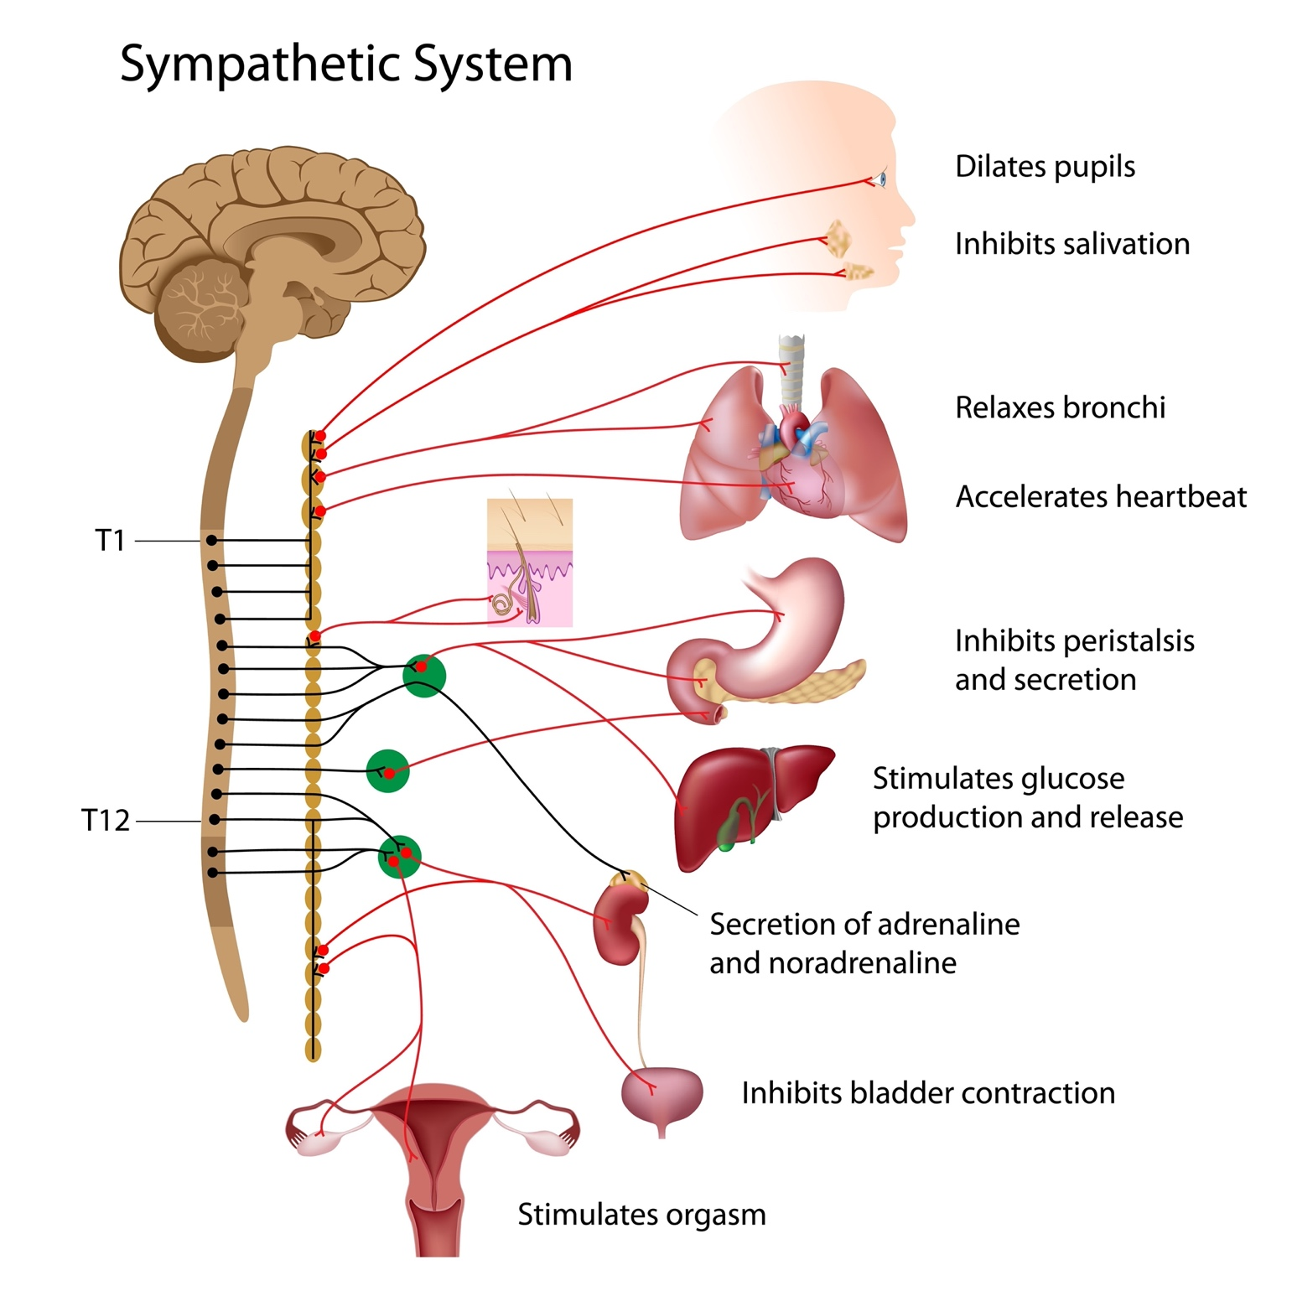
Shutterstock
Model Answers (Instructor Version):
- Pupils: Bear (Dilate - see far); Couch (Constrict - read near).
- Saliva: Bear (Thick/Dry mouth); Couch (Watery - digest food).
- Lungs: Bear (Dilate - more O2); Couch (Constrict - maintain baseline).
- Heart: Bear (Increase); Couch (Decrease).
- Digestion: Bear (Inhibit - blood diverted to muscles); Couch (Stimulate).
- Liver: Bear (Release Glucose - fuel); Couch (Store Glucose/Glycogen).
- Bladder: Bear (Relax muscle/Constrict sphincter - hold it, don't pee while running!); Couch (Contract muscle/Relax sphincter - voiding).
Engagement Tips:
- Debate: The "Bladder" is usually the point of confusion (people think fear makes you pee). Clarify that extreme terror might override it, but generally, the sympathetic system prevents voiding to keep you mobile.
- Use the handout/worksheet option here so they have a clean table to study from later.

Activity 3: The "Neuro-Matrix" (The Whiteboard Challenge)
Bloom’s Level: Analyze Group Size: Small Groups (Using the 12 mini-whiteboards) Time: 20 Minutes
Description: This covers the difficult biochemistry LOs (Receptors/NTs). Students must build a matrix that differentiates the neurotransmitters and receptors at every step of the pathway. This is the hardest cognitive load of the lecture.
Student Facing Text (Projected):
The Great Neuro-Matrix On your whiteboard, draw a table with these headers. Fill in every empty box.
Pathway | Preganglionic Neurotransmitter? | Receptor at the Ganglion? | Postganglionic Neurotransmitter? | Receptor at the Target Organ?
Parasympathetic |  |  |  | (Name the specific type)
Sympathetic |  |  |  | (Name the specific types)
Somatic Motor (Review) |  | N/A | N/A
Export to Sheets
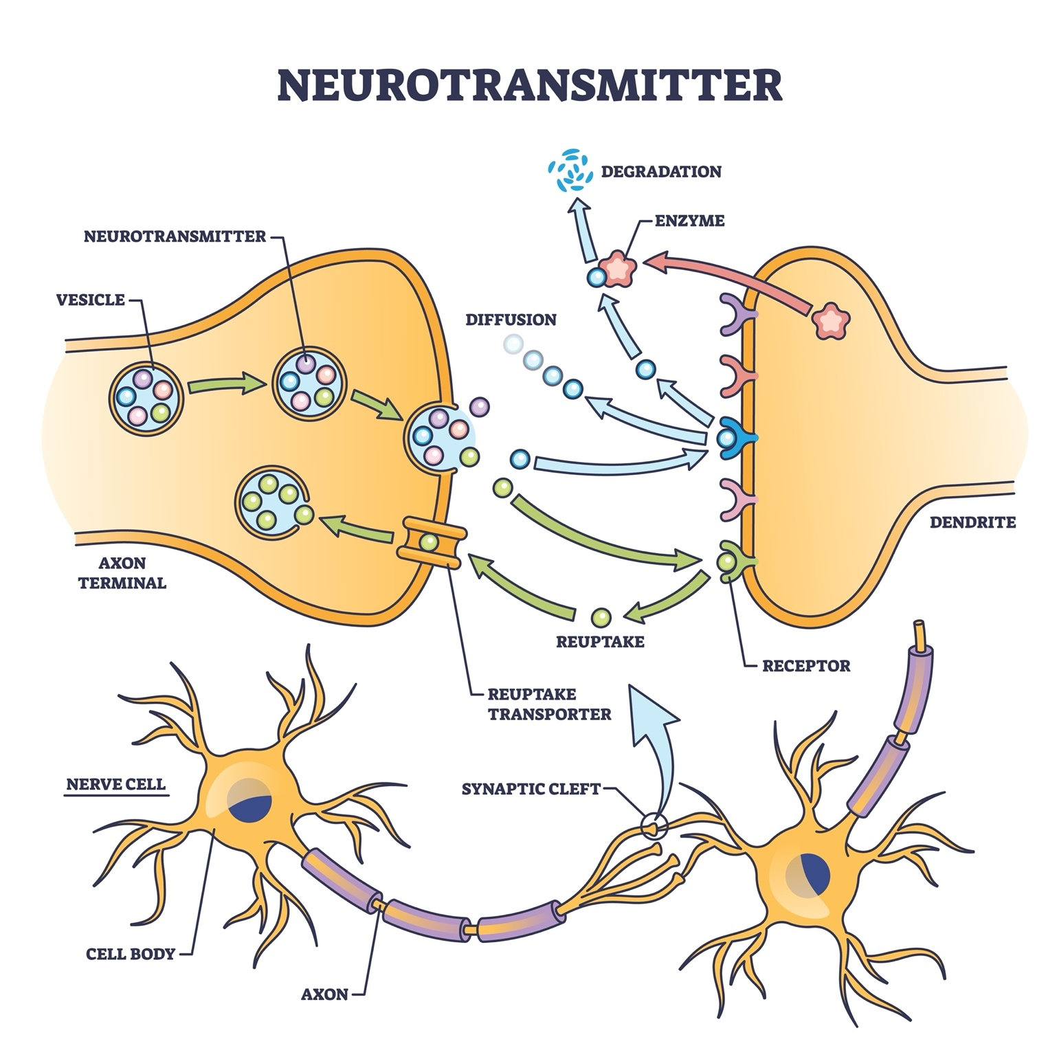
Shutterstock
Model Answers (Instructor Version):
- Parasympathetic: Acetylcholine (ACh) Nicotinic Receptor Acetylcholine (ACh) Muscarinic Receptor.
- Sympathetic: Acetylcholine (ACh) Nicotinic Receptor Norepinephrine (NE) Adrenergic Receptors ( or ).
  - Note to Instructor: Mention the exception (Sweat glands use ACh/Muscarinic) if you teach that level of detail, but keep the main model focused on NE.
- Somatic: Acetylcholine (ACh) Nicotinic Receptor (on skeletal muscle).
Engagement Tips:
- Check Point: Stop the class halfway through. Ask: "What is the ONE thing that is the same for Somatic, Sympathetic, and Parasympathetic?" (Answer: They all release ACh from the first neuron).
- Mnemonics: Encourage them to share mnemonics. (e.g., "Parasympathetic = Pair of AChs").

Activity 4: Clinical Case – "The Alpha/Beta Pharmacologist"
Bloom’s Level: Evaluate & Create Group Size: Whole Class Discussion (with individual reasoning) Time: 15 Minutes
Description: Students distinguish between Alpha-1, Beta-1, and Beta-2 receptors by predicting drug side effects. This appeals heavily to the nursing/pre-med students.
Student Facing Text (Projected):
The Patient: Mr. Jones has high blood pressure (needs to lower heart rate) AND he has Asthma (needs open airways).
The Receptors:
- (Beta-1): Located on Heart muscle. Activation increases heart rate.
- (Beta-2): Located on Bronchioles. Activation dilates airways.
The Problem: You have a drug called "Propranolol" which is a Non-Selective Beta-Blocker (it blocks both and ).
- Will this drug help his high blood pressure? Why?
- What will this drug do to his asthma? Why?
- Critical Thinking: Would you give this medication to Mr. Jones?
Model Answers (Instructor Version):
- BP Effect: Yes. Blocking prevents the sympathetic system from speeding up the heart, effectively lowering Heart Rate and BP.
- Asthma Effect: It causes a major problem. Blocking prevents the sympathetic system from dilating the airways. This leads to bronchoconstriction.
- Decision: NO. You would kill the patient (or cause severe respiratory distress). You need a Cardioselective blocker (Metoprolol) that only blocks .
Engagement Tips:
- Mnemonic Tip: Remind them: "You have 1 Heart () and 2 Lungs ()."
- Poll the Class: "Raise your hand if you would administer the drug. Raise your hand if you would hold the drug and call the doctor."
- This activity specifically hits the LO regarding differentiating alpha/beta effects and evaluating receptor specificity.

