Project Description.
This game design document describes the details for a multi-platform based 2D game with an original characters.
The name is to be defined but candidates are…
This is first version.
1. Story
In our days Covid-19 becoming epidemic, so frightened character washes hands and wears a mask . Will it be possible to survive in such conditions?

2. Characters
Main character shoots two types of bullets:

Main Enemy is coronavirus, which want to kill you smile:

Bullets:

Map:
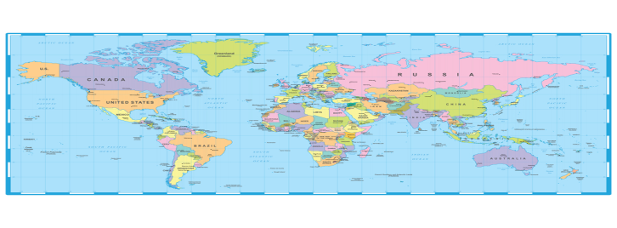
Aim:

Gameplay

User can use AWSD to move main character. Aim at the enemy by help mouse and shoot with the right and left (5 seconds to recharges ) mouse buttons.
