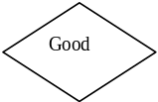
Start
Receive payment/receipt
Good
Receives all county data and generates national summaries and reports
Provides forms and data collection material
Receives schedule of work of community health worker
Summarises monthly data within the ward
Acknowledges receipt of designs and schedules appointments and visits/monthly work
Review data inputs and notes
Provides health worker with required data
Treatment presentation
Receives all sub county level data and creates constituency summaries
Receive all ward data summaries within constituency
Receive all constituency level data and creates constituency summary
Processes stipend/salary for community health workers
Generate monthly report summary

