Dormitory Cleaning Materials Management System

# FEASIBILITY STUDY

Members:  
Mutoni Uwingeneye Denyse  
Cyebukayire Peace   
Ntezirizaza Ernest  
Izere Uwonkunda Marie Claire Kerie   
  
Doc Version: 1.0

**Table of Contents**

1. INTRODUCTION 1

1.2. Overview of the Project 2

1.3 Objectives of the Project 2

1.4 The need for a project 2

2. Feasibility study 3

2.1 Financial Feasibility 3

2.2 Technical Feasibility 3

2.3 Market Strategy 4

2.4 Organization and stuffing 4

2.5 Economic Feasibility 5

2.6 Schedule Feasibility 6

2.7 Resource and Time feasibility 7

2.8 Risks and Assumptions 7

2.8.1 Assumptions underlying the project 8

2.8.2 Risks 8

2.8.3 Approach towards identified risks 8

2.9 Findings and recommendation 8

3. Requirements Specifications 9

3.1 Functional requirements 9

3.2 Non-functional requirements 10

# 1. INTRODUCTION

A dormitory cleaning material management system is basically a system that is going to ease how patrons/matrons/students manage the dormitory cleaning material.

## 1.2. Overview of the Project

DCMMS is a web-based project that helps in the management of the RCA dormitory Cleaning Materials Management System. It provides interfaces for various stakeholders like metrons and students.

Materials can be added to the system by their associated parameters (name, quantity, type, size, date, status, etc). The matrons and patrons can track the status of the cleaning materials by knowing their status thus if they are damaged or new and their report in general.

## 1.3 Objectives of the Project

The objectives of this project are to:

* Develop a central database for each cleaning material
* Provide daily, weekly, monthly and annual reports of cleaning materials to metrons and patrons.
* Provide a data entry for cleaning materials.
* Provide a way to change the status of the material.

## 1.4 The need for a project

Managing Cleaning materials in RCA is a cumbersome task when it comes to tracking the total number of working materials in RCA. This project will ease the way of managing resources in RCA by providing a statistical report to the end-users. This report will be informative enough to ease the management of cleaning materials.

# 2. Feasibility study

## 2.1 Financial Feasibility

Being a web application DCMMS will have associated hosting cost. Since the system doesn’t consist of any multimedia transfer, the bandwidth required for the operation of the application is very low.

The system will follow the freeware software standards. No cost will be charged from the potential customers. Bug fixes and maintaining tasks will have an associated cost. At the initial stage, the potential market space will be in RCA.

## 2.2 Technical Feasibility

Project DCMMS is a complete web-based application. The main technologies and tools that are associated with are:

* React js(Next)
* Nodejs(Nest)
* PostgreSQL
* Design tools(FIGMA)

Each of the technologies is freely available and technical skills are manageable. Time limitations

Product development and the ease of implementing these technologies are synchronized

Initially, the website will be hosted free web hosting space ( netlify or vercel ) but later implementations it will be hosted in paid web hosting space with sufficient bandwidth. The bandwidth required in this application is very low since it doesn’t incorporate any multimedia aspect

From there it’s clear that the DCMMS is technically feasible.

## 2.3 Market Strategy

We have different competitors around the world who are providing the same services as we do. Our key difference is that we are providing the best user experience of the platform so all targeted users like accountants, metrons, accountants, patrons, and students will be able to use it.

After implementing a project product, we will approach the project manager, the school will be the one who will use this system, after being approved by the school project manager, our next go-to person will be Accountant because he is the super admin of the system.

When the accountant approves the system to be used in management, we will continue approaching class monitors showing and training them how to use the system.

After all, We will meet school management staff asking them to buy our system.

## 2.4 Organization and stuffing

Board of Directors

Table 1: Board of Directors

|  |  |  |  |
| --- | --- | --- | --- |
| Position | Number of places | Description | Type |
| Project Manager - CEO | 1 | Planning, executing, monitoring, and closing project | Full time |
| Marketing manager | 1 | Reaching customers, customer care | Full time |
| Chief Technology officer | 1 | Create a great customer experience, not great products | Full time |
| Chief Operating Officer | 1 | Designing and implementing business operations.  Establishing policies that promote company culture and vision | Fullt-time |

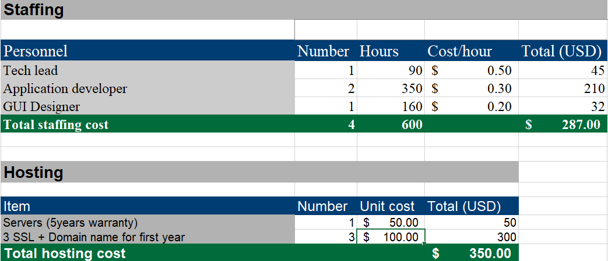

Figure 1: Staffing and hosting

## 2.5 Economic Feasibility

Being a web app we will have an associated cost. Since the system doesn't consist of any multimedia data transfer, the bandwidth for the operation of this application is very low.

The system will follow freeware standards, No cost will be charged from the potential customers. Bug fixes and maintenance will have associated costs.

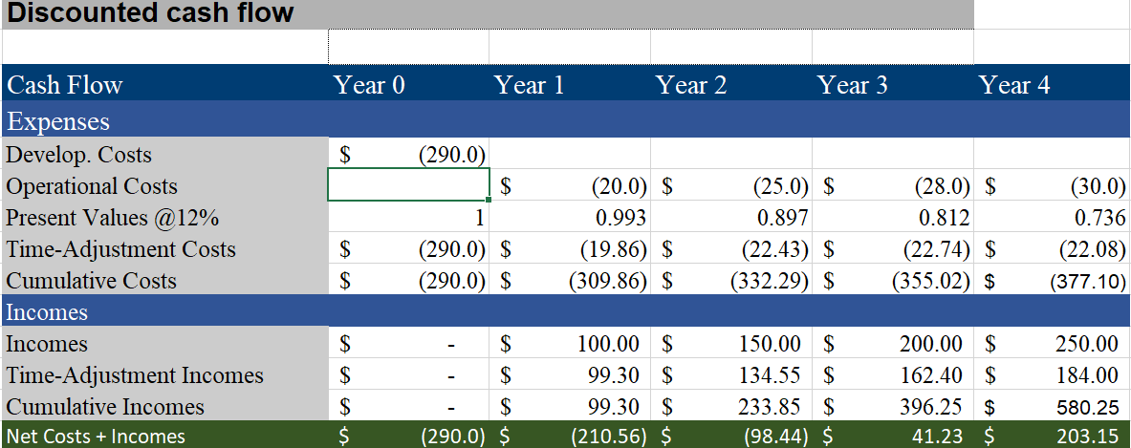

Figure 2: Economic feasibility

## 2.6 Schedule Feasibility

The DCMMS system is expected to take five months from project approval to the launch of the DCMMS platform. Many of the foundations for this platform, such as high-speed internet and web server capability, are already available. The following is a high-level schedule of some significant milestones for this initiative:

Table 2: Schedule feasibility

|  |  |  |  |  |  |
| --- | --- | --- | --- | --- | --- |
| **TASKS/PHASES** | **START DATE** | **END DATE** | **DAYS** | **STATUS** | **Comments** |
| Feasibility study | 23/11/2021 | 2/12/2021 | 9 | **COMPLETE** |  |
| Requirement Elicitation/gathering | 2/12/2021 | 10/12/2021 | 8 | **PENDING** |  |
| Design & Analysis | 11/12/2021 | 5/1/2022 | 17 | **PENDING** | **Days will extend because of Christmas and new year** |
| Development & Analysis | 6/1/2022 | 6/03/2022 | 60 | **PENDING** |  |
| Testing & Training | 7/03/2022 | 8/04/2022 | 30 | **PENDING** |  |
| Deployment | 8/04/2022 | 20/04/2022 | 13 | **PENDING** |  |

## 2.7 Resource and Time feasibility

Resource feasibility

Resources that are required for the CDMM project includes:

* Programming device (Laptop)
* Hosting space free available (freely available)
* Programming tools (freely available )
* Programming individuals

So it is clear that the project CDMM has the resource feasibility.

## 2.8 Risks and Assumptions

The risks identified in the ToRs are lack of availability and collaborations between all players due to other responsibilities; and lack of knowledge of beneficiaries and end-users on what really should be developed to produce the needed system.

### 2.8.1 Assumptions underlying the project

* Access to all excel templates which are recently in use.
* Frank collaboration between all stakeholders, partners, and beneficiaries of the system.

### 2.8.2 Risks

* Lack of basic knowledge (IT skills) of end-users.
* Absence of collaboration with stakeholders and beneficiaries.

### 2.8.3 Approach towards identified risks

* CDMM provides training and knowledge to end-users.
* Earlier involvement of stakeholders and beneficiaries in each phase of this system development and implementation.

## 2.9 Findings and recommendation

Based on the information presented in this feasibility study, it is recommended that DCMMS System approve the online well-managed cleaning materials process. The findings of this feasibility study show that it will be highly beneficial to the organization since it will be sold and has a high probability of success. Key findings are as follows:

**Technology:**

* Will utilize existing technology which lowers project risk
* Once in place, this technology is simple to operate and maintain for a relatively low cost.

**Marketing:**

* This initiative will allow the CDMM management system to reach a large number of target groups electronically at a low cost.
* CDMM management systems expect to expand the customer base beyond geographic areas (Rwanda) where the system is currently going to be used.
* CDMM management systems are highly needed by schools, especially which allow our system to grow.
* RCA CDMM management system is able to differentiate itself from its competitors and will utilize incentive programs to target a lot of consumers

**Organizational:**

* No new staffing is required to the organization
* No new facilities or capital investments are required

**Financial:**

* The Break-even point occurs early in the second year of operation
* Five-year projections show online sales accounting for 25% of total sales

# 3. Requirements Specifications

## 3.1 Functional requirements

* The system will allow users to login
* The system will allow users to logout
* The system will allow the admin to create a cleaning tool
* The system will allow the user to delete the tool
* The system will allow the user to update the status of the tool(old, new, damaged)
* The system will allow users to request new tools needed
* The system will allow users to report old tools and does need to be fixed
* The system will allow users to view all new and old tools available.
* The system will allow users to search a tool
* The system will allow users to update his/her profile
* The system will allow the user to deactivate his/her account
* The system will allow admin to see new tools requests made
* The system will allow the admin to delete requests
* The system will allow users to update requests
* The system will allow Admin users to mark requests as seen
* The system will allow users to mark requests as completed

## 3.2 Non-functional requirements

* The system will operate 24/7 days
* The system will grant access to accounts when users enter the correct username and password.
* The system will process 50 requests at the same time without affecting response time.
* User account names will be associated with a username which will be chosen by the user upon first use.
* If the user enters an incorrect password 3 times, they will be locked out for 2 min
* The interfaces of the system will be designed in a user-friendly manner such that the user will need less training to perform operations within the system. The interfaces will be easily navigable, clearly labeled, and a help menu will be provided with instructions for performing basic tasks.
* The system should respond to a user’s request for information in less than 5 seconds in any case.
* The system should timeout if there is not an activity for 10 minuteS
* System passwords will be case-sensitive, at least 6 characters, hashed, and stored in the database.
* The testers and project managers will be provided access to the system after they are registered into the database
* All history information will be stored in the database.
* The system will need 100MB