Initial Index Page: Without Login

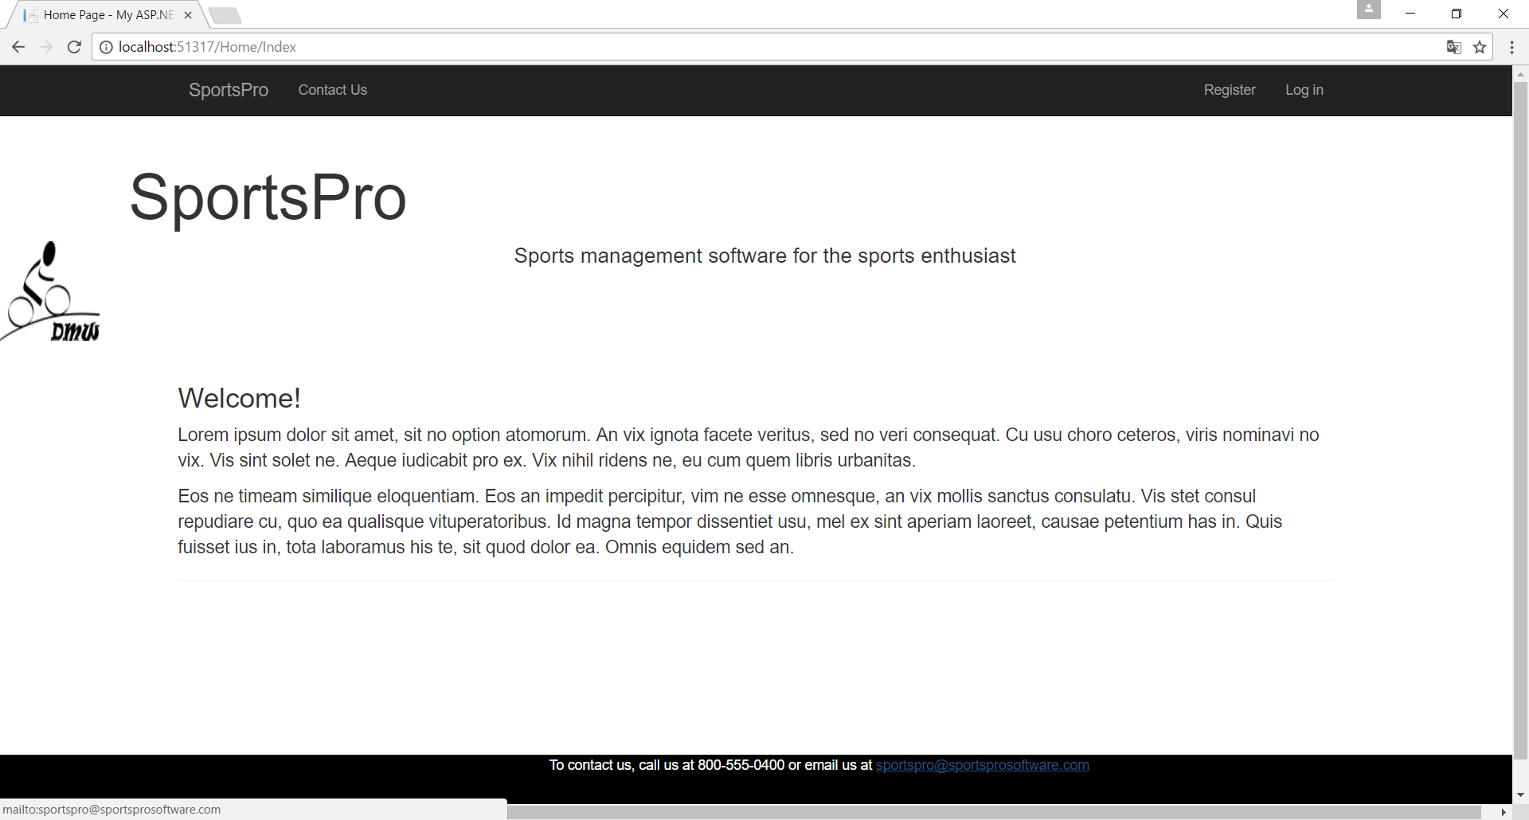

Notes:

* Uses logo & “Masterpage” specifications (SportsPro\Views\Shared\_Layout.cshtml)
* Uses ipsorum text
* Does not have any menus offered that are limited to role assignment/login.
* Bottom shows that link is set up to mail to appropriate email address

Contact Us Page: Without Login

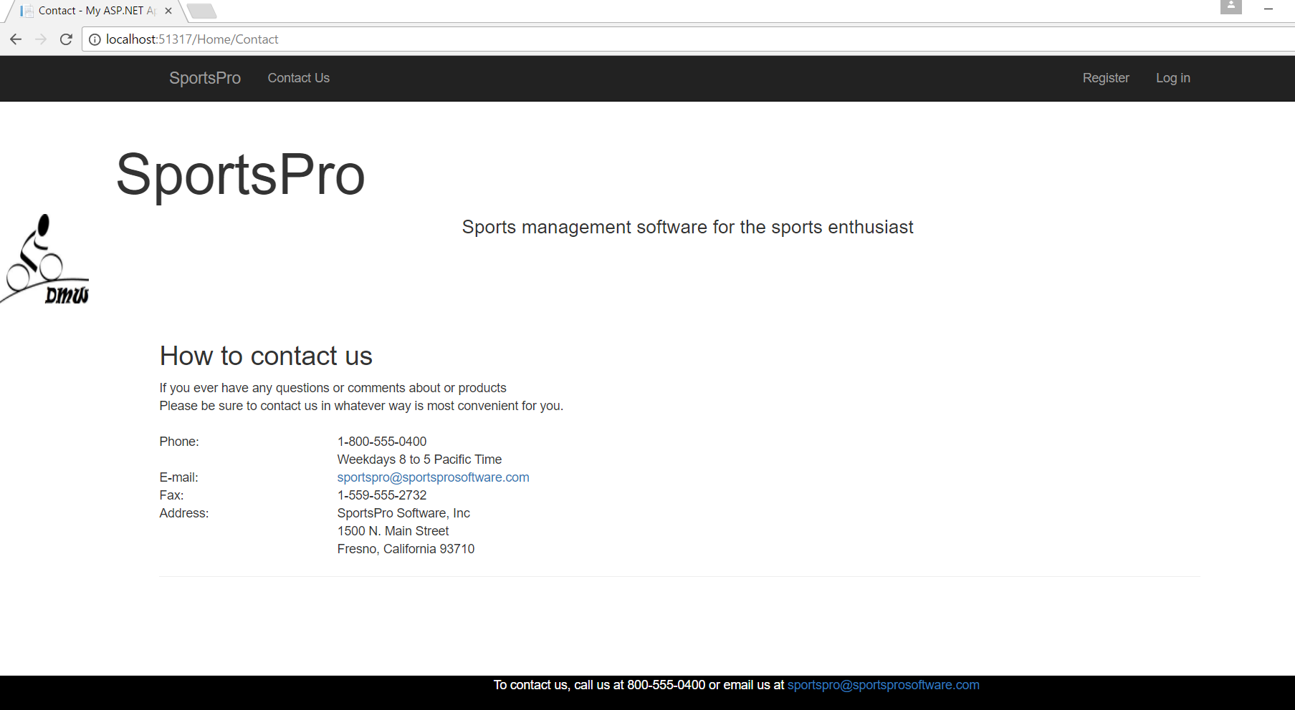

Register Page

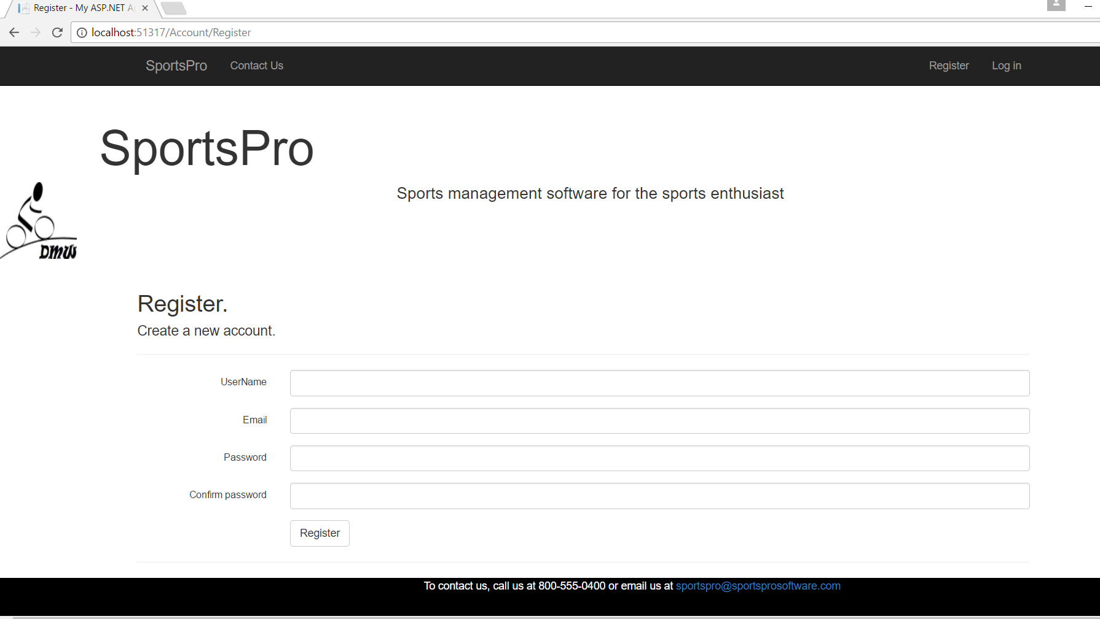

Notes:

* Have tried to shorten the box using bootstrap and custom class max-width settings on the textboxes, but it has not taken yet. Still hopeful it might eventually kick in like inverse footer eventually went black with white lettering three days after I did it.
* Otherwise, fully functional. I have registered six user using this page. Three are not usable because of changes that I made to the login using username instead of password in the greeting. The active login names you can use:

Email UserName

* Administrator: [MyNewAdmin@myadmin.com](mailto:MyNewAdmin@myadmin.com) MyNewAdmin
* Technician: [MyNewTech@techsrus.com](mailto:MyNewTech@techsrus.com) MyNewTech
* Customer: [dwalker1@pstcc.gov](mailto:dwalker1@pstcc.gov) DWalk
* Password for all logins is: *Admin2017

Login Page: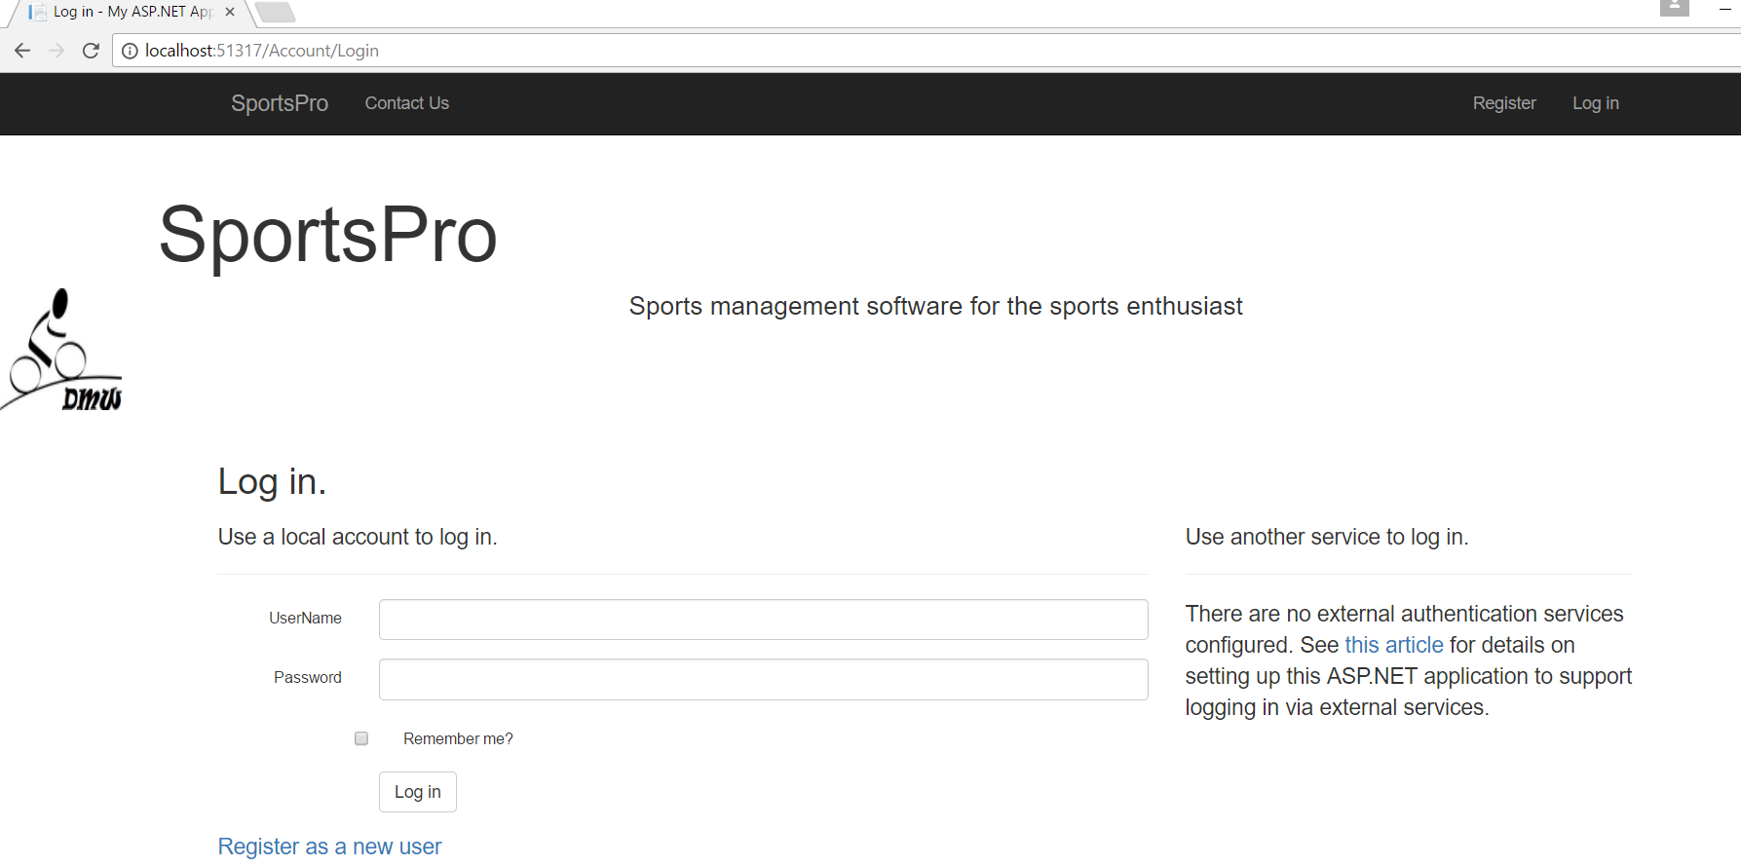

* Note that login does not take email (the default setting) but UserName instead
* While not very fond of the extra writing on the right side of the page about the page not having any external authorization configured, the login does work and the next three pages are the index page as it is shown with login by the three different roles with only their pertinent additional menu item accessible: (Customer menu for Customer logged in, etc)

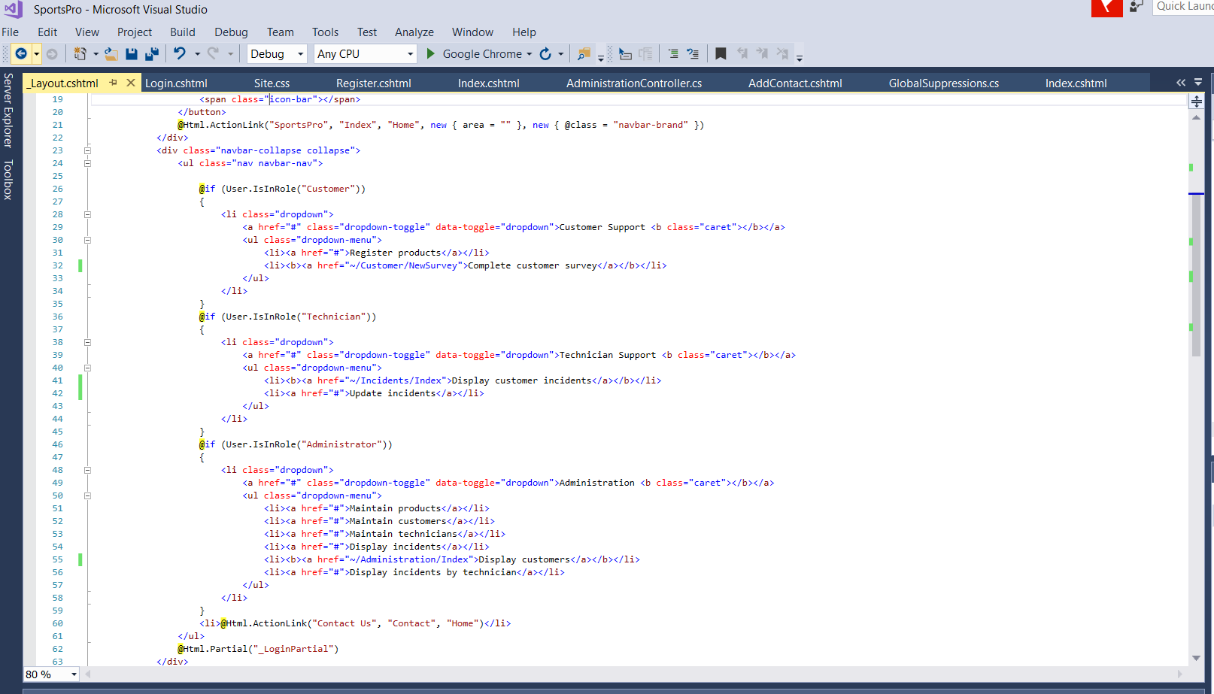

Also shows the submenu items I chose to implement for each type of user and that I chose one for each.

Index: Admin Login

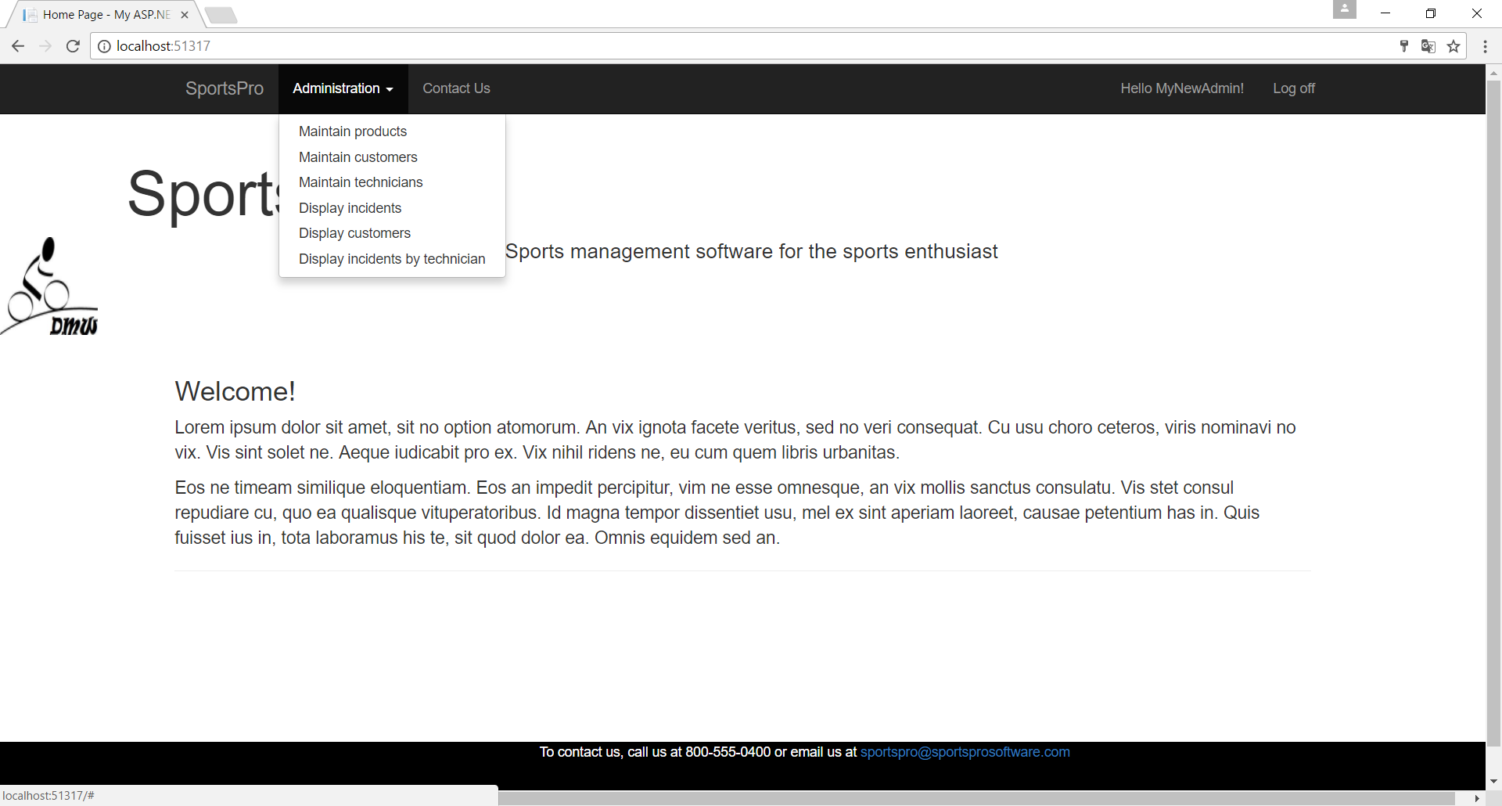

Note: Shows username, not password on the greeting next to Log off and Administration menu

Index: Tech Login

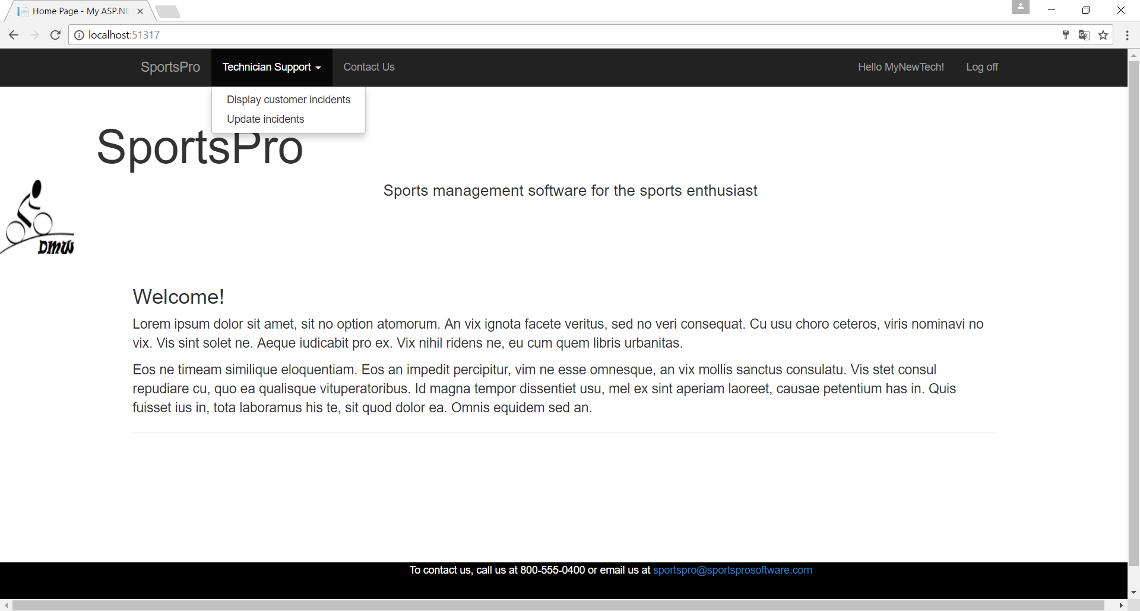

Index: Customer Login

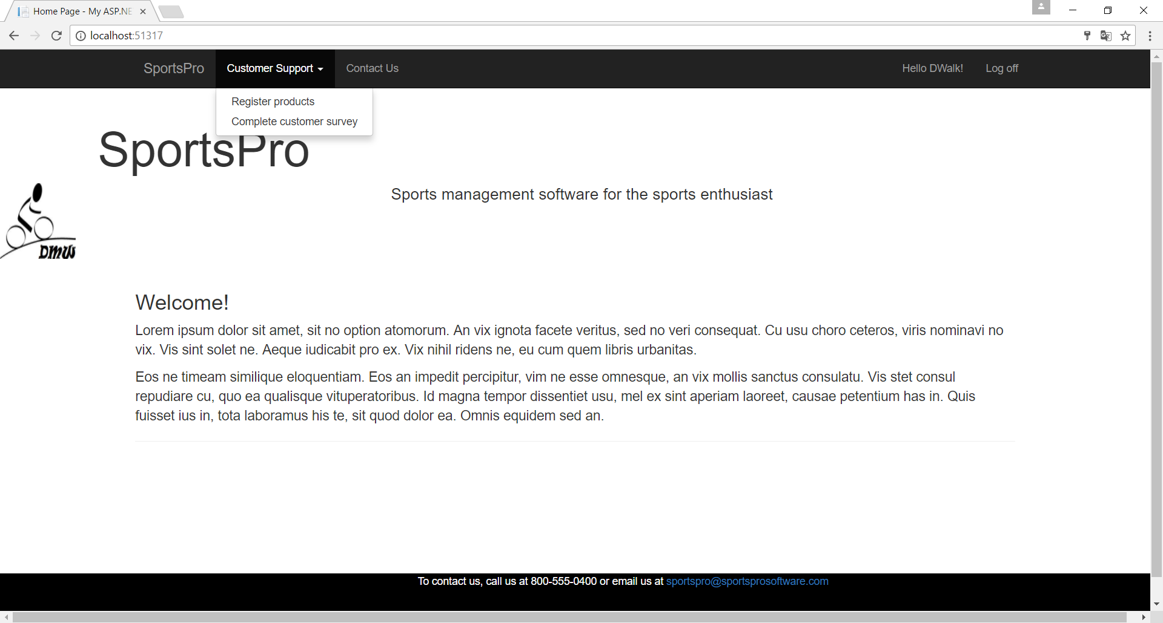

Login: Error Handling

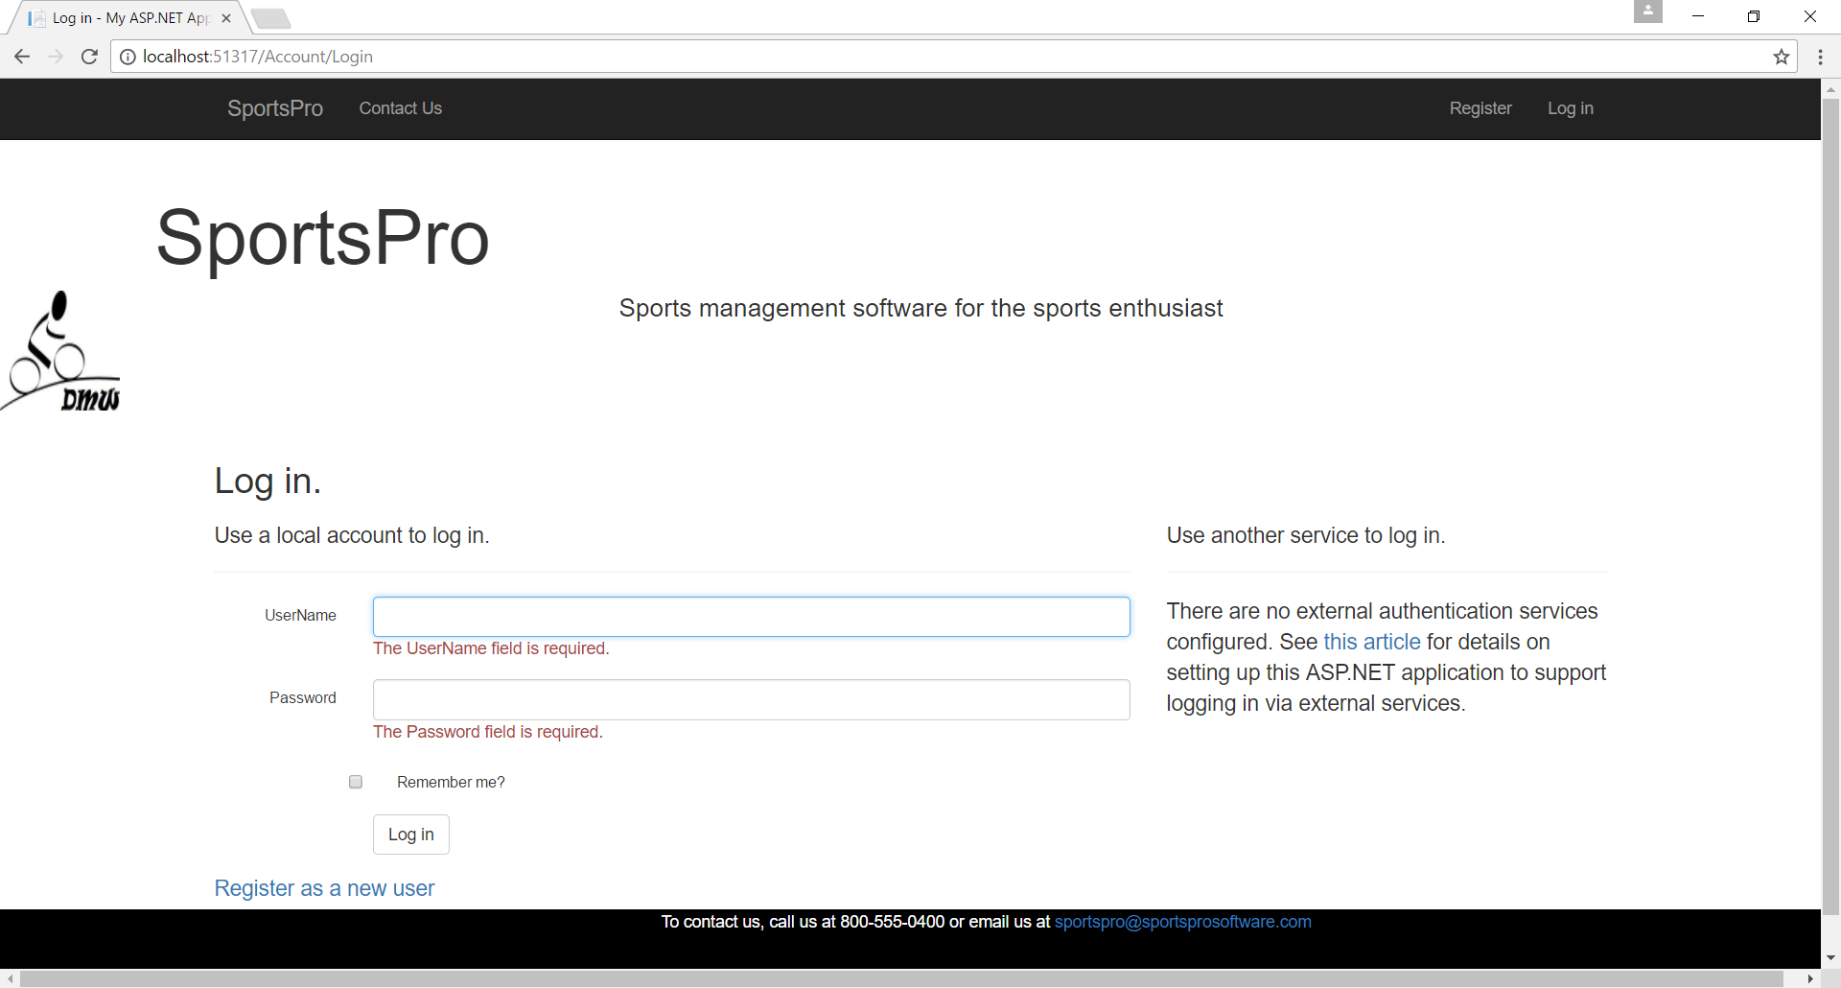

ROLES: (1 Index)

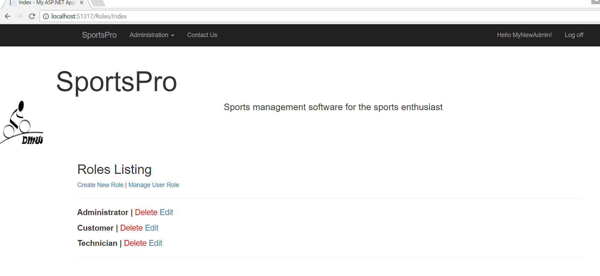

Note: The above screen shows the three roles that exist. (Previously created)

2(Create)

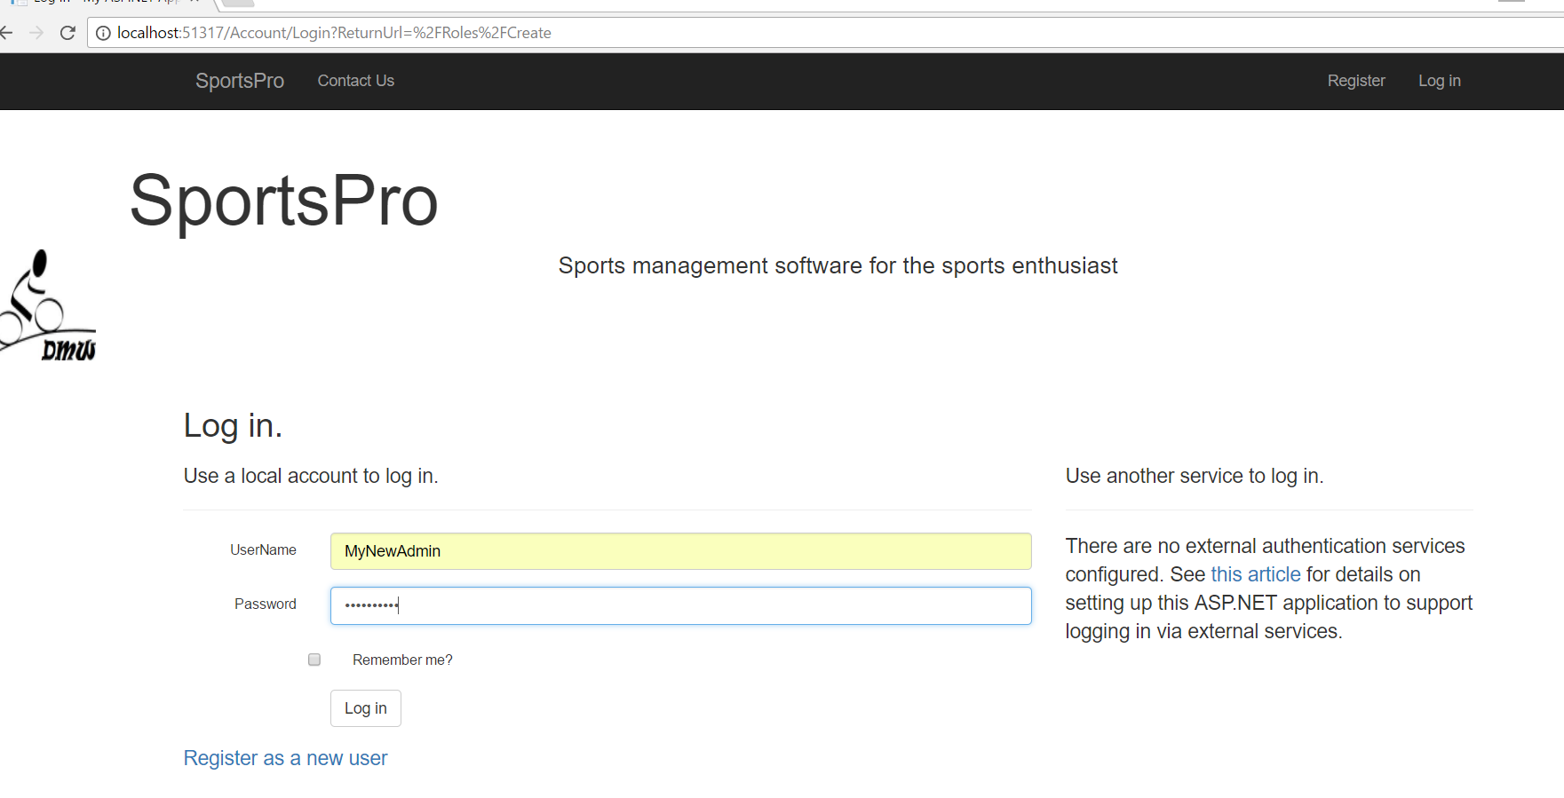

Note: As you can see from the browser reference, the user must log in to have access to the Roles controller. The pictures below show that the user must be an Admin to access the roles assignment screens and that the Admin account successfully signed into the account.

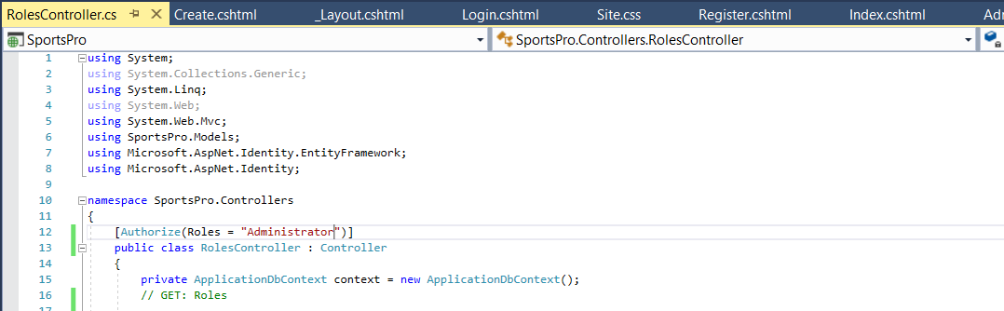

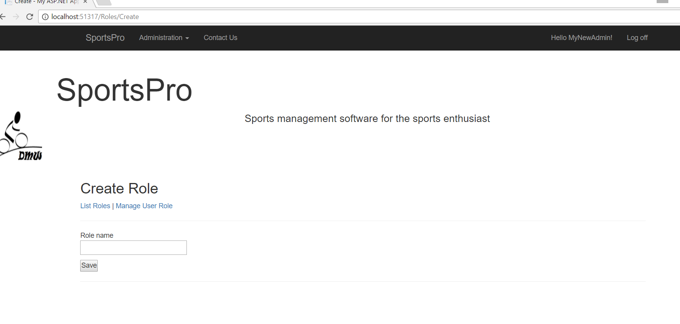

Note: The fact I have a Customer, Administrator and Technician Role that are assigned to users demonstrates the functionality of this function of the program. Feel free to sign in as an admin and assign another role, but know that there will be no menus showing other than Index (via SportsPro logo in nav bar, and Contact Us page will be accessible to other roles). [Shown in code on page 4 above]

Roles: 3 Edit

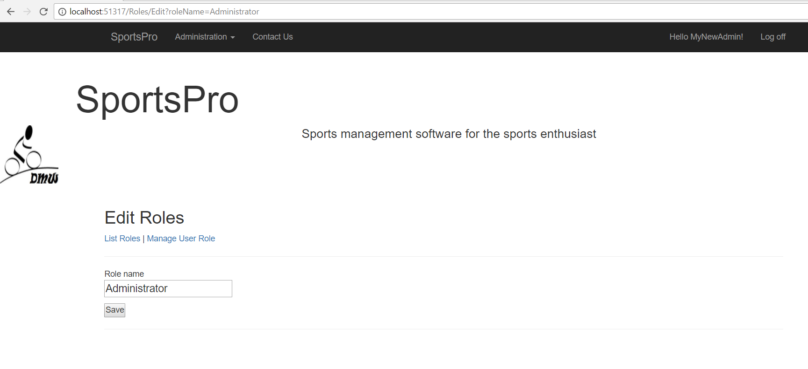

Allows users to change roles names.

Roles: Manage Roles

Shows current roles for MyNewAdmin:

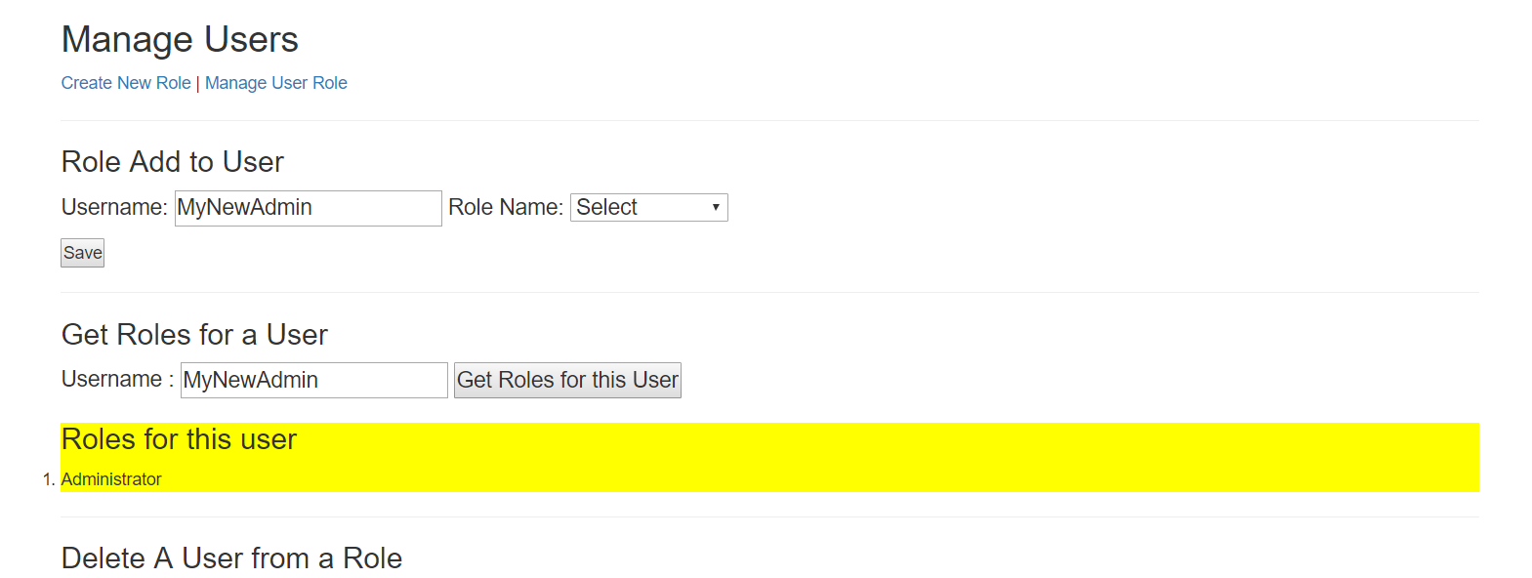

Shows Adding a New Role for MyNewAdmin:

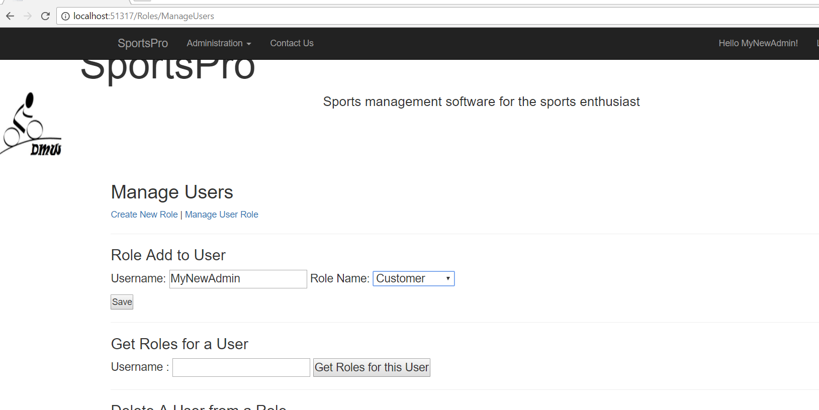

Note: Shows adding an additional role to MyNewAdmin

Updated Roles after using Add Role:

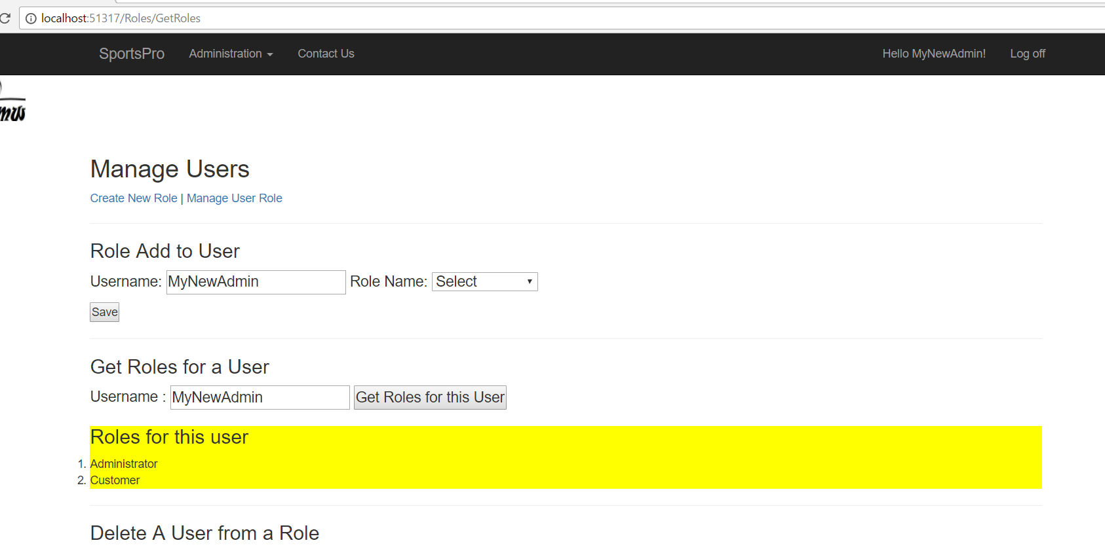

Delete Role:

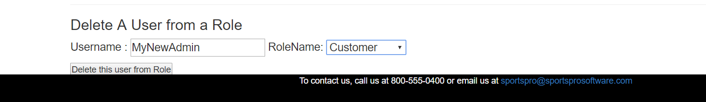

Outcome of delete: (No longer customer, only Administrator again)

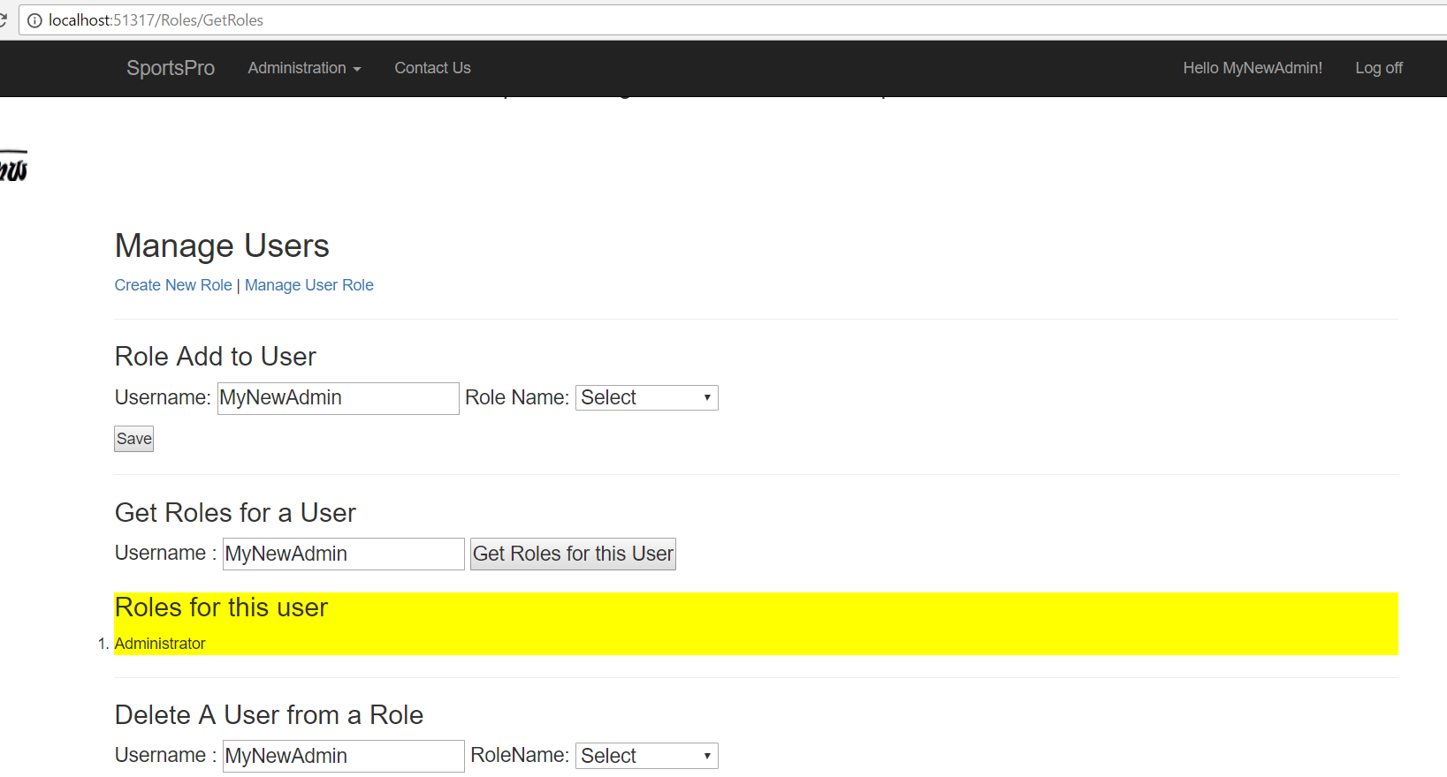

Controller Access Limited to Role:

Administration Controller:

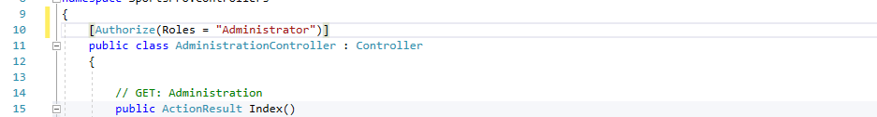

Customer Controller:

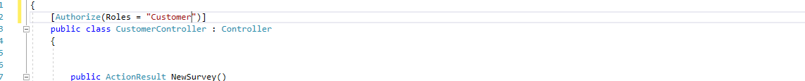

Incident Controller for Technician:

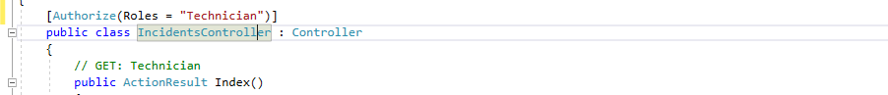

Note: This is done to keep users from accessing limited-access controllers by entering FriendlyUrls in the browser and avoiding login.

Proof of Concept:

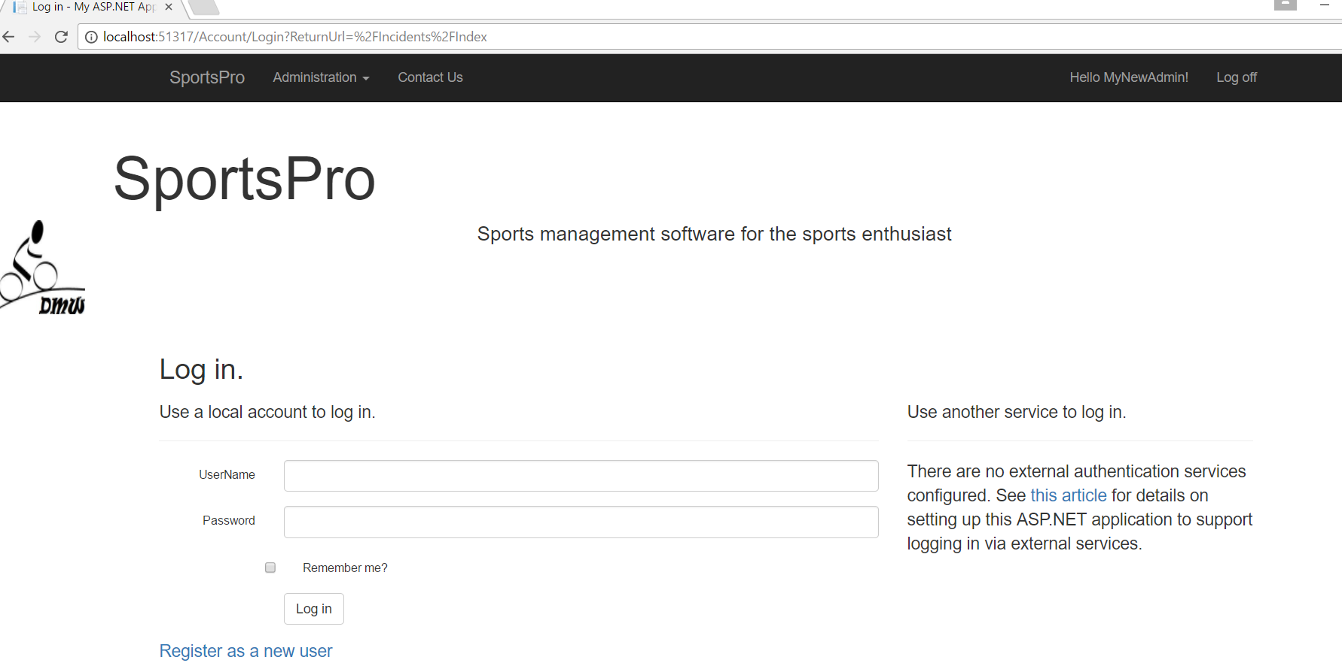

Note: In the above screen, you can see the logged in user MyNewAdmin (see hello message) tried to enter Incidents/Index into the browser, but was re-routed to the log in screen since they did not have access to the Technician controller. MyNewAdmin is only an Administrator.

When MyNewAdmin logs out. The Administrator is sent back to the Index page:

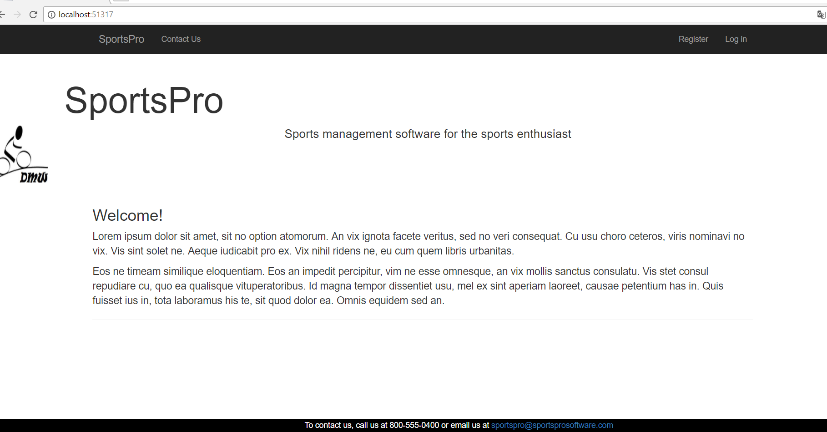

Admin: Display Customers

This is the Administrator page that I attempted. When the Admin selects Display Customers, they see this screen showing the first name alphabetically with the correct address for this customer:

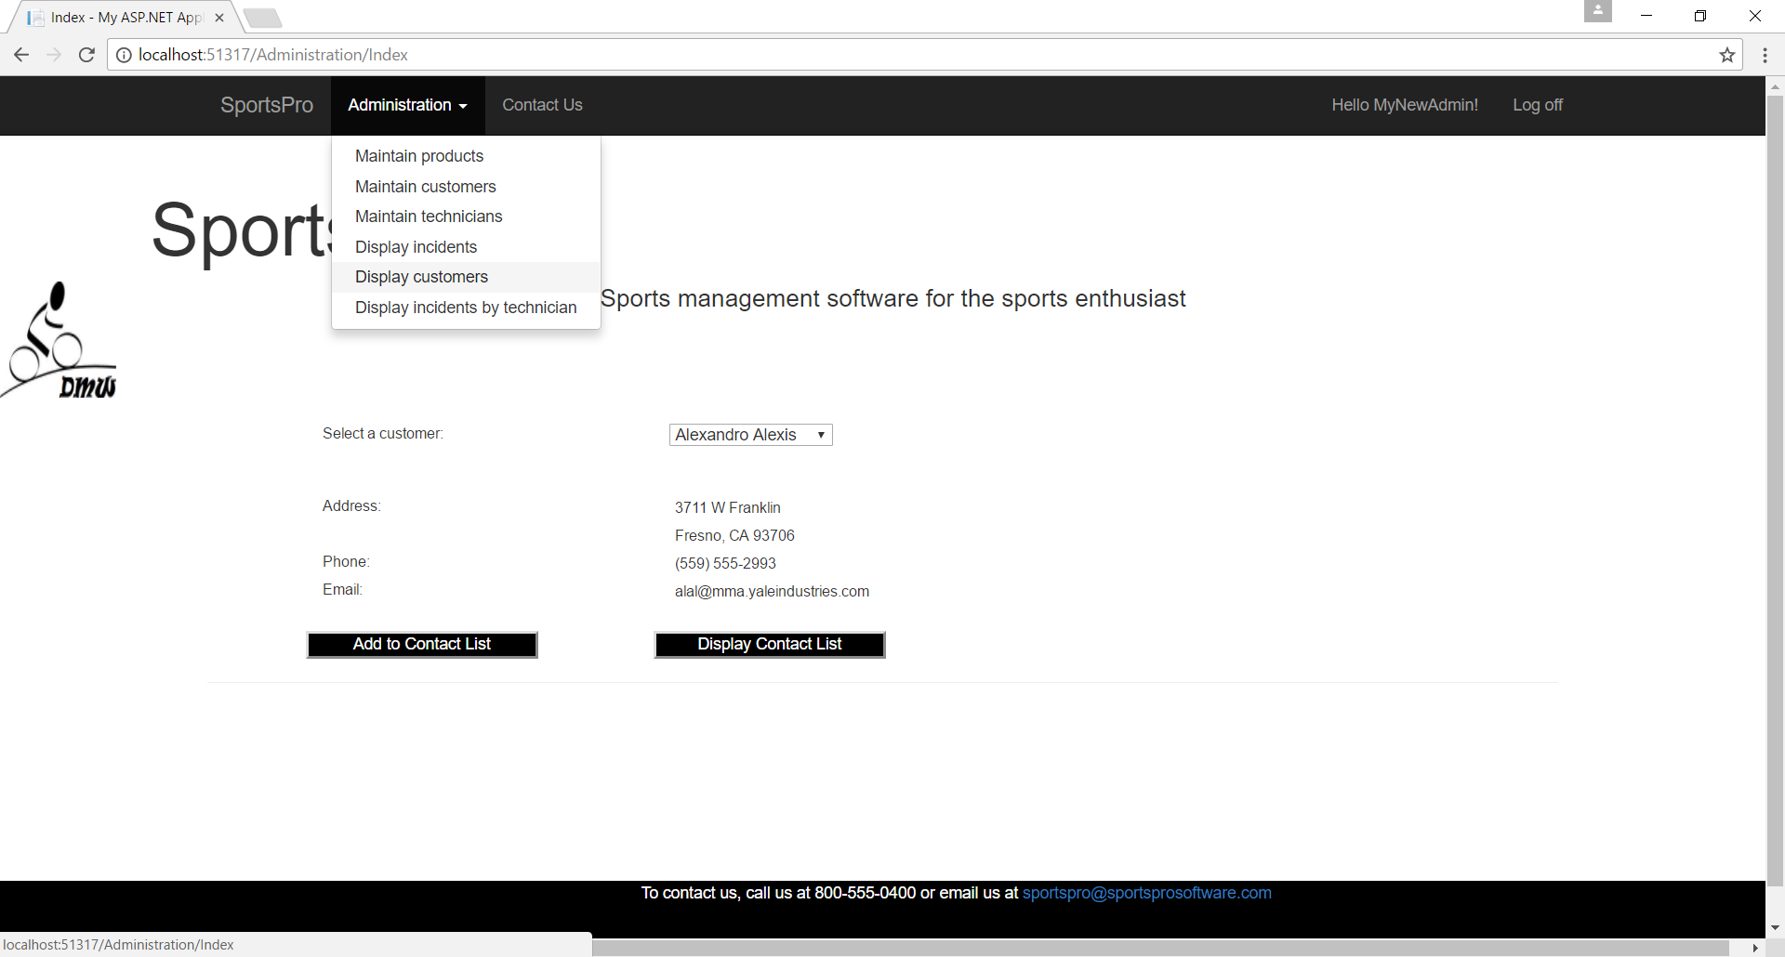

Postback of Display Customer:

The user can select a different customer and the page does automatically update to the correct contact information for the new selected customer:

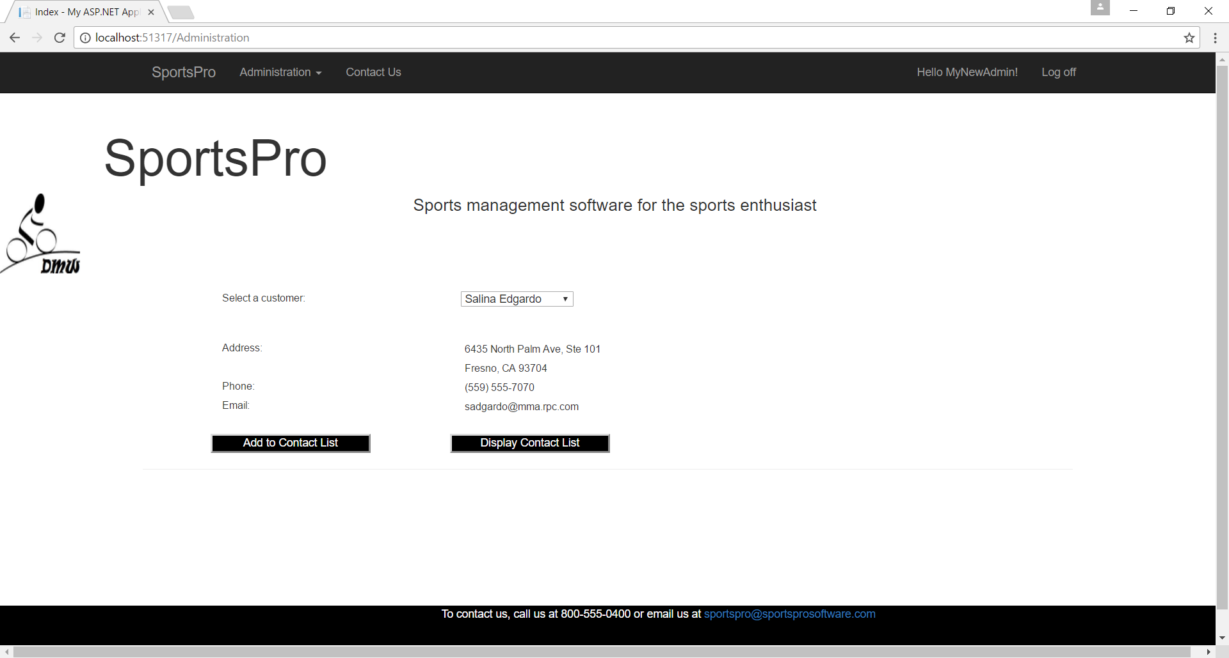

****Getting null list of customer that is causing exception CustomerList from the viewmodel. Need to work on how to do this using viewmodel to do Admin contact list.

May need to take pic and start over from scratch on how to do this to get it to function.

START HERE!!!!!!!

Incident Controller (Technician page)

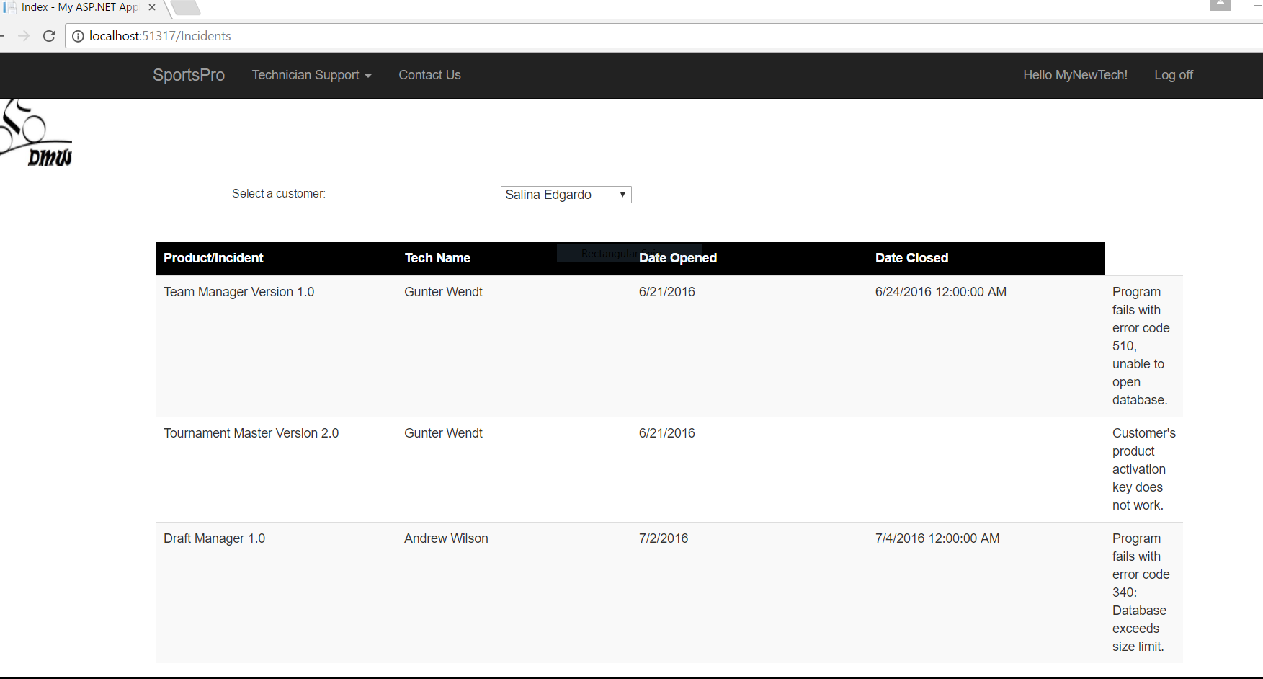

Note: As you can see, the tech is logged in to access the Customer Incident Display page.

My two issues are:

1. that the Incident is not wrapping to the next page though I have done several CSS grid classes that should have made them go to the next line. (see below) I hope it might click in at a later time and start working.
2. Also, I cannot get the Date Closed field to format the same as the Date Opened using ToShortDateString() because Date Closed is Nullable and must have a value to use that method.

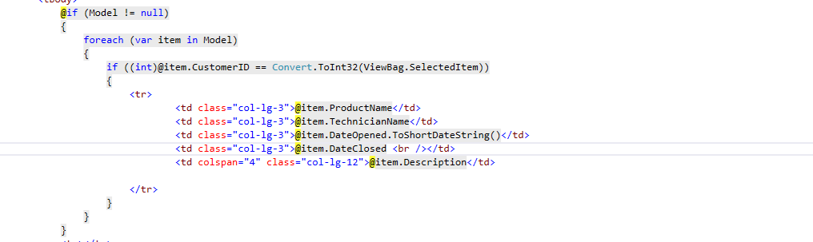

Customer Control (Customer Role)