**Name: Donna Walker**

**CSIT 2520 SQL Applications with Oracle**

**Lab 3 - Practice with Multiple Table Selections (40 points)**

**Note: Prior to designing your queries for this lab, you should try all examples in Chapter 2 in the section named *Performing SELECT Statements that Use Two Tables*,on pages 46-62 of your textbook, to be sure you understand the results for each.

**Part A**

To effectively and efficiently design multi-table queries that gather information from your database, you should consult an Entity Relationship Model to get an accurate picture of how each table in the schema is related to the other tables. If an ERM or ERD is not available, you should create one and refer to it frequently.

1. Download this instruction file to your H: drive or USB Flash drive. **ALL responses to ALL questions must be added to this document to earn points.** Add your name to the top right corner of this document and save it by appending *_yourLastName* to the original file name.
2. For this lab, you will need to add the Cloud Aviation Company schema to your CSIT 2520 Oracle database. From the *Helpful Inks 🡪 SQL Scripts* submodule of the D2L *Course Content* page, download the ***create_CloudAviationCo_schema.zip*** file. It contains a single text file that has a script for creating and populating the tables needed to complete this lab. Unzip the file. Open the script using an ASCII text editor, such as Notepad. Copy the code then paste it into your SQL Developer worksheet.
3. Examine the code to be sure you understand what it is doing. Be sure to inform your instructor if it seems like the names of the tables overlap with existing tables. Run the script only **after** you understand the code contained within it.
4. When you run the script for the first time, you will get errors for all of the DROP TABLE statements. Be sure you understand why. There shouldn’t be any other errors. Examine the script output to be sure the rest of the statements have completed successfully. If not, be sure to post a question on the D2L Discussion Board or ask about in class.
5. Using an electronic drawing tool such as Visio, create an ERD or ERM that models the relationships between all tables in the Cloud Aviation Co. schema. The model must contain all fields in each table and must indicate the primary keys (PK) and foreign keys (FK) that can be used to join the tables. (10 pts) Paste a screen capture of your model on the last page of this instruction sheet. Refer to the model when completing the rest of this lab.

**Part B**

Launch SQL Plus or SQL Developer. Using SQL statements, perform the following tasks. You will need to paste a copy of each query and the query results under each question. The SQL*Plus comment specifier  (--) will allow you to document your code if you feel the need. Commands can be done interactively at the SQL prompt or by saving in a script file. Refer to your textbook or online HELP when necessary.

Reminder: When using SQL Developer, output can be saved to a disk file from the Script Output window. Be sure to type “set echo on” at the top of the SQL Developer Worksheet each time you reconnect to the Oracle server so that SQL statements and comments will echo in the output file.

**Show two different queries for each request unless it’s impossible to provide an equivalent due to lack of support in the ANSI standard:**

1. **using ANSI SQL/86 syntax;**
2. **using the equivalent ANSI SQL/92 syntax**
3. Display the employee number, employee title, employee last name, employee first name, pilot license and pilot ratings for all aviation employees that are pilots. (4 pts)  
     
   **a. SQL/86 syntax:**

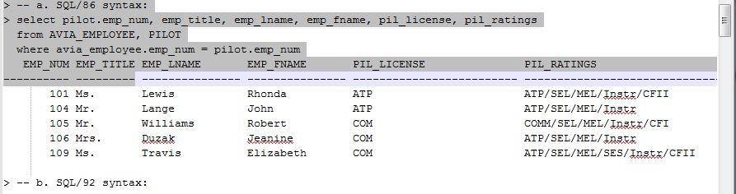

**b. SQL/92 syntax:**

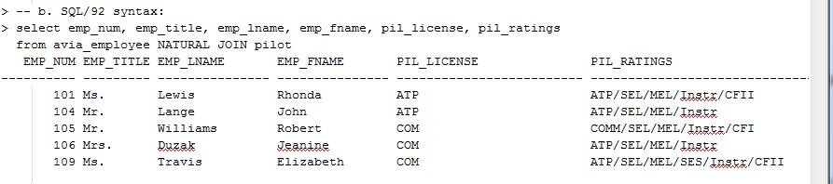

1. Display the information requested in question 1, but also include all aviation employees even if they aren’t pilots. (4 pts)  
     
   **a. SQL/86 syntax:**

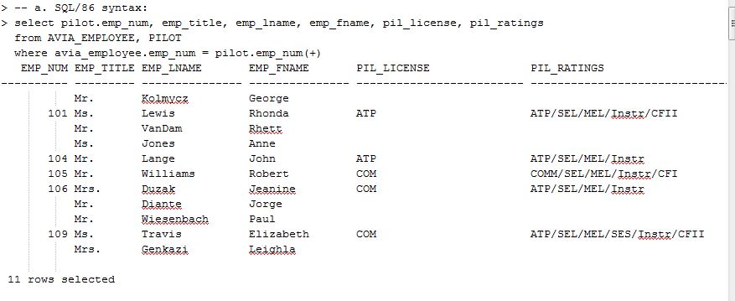

**b. SQL/92 syntax:**  
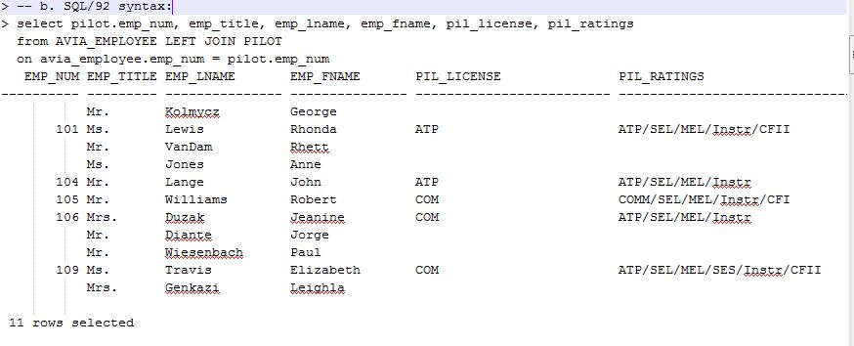

1. Display charter date, customer last name, customer first name, customer balance, charter trip identifier, charter destination, aircraft number, and the aircraft model code for each of our aviation customers who have charted an aircraft. Limit the results to only customers with a balance greater than zero. Sort the output by charter date and customer name (last, first). (5 pts)  
     
   **a. SQL/86 syntax:  
   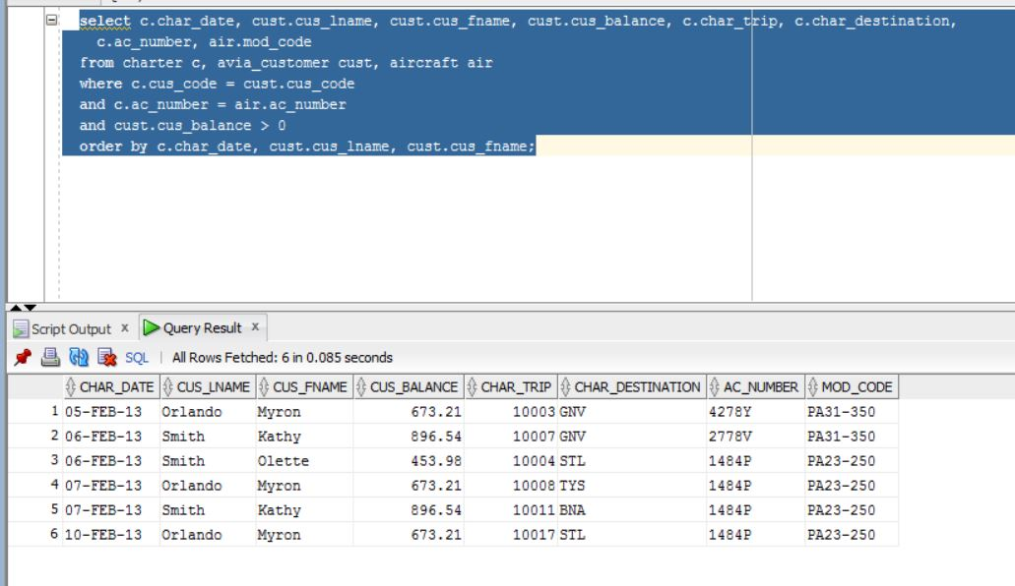  
   b. SQL/92 syntax:**

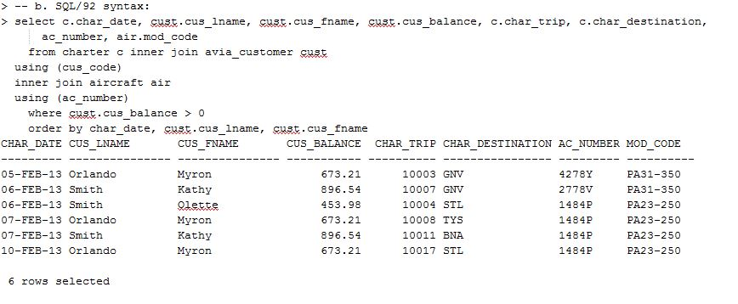  
  
4. Display the aircraft number, model code, model manufacturer, aircraft TTAF, TTEL, and TTER, charter trip identifier, charter date, charter destination and charter distance for all aircraft even if they have NOT yet been chartered. Sort the output by aircraft number. This query must continue to work in the future without modification . (6 pts)  
  
**a. SQL/86 syntax:**

**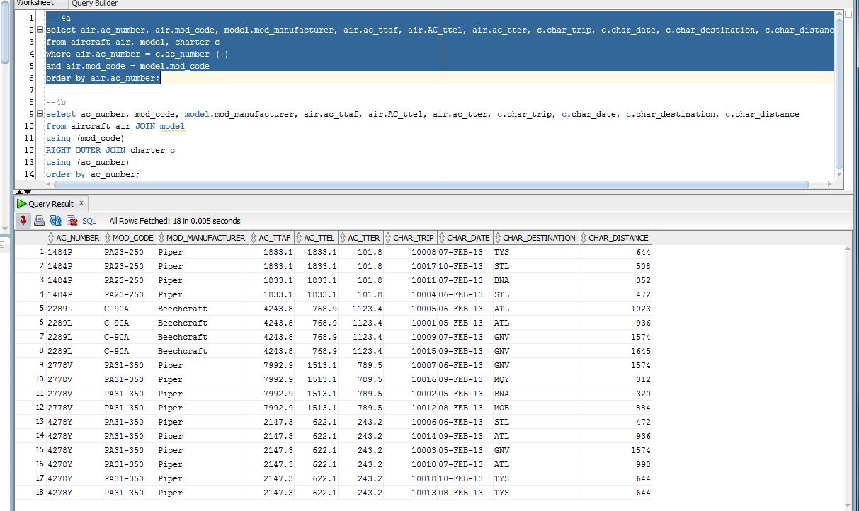  
  
b. SQL/92 syntax:**

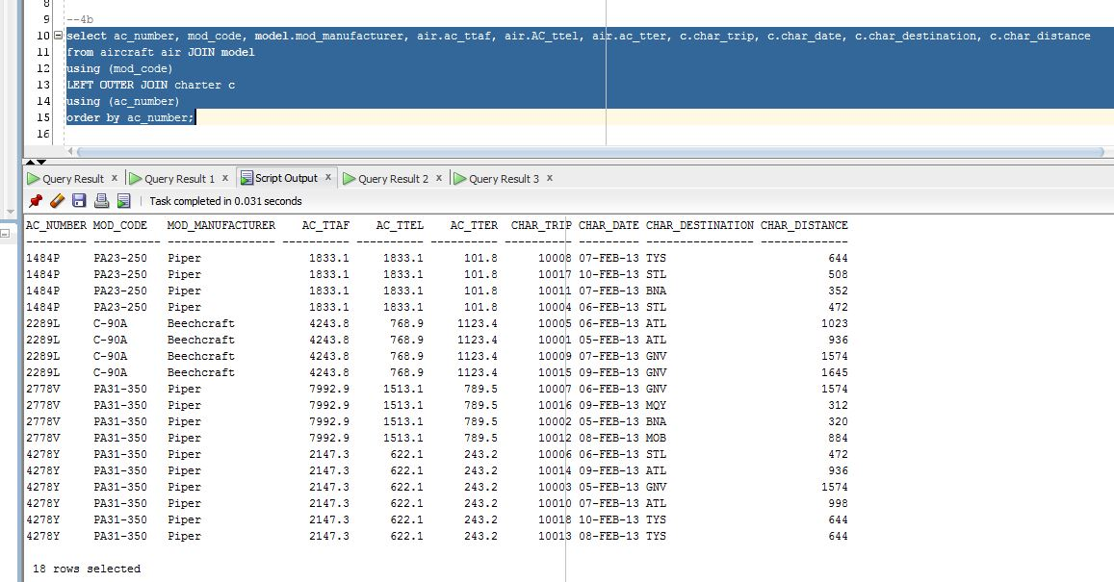

1. Insert the following row into your AIRCRAFT table. Then rerun your queries from parts a & b to be sure they still work as specified. Show proof that they still work.

**INSERT INTO AIRCRAFT (AC_NUMBER, MOD_CODE, AC_TTAF, AC_TTEL, AC_TTER) VALUES ('5289L', 'C-90A', 3950.2, 745.5, 1001.1);  
 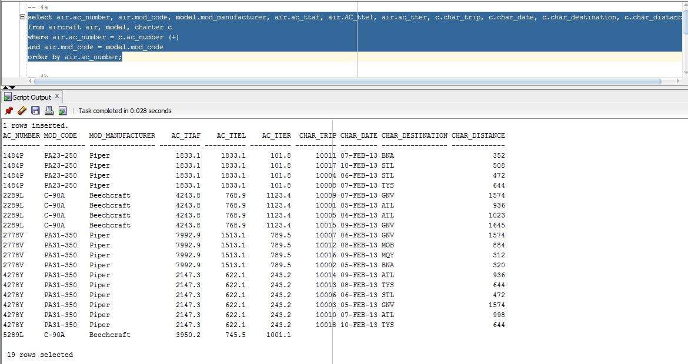**

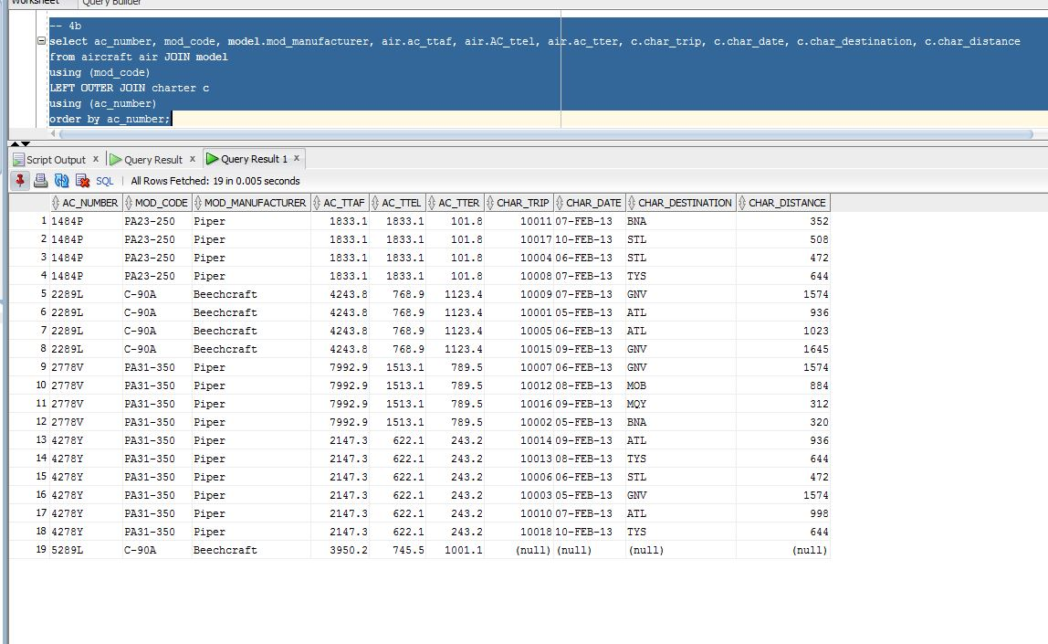

5.Display a list of the crew members for each charter flight that we operated on February 7, 2013. The results should include the charter date, aircraft number, destination, distance, aviation employee name (last, first), and crew job. (5 pts)  
  
**a. SQL/86 syntax:**

**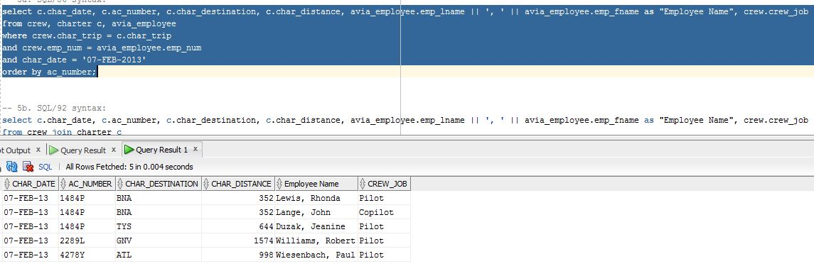  
  
b. SQL/92 syntax:**  
  
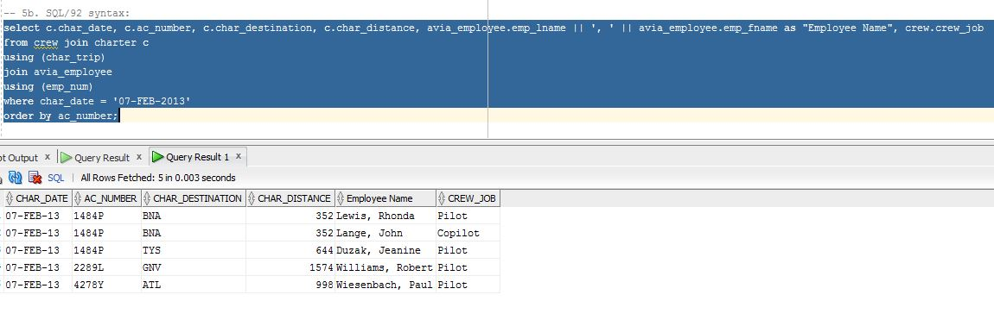

1. Add a new rating – multi-engine sea (MES) to your RATING lookup table using a statement similar to the following. Be sure to “check your work” and if it looks OK remember to COMMIT the change or ROLLBACK to fix errors.

**INSERT INTO RATING VALUES ('MES', 'Multiengine Sea'); -- add new rating**

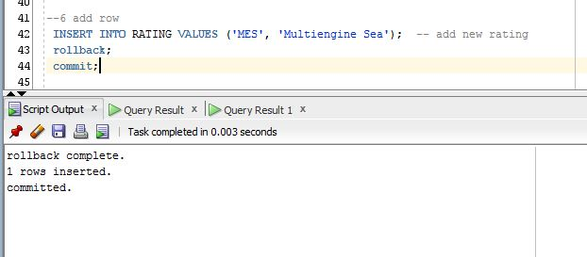

Using the SQL syntax of your choice, write a single query to display a list of **all** employees who work for Cloud Aviation. If the employee is a pilot, the rating codes for the pilot must also be displayed. In addition, all possible ratings must be listed even if no employee has yet achieved that rating. Include the employee name, hire date, age, rating code, rating name, and date the rating was earned (minimum – you may include other fields if you feel that will help the user). (6 pts)  
  
Hint: You will have to include a calculated field (a.k.a. *derived attribute*) to determine the employee’s age.

**\*\*\* All queries should still give accurate results even if the current data in the tables changes. Do not write queries that will only work on the minimal data that currently exists.**

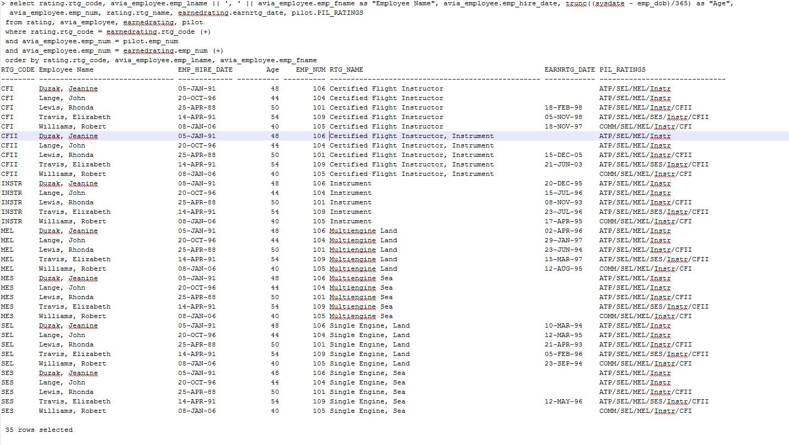

**Paste screen capture of your Entity Relationship Model here:**

