Advanced Software Engineering

Lab 1

ScrumDo Account Creation

Step 1: Enter into ScrumDo site ([www.scrumdo.com](http://www.scrumdo.com)) and start Sign Up for new account creation. Give your details and press “Create Account” button.

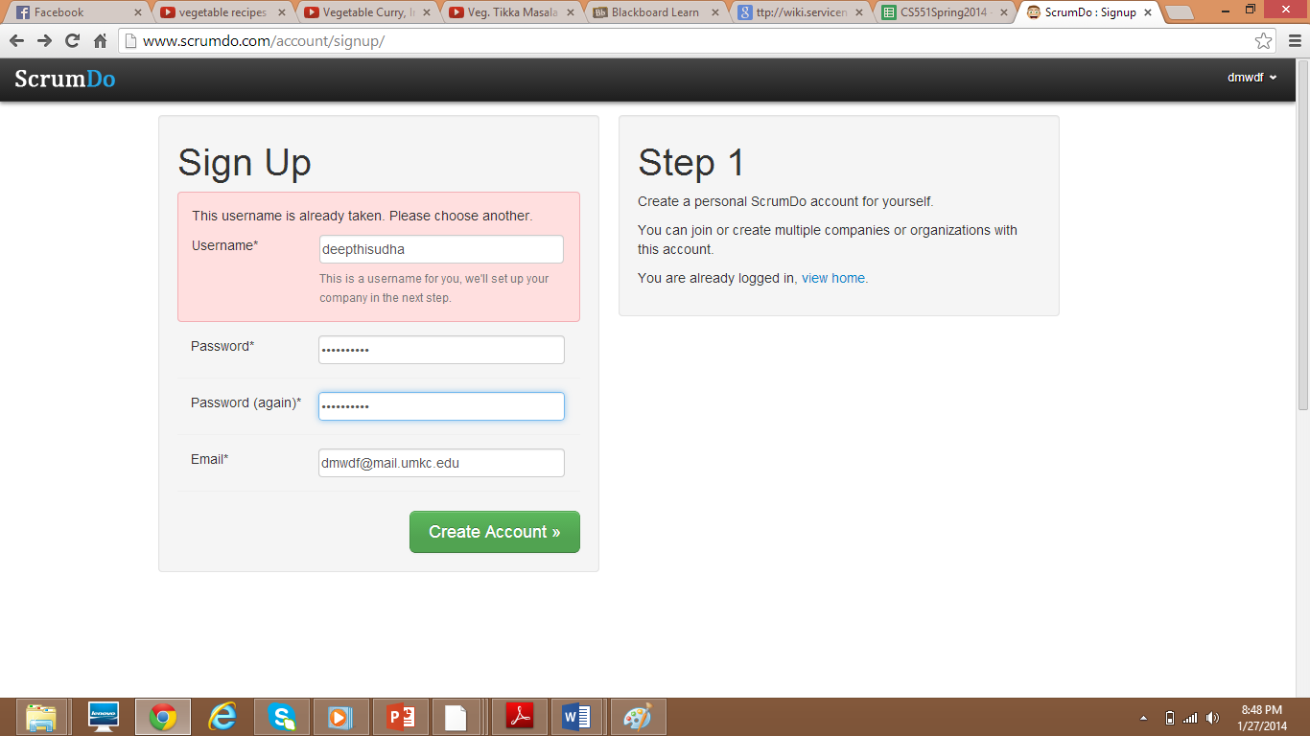

Step 2: Enter your Organization name(mandatory Field) project name and Project Members (optional) then proceed to next step by selecting “next” button in the bottom.

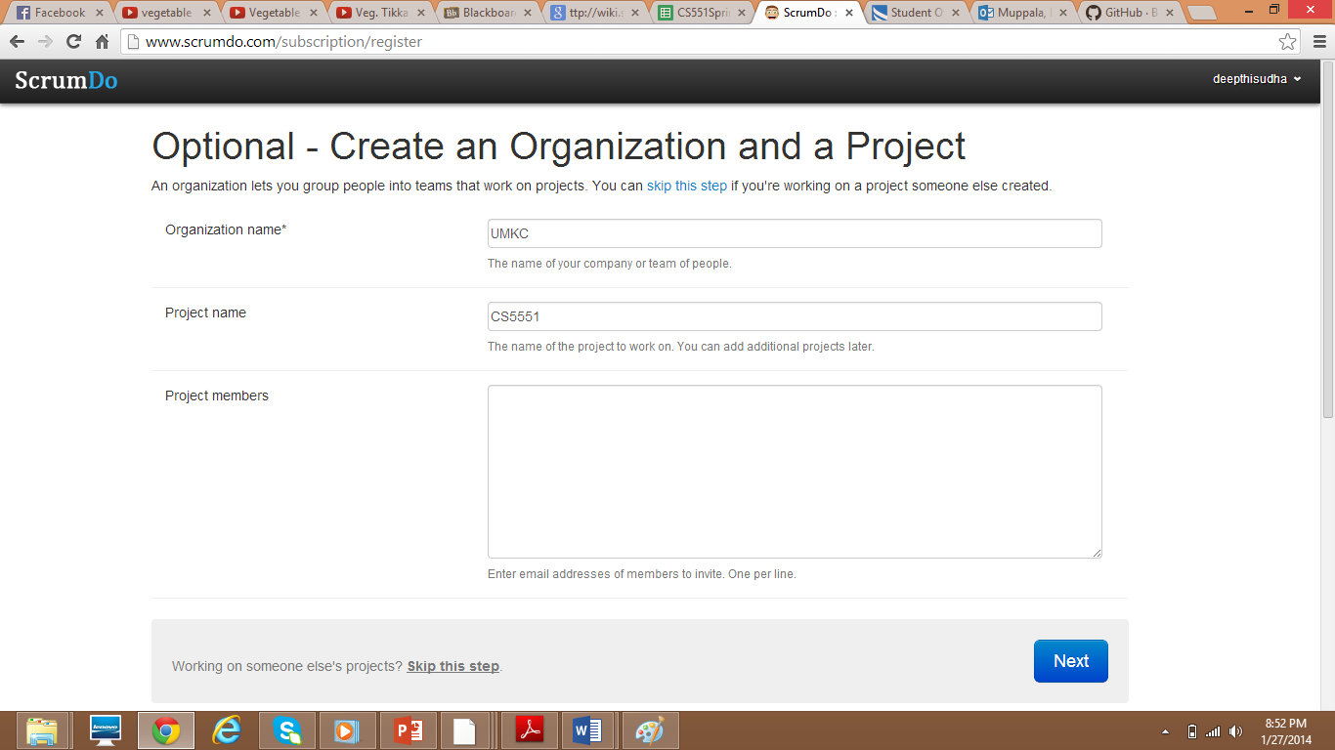

Step 3: Then choose a subscription plan (free plan in general).

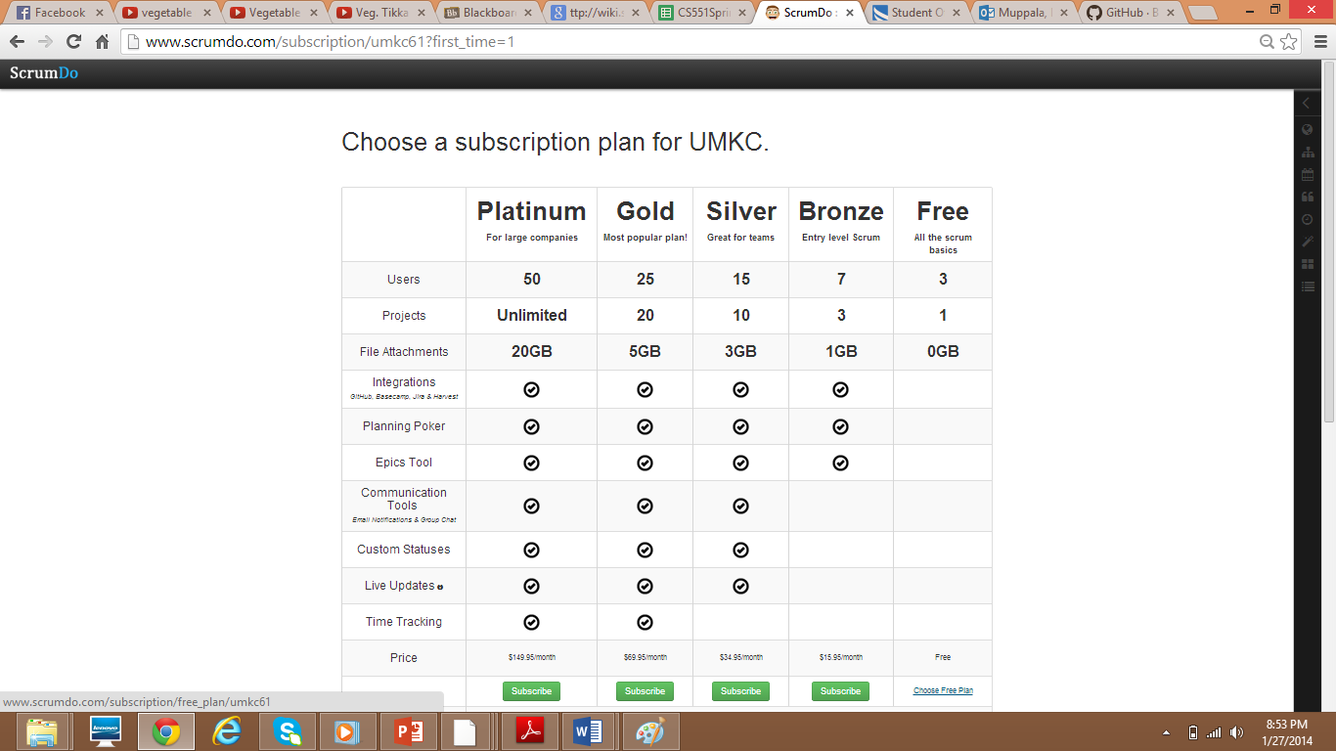

Then your Account is created.

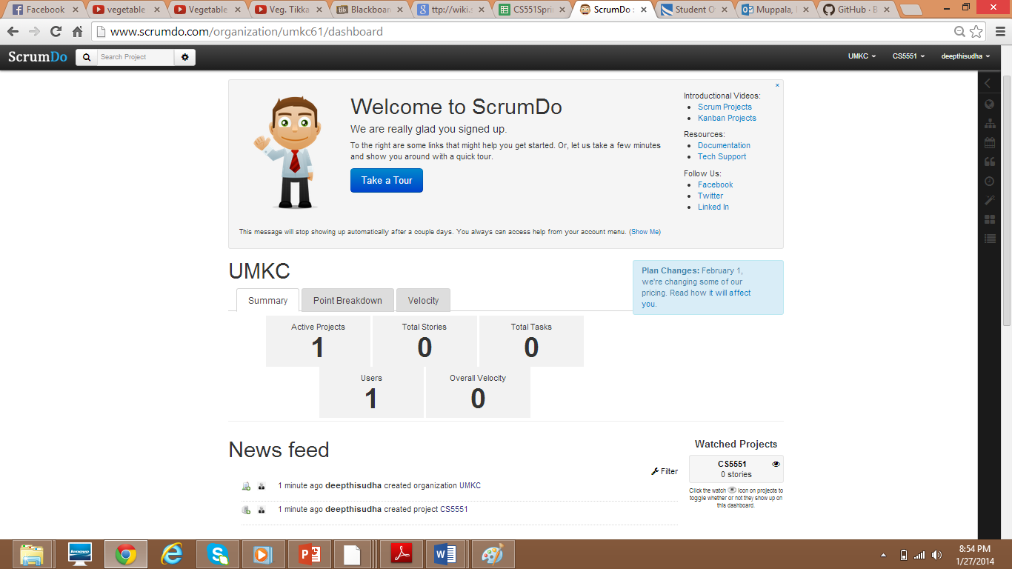

Then Select the project for adding Iterations and Stories.

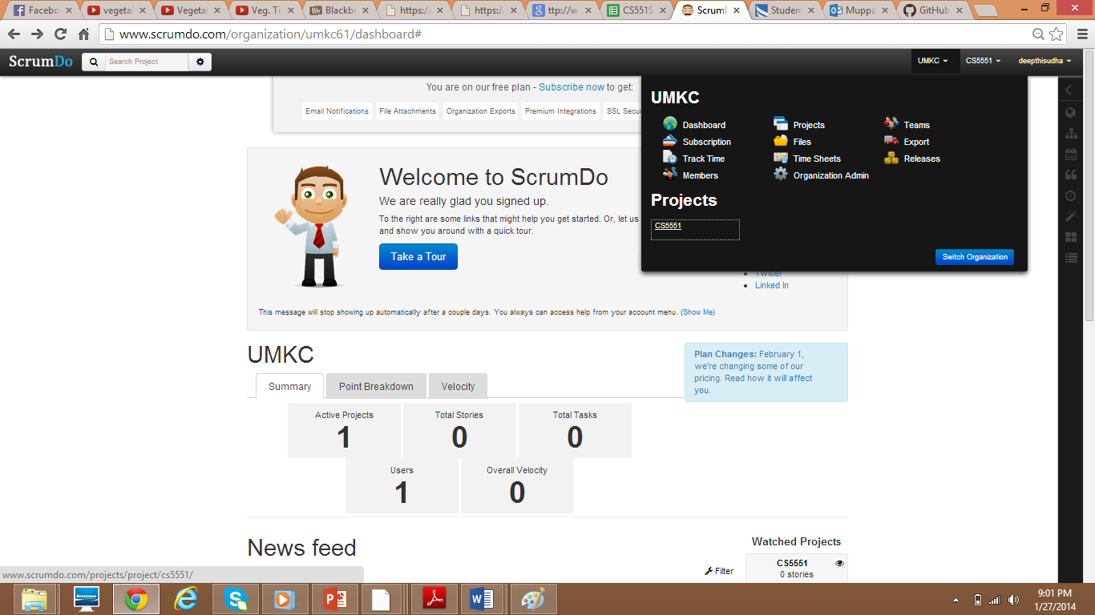

Creating New Iteration: Iteration1.

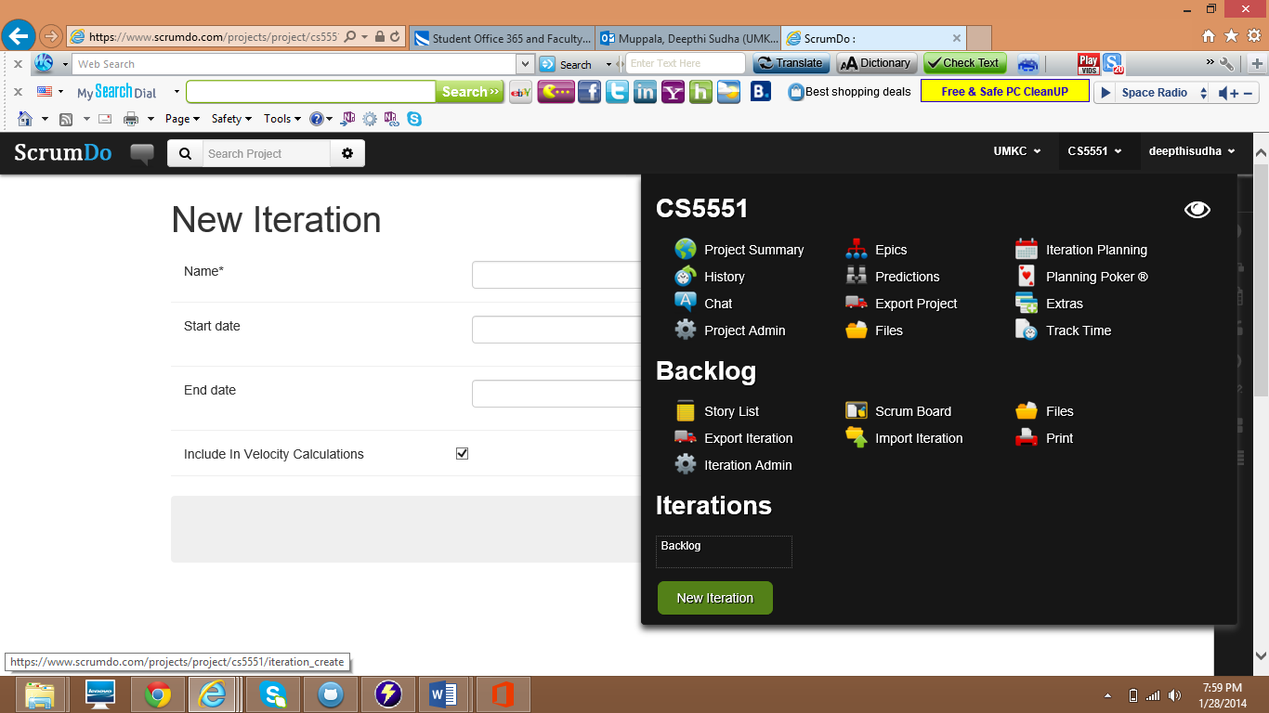

Then Select Add Iteration.

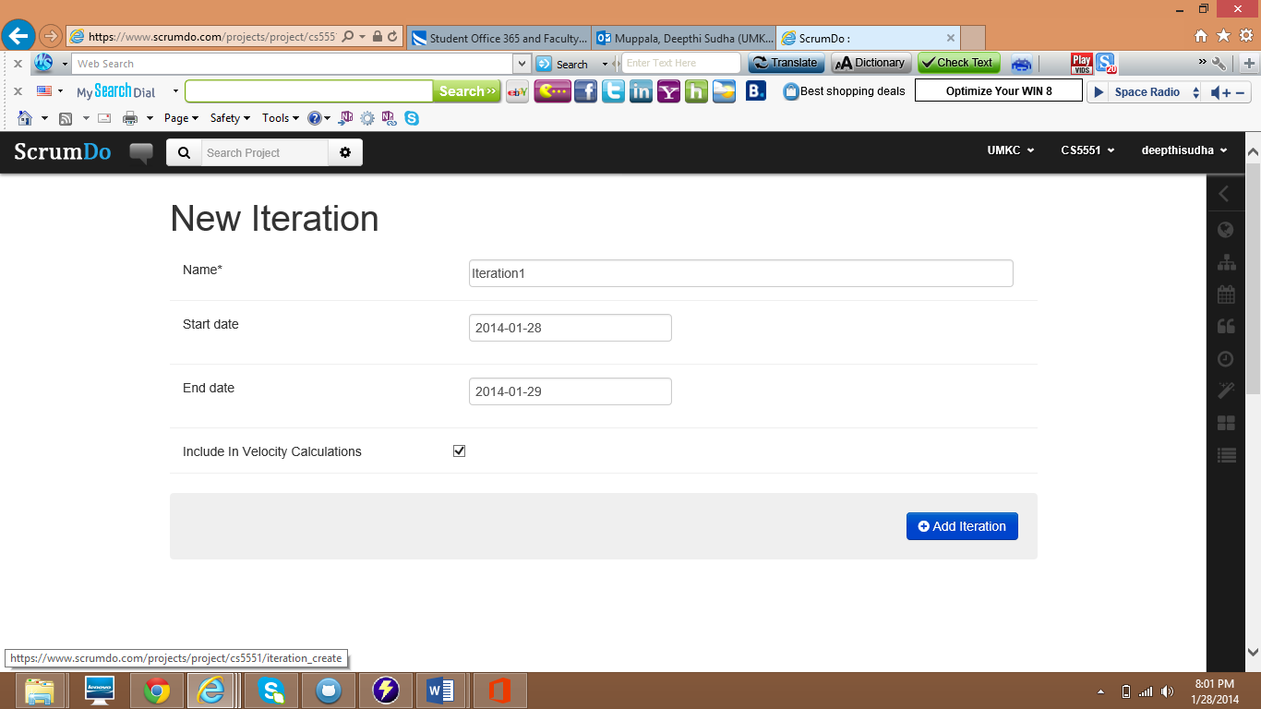

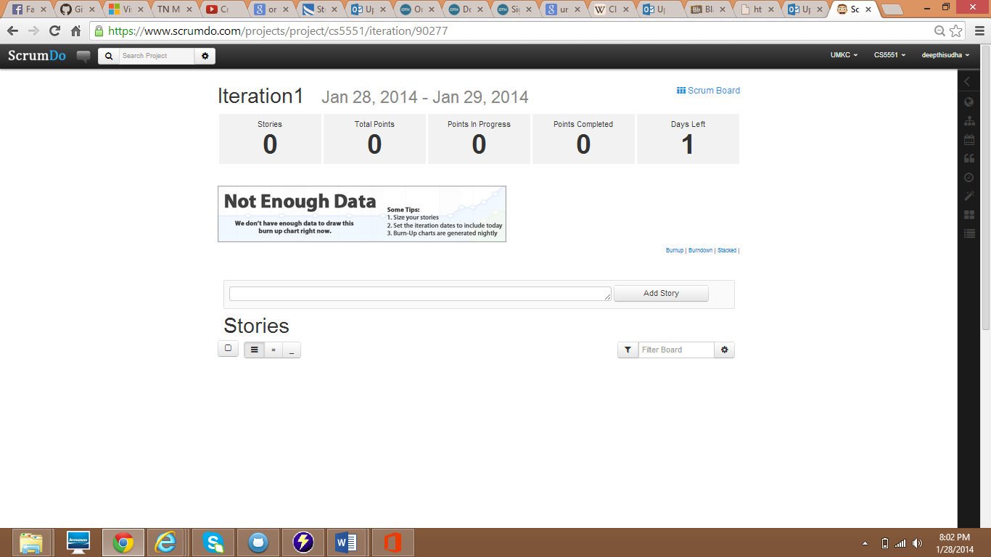

Adding Story

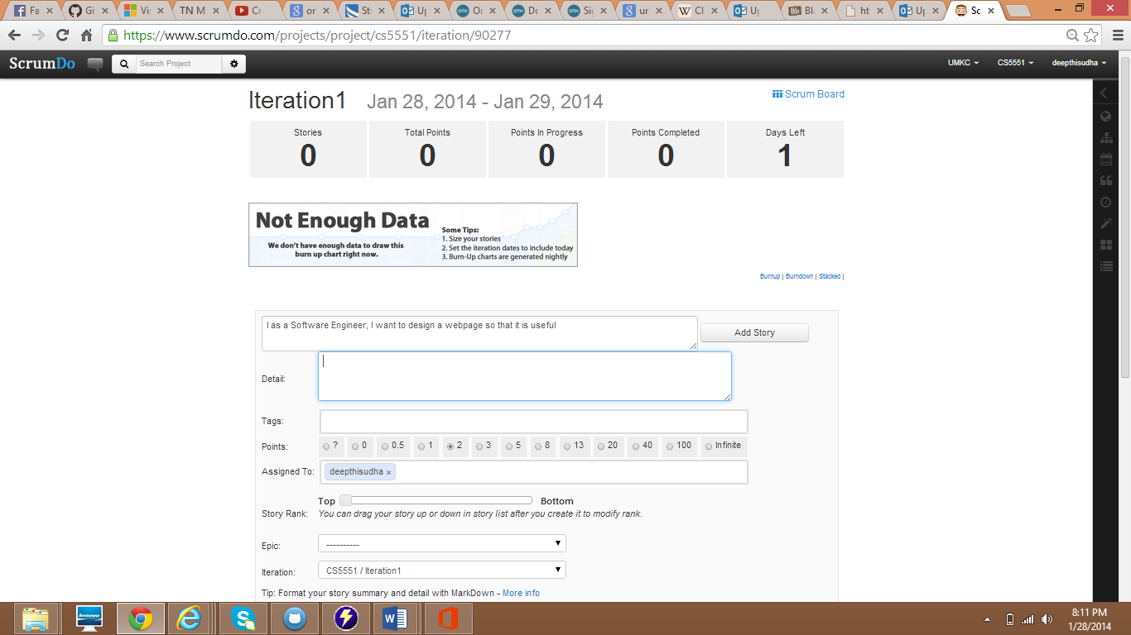

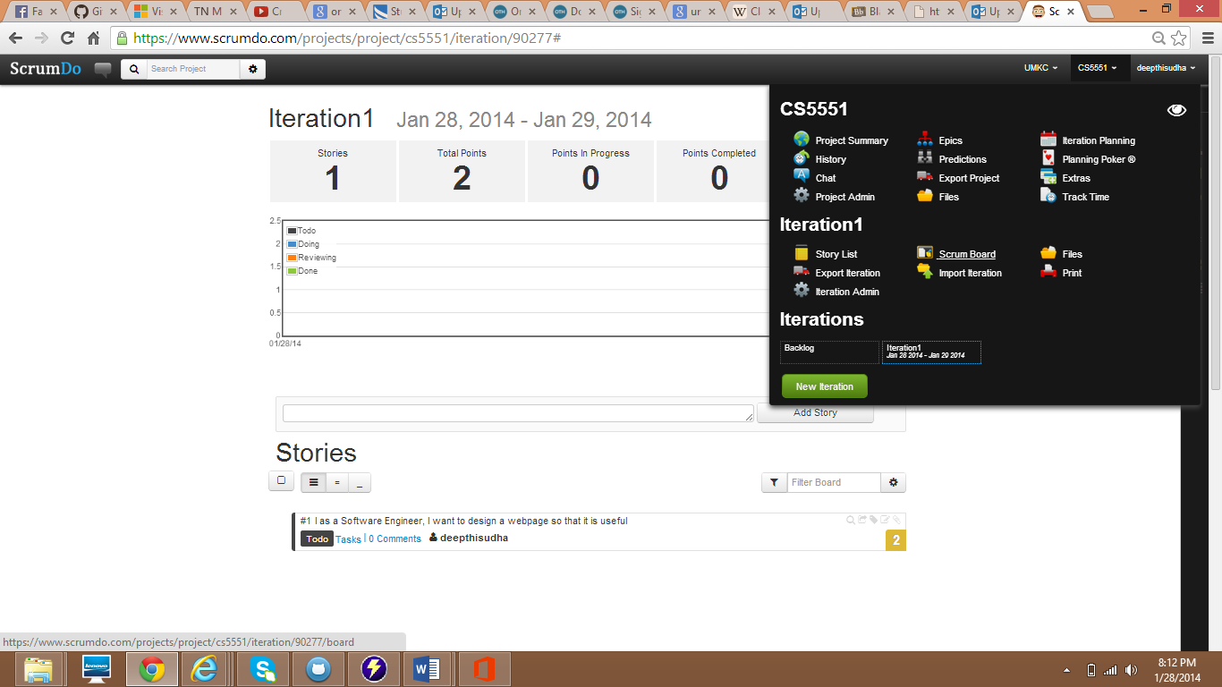

Iteration1 in Scrum Board

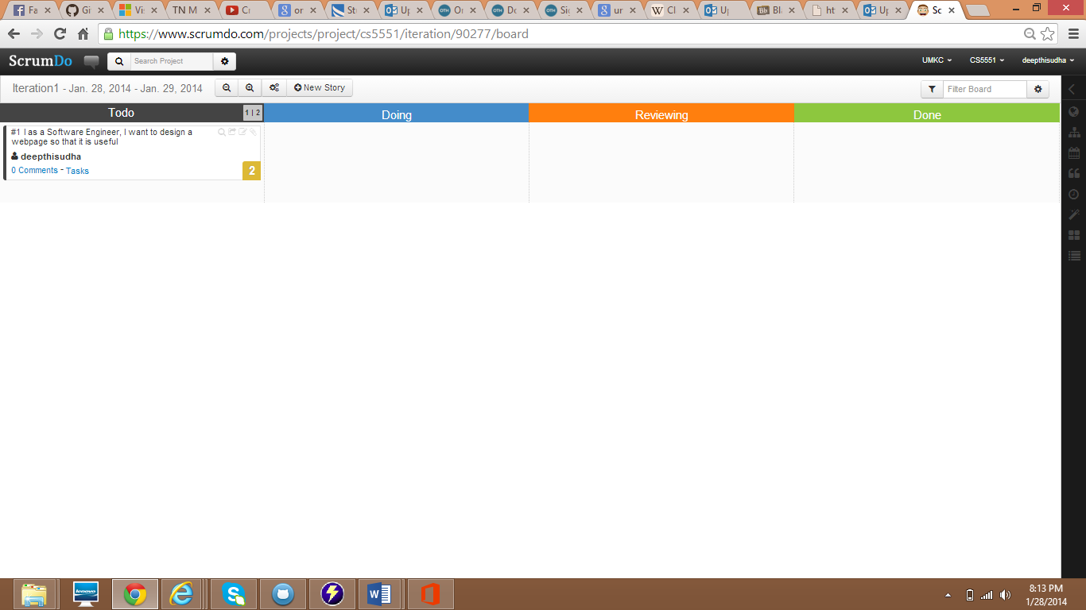

Iteration2 Creation:

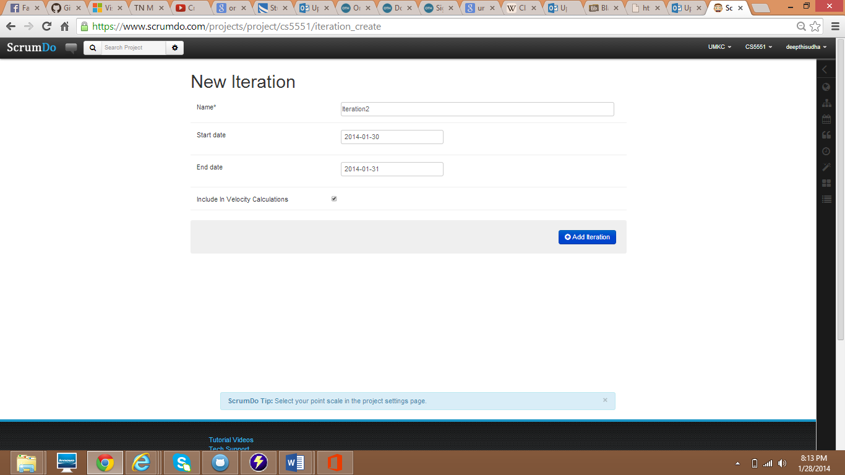

Adding Story to Iteration2:

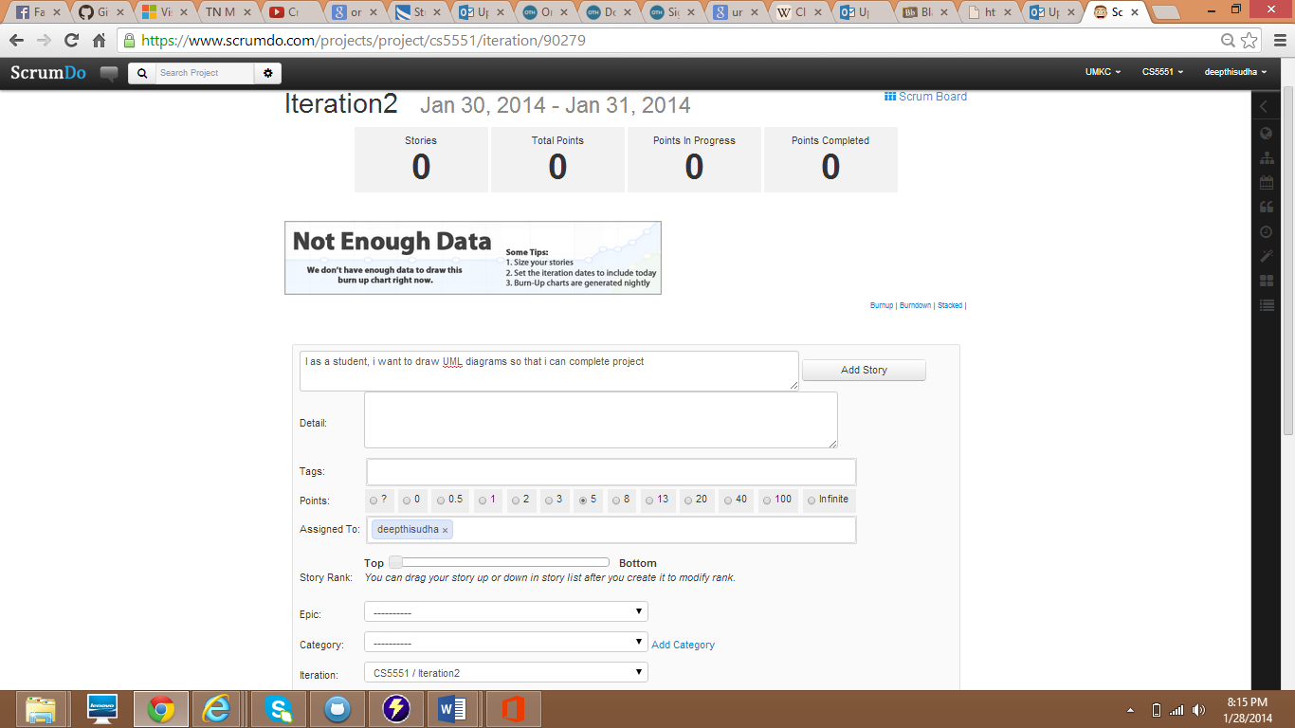

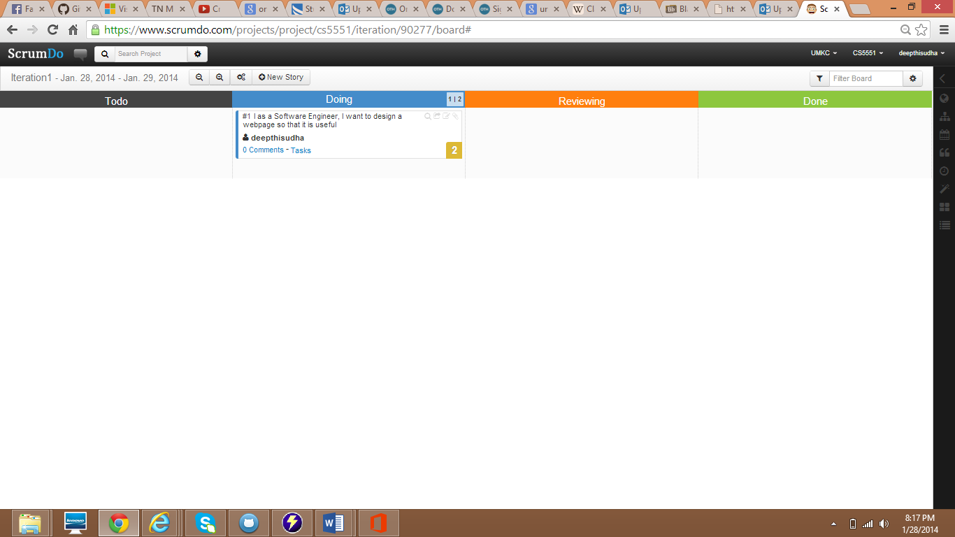

Iteration2 in Scrum board:

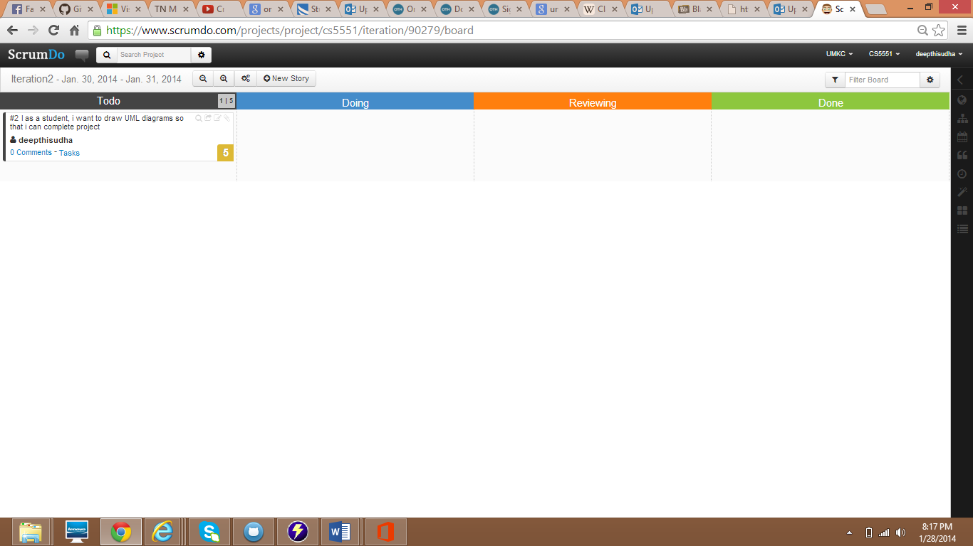

Adding Epic

Choose Epics from the top right corner.

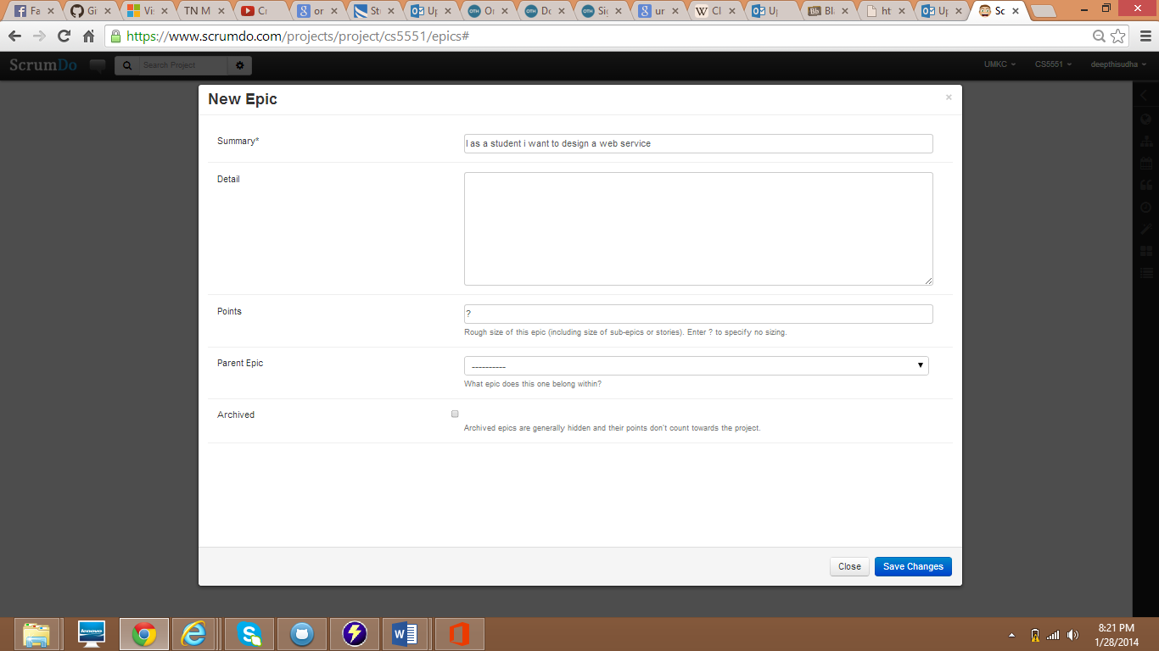

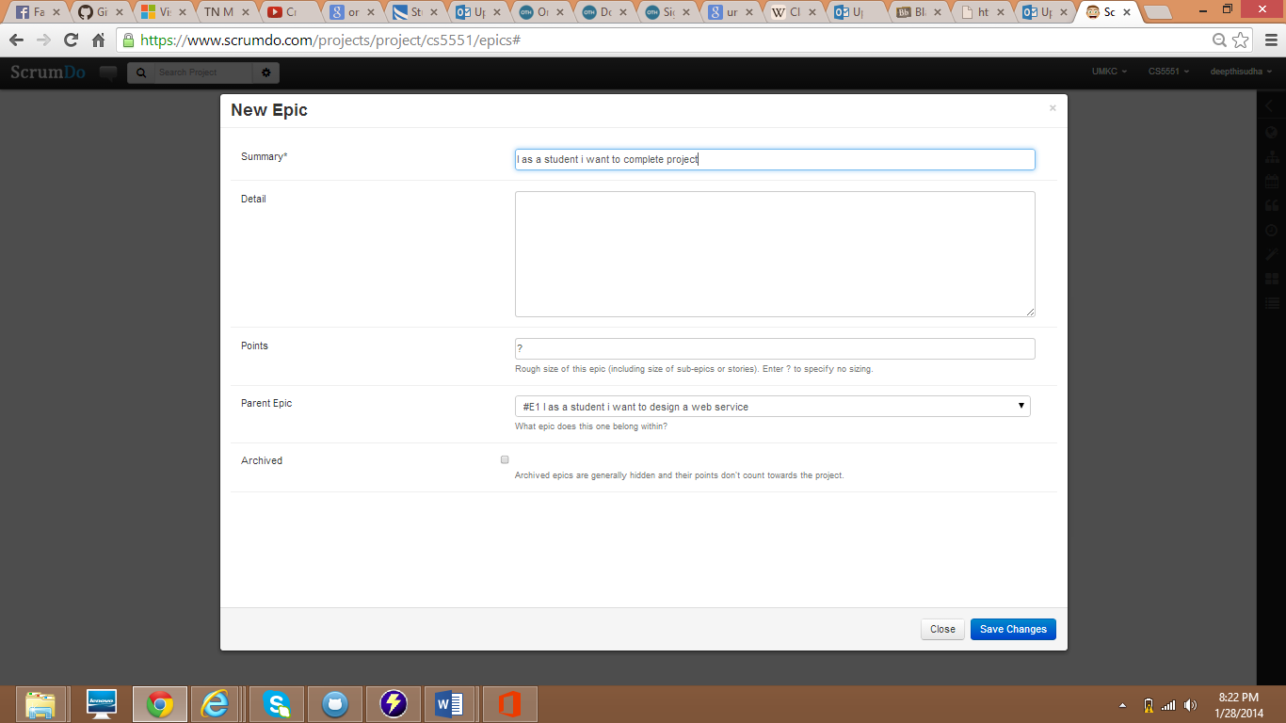

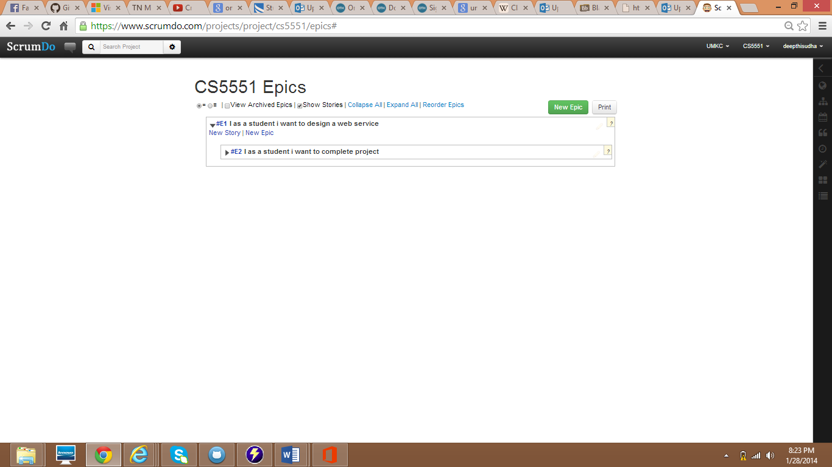

Github

Step 1 : Go to GitHub site ([www.github.com](http://www.github.com)) and give the details and create Account.

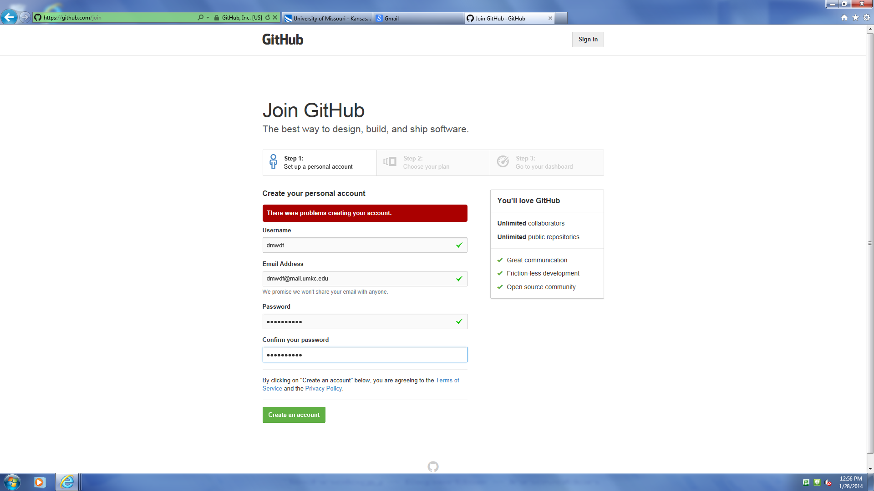

Choose the Subscription

