Advanced Software Engineering

Lab – 2

Step 1: Open jsfiddle.net and open and signup for jsfiddle then choose jQuery versions which you want to use.

The app that is below is used to get the temperature of any place using zip code of that place.

The input is given in the text box which is present and then submit the zip code using the submit button. Then the present temperature at that place is displayed with the weather.

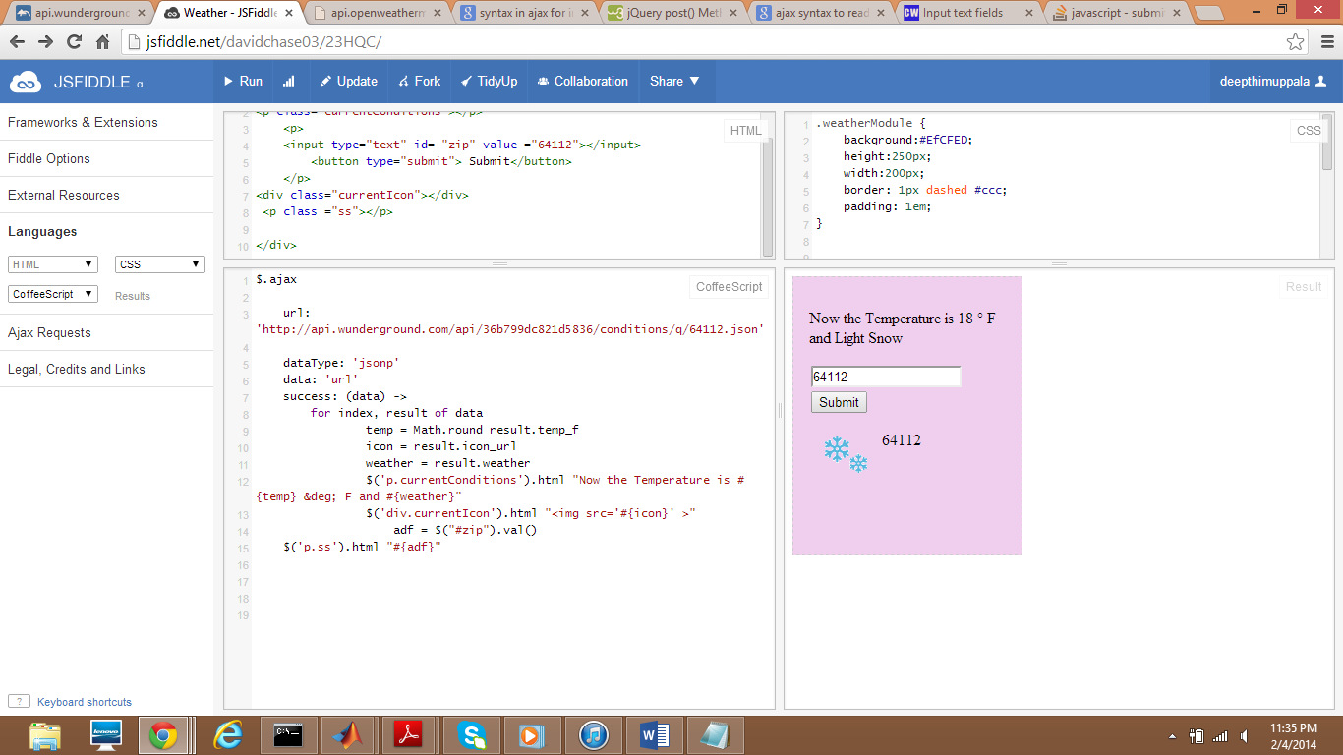

Step 2:change the zip code in the text box then the weather at that place is displayed.

