**Advanced Software Engineering**

**Lab 3 Report**

Step 1: We can get weather conditions using get weather button.

1. 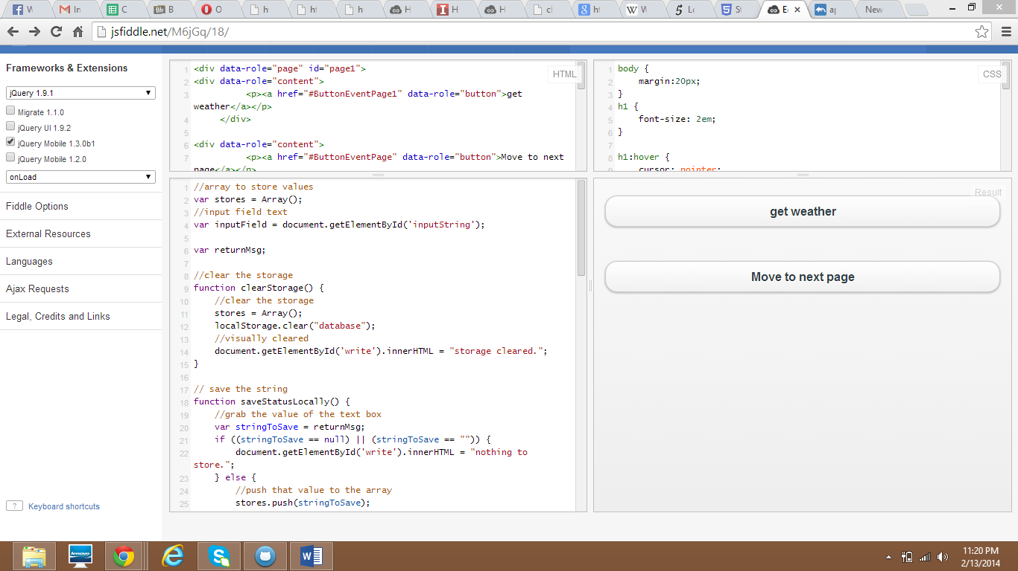

Step 2:

Weather condition is retrieved and we can navigate to previous page using the home that is on the top left.

1. 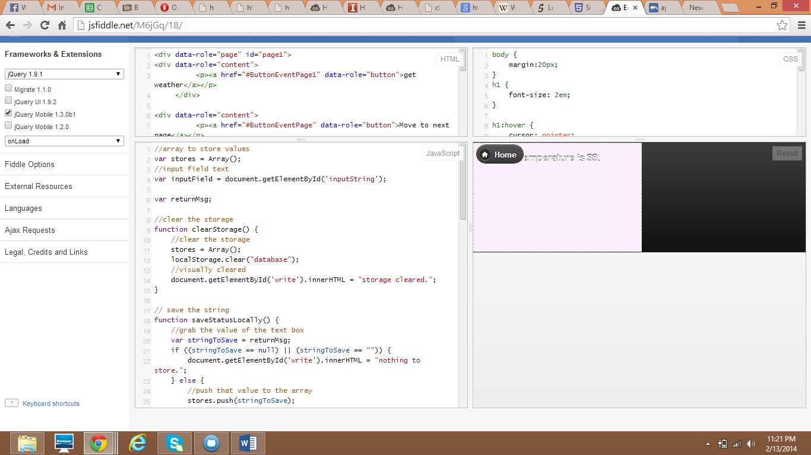

Step 3: choosing the local storage options.

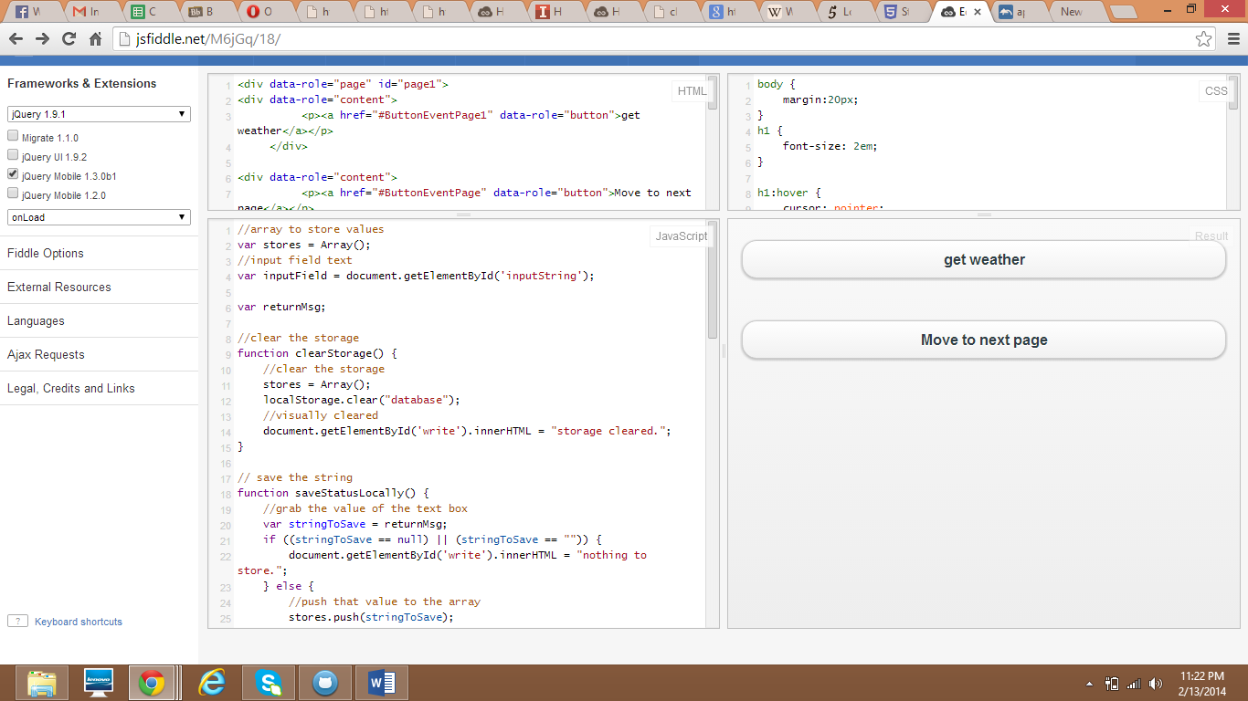

Then navigated page is displayed with some options.

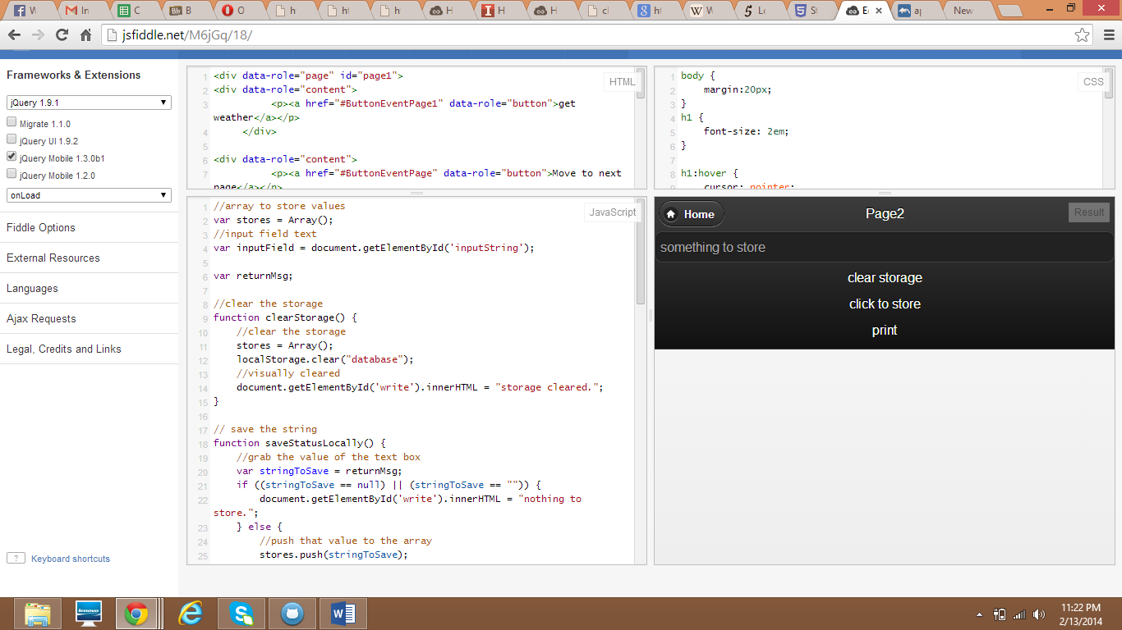

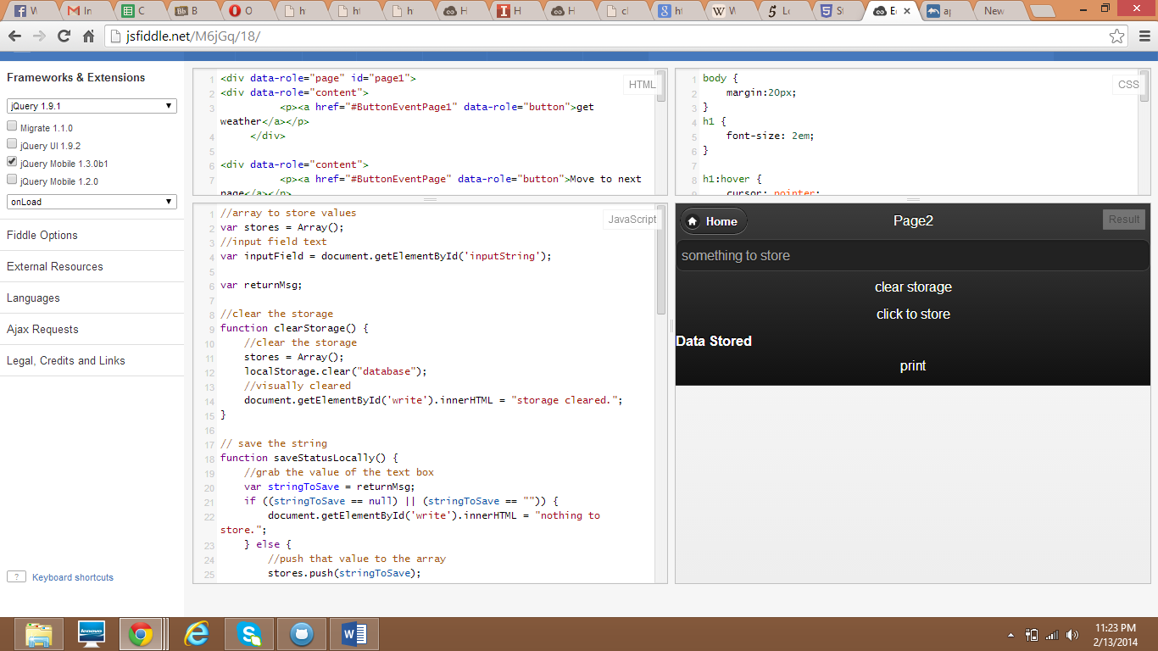

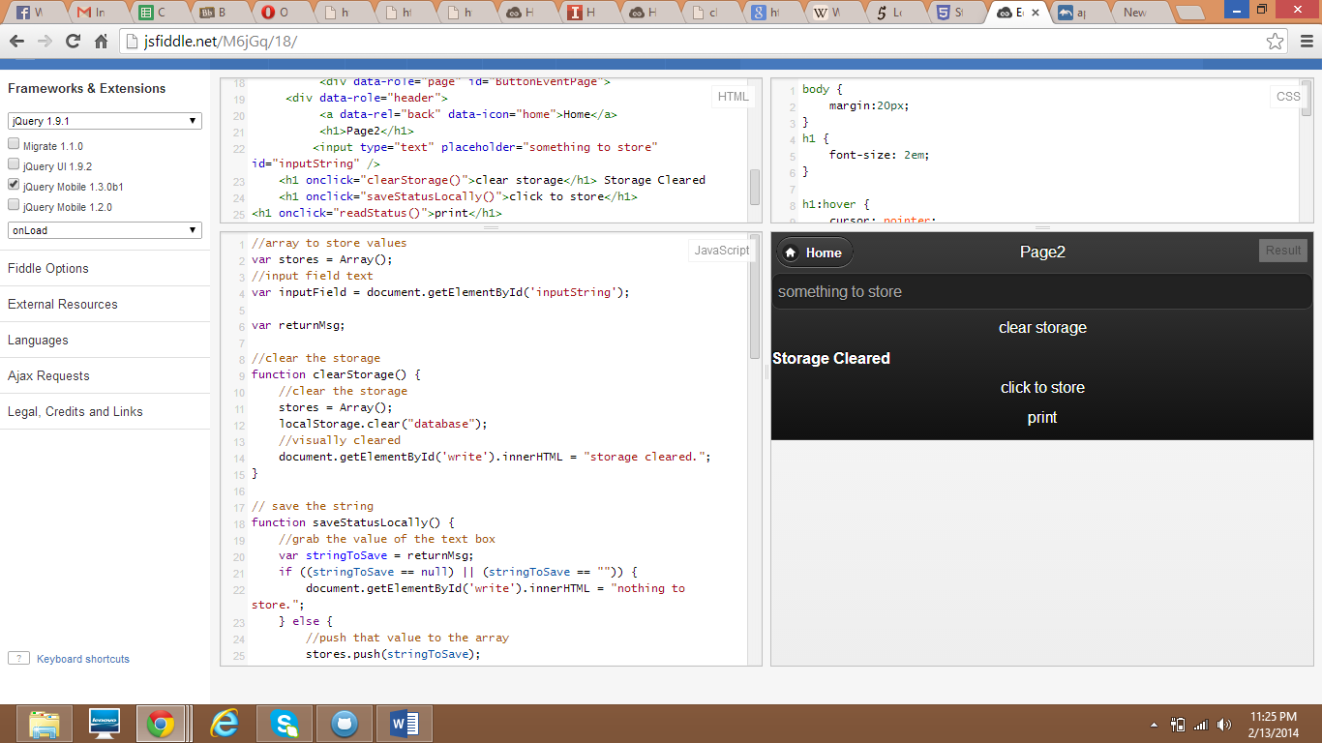

ii) Mashup application that uses weather services and web services such as images and twitter.

