**Dmytro Selikhov**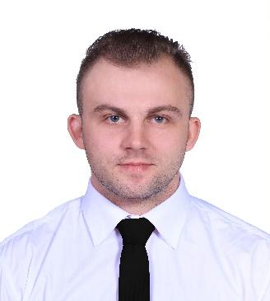

**Front-end Developer**

dmytro.selikhov@gmail.com

+38 050 66 98 758

Severodonetsk

**Key skills:** HTML5, CSS3, SASS, SCSS, GitHub, JavaScript, BEM.

**Tools:** Adobe Photoshop, Adobe Illustrator, Figma, VS Code, SublimeText, Gulp, Git Bash

**Social:**

<https://www.linkedin.com/in/dmytro-selikhov/>

<https://www.facebook.com/selikhov.dmytro/>

**Key skills:** HTML5, CSS3, SASS, SCSS, GitHub, JavaScript, BEM.

**Tools:** Adobe Photoshop, Adobe Illustrator, Figma, VS Code, SublimeText, Gulp, Git Bash

1. **Food delivery service “Ikura.ua”** : 06.2020 - 10.2021

**Responsibilities:** I was engaged in the administration of the website ([ikura.ua](https://ikura.ua/)). Filling the content of the site, searching for errors and bugs. Improving the usability of the site. Setting up network equipment, maintenance of video surveillance systems.

Training staff in the use Customer Relationship Management, search for bugs and completion functionality using technologies such as html, heart rate, javascript.

1. **Princess Cruises** : 02.2017 - 03.2020

**Responsibilities:** Organization of cooking for a large number of guests. Working in stressful situations in an international team. Following technological charts and recipes.

Improving communication and language skills. Improving the quality and speed of service.

2008-2012. Volodymyr Dahl East Ukrainian National University,  
“Electronic equipment specialist”

Certificates of specialized courses are here: <https://drive.google.com/drive/folders/1u2dWDuWbyDuXu8Gd5bu5fFwXo9FJlf9_?usp=sharing>

I know how to concentrate on the tasks at hand, to prioritize, to look for optimal solutions.

I learn quickly, take criticism objectively and appreciate it. With me on the team, you will get a person who appreciates the result.

I have 3 years of experience in an international team.