|  |
| --- |
| **CS4313** |
| Deliverable 1 |
|  |
| All Database tables |
| List of major processes |
| Flow charts |
| Page Mockups |
|  |
| **David O Neill 0813001** |
| **James McHugh 0052833** |
| **Keiran Duggan 0866504** |
|  |
| **5/3/2010** |
|  |

Table of Contents

Database 4

Tables 4

Auction items 4

Auction pictures 6

Auction categories 6

Auction sub categories 7

Item searching 7

Messages 8

Auction Bids 9

Item watching 10

Auction feedback 11

Addresses 12

OU users 13

OU groups 14

Countries 14

Locale 14

Referential Integrity Constraints 15

SQL 15

Overview 16

Relations Overview 16

Major Processes 17

User 17

Registration 17

Update Registration 17

Login 17

Logout 17

Forgot Password 17

Submit Auction Item 17

Update Auction Item 17

Bidding 17

Searching 17

Feedback 17

Watch Item 17

Administrator 17

Delete Users 17

Edit Users 17

Delete Users 17

Ban Users 17

Add Auction Categories 17

Update Auction Categories 17

Deleting Categories 17

Update Auction Items 17

Remove Auction Items 17

Flow Graphs 18

User 18

Registration 18

Update Registration 19

Login 20

Logout 21

Forgot Password 22

Submit Auction Item 23

Update Auction Item 24

Bidding 25

Searching 26

Feedback 27

Watch Item 28

Administrator 28

Delete Users 28

Edit Users 29

Delete Users 30

Ban Users 31

Add Auction Categories 32

Update Auction Categories 33

Deleting Categories 34

Update Auction Items 35

Remove Auction Items 36

Page Mockup 37

Main page 37

Registration 38

Browsing Auctions 39

# Database

## Tables

### Auction items

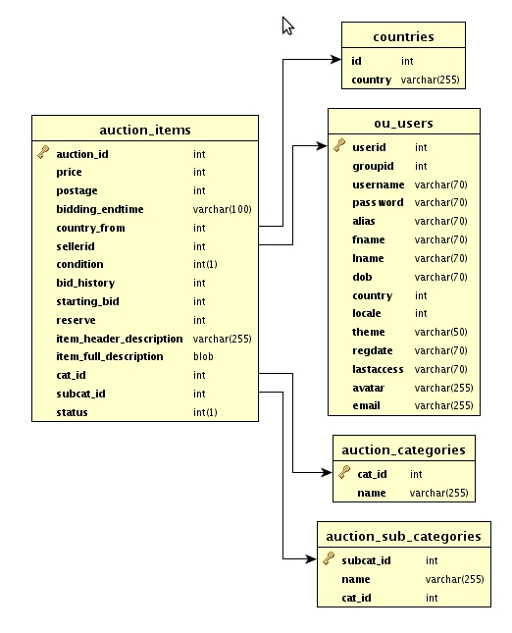

#### SQL

CREATE TABLE `auction_items` (

`auction_id` int(11) NOT NULL AUTO_INCREMENT,

`price` int(11) NOT NULL,

`postage` int(11) NOT NULL,

`bidding_endtime` varchar(100) NOT NULL,

`country_from` int(11) NOT NULL,

`sellerid` int(11) NOT NULL,

`condition` int(1) NOT NULL,

`bid_history` int(11) NOT NULL,

`starting_bid` int(11) NOT NULL,

`reserve` int(11) NOT NULL,

`item_header_description` varchar(255) NOT NULL,

`item_full_description` blob NOT NULL,

`cat_id` int(11) NOT NULL,

`subcat_id` int(11) NOT NULL,

`status` int(1) NOT NULL,

PRIMARY KEY (`auction_id`),

KEY `country_from` (`country_from`),

KEY `sellerid` (`sellerid`),

KEY `cat_id` (`cat_id`),

KEY `subcat_id` (`subcat_id`)

) ENGINE=InnoDB DEFAULT CHARSET=latin1 AUTO_INCREMENT=1 ;

### Auction pictures

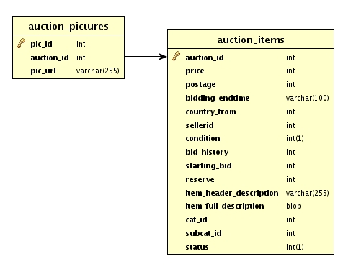

#### SQL

CREATE TABLE `auction_pictures` (

`pic_id` int(11) NOT NULL AUTO_INCREMENT,

`auction_id` int(11) NOT NULL,

`pic_url` varchar(255) NOT NULL,

PRIMARY KEY (`pic_id`),

KEY `auction_id` (`auction_id`)

) ENGINE=InnoDB DEFAULT CHARSET=latin1 AUTO_INCREMENT=1 ;

### Auction categories

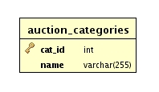

#### SQL

CREATE TABLE `auction_categories` (

`cat_id` int(11) NOT NULL AUTO_INCREMENT,

`name` varchar(255) NOT NULL,

PRIMARY KEY (`cat_id`)

) ENGINE=InnoDB DEFAULT CHARSET=latin1 AUTO_INCREMENT=1 ;

### Auction sub categories

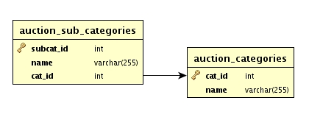

#### SQL

CREATE TABLE `auction_sub_categories` (

`subcat_id` int(11) NOT NULL AUTO_INCREMENT,

`name` varchar(255) NOT NULL,

`cat_id` int(11) NOT NULL,

PRIMARY KEY (`subcat_id`),

KEY `cat_id` (`cat_id`)

) ENGINE=InnoDB DEFAULT CHARSET=latin1 AUTO_INCREMENT=1 ;

### Item searching

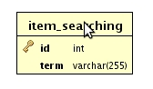

#### SQL

CREATE TABLE `item_searching` (

`id` int(11) NOT NULL AUTO_INCREMENT,

`term` varchar(255) NOT NULL,

PRIMARY KEY (`id`)

) ENGINE=InnoDB DEFAULT CHARSET=latin1 AUTO_INCREMENT=1 ;

### Messages

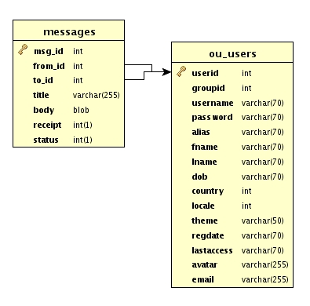

#### SQL

CREATE TABLE `messages` (

`msg_id` int(11) NOT NULL AUTO_INCREMENT,

`from_id` int(11) NOT NULL,

`to_id` int(11) NOT NULL,

`title` varchar(255) NOT NULL,

`body` blob NOT NULL,

`receipt` int(1) NOT NULL,

`status` int(1) NOT NULL,

PRIMARY KEY (`msg_id`),

KEY `from_id` (`from_id`),

KEY `to_id` (`to_id`)

) ENGINE=InnoDB DEFAULT CHARSET=latin1 AUTO_INCREMENT=1 ;

### Auction Bids

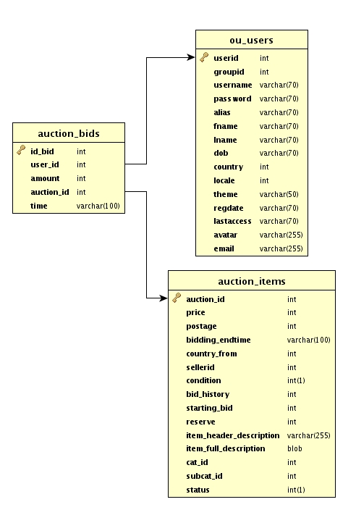

#### SQL

CREATE TABLE `auction_bids` (

`id_bid` int(11) NOT NULL AUTO_INCREMENT,

`user_id` int(11) NOT NULL,

`amount` int(11) NOT NULL,

`auction_id` int(11) NOT NULL,

`time` varchar(100) NOT NULL,

PRIMARY KEY (`id_bid`),

KEY `auction_id` (`auction_id`),

KEY `user_id` (`user_id`)

) ENGINE=InnoDB DEFAULT CHARSET=latin1 AUTO_INCREMENT=1 ;

### Item watching

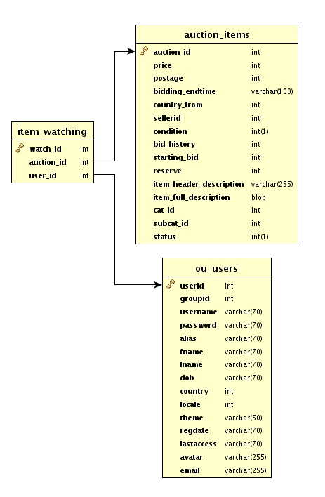

#### SQL

CREATE TABLE `item_watching` (

`watch_id` int(11) NOT NULL AUTO_INCREMENT,

`auction_id` int(11) NOT NULL,

`user_id` int(11) NOT NULL,

PRIMARY KEY (`watch_id`),

KEY `auction_id` (`auction_id`),

KEY `user_id` (`user_id`)

) ENGINE=InnoDB DEFAULT CHARSET=latin1 AUTO_INCREMENT=1 ;

### Auction feedback

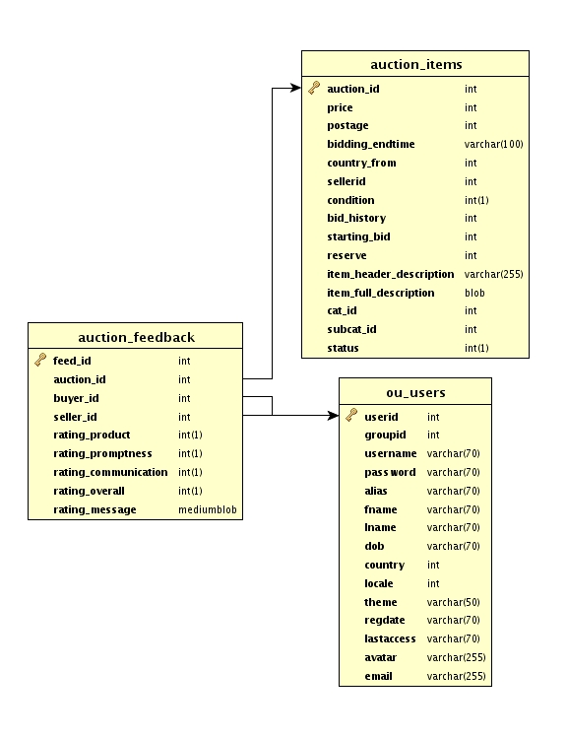

#### SQL

CREATE TABLE `auction_feedback` (

`feed_id` int(11) NOT NULL AUTO_INCREMENT,

`auction_id` int(11) NOT NULL,

`buyer_id` int(11) NOT NULL,

`seller_id` int(11) NOT NULL,

`rating_product` int(1) NOT NULL,

`rating_promptness` int(1) NOT NULL,

`rating_communication` int(1) NOT NULL,

`rating_overall` int(1) NOT NULL,

`rating_message` mediumblob NOT NULL,

PRIMARY KEY (`feed_id`),

KEY `auction_id` (`auction_id`),

KEY `buyer_id` (`buyer_id`),

KEY `seller_id` (`seller_id`)

) ENGINE=InnoDB DEFAULT CHARSET=latin1 AUTO_INCREMENT=1 ;

### Addresses

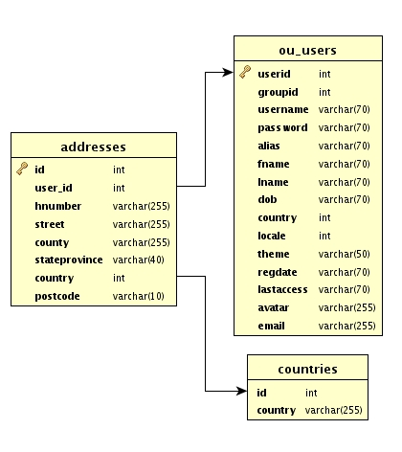

#### SQL

CREATE TABLE `addresses` (

`id` int(11) NOT NULL AUTO_INCREMENT,

`user_id` int(11) NOT NULL,

`hnumber` varchar(255) NOT NULL,

`street` varchar(255) NOT NULL,

`county` varchar(255) NOT NULL,

`stateprovince` varchar(40) NOT NULL,

`country` int(11) NOT NULL,

`postcode` varchar(10) NOT NULL,

PRIMARY KEY (`id`),

KEY `user_id` (`user_id`),

KEY `country` (`country`)

) ENGINE=InnoDB DEFAULT CHARSET=latin1 AUTO_INCREMENT=1 ;

### OU users

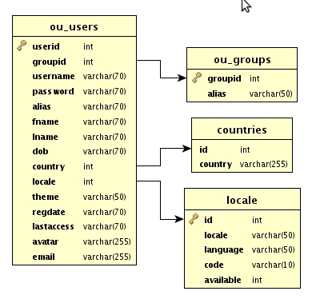

#### SQL

CREATE TABLE `ou_users` (

`userid` int(11) NOT NULL AUTO_INCREMENT,

`groupid` int(11) NOT NULL,

`username` varchar(70) NOT NULL,

`password` varchar(70) NOT NULL,

`alias` varchar(70) NOT NULL,

`fname` varchar(70) NOT NULL,

`lname` varchar(70) NOT NULL,

`dob` varchar(70) NOT NULL,

`country` int(11) NOT NULL,

`locale` int(11) NOT NULL,

`theme` varchar(50) NOT NULL,

`regdate` varchar(70) NOT NULL,

`lastaccess` varchar(70) NOT NULL,

`avatar` varchar(255) NOT NULL,

`email` varchar(255) NOT NULL,

PRIMARY KEY (`userid`),

KEY `groupid` (`groupid`),

KEY `country` (`country`),

KEY `locale` (`locale`)

) ENGINE=InnoDB DEFAULT CHARSET=latin1 AUTO_INCREMENT=3 ;

### OU groups

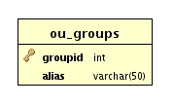

#### SQL

CREATE TABLE `ou_groups` (

`groupid` int(11) NOT NULL AUTO_INCREMENT,

`alias` varchar(50) NOT NULL,

PRIMARY KEY (`groupid`)

) ENGINE=InnoDB DEFAULT CHARSET=latin1 AUTO_INCREMENT=7 ;

### Countries

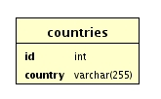

#### SQL

CREATE TABLE `countries` (

`id` int(11) NOT NULL,

`country` varchar(255) NOT NULL,

KEY `id` (`id`)

) ENGINE=InnoDB DEFAULT CHARSET=latin1;

### Locale

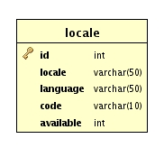

#### SQL

CREATE TABLE `locale` (

`id` int(11) NOT NULL AUTO_INCREMENT,

`locale` varchar(50) NOT NULL,

`language` varchar(50) NOT NULL,

`code` varchar(10) NOT NULL,

`available` int(11) NOT NULL,

PRIMARY KEY (`id`)

) ENGINE=InnoDB DEFAULT CHARSET=latin1 AUTO_INCREMENT=93 ;

## Referential Integrity Constraints

### SQL

ALTER TABLE `addresses`

ADD CONSTRAINT `addresses_ibfk_1` FOREIGN KEY (`user_id`) REFERENCES `ou_users` (`userid`),

ADD CONSTRAINT `addresses_ibfk_2` FOREIGN KEY (`country`) REFERENCES `countries` (`id`);

ALTER TABLE `auction_bids`

ADD CONSTRAINT `auction_bids_ibfk_1` FOREIGN KEY (`user_id`) REFERENCES `ou_users` (`userid`),

ADD CONSTRAINT `auction_bids_ibfk_2` FOREIGN KEY (`auction_id`) REFERENCES `auction_items` (`auction_id`);

ALTER TABLE `auction_feedback`

ADD CONSTRAINT `auction_feedback_ibfk_1` FOREIGN KEY (`auction_id`) REFERENCES `auction_items` (`auction_id`),

ADD CONSTRAINT `auction_feedback_ibfk_2` FOREIGN KEY (`buyer_id`) REFERENCES `ou_users` (`userid`),

ADD CONSTRAINT `auction_feedback_ibfk_3` FOREIGN KEY (`seller_id`) REFERENCES `ou_users` (`userid`);

ALTER TABLE `auction_items`

ADD CONSTRAINT `auction_items_ibfk_1` FOREIGN KEY (`country_from`) REFERENCES `countries` (`id`),

ADD CONSTRAINT `auction_items_ibfk_2` FOREIGN KEY (`sellerid`) REFERENCES `ou_users` (`userid`),

ADD CONSTRAINT `auction_items_ibfk_3` FOREIGN KEY (`cat_id`) REFERENCES `auction_categories` (`cat_id`),

ADD CONSTRAINT `auction_items_ibfk_4` FOREIGN KEY (`subcat_id`) REFERENCES `auction_sub_categories` (`subcat_id`);

ALTER TABLE `auction_pictures`

ADD CONSTRAINT `auction_pictures_ibfk_1` FOREIGN KEY (`auction_id`) REFERENCES `auction_items` (`auction_id`);

ALTER TABLE `auction_sub_categories`

ADD CONSTRAINT `auction_sub_categories_ibfk_1` FOREIGN KEY (`cat_id`) REFERENCES `auction_categories` (`cat_id`);

ALTER TABLE `item_watching`

ADD CONSTRAINT `item_watching_ibfk_1` FOREIGN KEY (`auction_id`) REFERENCES `auction_items` (`auction_id`),

ADD CONSTRAINT `item_watching_ibfk_2` FOREIGN KEY (`user_id`) REFERENCES `ou_users` (`userid`);

ALTER TABLE `messages`

ADD CONSTRAINT `messages_ibfk_1` FOREIGN KEY (`from_id`) REFERENCES `ou_users` (`userid`),

ADD CONSTRAINT `messages_ibfk_2` FOREIGN KEY (`to_id`) REFERENCES `ou_users` (`userid`);

ALTER TABLE `ou_users`

ADD CONSTRAINT `ou_users_ibfk_1` FOREIGN KEY (`groupid`) REFERENCES `ou_groups` (`groupid`),

ADD CONSTRAINT `ou_users_ibfk_2` FOREIGN KEY (`country`) REFERENCES `countries` (`id`),

ADD CONSTRAINT `ou_users_ibfk_3` FOREIGN KEY (`locale`) REFERENCES `locale` (`id`);

## Overview

### Relations Overview

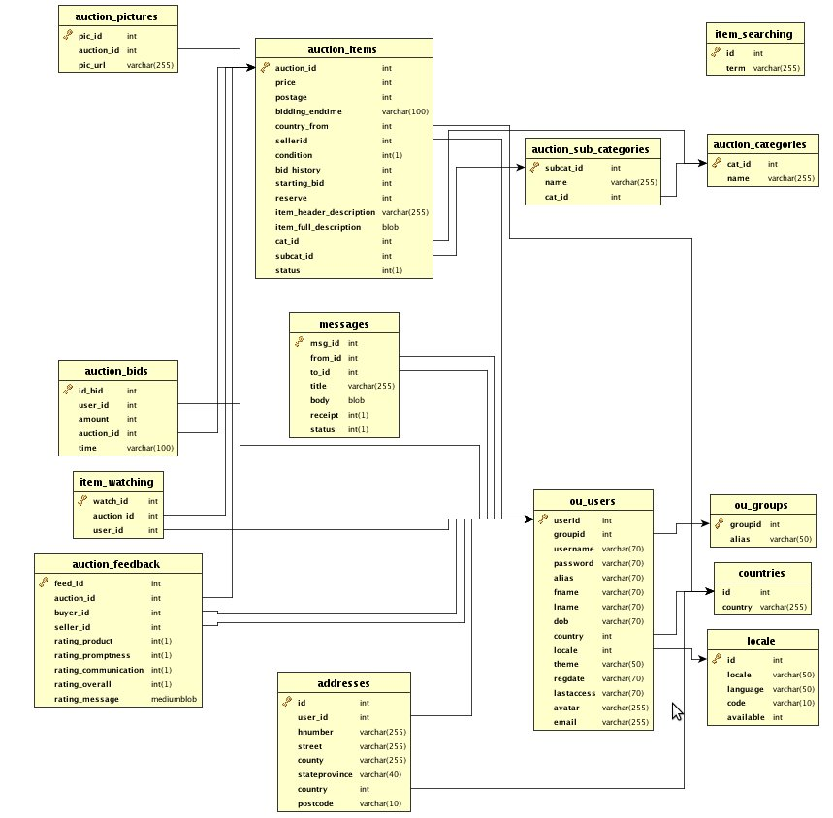

# Major Processes

## User

### Registration

### Update Registration

### Login

### Logout

### Forgot Password

### Submit Auction Item

### Update Auction Item

### Bidding

### Searching

### Feedback

### Watch Item

## Administrator

### Delete Users

### Edit Users

### Delete Users

### Ban Users

### Add Auction Categories

### Update Auction Categories

### Deleting Categories

### Update Auction Items

### Remove Auction Items

# Flow Graphs

## User

### Registration

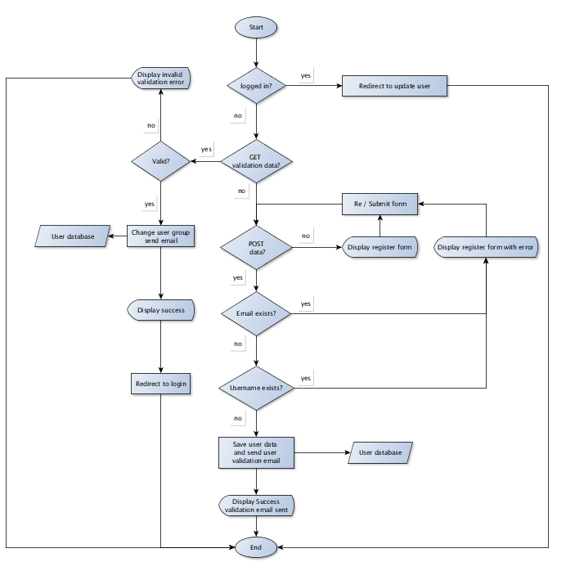

### Update Registration

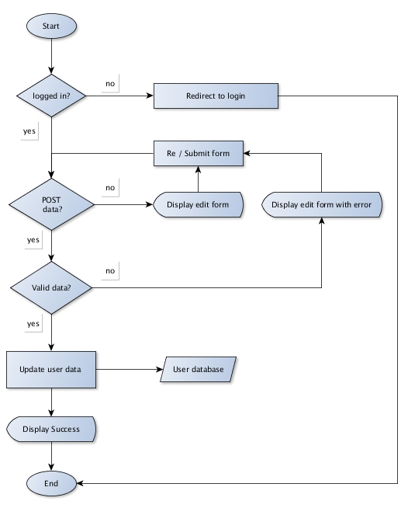

### Login

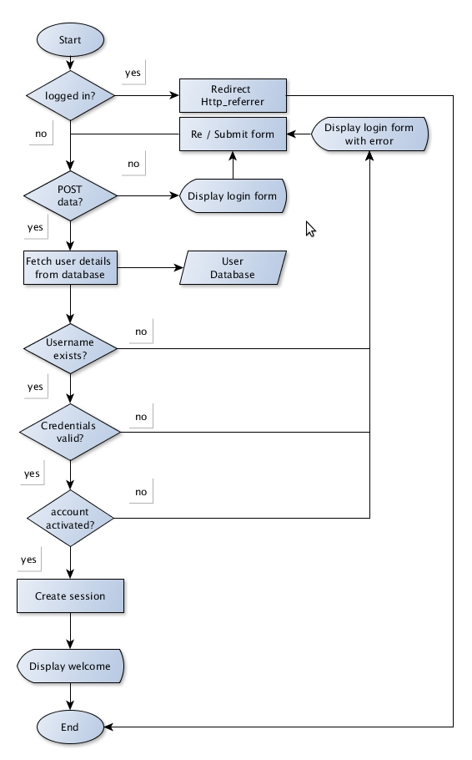

### Logout

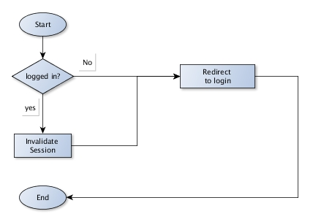

### Forgot Password

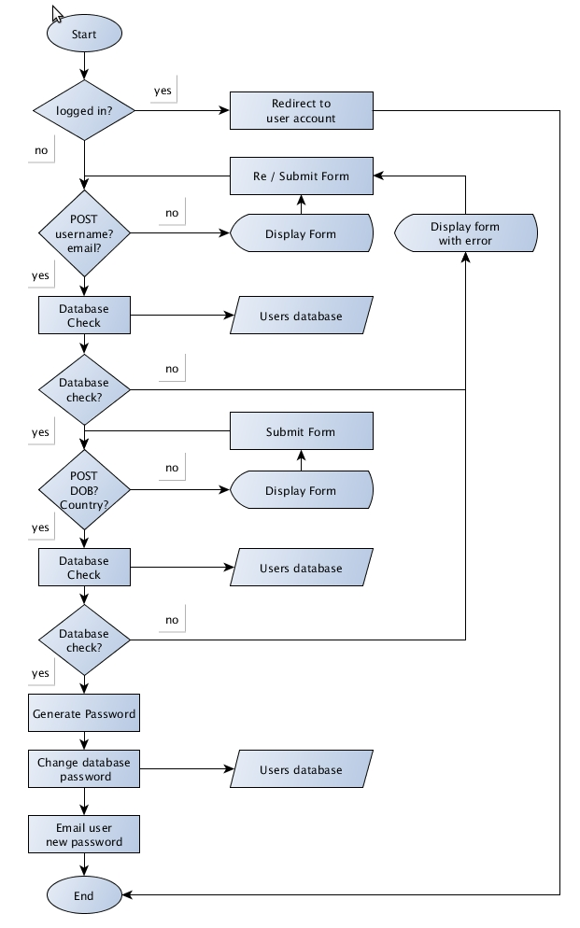

### Submit Auction Item

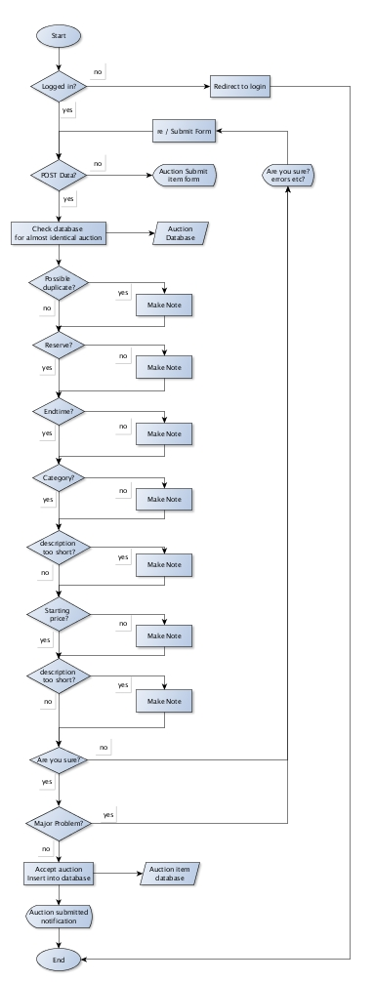

### Update Auction Item

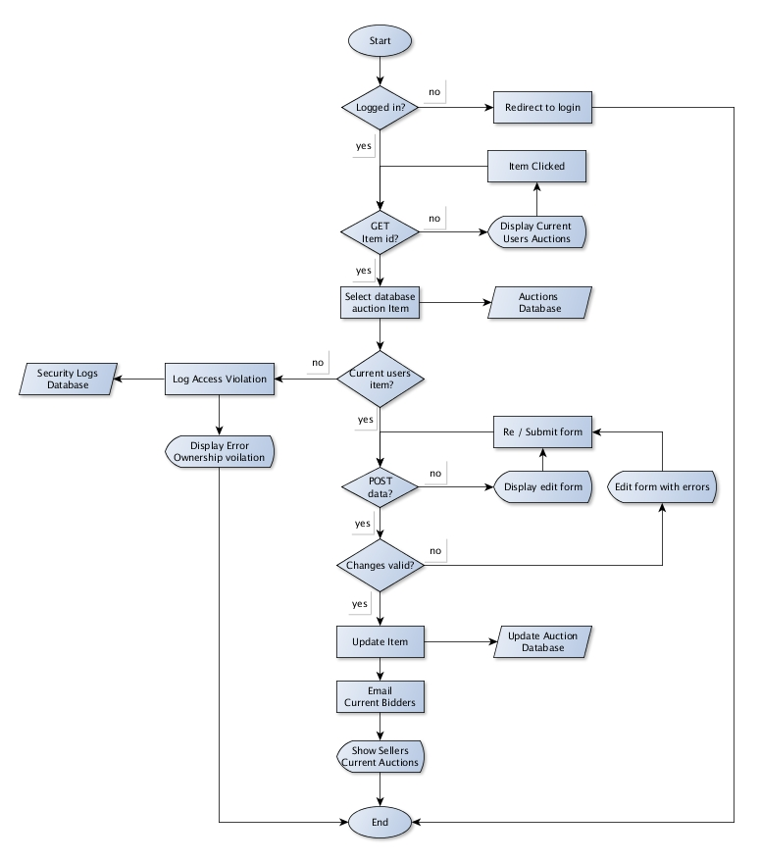

### Bidding

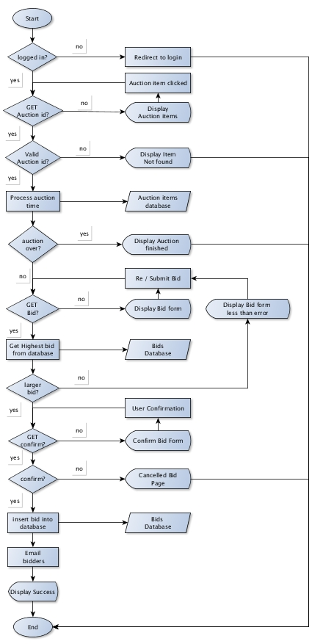

### Searching

### C:\Documents and Settings\Administrator\Desktop\graphs\flows\search.jpg

### Feedback

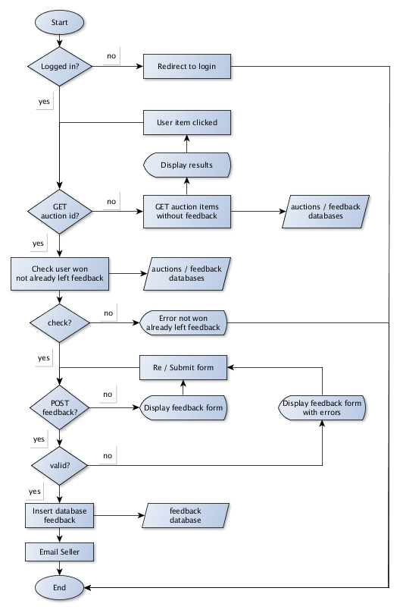

### Watch Item

## Administrator

### Delete Users

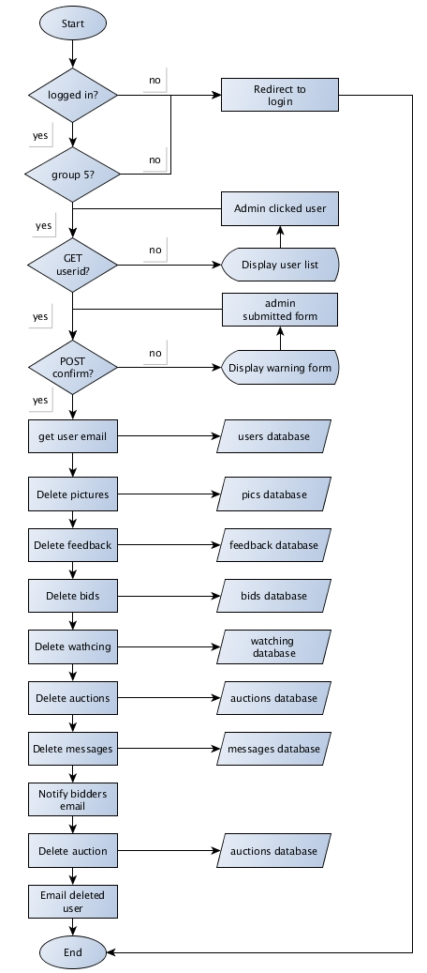

### Edit Users

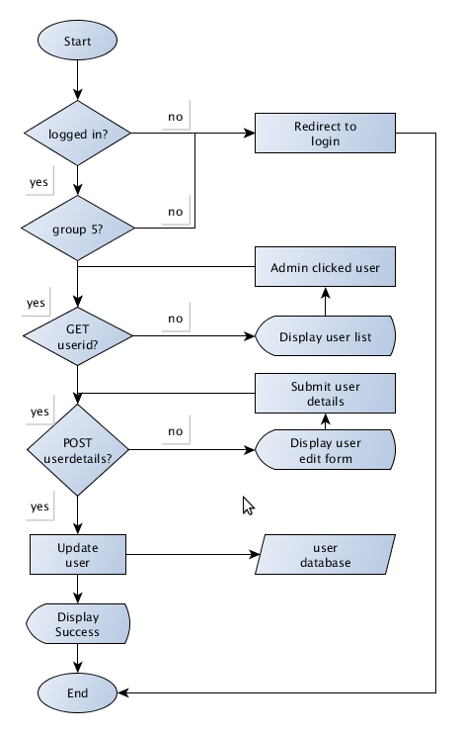

### Delete Users



### Ban Users

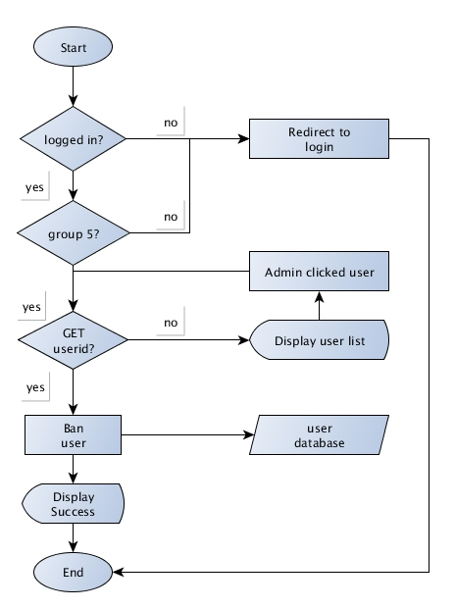

### Add Auction Categories

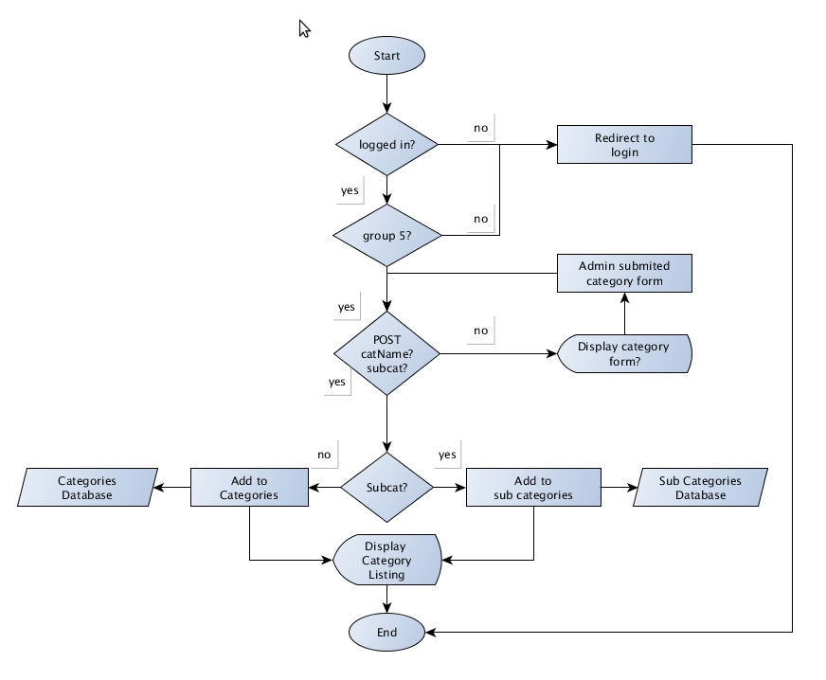

### Update Auction Categories

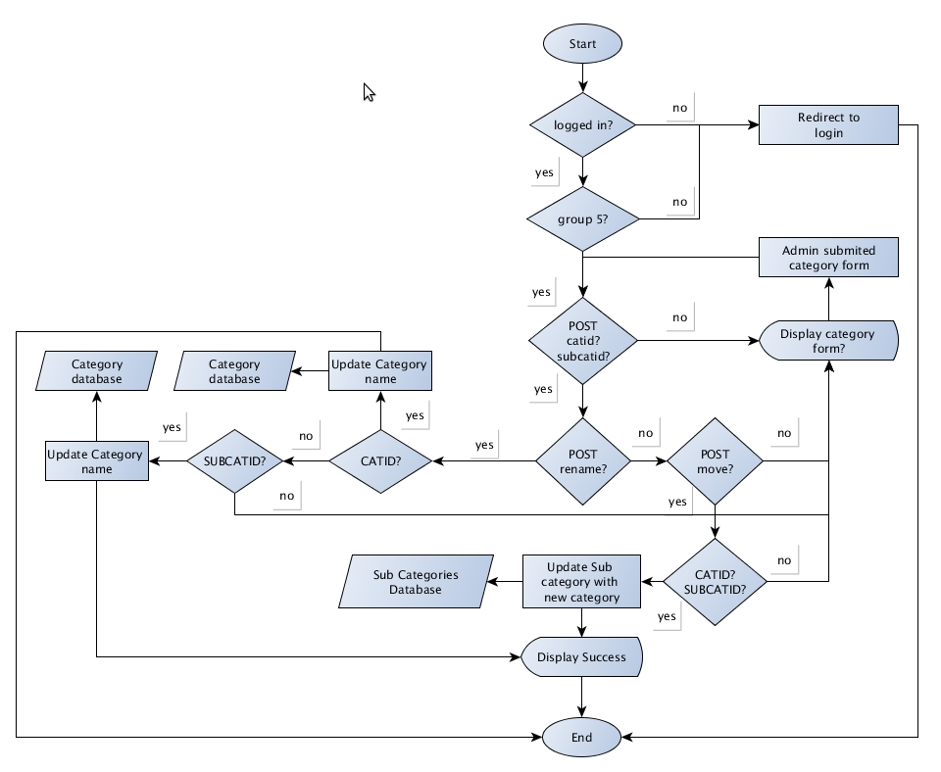

### Deleting Categories

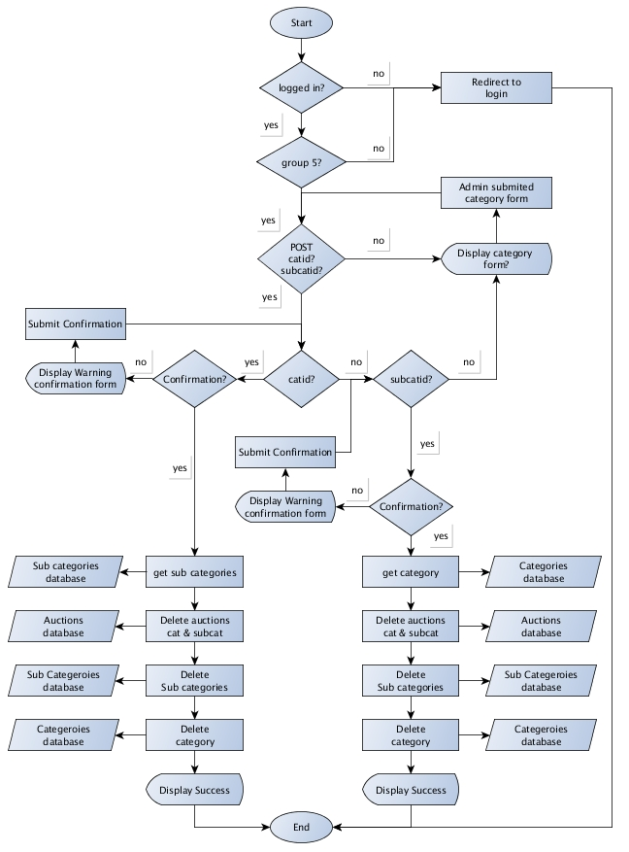

### Update Auction Items

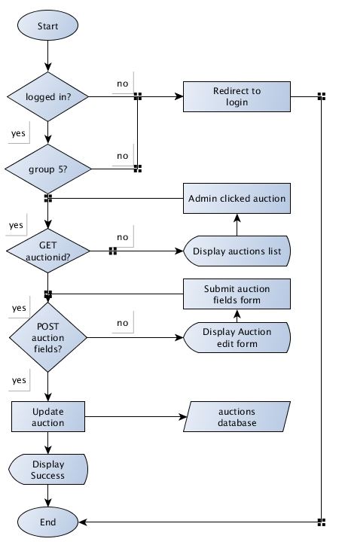

### Remove Auction Items

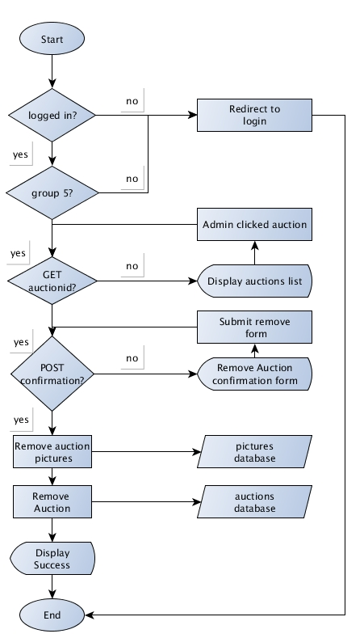

# Page Mockup

## Main page

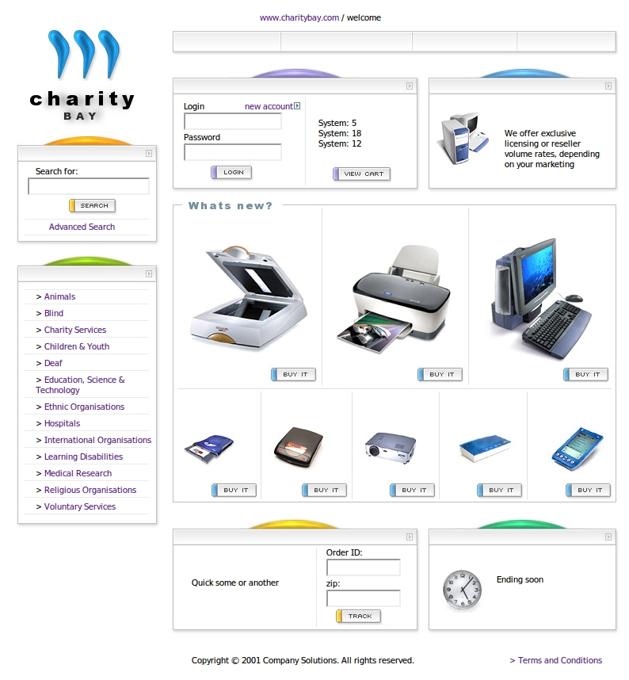

## Registration

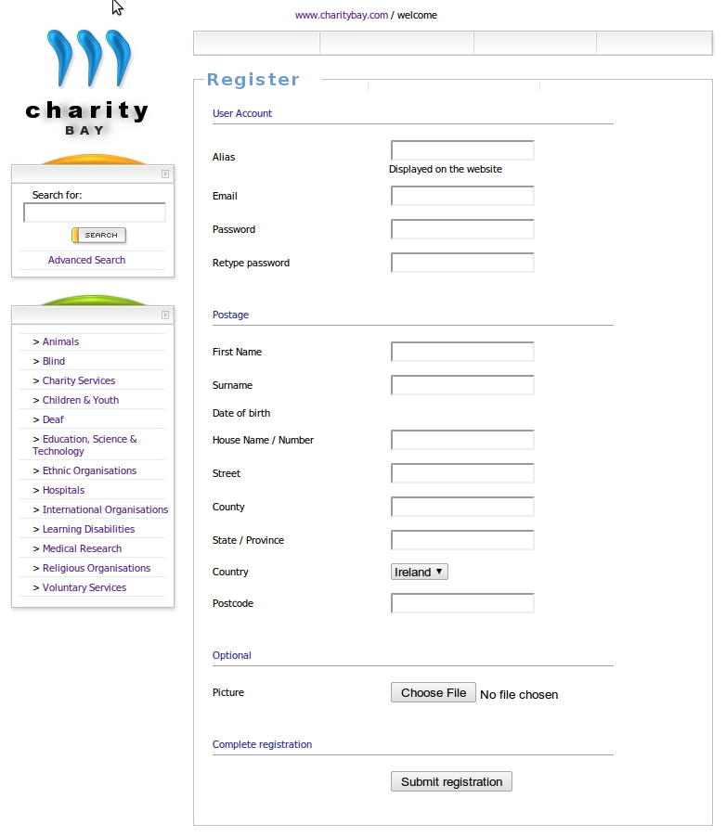

## Browsing Auctions

# C:\Documents and Settings\Administrator\Desktop\list.jpg