|  |
| --- |
| **CS4313** |
| Deliverable 3 |
|  |
| All Database tables |
|  |
|  |
|  |
|  |
| **David O Neill 0813001** |
| **James McHugh 0052833** |
| **Keiran Duggan 0866504** |
|  |
| **22/3/2010** |
|  |

Table of Contents

Status of major processes 3

User 3

Registration 95% (major) 3

Update Registration 95% (Minor) 3

Login 100% (major) 4

Logout 100% (major) 4

Forgot Password 0% (minor) 4

Submit Auction item 95% (major) 5

Update Auction item 42.5% (minor) 5

View Auction / Browse Listing 95% (Major) 6

Bidding 10% (major) 6

Searching 50% (major) 6

Feedback 0% (minor) 7

Watch item 0% (minor) 7

Administrator 0% (minor) 7

Other Functionality 7

Localisation 100% (minor) 7

Pictures 8

Error prevention 8

Localisation 9

Sorting & view options 9

Pagination & view options 9

Category browsing 10

References 10

# Status of major processes

# User

## Registration 95% (major)

**PHP**

The PHP logic implements a series of validation checks to prevent the user from entering unwanted data. Email, username, minimum password length, addresses, DOB etc. are further checked with regular expressions to ensure coherent data. Any errors will be shown to the user by indicating which fields had incorrect data.

Also the PHP logic has built in methods for taking AJAX requests, to check availability of username and email already is use prohibitions.

Activation, although can be completed by email; is disabled as the server not have ‘sendmail ‘ enabled.

**HTML – AJAX - CSS**

ALL html, CSS and Javascript completed. **JQuery** and plugins are used for AJAX requests to the server on form elements to verify email, username are not already in use. Using JQuery, problems fields are identified immediately indicating to the user which fields have problem data. Dates are handled by **JQuery** plugin **DATEPICKER** to ensure valid dates. **JQueryUI Modal** windows give further indication to the user when problems occur to increase the visibility of system status and error prevention. (Nielsen's heuristics)

Minor improvements to be made to CSS and avatar upload.

## Update Registration 95% (Minor)

**PHP**

The PHP logic implements a series of validation checks to prevent the user from entering unwanted data. Any errors will be shown to the user by indicating which fields had incorrect data.

Ajax and supported PHP logic upload allows the user to change the avatar, address, password and other details without refreshing the page.

**HTML – AJAX – CSS**

ALL html, CSS and Javascript completed. **JQuery** and plugins are used to show error and prevent error in user entered data. All updates are done using AJAX.

Minor improvements to be made, (change email address)

## Login 100% (major)

**PHP**

The PHP logic implements a series of validation checks to prevent the user from entering unwanted data. Any errors will be shown to the user by indicating which fields had incorrect data. On login complete the users profile will decide which locale will be used on the following pages.

**HTML – AJAX – CSS**

ALL html, CSS and Javascript completed. **JQuery** and plugins are used to show error and prevent error in user entered data.

## Logout 100% (major)

**PHP**

The user’s session is invalidated and the script returns the user to the main page.

## Forgot Password 0% (minor)

**Abstract**

Originally was going to be implemented via email. But as email is being blocked, this feature will be implemented by asking the user for their country and date of birth.

**PHP**

No logic completed

**HTML**

CSS and javascript / HTML ready

## Submit Auction item 95% (major)

**PHP**

The PHP logic implements a series of validation checks to prevent the user from entering unwanted data. Any errors will be shown to the user by indicating which fields had incorrect data. Prices, times etc are checked using regular expressions to check for coherent data. If there are any errors the page will be represented with notice errors next to the offending fields. Php implemented to handle temporary storage of upload images until the process is complete.

**HTML – AJAX – CSS**

ALL html, CSS and Javascript completed. **JQuery** and plugins are used to show error and prevent error in user entered data. Ajax is used to upload images and are immediately presented on the auction item page. The user has the ability to remove a picture immediately if they wish to do so. Times and prices fields are validate by **Jquery Date picker, time picker, price picker** to prevent invalid data before submitting to the server.

Minor improvements to be made, AJAX upload picture logic, tighter javascript to prevent less error in user data.

## Update Auction item 42.5% (minor)

**Abstract**

Only certain details are allowed to be changed after an auction has been submitted into the system. This process will be further evaluated and of major functionality is completed.

**PHP**

No logic completed

**HTML – AJAX – CSS**

CSS and javascript / HTML ready

## View Auction / Browse Listing 95% (Major)

**PHP**

PHP logic for **Items per page**, **pagination**, **sorting**, **categories** and browsing logic complete. View auction complete and ready for bidding process / watch item.

**HTML – AJAX – CSS**

All CSS and html complete, category / sub category browsing, auction viewing, sorting columns, time left, pagination, items per page and picture size.

Minor improvements to be made, view auction image carousal (multiple images) and better layout.

## Bidding 10% (major)

**PHP**

No PHP logic implemented

**HTML – AJAX – CSS**

Auction page is ready to accept bids and shows the current bid along with the amount of bids.

## Searching 50% (major)

**PHP**

PHP logic implemented for **auto suggest** feature on main page

**HTML – AJAX – CSS**

All layout implemented, Main search box has AJAX ready **auto suggest**

To do: implement advanced search, with sorting and search refinement enhancements.

## Feedback 0% (minor)

## Watch item 0% (minor)

# Administrator 0% (minor)

# Other Functionality

## Localisation 100% (minor)

Localisation in 42+ languages ( google API )

# 

# Pictures

## Error prevention

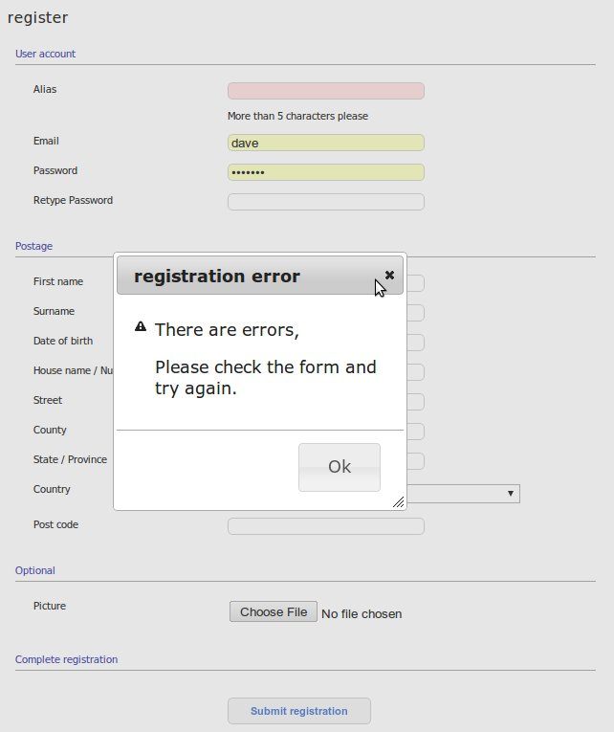

## LocalisationC:\Documents and Settings\Administrator\Desktop\localisation.jpg

## Sorting & view options

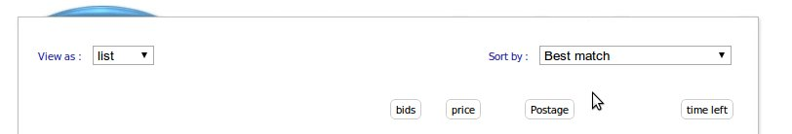

## Pagination & view options

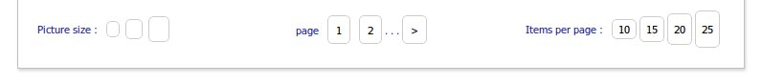

## Category browsing

## C:\Documents and Settings\Administrator\Desktop\category.jpg

# References

<http://www.jquery.com>

http://www.jqueryui.com