Intel Shannon
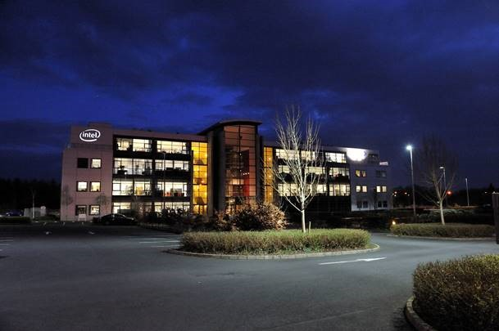
Safety Statement

INDEX

SECTION 1: INTEL SAFETY POLICY STATEMENTS
1.1 Intel Shannon Safety Policy 1
1.2 Intel Corporate EHS Policy 2

SECTION 2: SAFETY STRUCTURE
2.1 Intel Shannon Organisational Chart 3
2.2 Safety Structure 3
2.3 Employee Co-operation and Consultation 4
2.4 Safety Statement Update Procedure 4
2.5 Communication of Safety Statement 5

SECTION 3: SAFETY RESPONSIBILITIES
3.1 General Manager 6
3.2 Operations Manager 6
3.3 Site Operations Committee Managers 6
3.4 Supervisors 7
3.5 All other on-site Employees 7
3.6 EHS Leixlip 8

SECTION 4: HAZARD IDENTIFICATION AND MINIMISATION OF RISKS
4.1 Office Risk Assessment 9
4.2 IT Risk Assessment 13
4.3 Lab Risk Assessment 16
4.4 Facilities Risk Assessment 20

SECTION 5: SAFETY PROCESSES
5.1 Accident/Incident Investigation 24
5.1.1 Contractor Incident Notification Process 24
5.2 Injury Management 25
5.3 Office Response Team 25
5.4 Anti-Bullying 28
5.5 Stress 29
5.6 Employee Assistance Programme 29
5.7 Pregnant Workers and New Mothers 29
5.8 Chemical Use 30
5.9 Safety Training 30
5.10 Safety Management by Walkabout (SMBWA) 30
5.11 Safety Signage 31

SECTION 1:
INTEL SAFETY POLICY STATEMENTS

1.1 Intel Shannon Safety Policy

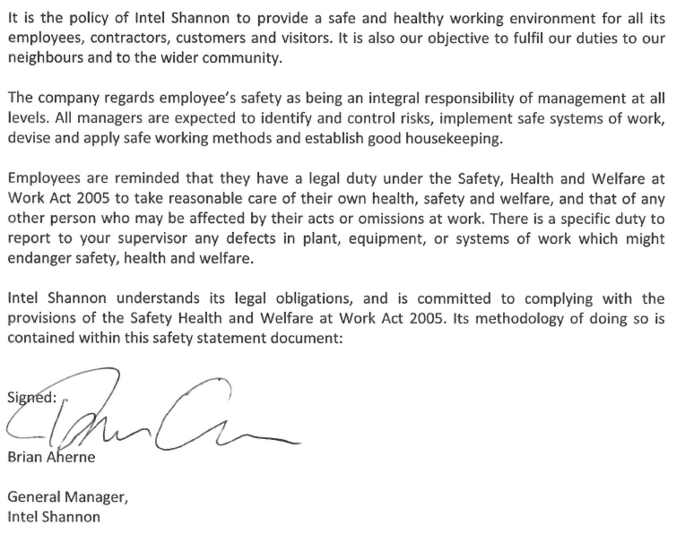

1.2 Intel Corporate EHS Policy

Intel is committed to caring for our people and the planet by integrating design for the environment and safety principles into all aspects of our business; from the development of our products, through our supply chain and manufacturing. We believe that responsible environmental stewardship is good business and that our technology can play a key role in addressing the planet’s sustainability challenges.

We will comply with all applicable regulatory and Intel Environmental Health & Safety (EHS) requirements wherever we operate. We will engage with stakeholders to develop responsible laws, regulations and innovative programs that provide safeguards for the community, the workplace, and the environment while providing flexibility to meet the needs of our business.
We are committed to provide a safe, injury-free workplace by integrating safety into our daily business decisions and processes. Management leads the effort behind this important Intel value, and all employees are responsible for both their safety and the safety of those around them. We actively promote a healthy lifestyle and encourage employees to proactively manage their personal health.

We strive to conserve natural resources through innovative processes and continuous improvement methodologies with the goal of reducing, reusing, recycling, and identifying safer material substitutes or alternatives for our operations. We strive to utilize green chemistry principles to identify safer material substitutes or alternatives for our operations. We will continue to invest in energy conservation, we will work to reduce our emissions over time and adhere to our climate change policy and water policy.

We are committed to designing and manufacturing products that are safe, energy efficient and minimize impact to the environment. We will be a responsible member of the communities in which we live and work. As we expand our knowledge and understanding of the impact of our operations and our products, we will share this knowledge with the broader community.
Overall, we are committed to continually improving our EHS standards, culture and performance, and will transparently report our performance goals and metrics. We will continue to maintain appropriate controls, including periodic review, to ensure that this policy is being followed.

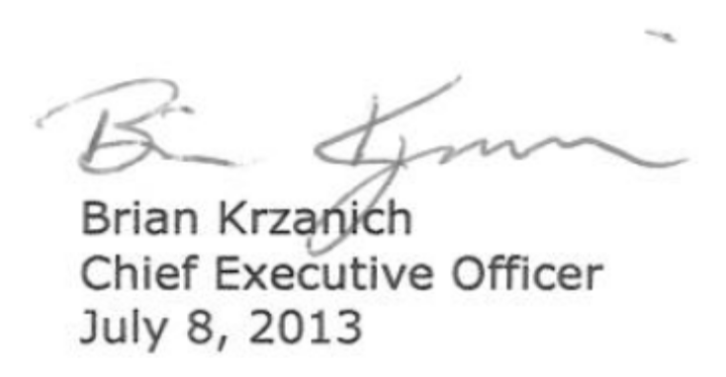

SECTION 2:
SAFETY STRUCTURE

2.1 Intel Shannon Site Operations Committee Organisation Chart

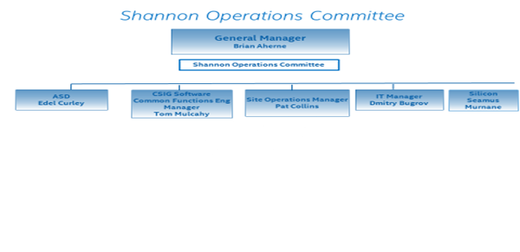

2.2 Safety Structure

The Shannon Operations Committee is responsible for setting the strategic safety direction for the Shannon Site and it is lead by the General Manager. Its charter is to establish and reinforce safety as a value on the site and to set strategic safety direction for the Site. The Site Safety Committee is chartered with the development and implementation of a safety plan consistent with The Intel Shannon Safety Policy our the stagiest safety direction. Their charter is also to provide the tactical implementation of safety systems, provide follow-up to safety issues and to act as contact for employees on safety related issues. Participation in the Site Safety Committee is on a voluntary basis and is a mixture of management and employees from a cross section of levels and Departments. The team membership will consist of a lab rep, office reps, facilities rep, IT rep, Site Operations Committee and EHS. Site Operations Manager leads the Site Safety Committee and he shall provide regular progress updates to the Site Operations Committee.

EHS will provide technical guidance to the Shannon Operations Committee. EHS will sit on the Site Safety Committee and be a resource as required to the Shannon Operations Committee. EHS will support an annual Safety Self-Assessment process with Shannon Operations Committee.

2.3 Employee Co-operation and Consultation

To ensure we have an effective safety and health policy, the co-operation of individuals in matters relating to safety, health and welfare is of paramount importance, and Intel Shannon expects each employee, contractor and visitor to:
- Take reasonable care for their own safety, health and welfare and that of any other person who may be affected by their acts or omissions while at work.
- Co-operate with their supervisors/managers to comply with any of the relevant statutory provisions and Intel EHS Guidelines.
- Make proper use of all appliances, personal protective equipment, the adherence to lifting methods and housekeeping procedures or other means provided in order to maintain a safe and healthy workplace.
- Report to their manager/supervisor, without unreasonable delay, any defects in plant, equipment, procedures or any unsafe conditions which might endanger safety, health or welfare of a colleague.
- Be aware of the safety organisational support structure in Intel Shannon, and to report injuries to their supervisor immediately.
- Understand the emergency evacuation procedures.
- Undertake all mandatory safety training and adhere to all training provided by Intel.
- Be aware that if they wilfully or knowingly disregard their duty in relation to their own or a colleagues health and safety, that they may be subject to disciplinary action up to and including termination.
- Ensure that they are not under the influence of any intoxicant while at work.

Employees can volunteer to participate in the Site Safety Committee. All employees are also actively encouraged to make representation on any issues relating to safety, health and welfare. Employees have access for addressing issues with any individual in the company using the normal processes of openness and participation.

HR - Open Door policy is available at
https://employeecontent.intel.com/contentdelivery/getcontent.aspx?webpath=cn_Active/Support/HRContent/IREOpenDoor.htm

2.4 Safety Statement Update Procedure

The Safety Statement for Intel Shannon is reviewed by the EHS representative with Site Operations Manager annually.

In addition, if in the event of any major changes outside of this review cycle there will be a re-assessment of the risks and the Safety Statement will be updated accordingly.

A copy of the Safety Statement is available on the intranet at the following address:
http://curam.ir.intel.com/index.php/safety

Hard copies are available at reception in Dromore House.

2.5 Communication of Safety Statement

New Employees - The Safety Statement and its location are communicated to newly recruited employees during Site Operations Induction Training.

Annually - The Safety Statement is communicated annually after it has been updated to all employees during a business update meeting.
SECTION 3:
SAFETY RESPONSIBILITIES

Specific responsibilities are detailed for the positions listed below:

3.1 General Manager:

The General Manager has overall responsibility for the provision of a safe working environment for all employees, contractors and visitors whilst they are at Intel Shannon.

The General Manager is responsible for the establishment and maintenance of an effective policy on Safety Health and Welfare at Intel Shannon by ensuring that:
- The Policy is established, current and understood at all levels.
- The appropriate staff and resources are made available to meet the requirements of all applicable safety legislation and Intel corporate environmental, health and safety guidelines and directives.
- The responsibility for safety, health and welfare is assigned and accepted at all levels within the company.
- All Shannon based Intel employees are held accountable by the General Manager for their performance in relation to occupational health and safety and being role-models.

3.2 Operations Manager:

The Site Operations Manager is responsible for facilitating the implementation of health and safety measures within the company as required by Irish legislation and Intel Corporate Environmental Health and Safety directives. In addition the Operations Manager is responsible for ensuring that all operations employees and others, such as contractors and visitors, are made aware of and fully comply with the requirements of the company's safety statement, and that they understand the organisational structure and arrangements present for carrying it out.

In particular, the Operations Manager is responsible for ensuring:
- Adequate resources and safety training are made available (this includes office ergo training, first aid training and refresher, manual handling, ERT training).
- All new plant, processes and machinery brought onto the premises conform to the current regulatory provisions governing health and safety within Ireland.
- All operation employees are fully trained and competent to carry out their duties, and they are aware of all potential hazards.
- Relevant persons (EHS, Materials, Corporate Services Construction) are kept informed regarding new equipment, projects and work in order that Intel's standard safety and health practices may be implemented as appropriate.

3.3 Site Operations Committee Managers:

Each manager is responsible for ensuring that all employees under their control, and others such as contractors and visitors, are made aware of, and fully comply with the requirements of the company's Safety Statement and that they understand the organisational structure and arrangements present for carrying it out.

In particular each manager is responsible for:
- Ensuring that all employees within his/her department receive adequate safety training and instruction appropriate to the tasks they perform.
- Role modelling, through personal behaviour, that only the highest standards of safety are acceptable.
- Ensuring that systems supporting safety and health are functional in the department to enhance protection of personnel from risks whilst carrying out their duties.
- Investigate all accidents and dangerous occurrences, in their area of control, and reporting on it according to standard Intel procedures (Standard procedure is available on intranet).
- Carrying out regular safety audits of their area, together with the relevant supervisors.
- Ensuring that all staff under their control are held accountable for their performance in relation to occupational health and safety.
- Ensuring, at appropriate frequency, that safety, health, and related information is communicated to his/her employees.

3.4 Supervisors: (people managers)

Supervisors are responsible for ensuring that the employees under their immediate control and others, such as contractors and visitors, under their control are made aware of and comply with the company's Health and Safety Statement and the organisation and arrangements for carrying it out by:
- Being fully familiar with the Safety Statement, policies, guidelines and procedures.
- Showing, through personal behaviour, that only the highest standards of safety are acceptable.
- Ensuring that all employees in their section receive adequate safety training and instruction appropriate to their tasks performed.
- Ensuring that all employees under their control are aware of actions to be taken in case of emergency.
- Ensuring that good housekeeping standards are maintained and in particular reporting any safety concerns.
- Ensuring that thorough and prompt investigations are carried out into all reported injury, accidents and dangerous occurrences to establish their cause and avoid recurrence.
- Ensuring that regular safety audits(SMBWA) are been carried out in their area..
- Ensuring the wearing of required personal protective equipment is adhered to at all times.

3.5 All Other On-Site Employees

Engineers/specialists are responsible for ensuring that the employees under their immediate control and others such as contractors and visitors, under their control, are made aware of and comply with the company's Health & Safety Statement and the organisation and arrangements for carrying it out by:
- Being fully familiar with the Safety Statement, safety policies, procedures and guidelines.
- Showing, through role modelling, that only the highest standards of safety are acceptable.
- Ensuring that all visitors/contractors under their control are aware of actions to be taken in case of emergency.
- Take all mandatory training.
- Take responsibility for their own health, safety and welfare, and that of any other person who may be affected by their acts or omissions at work.
- Report to your supervisor any defects in plant, equipment, or systems of work which might endanger safety, health and welfare.

3.6 Environmental Health & Safety Department

EHS provides technical guidance to the Site and Site Safety Committee. In particular they are responsible for:
- Accident and event investigation and documentation support.
- Case management support.
- Technical support regarding on site risk assessments.
- Review of safety statement yearly.
- Member of the Site Safety Committee.
- Support Site Operations Committee as required.
- Support Site Management in continual improvement of the safety processes and systems.
- Safety project management for construction projects.
- Lead Annual Safety Self-Assessment.
- Ensuring compliance with local legal requirements and Intel Corporate Policies.
- Providing required trainings to follow local legislation and Intel Corporate Policies.
- Determines parameters for the site Ergonomics program.

SECTION 4:

HAZARD IDENTIFICATION AND MINIMISATION OF RISKS

In Intel Shannon we conduct our assessment of health and safety risk by work environment – office, IT, lab and facilities. These assessments are reviewed and updated on an annual basis, unless there is a major change. Assessments are carried out by EHS in association with the local process owner.

4.1 Office Risk Assessment

Office | Scope:  All office locations within Intel Shannon.
Owner | SIE Site Operations Committee
HAZARD |  | CONSEQUENCE | CONTROL MEASURE
Office ergonomics |  | MSD Injury. (Musculoskeletal Disorder. MSD would be used to describe injuries of a cumulative nature only. An MSD cannot be an acute injury.) | - Office chairs meet Irish legal adjustability requirements. Office ergonomic assessors trained and certified.  - Office ergo assessments have been completed and will be reassessed on an ongoing basis.  - All employees have been made aware of the on-line office ergonomics training and are required to complete this training.  - Ergo approved accessories are identified and acquired from an approved provider.  - Software tools are also available (e.g. Wellnomics)  - There is an Office Move procedure in place
Office Ergonomics for Home Based Employees |  | MSD Injury | - System in place to support Home Based Employees (HBO). EMEA Home Based Employees policy is located at https://employeecontent.intel.com/content/hr/legalandhr/employment/EMEA_Home_Based_Office_Policy.html  - All home based employees are obliged to complete the HBO EHS self-assessment checklist available under the EMEA HBO Policy.  - Employees are also expected to complete the On Line Office Ergo training class. Their managers are responsible for checking that employees meet these obligations.
Electricity:  Electric Shock  Fire  Trips and falls from loose cables. |  | Electric Shock.  Serious injury or fatality.  Damaged property. | - No live electrical work is conducted in the offices.  - Equipment must be fitted with correctly rated fuses.  - Flexible cables shall not run across floors. If it is necessary to run cables across walkways, they must be covered with cable protectors.  - Sufficient sockets are provided to prevent overloading by use of adapters.  - Damaged or defective leads and plugs must be removed from service immediately.  - End of flexible cables must always have the outer sheath of the cable firmly clamped to stop the wires pulling out of the terminals.  - Electrical cable must be in good condition and free from breaks in the insulation.  - Extension leads must not be daisy-chained.  - Electrical equipment must only be repaired by a competent person.  - Portable electrical equipment must be visually checked for defects by the user prior to use.  - All portable electrical equipment must comply with Portable Appliance Testing (PAT) requirements.  - When using portable equipment, use socket outlets close by so that equipment can be easily disconnected in an emergency.  - Any defects should be reported to the supervisor and the equipment must be labelled 'Do not use' and immediately taken out of service.  - Where possible, tools and power socket outlets should be switched off before plugging in or unplugging.  - Equipment must be switched off and/or unplugged prior to cleaning or making adjustments.  - All electrical equipment and installations must be properly maintained.
Slips, trips and falls.  Spillage of wet/dry substances.  Trailing cables  Poor lighting |  | Employee fall or injury | - Cleaning is carried out if practicable outside of working hours.  - All spillages shall be cleaned immediately.  - Where floors are wet as a result of cleaning operations, warning signs shall be erected to that effect.  - Equipment is positioned to avoid trailing cables across pedestrian routes. Cable covers must be used to securely fix to surfaces.  - Consider use of cordless tools.  - All areas shall be kept clean and tidy at all times and any obstructions immediately removed.  - All damaged floor covering, equipment or machinery shall be reported, replaced or repaired.  - Lighting shall be adequate.
Working at heights |  | Falls from height leading to serious injury. | - When working on ladders in an occupied area, cones or barrier tape must be set up in front and behind the ladder to warn any oncoming traffic. If ladder work is being performed in front of a door, a control zone made up of cones, caution tape and a sign must be displayed.  - Ladders and step ladders are inspected prior to use by the user. Any defects should be reported to your supervisor and the ladder/step ladder labelled 'Do not use' and removed from service.  - The top three rungs of the ladder and top two rungs of the step ladder are not to be used for standing, climbing or sitting.  - Three points of contact must be maintained at all times on the ladder or stepladder.  - Both hands must be used when climbing up and down ladder/step ladder.  - Face ladder/step ladder when climbing up and down and when working.  - Floor areas shall be kept clear of materials and litter.  - Step ladders shall be used to access high areas.  - Ensure there is space to fully open.  - Use any locking devices.  - Ensure ladders are placed, fixed, secure and stable during use.  - Prevent the ladder from moving by tying it off securely, using an anti-slip device or asking someone to foot it.  - All damaged floor covering, equipment or machinery shall be reported, replaced or repaired.  - Only competent personnel are permitted to use ladders/stepladders.  - Fiberglass ladders are to be used for the electrical works at height.
Manual Handling |  | Back injury. Lacerations.  Crushing/Bruising of hands, fingers, feet and toes.  Repetitive strain injury.  Sprains, strains. | - Assessment shall be completed of loads which have to be manually handled.  - Trolleys available and used where appropriate.  - All personnel, as required by the appropriate risk assessments, are trained in safe manual handling techniques.  - Suitable gloves are available as required for the handling of materials which could cause injury to the hands.  - Steps are available to place/remove objects located at heights.
Fire  Loss of power to facility due to fire. |  | Serious injury or fatality.  Damaged property.  Equipment damage. | - Fire exit routes and doors must be marked and unobstructed.  - Evacuation routes must be up-to-date and clearly posted.  - Extinguishers must be placed along normal paths of travel and are to be used by trained personnel only.  - A sign must be placed above the extinguisher in its designated location and be clearly visible from two or more directions.  - Fire extinguishers must be tested annually by a competent person and must be inspected monthly.  - Smoke detection system in place.  - Testing and inspection system in operation for fire safety systems.  - Emergency response team in place to provide emergency evacuation.  - Emergency evacuation drills are conducted twice a year.  - Backup power supply.
Work Equipment |  | Serious injury or fatality.  Damaged property. | - Use the correct equipment for the task.  - Visually inspect the equipment prior to use.  - Any defects must be reported to the supervisor and the equipment must be labelled 'Do not use' and immediately taken out of service.
Falling objects. |  | Injury to personnel. | - All items stored above head level shall be stored properly to prevent falling.  - Personnel are instructed to take due care when retrieving items from a height.
Radon (naturally occurring radioactive gas) can accumulate in basement and ground floor workplaces leading to a build-up of harmful radiation. |  | Long term exposure to high levels of radon has been shown to irradiate lung tissue and increase the risk of lung cancer.  The risk of contracting lung cancer from exposure to radon depends on how much radon you have been exposed to and for how long.  Smokers are at greater risk than non-smokers. | - According to the HSA, all indoor workplaces in High Radon Areas located at ground floor or basement level must be measured for radon. A high radon area is defined as an area where the predicted percentage of homes in a given grid square is 10% or greater that the national Reference Level of 400 Bq/m3 measured over a three month period. Intel Shannon is located in an area where it is estimated that 10 - 20% of homes are above the reference level. Although Intel Shannon is located in a High Radon Area, as none of the office areas are located at ground floor or basement level, radon measurements will not be conducted until directed to do so by the RPII.

4.2 IT Risk Assessment

IT | Scope:  Operational and maintenance of Intel owned assets and controlled rooms.
Owner | Artem Amogolonov (IT Manager)
HAZARD | CONSEQUENCE | CONTROL MEASURE
Electricity:  Electric Shock  Fire  Trips and falls from loose cables. | Electric Shock.  Serious injury or fatality.  Damaged property. | - Any work on live electrical services will be completed by a designated specialist electrical contractor.  - Equipment must be fitted with correctly rated fuses.  - Flexible cables shall not run across floors. If it is necessary to run cables across walkways, they must be covered with cable protectors.  - Sufficient sockets are provided to prevent overloading by use of adapters.  - Damaged or defective leads and plugs must be removed from service immediately.  - End of flexible cables must always have the outer sheath of the cable firmly clamped to stop the wires pulling out of the terminals.  - Electrical cable must be in good condition and free from breaks in the insulation.  - Extension leads must not be daisy-chained.  - Electrical equipment must only be repaired by a competent person.  - Portable electrical equipment must be visually checked for defects by the user prior to use.  - When using portable equipment, use socket outlets close by so that equipment can be easily disconnected in an emergency.  - Any defects should be reported to the supervisor and the equipment must be labelled 'Do not use' and immediately taken out of service.  - Where possible, tools and power socket outlets should be switched off before plugging in or unplugging.  - Equipment must be switched off and/or unplugged prior to cleaning or making adjustments.  - All electrical equipment and installations must be properly maintained.  - All portable electrical equipment must comply with Portable Appliance Testing (PAT) requirements.
Working at heights | Falls from height leading to serious injury. | - When working on ladders in an occupied area, cones or barrier tape must be set up in front and behind the ladder to warn any oncoming traffic. If ladder work is being performed in front of a door, a control zone made up of cones, caution tape and a sign must be displayed.  - Ladders and step ladders are inspected prior to use by the user. Any defects should be reported to your supervisor and the ladder/step ladder labelled 'Do not use' and removed from service.  - The top three rungs of the ladder and top two rungs of the step ladder are not to be used for standing, climbing or sitting.  - Three points of contact must be maintained at all times on the ladder or stepladder.  - Both hands must be used when climbing up and down ladder/step ladder.  - Face ladder/step ladder when climbing up and down and when working.  - Floor areas shall be kept clear of materials and litter.  - Step ladders shall be used to access high areas.  - Ensure there is space to fully open.  - Use any locking devices.  - Ensure ladders are placed, fixed, secure and stable during use.  - Prevent the ladder from moving by tying it off securely, using an anti-slip device or asking someone to foot it.  - All damaged floor covering, equipment or machinery shall be reported, replaced or repaired.  - Only competent personnel are permitted to use ladders/stepladders.  - Fiberglass ladders are to be used for the electrical works at height.
Manual Handling | Back injury. Lacerations.  Crushing/Bruising of hands, fingers, feet and toes.  Repetitive strain injury.  Sprains, strains. | - Assessment shall be completed of loads which have to be manually handled.  - Trolleys available and used where appropriate.  - Server lift used in ITIR Room to put in servers.  - All appropriate personnel are trained in safe manual handling techniques.  - Suitable gloves are available as required for the handling of materials which could cause injury to the hands.  - Steps are available to place/remove objects located at heights.
Sharp edges/knives | Cuts | - Use of approved knives and use of Kevlar gloves.
Slips, trips and falls.  Spillage of wet/dry substances.  Trailing cables  Poor lighting | Injury to personnel. | - Cleaning is carried out if practicable outside of working hours.  - All spillages shall be cleaned immediately.  - Where floors are wet as a result of cleaning operations, warning signs shall be erected to that effect.  - Equipment is positioned to avoid trailing cables across pedestrian routes. Cable covers must be used to securely fix to surfaces.  - Consider use of cordless tools.  - All areas shall be kept clean and tidy at all times and any obstructions immediately removed.  - All damaged floor covering, equipment or machinery shall be reported, replaced or repaired.  - Lighting shall be adequate.  - Signage in place where moving from one level to another.
Manual Handling | Back injury. Lacerations.  Crushing/Bruising of hands, fingers, feet and toes.  Repetitive strain injury.  Sprains, strains. | - Assessment shall be completed of loads which have to be manually handled.  - Trolleys available and used where appropriate.  - Server lift used in Data Centre to put in servers.  - All appropriate personnel are trained in safe manual handling techniques.  - Suitable gloves are available as required for the handling of materials which could cause injury to the hands.  - Steps are available to place/remove objects located at heights.
Sharp edges/knives | Cuts | - Use of approved knives and use of Kevlar gloves.
Fire  Loss of power to facility due to fire. | Serious injury or fatality.  Damaged property.  Equipment damage. | - Fire exit routes and doors must be marked and unobstructed.  - Evacuation routes must be up-to-date and clearly posted.  - Extinguishers must be placed along normal paths of travel and are to be used by trained personnel only.  - A sign must be placed above the extinguisher in its designated location and be clearly visible from two or more directions.  - Fire extinguishers must be tested annually by a competent person and must be inspected monthly.  - Smoke detection system in place.  - Aragonite fire suppression system in ITIR Room  - Testing and inspection system in operation for fire safety systems.  - Emergency response team in place to provide emergency evacuation.  - Emergency evacuation drills are conducted twice a year.  - Backup power supply.
Work Equipment | Serious injury or fatality.  Damaged property. | - Use the correct equipment for the task.  - Visually inspect the equipment prior to use.  - Any defects must be reported to the supervisor and the equipment must be labelled 'Do not use' and immediately taken out of service.  - Leak detection system under floor in canteen with sonic alert.
Falling objects. | Injury to personnel. | - All items stored above head level shall be stored properly to prevent falling.  - Personnel are instructed to take due care when retrieving items from a height.  - Climbing on racking or shelving is strictly forbidden.

4.3 Lab Risk Assessment

Lab | Scope:  Software Engineering Lab, TME Lab, Comms Room, Silicon Validation Lab
Owner | Tom Mulcahy (Software Eng. Lab), Paul Girr/Brian Baker (IOT Lab) Tom Mulcahy (Silicon Validation Lab)
HAZARD | CONSEQUENCE | CONTROL MEASURE
Noise: | Health consequences of regular exposure to elevated noise levels | - Hearing Conservation WBT is in place for affected employees.  - Restricted access to the lab.  - Personal Protection Equipment is in place.  - Audiometry Examination in being set up for affected employees.
Electricity:  Electric Shock  Fire  Trips and falls from loose cables. | Electric Shock.  Serious injury or fatality.  Damaged property. | - No live electrical work is conducted in the labs.  - Restricted access to the labs.  - Equipment must be fitted with correctly rated fuses.  - Extension cords shall not be routed through holes in the wall, ceiling or floors, through doorways or windows or through similar openings  - When temporary extension cords are needed they should not be routed across normal paths of travel. In the event a cord must be routed across or through a normal path of travel, means shall be taken to minimize trip hazards, to warn of their existence and to protect the cord from damage by people or equipment  - Sufficient sockets are provided to prevent overloading by use of adapters.  - Damaged or defective leads and plugs must be removed from service immediately.  - End of flexible cables must always have the outer sheath of the cable firmly clamped to stop the wires pulling out of the terminals.  - Electrical cable must be in good condition and free from breaks in the insulation.  - Extension leads must not be daisy-chained.  - Electrical equipment must only be repaired by a qualified person.  - Portable electrical equipment must be visually checked for defects by the user prior to use.  - When using portable equipment, use socket outlets close by so that equipment can be easily disconnected in an emergency.  - Any defects should be reported to the Lab Manager and the equipment must be labelled 'Do not use' and immediately taken out of service.  - Where possible, tools and power socket outlets should be switched off before plugging in or unplugging.  - Equipment must be switched off and/or unplugged prior to cleaning or making adjustments.  - All electrical equipment and installations must be properly maintained.  - All portable electrical equipment must comply with Portable Appliance Testing (PAT) requirements.  - When work is completed, all electrical equipment, tools and reusable material should be returned to their designated storage areas
Use of chemicals | Personal exposure | - All chemicals must be approved by EHS prior to being brought on site.  - Chemicals must be appropriately labelled, stored properly and stored only in minimum quantities.
Laser | Eye damage | - Only Class 1 Lasers are used in the labs which are deemed as low risk with sufficient controls to prevent exposures to being hazardous under all circumstances.
Soldering | Personal exposure and thermal burns | - Hand soldering is conducted in the lab, the risk of personal exposure is low.  - Only trained and qualified personal are permitted to carry out hand soldering.  - Hand soldering is only permitted to be carried out in a designated area.  - Visually inspect the soldering iron/gun prior to use, in particular inspect the cord for damage.  - Local exhaust ventilation (LEV) must be used during soldering operations. It is required to be turned on prior to use.  - Any defects must be reported to the Lab Manager and the soldering gun/iron must be labelled 'Do not use' and immediately taken out of service.  - All combustible materials and flammable chemicals must be removed from the hand soldering operation.  - Soldering iron/gun temperatures shall be kept below 427 degrees Centigrade.  - Each soldering iron/gun shall be housed in their proper cradle when not in use.  - Solder tip changes shall be done in accordance with documented procedures.  - Safety glasses must be worn when performing hand soldering or when in close proximity of hand soldering operations unless using microscopes with eyecups.  - After use, verify that the soldering iron/gun and local exhaust ventilation (LEV) are switched off.  - After use, the work surface and surrounding areas must be thoroughly cleaned using wet wipes.
Sharp edges/scalpels/microprobe | Cuts and lacerations | - Use of approved knives and use of Kevlar gloves.
Slips, trips and falls.  Spillage of wet/dry substances.  Trailing cables  Poor lighting | Employee fall or injury | - Cleaning is carried out if practicable outside of working hours.  - All spillages shall be cleaned immediately.  - Where floors are wet as a result of cleaning operations, warning signs shall be erected to that effect.  - Equipment is positioned to avoid trailing cables across pedestrian routes. Cable covers must be used to securely fix to surfaces.  - Consider use of cordless tools.  - All areas shall be kept clean and tidy at all times and any obstructions immediately removed.  - All damaged floor covering, equipment or machinery shall be reported, replaced or repaired.  - Lighting shall be adequate.
Working at heights | Falls from height leading to serious injury. | - When working on ladders in an occupied area, cones or barrier tape must be set up in front and behind the ladder to warn any oncoming traffic. If ladder work is being performed in front of a door, a control zone made up of cones, caution tape and a sign must be displayed.  - Ladders and step ladders are inspected prior to use by the user. Any defects should be reported to your supervisor and the ladder/step ladder labelled 'Do not use' and removed from service.  - The top three rungs of the ladder and top two rungs of the step ladder are not to be used for standing, climbing or sitting.  - Three points of contact must be maintained at all times on the ladder or stepladder.  - Both hands must be used when climbing up and down ladder/step ladder.  - Face ladder/step ladder when climbing up and down and when working.  - Floor areas shall be kept clear of materials and litter.  - Step ladders shall be used to access high areas.  - Ensure there is space to fully open.  - Use any locking devices.  - Ensure ladders are securely placed and fixed and secure and stable during use.  - Prevent the ladder from moving by tying it off securely, using an anti-slip device or asking someone to foot it.  - All damaged floor covering, equipment or machinery shall be reported, replaced or repaired.  - Only competent personnel are permitted to use ladders/stepladders.  Fiberglass ladders are to be used for the electrical works at height.
Manual Handling | Back injury. Lacerations.  Crushing/Bruising of hands, fingers, feet and toes.  Repetitive strain injury.  Sprains, strains. | - Assessment shall be completed of loads which have to be manually handled.  - Trolleys available and used where appropriate.  - All appropriate personnel are trained in safe manual handling techniques.  - Suitable gloves are available as required for the handling of materials which could cause injury to the hands.  - Steps are available to place/remove objects located at heights.
Fire or  Loss of power to facility due to fire. | Serious injury or fatality.  Damaged property.  Equipment damage. | - Fire exit routes and doors must be marked and unobstructed.  - Evacuation routes must be up-to-date and clearly posted.  - Extinguishers must be placed along normal paths of travel and are to be used by trained personnel only.  - A sign must be placed above the extinguisher in its designated location and be clearly visible from two or more directions.  - Fire extinguishers must be tested annually by a competent person and must be inspected monthly.  - Smoke detection system in place.  - Testing and inspection system in operation for fire safety systems.  - Emergency response team in place to provide emergency evacuation.  - Emergency evacuation drills are conducted twice a year.  - Backup power supply in Comms Room/ITIR.
Work Equipment | Serious injury or fatality.  Damaged property. | - Use the correct equipment for the task.  - Visually inspect the equipment prior to use.  - All safety guards, shields and protective devices must be operational and in position prior to the tool being used.  - Any defects must be reported to the supervisor and the equipment must be labelled 'Do not use' and immediately taken out of service.
Falling objects. | Injury to personnel. | - All items stored above head level shall be stored properly to prevent falling.  - Personnel are instructed to take due care when retrieving items from a height.

4.4 Facilities Risk Assessment

Facilities | Scope:  Operational and maintenance of Intel owned and controlled building support systems.
Owner | Pat Collins (Site Operations Manager)
HAZARD |  | CONSEQUENCE | CONTROL MEASURE
Electricity:  Electric Shock  Fire  Trips and falls from loose cables. |  | Electric Shock.  Serious injury or fatality.  Damaged property. | - Any work on live electrical services will be completed by a designated specialist electrical contractor.  - Equipment must be fitted with correctly rated fuses.  - Flexible cables shall not run across floors. If it is necessary to run cables across walkways, they must be covered with cable protectors.  - Sufficient sockets are provided to prevent overloading by use of adapters.  - Damaged or defective leads and plugs must be removed from service immediately.  - End of flexible cables must always have the outer sheath of the cable firmly clamped to stop the wires pulling out of the terminals.  - Electrical cable must be in good condition and free from breaks in the insulation.  - Extension leads must not be daisy-chained.  - Electrical equipment must only be repaired by a competent person.  - Portable electrical equipment must be visually checked for defects by the user prior to use.  - When using portable equipment, use socket outlets close by so that equipment can be easily disconnected in an emergency.  - Any defects should be reported to the supervisor and the equipment must be labelled 'Do not use' and immediately taken out of service.  - Where possible, tools and power socket outlets should be switched off before plugging in or unplugging.  - Equipment must be switched off and/or unplugged prior to cleaning or making adjustments.  - All electrical equipment and installations must be properly maintained.  - All portable electrical equipment must comply with Portable Appliance Testing (PAT) requirements.
Working at leading edge of roof and from ladders/step ladders over 2 meters |  | Fall from height leading to death or serious injury | - Protection of leading edges.  - Controlled access to roof area.
Working at heights |  | Falls from height leading to serious injury. | - When working on ladders in an occupied area, cones or barrier tape must be set up in front and behind the ladder to warn any oncoming traffic. If ladder work is being performed in front of a door, a control zone made up of cones, caution tape and a sign must be displayed.  - Ladders and step ladders are inspected prior to use by the user. Any defects should be reported to your supervisor and the ladder/step ladder labelled 'Do not use' and removed from service.  - The top three rungs of the ladder and top two rungs of the step ladder are not to be used for standing, climbing or sitting.  - Three points of contact must be maintained at all times on the ladder or stepladder.  - Both hands must be used when climbing up and down ladder/step ladder.  - Face ladder/step ladder when climbing up and down and when working.  - Floor areas shall be kept clear of materials and litter in the vicinity of area where ladder is being used.  - Step ladders shall be used to access high areas.  - Ensure there is space to fully open the stepladder prior to use.  - Use any locking devices.  - Ensure ladders are placed, fixed, secure and stable during use.  - Prevent the ladder from moving by tying it off securely, using an anti-slip device or asking someone to foot it.  - All damaged floor covering, equipment or machinery shall be reported, replaced or repaired.  - Only competent personnel are permitted to use ladders/stepladders.  - Fiberglass ladders are to be used for the electrical works at height.
Manual Handling |  | Back injury. Lacerations.  Crushing/Bruising of hands, fingers, feet and toes.  Repetitive strain injury.  Sprains, strains. | - Assessment shall be completed of loads which have to be manually handled.  - Trolleys available and used where appropriate.  - All appropriate personnel are trained in safe manual handling techniques.  - Suitable gloves are available as required for the handling of materials which could cause injury to the hands.  - Steps are available to place/remove objects located at heights.
Sharp edges/knives |  | Cuts | - Use of approved knives and use of Kevlar gloves.
Slips, trips and falls.  Spillage of wet/dry substances.  Trailing cables  Poor lighting  Stairwells |  | Injury to personnel. | - Cleaning is carried out if practicable outside of working hours.  - All spillages shall be cleaned immediately.  - Where floors are wet as a result of cleaning operations, warning signs shall be erected to that effect.  - Leak detection system under floor in canteen with sonic alert.  - Equipment is positioned to avoid trailing cables across pedestrian routes. Cable covers must be used to securely fix to surfaces.  - Consider use of cordless tools.  - All areas shall be kept clean and tidy at all times and any obstructions immediately removed.  - All damaged floor covering, equipment or machinery shall be reported, replaced or repaired.  - Lighting shall be adequate.  - Signage in place where moving from one level to another.  - Stairs are of sound construction, well lit and properly maintained.  - Use the handrail.  - Take steps one at a time.  - Use a lid for beverage cups.  - Single file on the stairs (not side by side).  - Do not hold meetings on the stairs or landings.  - Do not read while walking on stairs on in corridor.  - If your hands are full, use the elevator.  - All spillages shall be cleaned immediately by calling reception on 0.
Fire  Loss of power to facility due to fire. |  | Serious injury or fatality.  Damaged property.  Equipment damage. | - Fire exit routes and doors must be marked and unobstructed.  - Evacuation routes must be up-to-date and clearly posted.  - Extinguishers must be placed along normal paths of travel and are to be used by trained personnel only.  - A sign must be placed above the extinguisher in its designated location and be clearly visible from two or more directions.  - Fire extinguishers must be tested annually by a competent person and must be inspected monthly.  - Smoke detection system in place.  - Testing and inspection system in operation for fire safety systems.  - Emergency response team in place to provide emergency evacuation.  - Emergency evacuation drills are conducted twice a year.  - Backup power supply.
Work Equipment |  | Serious injury or fatality.  Damaged property. | - Use the correct equipment for the task.  - Visually inspect the equipment prior to use.  - Any defects must be reported to the supervisor and the equipment must be labelled 'Do not use' and immediately taken out of service.
Falling objects. |  | Injury to personnel. | - All items stored above head level shall be stored properly to prevent falling.  - Personnel are instructed to take due care when retrieving items from a height.  - Climbing on racking or shelving is strictly forbidden.
Legionella |  | Pontiac fever.  Legionnaires disease | - Water is run on all sinks and showers on site on a weekly basis. Water Temperature monitoring is also completed
Gym |  | Injury to personnel. | - For the purposes of the risk assessment, it is agreed that the scope is confined to the facilities/amenity of the gym. Use of the gym and employee participation in any fitness programme is voluntary and is therefore outside the scope of the risk assessment. Users are fully responsible for their own safety in using the gym or fitness programme. Employees must comply with Fitness Centre – Guidelines for Use.

SECTION 5:
SAFETY PROCESSES

5.1 Event Management System

EHS Event Management System is one of first developed modules in Enablon (EHS Software), where we track all environmental, health & safety events. The objective of this system is to globally share lessons learned and prevent reoccurrence of EHS events in the future. Each event shall be submitted to EHS and investigated. The timelines of the follow-up will be determined by the classification of the event.

5.2 Injury/Accident Investigation
Owner: Supervisor/EHS/Site Safety Committee

The Injury/Accident Investigation process is designed to ensure that a standard methodology is used to determine the root cause of an accident, using a team based approach. This ensures that a robust tracking mechanism is in place for completion of Accident Reports and completion of necessary follow- up actions.

To facilitate the investigation of incidents and root cause analysis EHS will facilitate supervisors in the investigation of incidents.

All work-related injury, illness, mental or physical discomfort, should be reported to Occupational Health Advisor (OHA) via the Workplace Illness/Injury Report The form is accessible through My Benefits & Career > Health > Wellness Programs > Report Workplace Illness or Injury. The form requires the minimal amount of details to ensure the process is confidential. After the form is submitted, the Occupational Health advisor will contact employee within two business days for more information. If any additional local reporting is needed OHA will contact local EHS contact.

5.2.1 Contractor Incident Notification Process

In the event of an injury/safety related incident at Intel Shannon site:
- Contractor company notifies Intel Shannon contact in writing as soon as possible but no later than one working day after the incident has occurred.
- Intel Shannon contact notifies EHS representative in writing.
- Contractor company forwards all relevant incident investigation documentation to the Intel Shannon contact for information purposes as it becomes available.
- Intel Shannon contact forwards all relevant incident investigation documentation to the EHS representative for review as it becomes available.
- EHS representative and Intel Shannon contact review incident investigation documentation.
- Contractor company closes out investigation in a timely manner.
- Contractor company informs Intel Shannon contact of actions required to prevent a
reoccurrence.
- Intel Shannon contact needs to close on Intel specific actions required (if any) in a timely manner.

5.2 Injury Management Owner: First-Aiders/Site Safety Rep. Dromore House First Aiders are:
- James Chapman, Gary Quinn, , Kim Jones, David Rogers, David Kennedy, Declan O’Boyle, Conor Clancy, , Sinead Fitzpatrick, Kareena McMahon, Charles Quinn, David Rogers, Jonathan Kenny, Jim McHale

Certified first-aiders provide immediate first aid in the event of an injury. A list of first-aiders is posted in reception and on the intranet and listed below.

First-aiders have attended the statutory training and recertification classes. Details of all cases treated by occupational first-aiders will be entered by the first-aider into the first-aid treatment record book which is available from Site Services.

The first-aid room is located on the 2nd floor in Dromore House. The first-aid room will be stocked. There is a mobile first-aid kit located in the first-aid room. All are audited monthly by the site safety representative and restocked as necessary. All first-aiders have a first-aid box. First-aiders are responsible for contacting the site safety representative to order refills.

  - Emergency Response Team Owner: ERT Leader

ORT Leader
Pat Collins
Brian Aherne
GM
Dromore House
Pat Collins
Ground Floor
1st Floor
Pat Collins
Tom Brown
Marian O’ Connell
Paul Mannion
Conor Clancy
John Cormican
Ger Maloney
Edel Curley
Eoin Walsh
Declan O’ Boyle
Paul Hough
Radu Nicolau
Javier Olarreta
Niall Power
Jonathan Kenny
Denise Murphy
Dan Madigan
Aengus Gorey
Gary Quinn
Emma Collins
Sophie Lennon
Kim Marie Jones
Shane Keating
Coleman Finn
Stephanie Courtney
Francis Cahill
Noelle Ryan
Dave Rodgers
Shane Donohue
Gillian Dunne
Joe Looby
Eamon Whelan

2nd Floor

Intel Shannon’s priority relating to emergencies is to get everybody out safely, including our ERT team. ERT members are easily identifiable by their yellow luminous vests and they are in command in the event of an emergency. It is the building supervisor that decides whether it is safe to re-enter the building or not. There are minimum 2 dedicated ERT members per every 2 zones.

There are three floors in Dromore House: 1st floor and 2nd floor. Each floor is divided into 2 zones.

Ground Floor
Walton, Boole, Hamilton and Clancy Meeting rooms, cafeteria/collaboration area and surrounding office cubes, IOT Lab, ABCR Room and Rest rooms.
1st Floor
Zone East: Open office area, canteen staff restrooms, ladies restrooms and all lab areas.
Zone West: Yeats, Heaney, Joyce, Shaw, Wilde, Beckett, Behan, Clarke meeting rooms and surrounding office cubes, Store room, Innovation room, canteen, disabled and gents restrooms and Gym.
2nd Floor
Zone East: Achill, Loop, Erris, Kerry, Mizen meeting rooms, Store room, Coffee dock, restrooms and surrounding office cubes.
Zone West: Bennett, Kinsale, Hook and Wicklow, Derg, Howth, Bray, Brandon, Carnsore, Dunmore and Galley meeting rooms, first-aid/mothering room, I.T. Store, B.C.R. room and surrounding office cubes.

A siren will accompany an evacuation in the building..

Dromore House ERT Zones

Dromore House – Ground Floor West Side only

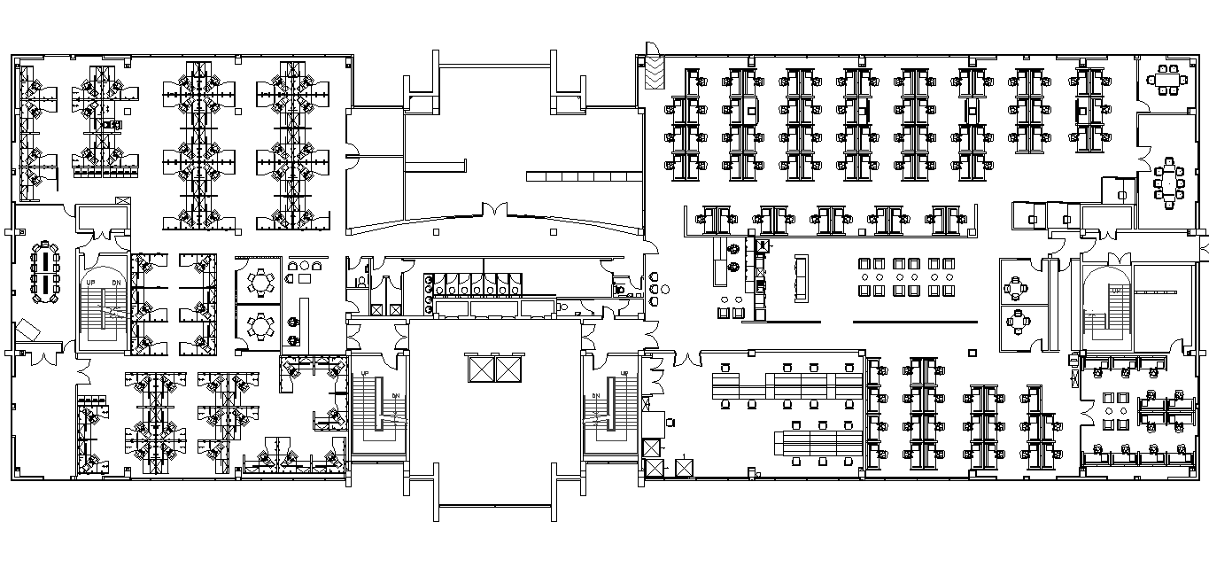Dromore House First Floor
W

E
W

Dromore House 2nd Floor
W

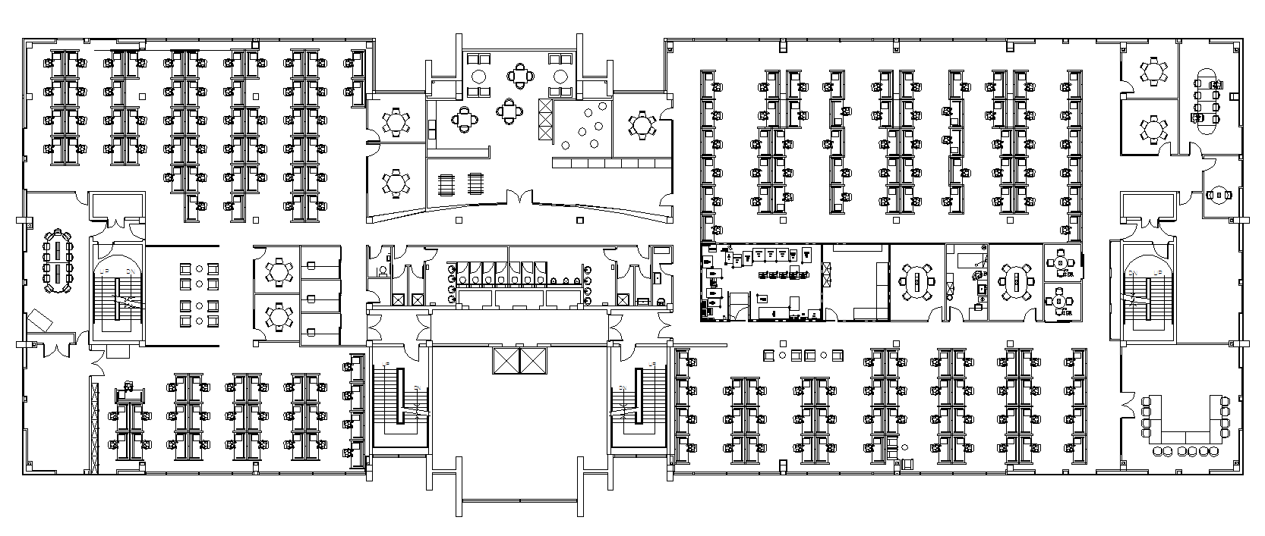

Dromore House:
The siren is scheduled to be tested at 10:30am on the 3rd Wednesday of every month. The siren sound is best described as a series of short high pitched beeps. Prior to the siren being sounded a security email announcement is made confirming that it is a test.

ERT Members, employees and managers have distinct responsibilities which are detailed below:

ERT Members:
- Sweep the building, both common areas and office areas, ensuring that all employees, visitors and contractors have left the building.
- Liaise between employees/managers and the ERT leader.

Employees:
- Know the evacuation procedure. It is posted at http://curam.ir.intel.com/index.php/safety
- Walk, don’t run to your nearest emergency exit and proceed down stairs to the assembly point in the car park (do not use the lift).
  - Do not stop to pick up personal belonging etc during an evacuation. Report any concerns you have to an ERT member.
  - Obey the ERT members. Do not leave the assembly point without ERT permission, and only re-enter the building on their approval.
  - You are responsible for your visitors and must guide them to the assembly point in the car park.

Managers:
- Ensure employees are familiar with the evacuation plan, nearest exit and assembly point.
- Ensure the evacuation plan is communicated to new hires on their first day.
- Plan for the safe evacuation of physically challenged employees.
Report concerns to ERT members.

Evacuation Procedure (“False evacuation scenario”)
If an alarm goes off, on any floor and we know it’s a false alarm, the following procedure has been agreed by the Site Safety Committee and Site Operation Committee
If the Alarm goes off for 30 sec or more, we evacuate that floor only, even if the alarm is killed off (which will be the case in a false alarm )
The ORT team on that floor make the call, if one ORT member makes the decision to evacuated, all other ORT will agree and go with the evacuation.
The other two floors will not be evacuated where it is a false alarm.

5.4 Anti-Bullying Owner: Site Operations Committee

Intel Shannon believes that everyone on site should be treated with dignity and respect.

Intel Shannon is committed to providing a workplace free of, bullying, sexual harassment, as well as harassment based on factors such as race, colour, religion, national origin, age, marital status, sexual orientation, disability, or membership of the traveller community.

Intel Shannon strongly disapproves of and will not tolerate harassment or bullying of any personnel on site by managers, co-workers or any other persons on site. Harassment is measured
in the context of the impact of the harasser's conduct, not his/her intent. All complaints of harassment, sexual harassment or bullying will be treated with fairness, sensitivity and in a confidential manner.

  - Stress Owner: Site Operations Committee

Intel Shannon understands that stress is the adverse reaction people have to excessive pressure or other types of demands placed on them. It can be caused by factors at work, outside of work or both. Based on data points to date there is evidence that symptoms of both positive and negative stress are being experiences by some employees across the site whether due to internal or external causes. Support systems are in place to provide assistance to employees who seek help by means of employees assistance programme.

5.6 Employee Assistance programme (EAP) Owner: Shannon Operations Committee

The employee assistance programme provides an external confidential service to assist employees who are experiencing personal and life difficulties (anxiety, stress, bereavement, depression, personality conflicts, chronic anger, bullying, post traumatic stress, alcohol/drug dependence and other additions). The EAP involves an initial assessment with referral as appropriate to one of the specialised treatment programmes.

Referral is voluntary. Any employee needing assistance may call the EAP coordinator directly on 1800 251 069. Others like the supervisor or manager may encourage access to the programme but the decision to avail of the programme rests firmly with the individual.

5.7 Pregnant Workers and New Mothers
Owner: Employee's Manager/EHS

Any reference to a pregnant worker or new mother in this section includes:
- Employees who are pregnant
- Employees who have recently given birth (not more than 14 weeks preceding a material date)
- Employees who are breast feeding (within 26 weeks of birth of child).

Intel Shannon is committed to ensuring the safest possible working conditions on site for all pregnant employees.

As the earliest stages are the most critical ones for the developing child it is in the employee's interest to let her employer know she is pregnant as soon as is possible. The employee should inform their supervisor/manager and payroll in writing as soon as the employee knows their exact leave commencement date but not less than 8 weeks before leave is due to commence.

As soon as formal notification of pregnancy, recent birth or breast feeding is received, a specific risk assessment will be carried out in the employee's area in consultation with the employee to assess any possible effect of work activities involving a risk of exposure to any physical, chemical agents or working conditions listed in Schedule 8 Chapter 2 of Part 6 of the Safety, Health and Welfare at Work (General Application) Regulations 2007 and to take account of any advice given by her GP, gynaecologist or obstetrician.

Based on the risk assessment, the employee will be advised on any preventative and protective measures to be taken to ensure a safe place of work.

A mothering room is available on 2nd floor in Dromore House.

5.8 Chemical Use Owner: Site Operation
Prior to use on site, all chemicals must be approved by the EHS Department to ensure they will be used safely, do not create a risk to the environment, and that the requirements to use and dispose of the chemical properly are understood and documented. Safety Data Sheets (SDSs) are maintained for all approved contractor chemicals and the folder is available from Site Operations.
Prior to purchasing the chemical, the requestor should send the MSDS copy and the EMEA Chemical Approval Form to EHS for formal approval.

5.9 Safety Training Owner: Site Safety Rep.

Intel Shannon in addition to technical training is committed to providing appropriate health and safety training for all employees and providing contractors and vendors with their requirements for training of their employees.

Identification of training needs is identified based on legislation, the tasks and their associated risks. Both instructor led, practical, on-line and refresh training is carried out. All employees receive induction training, New Employee Orientation (NEO) on commencing employment with Intel. Specialist training will be given to certain groups on site e.g. office response team, first-aiders. Specialist training is tracked by the site safety representative to ensure compliance.

5.10 Safety Management by Walkabout Audits (SMBWA)
Owner: Site Safety Committee

Intel Shannon recognises the need to have an internal inspection system to assess the day-to-day safety performance throughout the site.

Safety audits provide an effective means to discuss and inspect the actions of employees and workplace conditions as they affect safety; provide effective feedback amongst the workforce and raise the awareness of safety behaviours that all must comply with. The audits are designed to be a proactive approach to safe behaviour and to engage employees in conversation.

A structured format exists as regards auditing. There is an audit schedule drawn up by the site safety committee and each area carries out their audits in accordance with this schedule. Their performance is tracked by this schedule. Audit results are analysed to highlight or focus on behaviours or situations which need to be improved upon by the site safety committee.

As employees walk about carrying out the audit, they may observe unsafe behaviours or conditions in the area. A discussion follows with personnel involved as to the reason for performing work in the manner observed. Issues that arise which can be dealt with immediately are handled on the spot. Other issues, which cannot be, are assigned an owner and the area tracks actions until completion.

5.11 Safety Signage Owner: Site Operations Mgr.
Safety signs must comply with the Safety, Health and Welfare at Work (General Application) Regulations 2007 Chapter 1 of Part 7: Safety Signs at Places of Work. Signboards should not contain text as the symbols or pictograms on a signboard are intended to be understood, independently of the language ability of the worker viewing it. Text may be included on a supplementary signboard provided that it does not adversely affect the effectiveness of the safety signboard.
The shapes of the signboards are standardised:
- Discs for prohibitions and instruction,
- Triangles for warnings,
- Squares, and rectangles for emergency and informative signs.

Colour | Meaning or Purpose | Instructions and Information
Red | Prohibition sign | Dangerous behaviour.
Red | Danger alarm | Stop, shutdown, emergency machine off, evacuate.
Red | Fire-fighting equipment | Identification and location.
Yellow or Amber | Caution sign | Be careful, take precautions,  Examine.
Blue | Mandatory sign | Specific behaviour or action.  Wear personal protective equipment.
Green | Emergency escape, first aid sign | Doors, exits, routes, equipment, facilities.
Green | No danger/Positive action | Return to normal.

END OF INTEL SHANNON SAFETY STATEMENT.

