### Name: Danish Raja

### Roll no: RA2111003010478

### Btech CSE G1

## PROJECT NAME: MATRIX MULTIPLICATION USING C PROGRAM

A matrix that contains the same number of rows and columns then it is called a square matrix. Matrix is used to store a group of related data. Some of the programming languages are used to support matrices as a data type that offers more flexibility than a static array. Instead of storing the values in a matrix, it can be stored as an individual variable, a program can access and perform operations on the data more efficiently. In C programming matrix multiplications are done by using arrays, functions, pointers.

# Algorithm of C Programming Matrix Multiplication

**Step 1:**Start the Program.

**Step 2:**Enter the row and column of the first (a) matrix.

**Step 3:**Enter the row and column of the second (b) matrix.

**Step 4:**Enter the elements of the first (a) matrix.

**Step 5:**Enter the elements of the second (b) matrix.

**Step 6:**Print the elements of the first (a) matrix in matrix form.

**Step 7:**Print the elements of the second (b) matrix in matrix form.

**Step 8:**Set a loop up to row.

**Step 9:**Set an inner loop up to the column.

**Step 10:**Set another inner loop up to the column.

**Step 11:**Multiply the first (a) and second (b) matrix and store the element in the third matrix (c)

**Step 12:**Print the final matrix.

**Step 13:**Stop the Program

### FLOW CHART

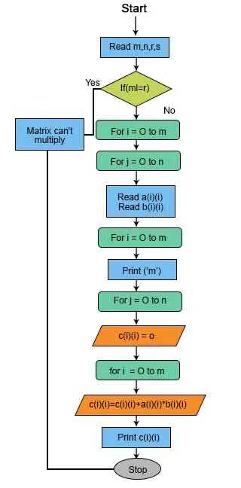

### OUTPUT

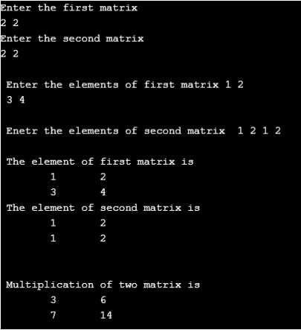Conclusion

Matrix multiplication is repeatedly used in programs to represents a graphical data structure, which is used to store multiple vectors and also it is used in many applications like solving linear equations and more. Lots of research has been done on multiplying matrices using a minimum number of operations.