[](https://www.genmymodel.com/)

# project

Author: netaneld88

Date: 2023-07-03

**IRMS - Interactive Restaurant Management System**

Author: Netanel Dahan

Location: Ashdod, Israel

Language: Python

# project (Model)

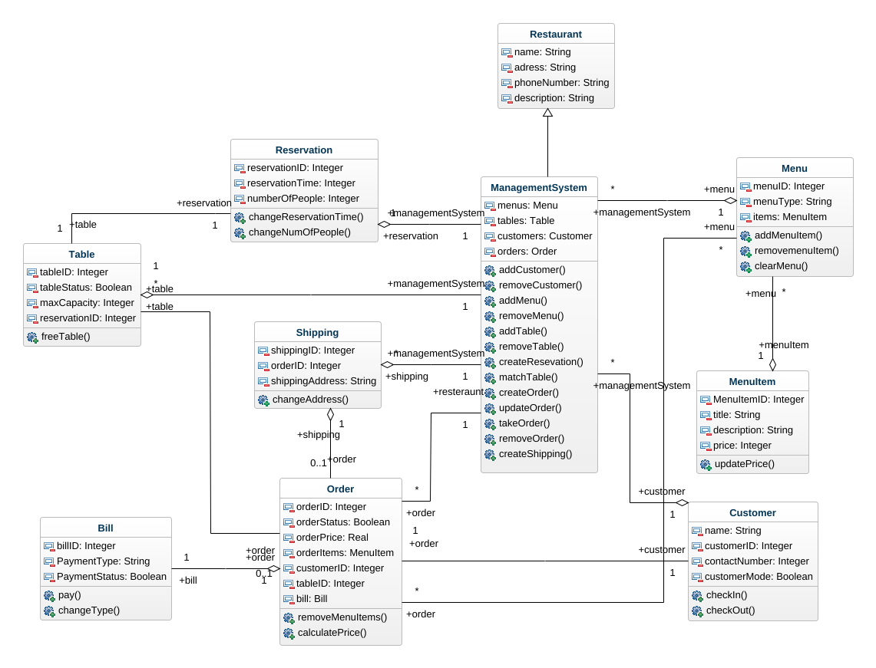

class-diagram

## 1. Bill (Class)

In project

| Attributes |
| --- |
| billID : Integer [1] |
| PaymentType : String [1] |
| PaymentStatus : Boolean [1] |
| Operations |
| pay |
| changeType |
| Associations |
| Order_Bill - order : Order [1] - see definition |

## 2. Customer (Class)

In project

| Attributes |
| --- |
| name : String [1] |
| customerID : Integer [1] |
| contactNumber : Integer [1] |
| customerMode : Boolean [1] |
| Operations |
| checkIn |
| checkOut |
| Associations |
| Customer_Customer - customer : Shipping [0..1] - see definition |
| Customer_Order - order : Order [1] - see definition |
| Customer_ManagementSystem - managementSystem : ManagementSystem [*] - see definition |

## 3. ManagementSystem (Class)

In project

Extends

* Restaurant - see definition

| Attributes |
| --- |
| menus : Menu [1] |
| tables : Table [1] |
| customers : Customer [1] |
| orders : Order [1] |
| Operations |
| addCustomer |
| removeCustomer |
| addMenu |
| removeMenu |
| addTable |
| removeTable |
| createResevation |
| matchTable |
| createOrder |
| updateOrder |
| takeOrder |
| removeOrder |
| createShipping |
| Associations |
| Resteraunt_Order - order : Order [*] - see definition |
| Reservation_ManagementSystem - reservation : Reservation [1] - see definition |
| Table_ManagementSystem - table : Table [*] - see definition |
| Shipping_ManagementSystem - shipping : Shipping [*] - see definition |
| Menu_ManagementSystem - menu : Menu [1] - see definition |
| Customer_ManagementSystem - customer : Customer [1] - see definition |

## 4. Menu (Class)

In project

| Attributes |
| --- |
| menuID : Integer [1] |
| menuType : String [1] |
| items : MenuItem [1] |
| Operations |
| addMenuItem |
| removemenuItem |
| clearMenu |
| Associations |
| MenuItem_Menu - menuItem : MenuItem [1] - see definition |
| Menu_Order - order : Order [*] - see definition |
| Menu_ManagementSystem - managementSystem : ManagementSystem [*] - see definition |

## 5. MenuItem (Class)

In project

| Attributes |
| --- |
| MenuItemID : Integer [1] |
| title : String [1] |
| description : String [1] |
| price : Integer [1] |
| Operations |
| updatePrice |
| Associations |
| MenuItem_Menu - menu : Menu [*] - see definition |

## 6. Order (Class)

In project

| Attributes |
| --- |
| orderID : Integer [1] |
| orderStatus : Boolean [1] |
| orderPrice : Real [1] |
| orderItems : MenuItem [1] |
| customerID : Integer [1] |
| tableID : Integer [1] |
| bill : Bill [1] |
| Operations |
| removeMenuItems |
| calculatePrice |
| Associations |
| Menu_Order - menu : Menu [*] - see definition |
| Resteraunt_Order - resteraunt : ManagementSystem [1] - see definition |
| Customer_Order - customer : Customer [1] - see definition |
| Shipping_Order - shipping : Shipping [1] - see definition |
| Order_Bill - bill : Bill [1] - see definition |
| Table_Order - table : Table [1] - see definition |

## 7. Reservation (Class)

In project

| Attributes |
| --- |
| reservationID : Integer [1] |
| reservationTime : Integer [1] |
| numberOfPeople : Integer [1] |
| Operations |
| changeReservationTime |
| changeNumOfPeople |
| Associations |
| Reservation_ManagementSystem - managementSystem : ManagementSystem [1] - see definition |
| Reservation_Table - table : Table [1] - see definition |

## 8. Restaurant (Class)

In project

| Attributes |
| --- |
| name : String [1] |
| adress : String [1] |
| phoneNumber : String [1] |
| description : String [1] |

## 9. Shipping (Class)

In project

| Attributes |
| --- |
| shippingID : Integer [1] |
| orderID : Integer [1] |
| shippingAddress : String [1] |
| Operations |
| changeAddress |
| Associations |
| Shipping_ManagementSystem - managementSystem : ManagementSystem [1] - see definition |
| Customer_Customer - customer : Customer [0..1] - see definition |
| Shipping_Order - order : Order [0..1] - see definition |

## 10. Table (Class)

In project

| Attributes |
| --- |
| tableID : Integer [1] |
| tableStatus : Boolean [1] |
| maxCapacity : Integer [1] |
| reservationID : Integer [1] |
| Operations |
| freeTable |
| Associations |
| Table_Order - order : Order [0..1] - see definition |
| Reservation_Table - reservation : Reservation [1] - see definition |
| Table_ManagementSystem - managementSystem : ManagementSystem [1] - see definition |