Record Lathe
Frame, transport and cutter head construction
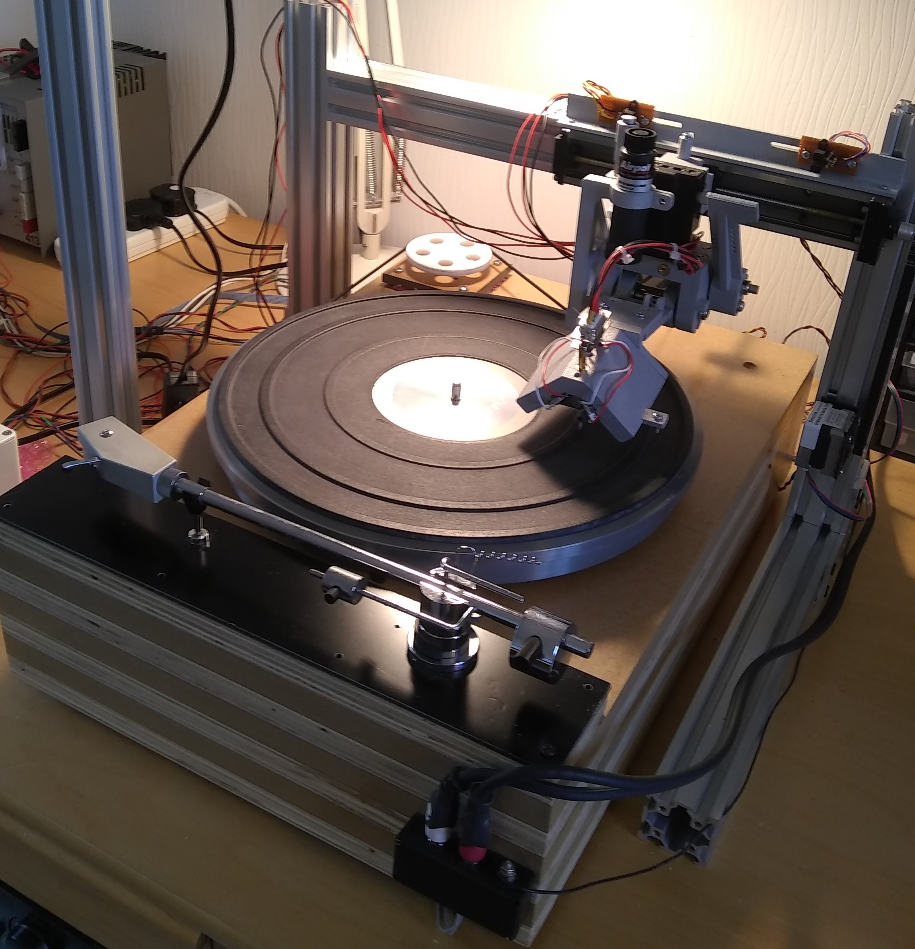
David Nelson
January 2022
Version 0.1


This work is licensed under the Creative Commons Attribution-ShareAlike 4.0 International License. To view a copy of this license, visit https://creativecommons.org/licenses/by-sa/4.0/
or send a letter to Creative Commons, PO Box 1866, Mountain View, CA 94042, USA.

This document is intended as a guide for the use of anyone who wishes to build a record lathe assembly using my FreeCad designs for a set of 3D-printed parts.

Disclaimer: this document is being made available, with the original FreeCad files, in the hope that they might prove useful. I am writing the document based on my after-the-event memory of what I did. The document and files are supplied as-is with absolutely no warranty whatsoever, and I can accept no responsibility for errors contained within, or for any difficulties arising therefrom, or for any inability to use any part of the systems described. Caveat lector!
Table of Contents
Parts list 4
Frame 4
Cutter head transport – main off-the-shelf parts 6
3D-printed parts 7
Small parts, fixings etc 11
Assembly 12
Frame 12
Cutter head transport 13
Attaching the Z-axis mount to the linear rail 13
Assembling the lever arm 13
Fitting the bearings 13
Fixing the Z-axis slide to the main bracket 14
Fixing the bearing plate to the main bracket 14
Fixing the lever arm to the main bracket 15
Fixing the cutter head counterweight 16
If using a swarf tube or dashpot: 16
Attaching the assembly to the linear rail 17
Sensor rail 18
Cutter head assembly 20
Fixing the cutter head to the bracket 23
Mounting the cutter head 23
Motor mounting 25
A word on turntables 26
Software 27

Parts list

Frame

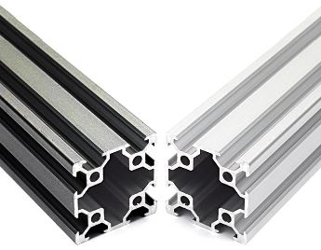
2 x 40x40 V-Slot Linear Rail, 300mm
3 x 40x40 V-Slot Linear Rail, 400mm
https://ooznest.co.uk/product/v-slot-linear-rail-40x40mm-cut-to-size/

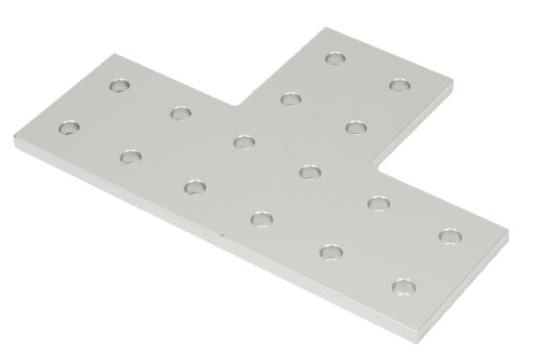
4 x Double T Joining Plate, 120 x 80mm, for 40x40 rail https://ooznest.co.uk/product/double-t-joining-plate/

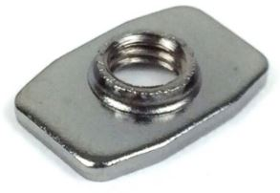
32 x M5 Tee Nut
7 x M3 Tee Nut
https://ooznest.co.uk/product/tee-nuts/

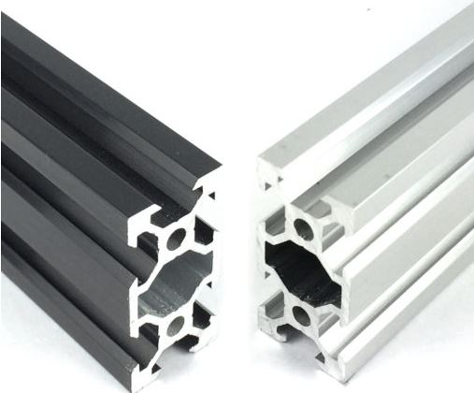
1 x 20x40 V-Slot Linear Rail, 750mm
https://ooznest.co.uk/product/v-slot-linear-rail-20x40mm-cut-to-size/

(This is to provide an upright to which a vivarium heat lamp can be fitted. If no heat lamp is required, then this part and the two Double L Brackets listed below can be omitted.)

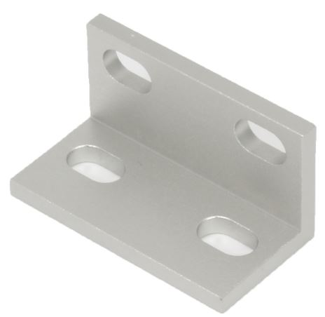
2 x Double L Bracket
https://ooznest.co.uk/product/universal-l-brackets/

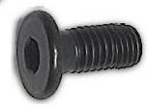
32 x M5 Low Profile Bolt – 8mm
https://ooznest.co.uk/product/low-profile-m5-bolts/

(Only 24 required if not using heat lamp)

Cutter head transport – main off-the-shelf parts
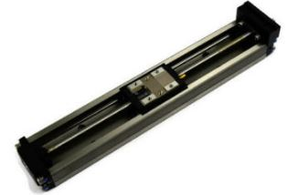
1 x THK linear slide, model KR2001, pitch 1mm https://tech.thk.com/upload/catalog_claim/pdf/cat_kr_en.pdf

(I bought mine second-hand from this eBay trader: https://www.ebay.co.uk/str/outlet3deu )

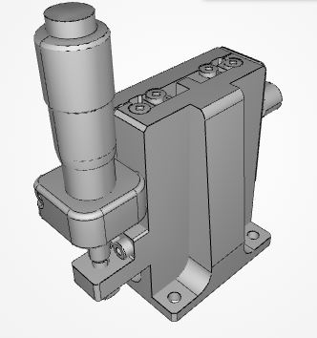
1 x Sigma Koki Z-axis linear slide, model TSD-403RL https://www.optosigma.com/eu_en/40x40mm-exc-bearing-steel-z-axis-stage-vertical-platform-horizontal-base-side-micrometer-6-5mm-m3-threads-right-handed-TSD-403RL.html

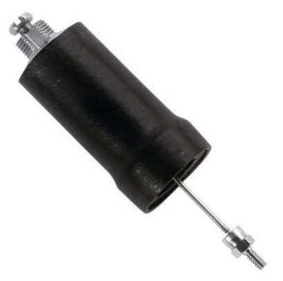
1 x Airpot push/pull dashpot, model 2KS160A2.0NF (L4574.A2000-TW) https://www.automotioncomponents.co.uk/en/catalog/linkages-rotary-components/pivot-bearings-air-motors-cylinders/cylinders/dashpots/l4574/l4574.a2000-tw/g+m+c+s+a+nr

Note that if substitutions are made for any of these parts, then it is likely that fixing holes, mounts or even the whole geometry of some of the 3D-printed parts will need to be changed.

3D-printed parts
All FreeCad 3D printing files are in the folder Construction.
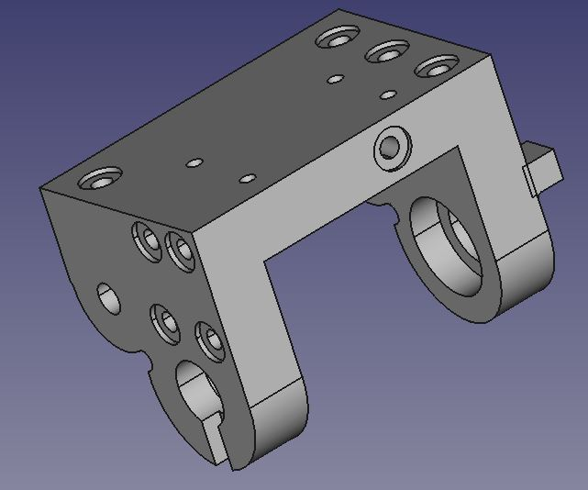Main bracket, showing the top, left side and front. (File: \Common\Main Bracket.FCStd)

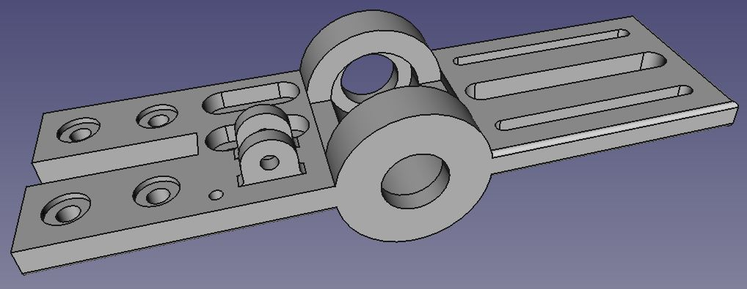Bearing plate. Four holes to front, three slots to rear. (File: \Common\Bearing Plate.FCStd)
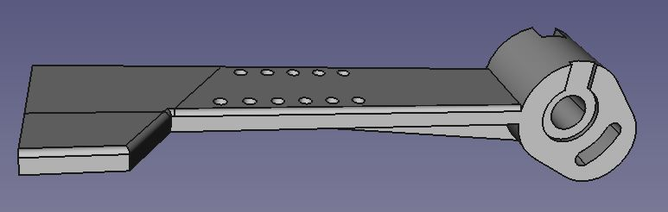Lever arm, seen from above right.(File: \Common\Lever Arm.FCStd)

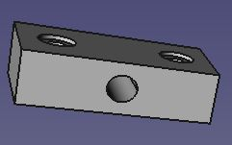Counterweight block (File: \Common\Counterweight.FCStd)
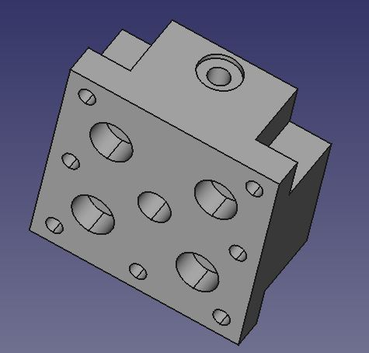Z-axis mount (File: \Common\Z-Axis Mount.FCStd)
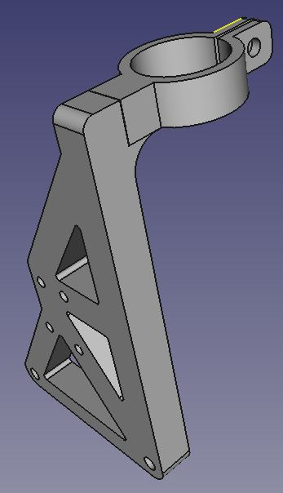Side bracket, seen from front left. (File: \Common\Side Bracket.FCStd)

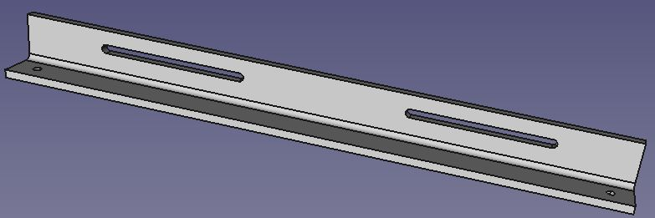Sensor rail (fits THK KR2001 linear rail assembly) (File: \Common\Sensor Rail.FCStd)

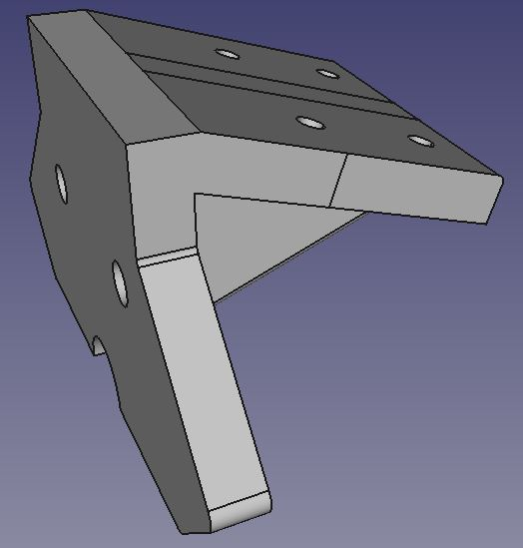Cutter head bracket (File: \TEAX19C01\BackBracket with 18deg Tilt.FCStd)

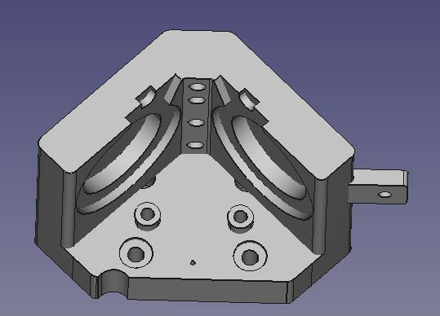Cutter head (File: \TEAX19C01\Cutterhead for TEAX19C01 with 18deg Tilt.FCStd)

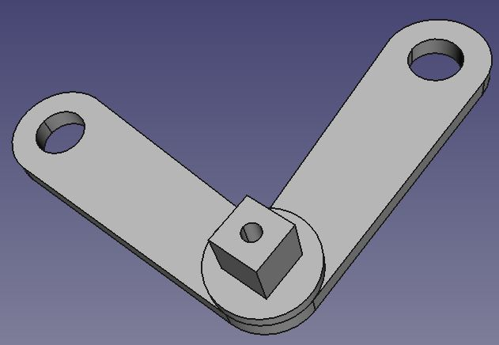V-spring (File: \TEAX19C01\VSpring1-2.FCStd)
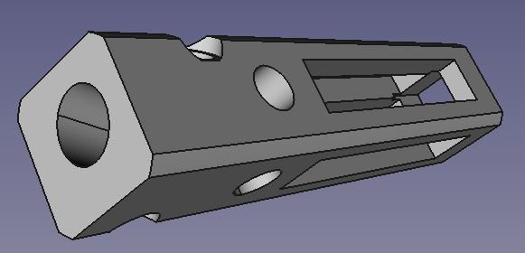Torque tube (File: \TEAX19C01\Torque Tube with 18deg Tilt.FCStd)
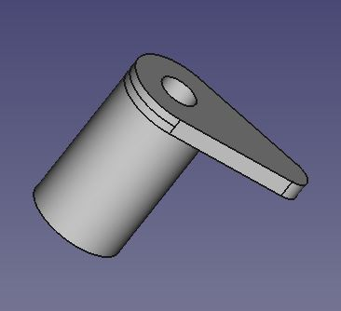Sensor trigger (File: \Common\Sensor Trigger.FCStd)
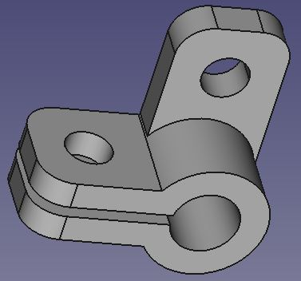Swarf pipe grip (File: \Common\Pipe Grip.FCStd)
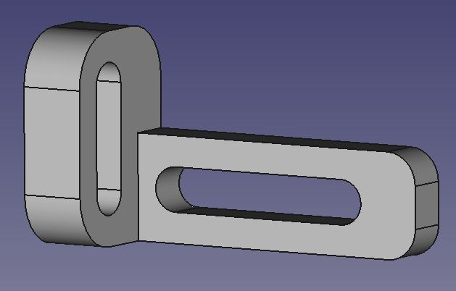L-slot for attaching pipe grip (File: \Common\L_Slot.FCStd)
The file \TEAX19C01\Assembly.FCStd shows the completed assembly.

This assembly assumes right-handed operation. If left-handed operation is preferred, the FreeCad drawings for the lever arm, the main bracket, the side bracket and the bearing plate will all have to be reflected left-to-right before printing, and the instructions that follow modified to take account of this.

Small parts, fixings etc

1 x Stainless steel rod, diameter 6mm, length 105mm
1 x Stainless steel rod, diameter 6mm, length 80mm
1 x Stainless steel rod, diameter 6mm, length 150mm
4 x Skate bearings, 626RS, ID 6mm, OD 19mm, length 6mm
21 x Flanged brass push-in inserts, for M3 machine screws
(specified as M3 x 4.1 (3mm Thread, 4.1mm length, 3.7 - 4.0mm Hole Diameter)).
2 x Flanged brass push-in inserts, for M5 machine screws
(specified as M5 x 10.1 (5mm Thread, 10.1mm length, 6.0 - 6.5mm Hole Diameter)).
8 x Oilite bearings, ID 6mm, OD 8mm, length 6.2mm
1 x Setscrew, M3 x 3mm
13 x collars with setscrew, ID 6mm, OD 10mm, length 5mm
1 x M4 machine screw, length 50mm
1 M/F pair DB9 connector
2 x M3 M/F stand-offs, 15mm
2 x audio exciters, Tectonic TEAX-19C01-8
https://uk.rs-online.com/web/p/speaker-drivers/8765266
2 x collars, ID 3mm, or a supply of penny washers (ID 3mm, OD no bigger than 12mm)
12 x large penny washers, ID 6mm, OD 30mm
2 x M2.6 screws, length 6mm
M3 and M4 screws, various lengths
Silicone-insulated wire, 24 or 26 gauge, various colours and lengths

Embossing stylus, Presto short-shank https://www.recordlatheparts.com/
Stepper motor, NEMA 14, and motor mounting bracket (Pololu P/N 2257: https://www.pololu.com/product/2257 or similar)
Round belt, 2.5 or 3mm, ID about 150mm
2 x round belt pulleys, OD 20mm, IDs to fit on stepper motor and linear rail, using adapters if required
4 x M3 anti-vibration mounts (M/F)
Cable clips with M3 fixing hole
50mm or so of steel wire, diameter 1mm
Aluminium sheet from drink can
Cyanoacrylate adhesive
J-B Weld adhesive
A roll of Sellotape

Assembly
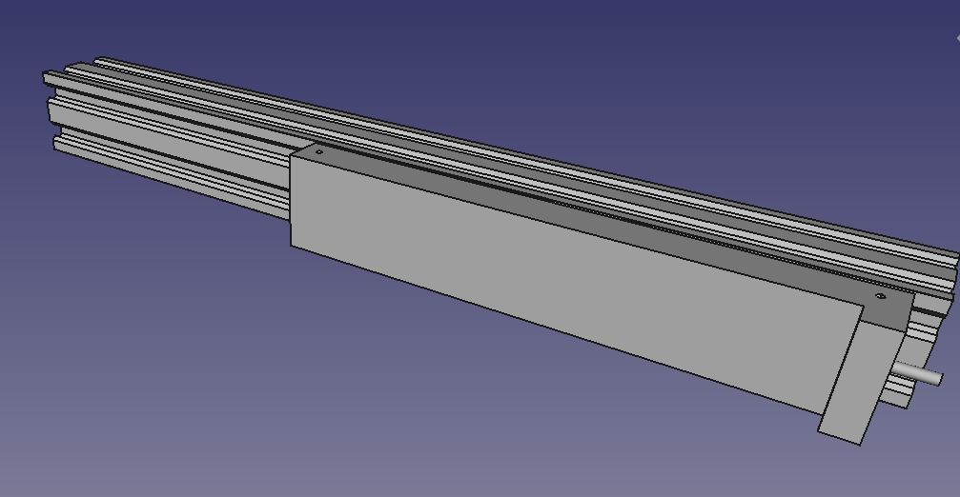Linear rail unit on V-Slot. (linear rail detail not shown)

Frame

Attach the linear rail unit (THK KR2001) to one of the 400mm lengths of V-Slot. The two rows of fixing holes on the KR2001 are spaced vertically such that it is not possible to use both for attaching to V-Slot, but I found that attaching using just one row was perfectly adequate and stable.
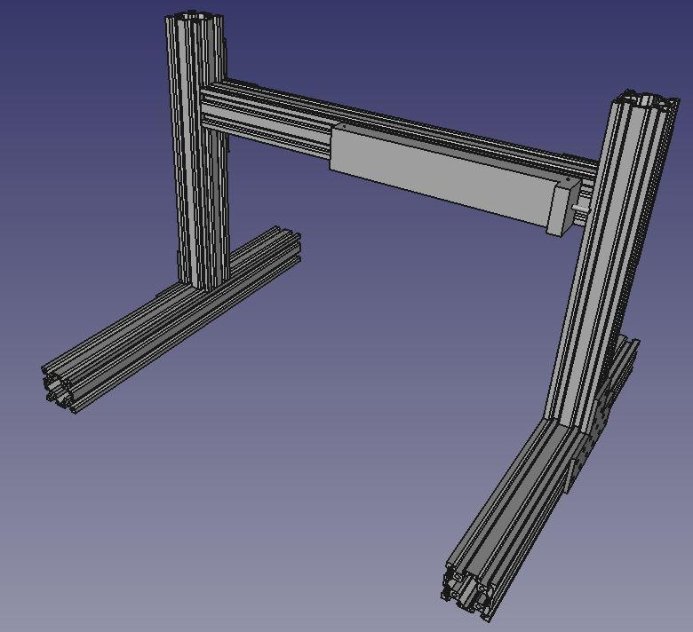Frame, from front
Slide three M3 tee nuts into the upper of the two horizontal recesses in the V-Slot, and screw the rail into place, moving the carriage (by rotating the shaft) as necessary to access the upper set of mounting holes. Make sure the rail is absolutely level with respect to the V-Slot.

You may need to move the unit along the V-Slot later; exactly where depends on how you organise the motor that is to drive the linear rail. (Note: you may want to fix the motor to one of the uprights now, rather than later, as locating the tee nuts in the V-Slot is far easier when the V-Slot is lying flat. You can adjust the exact position of the motor on the V-Slot later. See 'Motor mounting' section.)

Then assemble the rest of the frame. The 300mm lengths are the uprights. The double T plates have 16 holes. To fix each of these, six bolts and six tee nuts is sufficient, organised as two at each extremity of the T-plate.

The height of the crossbar with the linear rail will ultimately depend on the platter height of the recording turntable used. For the moment, fix it near the top of the uprights.
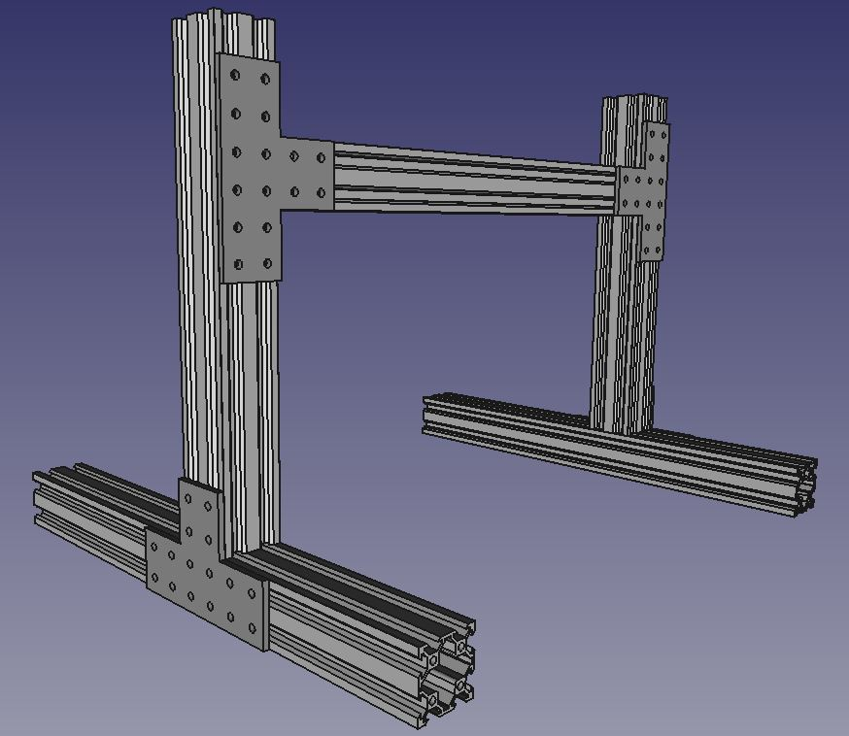Frame, from rear

Cutter head transport

Carefully push or tap in the brass inserts:

Main bracket 9 x M3
Bearing plate 4 x M3
Counterweight attachment 2 x M3
Lever arm 1 x M3
Cutter head 4 x M3, 2 x M5
Z-Axis mount 1 x M3

You may have to enlarge the holes for these with a hand-drill or reamer. The inserts should go in with a thumb-push, or at the most a gentle tap from a small hammer. Make sure the area being struck is fully supported (with a piece of wood, edge of table top or similar) so that pieces do not break off.

Attaching the Z-axis mount to the linear rail
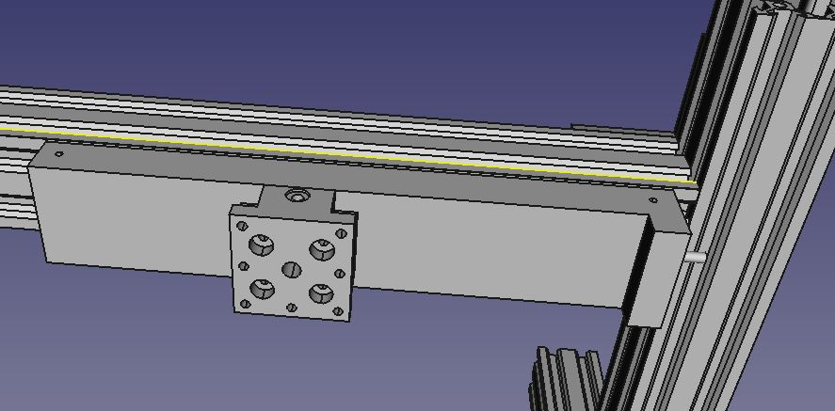
Use four M3 20mm screws, with washers, to fix the Z-axis mounting block to the carriage of the linear rail. Take care to orientate the block so that the mounting hole for the sensor trip flange is at the top.

Assembling the lever arm

Take an M4 50mm screw and place a washer on it, and pass it, from the right-hand side, through the arcuate slot beneath the bearing hole on the lever-arm. Place a hex-nut on to the bolt, and tighten so that the nut nests in the recess on the left-hand side of the arm. Do not over-tighten, as this will need to be adjusted later.
Take an M3 15mm screw and place two 3mm collars on it, then screw it into the brass insert on the rear of the arm. This will act as a counterweight to the arm's own weight when it is raised.

Fitting the bearings

Use a good adhesive to glue a 626RS bearing into each of the two wells on the bearing plate, and into each of the wells on the main bracket. Take care not to get any glue on the bearing hub. In each case, before the glue sets hard, insert one of the steel rods through both bearings to make sure everything is aligned and that nothing is binding. (You may have to sand the rod with a fine paper so that it slides through easily.) Once this has been checked, remove the rods.

Fixing the Z-axis slide to the main bracket

Take four M3 20mm screws, fit a washer on each, and pass them, from the underside, up through the top plate of the main bracket. Attach the base of the Z-axis slide, orientating it so that its vertical square plate is to the rear, and fix the slide securely to the main bracket using washers and nuts.

Fixing the bearing plate to the main bracket

Pass the 80mm steel rod through the right-hand front bearing on the main bracket. Once the end of the rod is inside the bracket, present the right-hand bearing hole of the bearing plate to it, and push the rod through until it is just inside the bearing plate. Place two 6mm collars on to the rod, then pass the rod end through the left-hand bearings of the bearing plate and main bracket.
Make sure that the rod is centred with respect to the main bracket, place an Oilite bearing and 6mm collar on either end, and tighten. Adjust the position of the bearing plate within the bracket so that it is centred (leaving a 2mm gap either side), then carefully move the inner collars so that each bears hard against the bearing hub within the bearing plate. Tighten both collars firmly. The bearing plate must be absolutely free to rotate in its bearings, but it must not be capable of any side-to-side movement along the rod; nor must the rod itself be able to slide along its own axis.
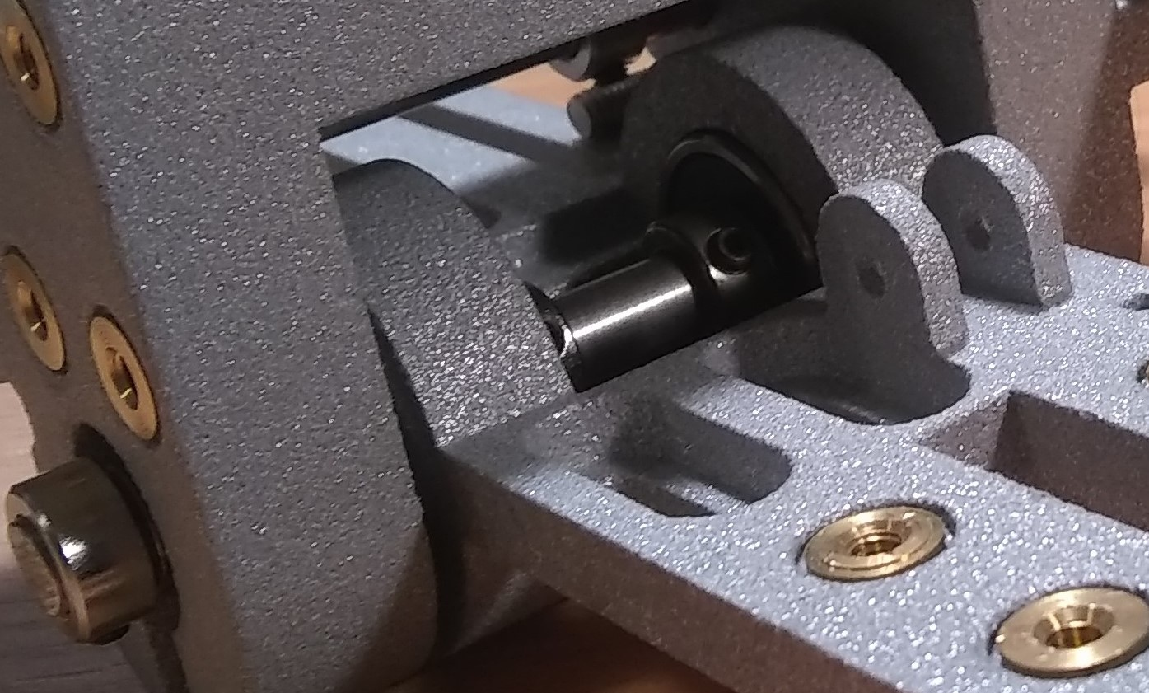Bearing plate mounted in main bracket. Note position of collars.

Fixing the lever arm to the main bracket

Pass the 105mm steel rod through the right-hand rear bearing hole on the main bracket. Once the end of the rod is inside the bracket, place on to the inside end two Oilite bearings, two 6mm collars and two more Oilite bearings. Then pass the rod through the left-hand rear bearing hole. Push the two pairs of Oilite bearings, as far as they will go (this isn't very far; most of the second bearing in each case will still be visible), into the left- and right-hand recesses on the inside of the bracket, and fix one of the two 6mm collars firmly against each pair. Ensure that all the excess length of the rod protrudes from the right-hand side of the bracket. Tighten the setscrews on both collars so that the rod cannot move axially. It should, of course, be free to rotate within its bearings.

On the right-hand end of the rod, place one 6mm collar and two Oilite bearings, and, presenting the left-hand side of the bearing hole of the lever-arm, slide the lever-arm on. Place a further 6mm collar on the right-hand side of the lever-arm. Adjust the distance between the arm and the main bracket (1 – 2 mm) so that the arm rests on the small oblong projection on the right-hand side of the bracket, and tighten both collars so that the arm does not slip along the rod.

The position of the 50mm bolt through the arm should be carefully adjusted, so that:
- When the arm is horizontal, in the down position, the bolt must be clear of the bearing plate.
- When the arm is raised, at the start of its travel, the bolt pushes the bearing plate down at the rear so that its front part rises.
- When the arm reaches an angle of about 30 – 40 degrees off horizontal, the bearing plate stops rising. Raising the arm further, to about 55 – 60 degrees, allows the bearing plate to descend slightly. This means that when the arm is raised with the cutter head installed, its weight will lock the arm in the raised position. (If the cutter head is very light, its weight will not be sufficient to do this, and the arm will fall: in which case add more weight (large penny-washers) to the counterweight at the rear of the lever arm.)
For best results, the threaded part of the bolt should be covered in some smooth material, such as cable insulation or shrink-wrap, to minimise friction between the bolt and the bearing plate.
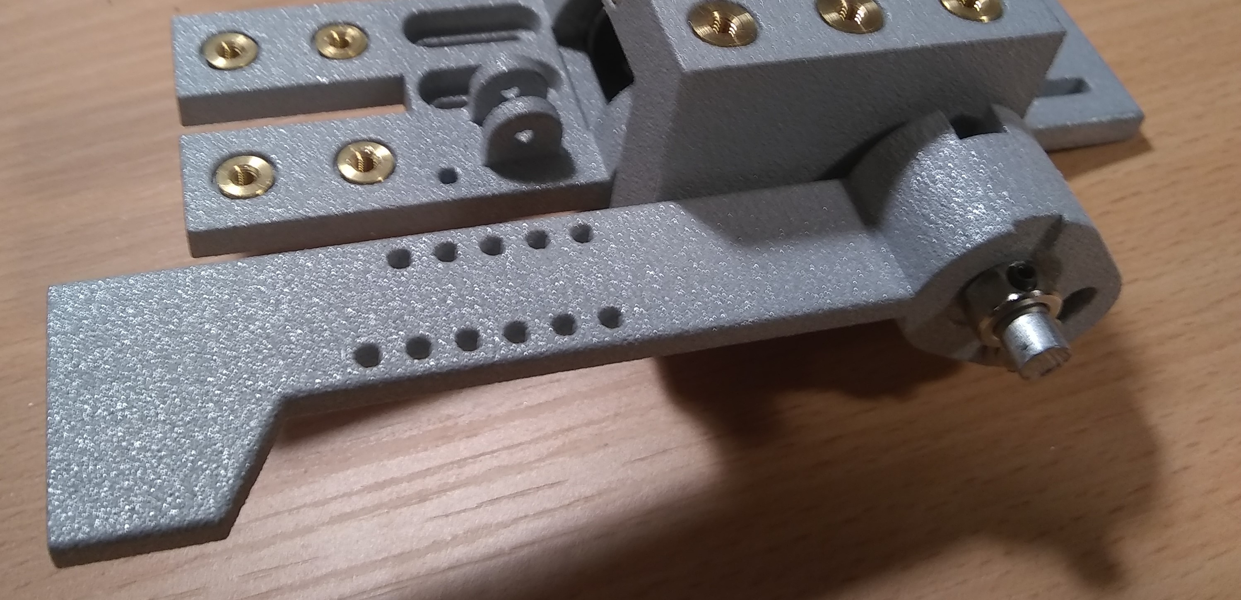Lever-arm on main bracket.

Fixing the cutter head counterweight

Insert the 150mm stainless steel rod into the 6mm through hole in the counterweight block until it just emerges at the other side. Fix one 6mm collar on to the rod either side of the block, so that it cannot slide along the rod.
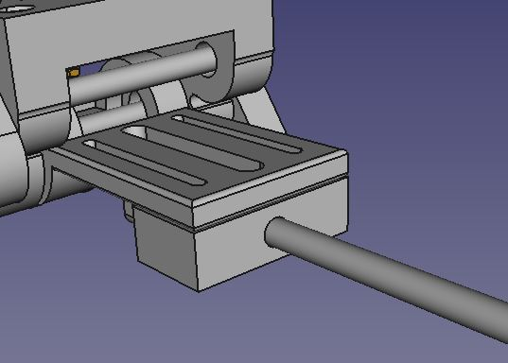Counterweight rod in position, seen from rear. (Collars and small parts not shown)

Take two M3 12mm screws, fit washers, and pass each through the left and right (narrow) channels at the extreme rear of the bearing plate. Screw these into the brass inserts in the counterweight block. The steel rod must project to the rear. You can use several large penny washers, sandwiched between 6mm collars, as a counterweight. Fix a third collar at the very end of the rod: this should be left fixed in place, so that the collection of washers cannot fall off while the weight is being adjusted.

If using a swarf tube or dashpot:
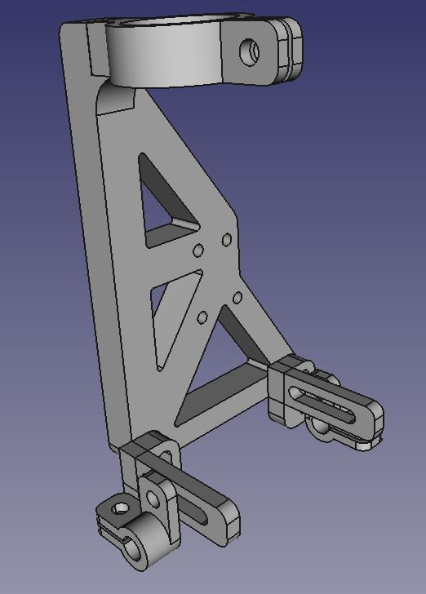Side bracket showing positions of swarf tube grips and brackets (nuts and bolts not shown)

The parts are designed for a swarf tube of OD 6mm and the dashpot listed in the parts list.
If you will be using a swarf collection tube:

The tube will have to be bent, and its open end flattened somewhat, so that its open end lies about 2mm behind the stylus when the cutter head is on the disc.
With M4 screws, washers and nuts:
Fix the two tube grips to the two small L-shaped brackets.
Fix the L-shaped brackets to the side bracket.

Fix the side bracket to the main bracket using four M3 screws. The dashpot can then be fitted to the side bracket, its piston rod passing through the left-hand slot in the bearing plate and being secured under the bearing plate using the nut supplied with the dashpot.
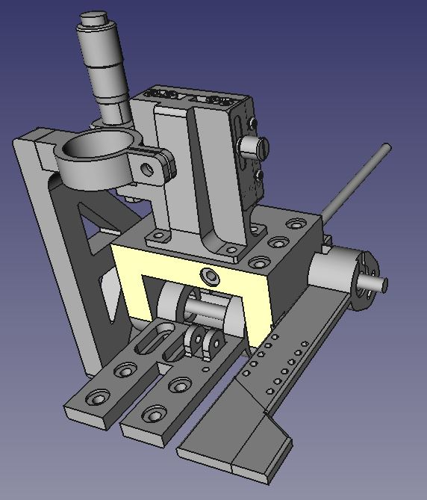Carriage assembly, showing main parts. (Inserts, collars and other small parts are not shown.)

Attaching the assembly to the linear rail

Take four M3 10mm screws and, passing them from the rear through the Z-axis mounting block (by now attached to the linear rail), attach it to the square vertical platform of the Z-axis slide. This is quite fiddly to do, as the screwdriver must be held at an angle to the screw heads while driving the screws in. Aim to get all four screws at least threaded first, and then tighten them.

Sensor rail

The sensor rail is designed to accommodate two small circuit boards, each with a photointerrupter, to prevent overruns at either end of the linear rail. The sensor flange fixes to the top of the Z-axis mounting block, and during operation it passes along the sensor rail at exactly the height of the mounting channels in the rail. Two simple circuits can be built on stripboard using HY870P photointerrupters and mounted on the rail, and the output of these should be linked to the linear rail driving logic. Take care to organise the positions of the photointerrupters and stripboard so that the sensor flange passes through without bumping into anything.

The sensor rail attaches to the top of the KR2001 linear rail with two M2.6 screws. Also fix the sensor trigger to the top of the Z-axis mount using an M3 screw.
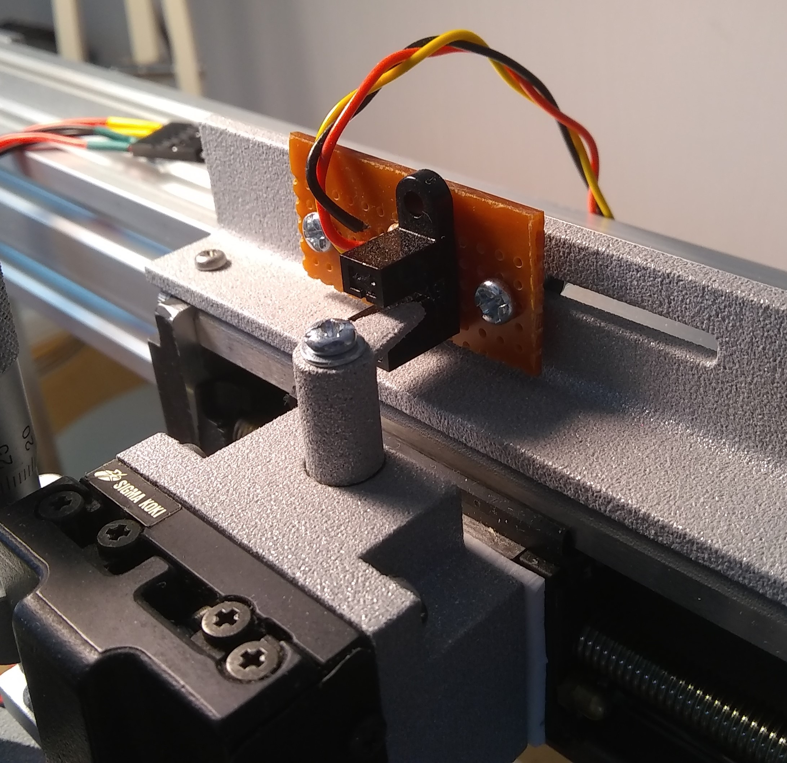Photointerruptor circuit mounted on sensor rail, showing position of trigger flange.

At this point the construction should look like this:

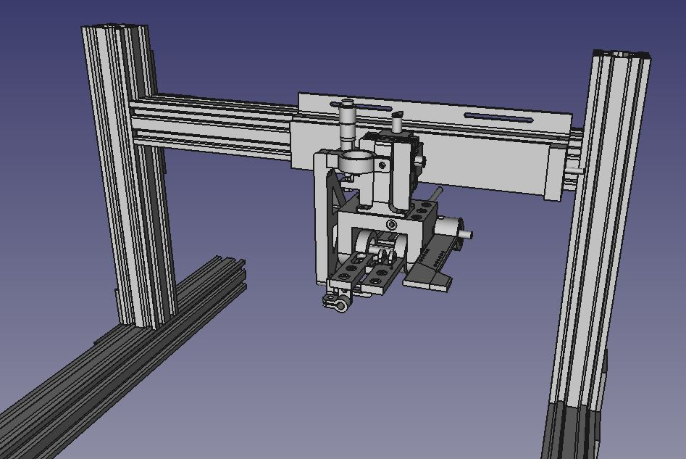

Cutter head assembly

As construction using cyanoacrylate glue or J-B Weld adhesive is non-reversible, it is strongly advised that you carry out several 'dry runs' of the assembly of this stage before proceeding with gluing. You can use Sellotape or Blue Tack to hold things temporarily in place.

Tap the M3 hole at the front of the torque tube. Note that the hole is at an angle of 18° with respect to the top edge. Check that your stylus will fit in the stylus hole, and that the M3 setscrew holds it in place so that it does not move or fall out. Remove the setscrew and the stylus.
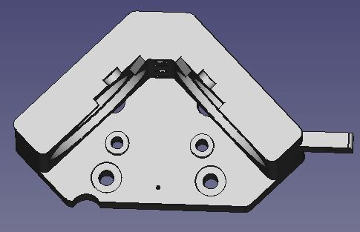
Using a hand-drill, open up the tiny 1mm hole at the rear of the head, directly behind where the torque tube goes. Make sure that the 1mm steel wire will pass through.

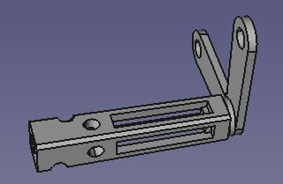
Fix the torque tube to the V-spring, mating the square projection on the V-spring with the recess at the rear of the tube, and ensuring correct orientation of the stylus hole.

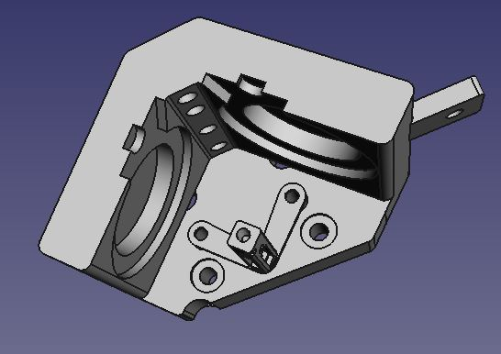
Using M3 screws, washers and nuts, attach the V-spring to the round projections at the inside rear of the cutter head. Insert the 1mm steel wire through the small hole in the rear of the head so that it passes through the V-spring and enters the rear of the torque tube.

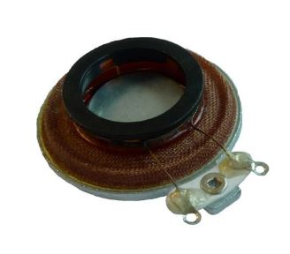
Remove the adhesive cover-sheet and all the self-adhesive material from the black ring on each of the TEAX19C01 drivers. The adhesive is very easy to remove.

Place a driver into each of the recesses in the left and right of the cutter head, orientating both so that the wire terminals project at the front. You may need to tape the drivers in position while you carry out the next stage.

You now need to establish the correct dimensions for the two cones that will be mounted on the drivers. I recommend this site: http://www.wegmuller.org/cones/ as it calculates what the net of the cone should look like and generates a PDF that you can print out. Start with a base of 20mm, and height 14mm, and make several cones of slightly different dimensions. You can use thin card or even paper for this. Make up the cones using small pieces of tape, and try each in turn between the driver ring and the recess on the torque tube, until you find the size that fits best. You want the tip of the cone to just nestle inside the torque tube recess, without putting any pressure on either the tube or the driver. When you are happy with the cones, make up the real ones using thin aluminium sheet (ex drink can) and cyanoacrylate glue. (Wear disposable gloves for this step!)

When the glue has set – which it does in seconds – try the finished cones between the driver and torque tube again. If they're not quite right, make up some more cones and have another go: you want this bit to be as near perfect as possible.

When you're happy with the way things fit together – and not before – remove the cones and drivers from the head, and use J-B Weld to fix
- the rear of the torque tube to the projection on the V-spring;
- the steel wire to the V-spring and cutter head body
and allow to set.

Orientate the head so that one of the driver recesses is horizontal. Use J-B Weld to fix
- the driver into its recess;
- the base of the cone on top of the black ring on the driver;
- the apex of the cone into the torque tube recess.
Check that the cone is centred on the driver ring, and that the torque tube remains absolutely level and square with the edges of the body. Allow adhesive to set, then repeat this step for the other driver and cone.

Solder wires to the terminals of the drivers, and solder the wires to four of the terminals of a DB9 connector. Which four you use is up to you, but make a note of which wire has gone where. (The remaining terminals can be used later, for a heater circuit (for cutting), and LEDs if you want to mount one or two inside the head. Two mounting holes are provided in the top of the head for the latter.) Insert two 15mm standoffs into the two brass inserts on the top of the head, and fix the DB9 connector to these with M3 screws.

The wires from your amplifier should be terminated in the complementary DB9 connector. I recommend using wire with silicone insulation as it is very flexible. The wires should be gathered together using cable clips with an M3 screw hole: they can thus be fixed to the top of the main bracket using one or more of the brass inserts – see picture below.

Fixing the cutter head to the bracket
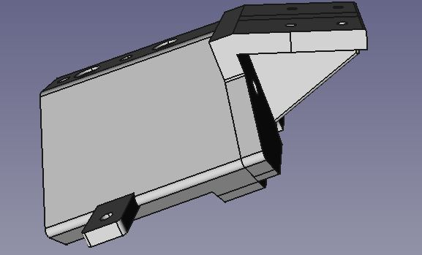
The completed head can now be fitted to the cutter head bracket. Pass two M5 screws through the rear of the bracket (the inside of the L-shape) and screw these into the brass inserts on the rear of the head.

Mounting the cutter head
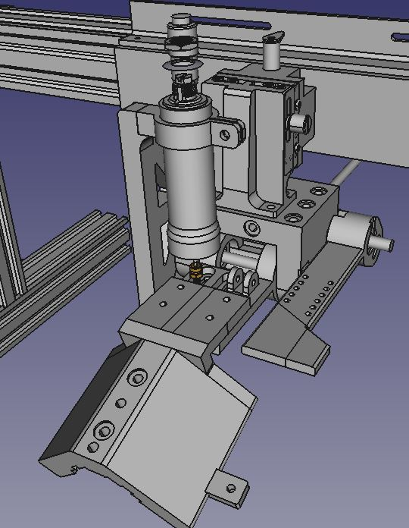The cutter head and its bracket in position on the bearing plate. (Small parts not shown)
Pass four M3 screws through the holes on top of the cutter head bracket, and screw these into the brass inserts on the front end of the bearing plate.

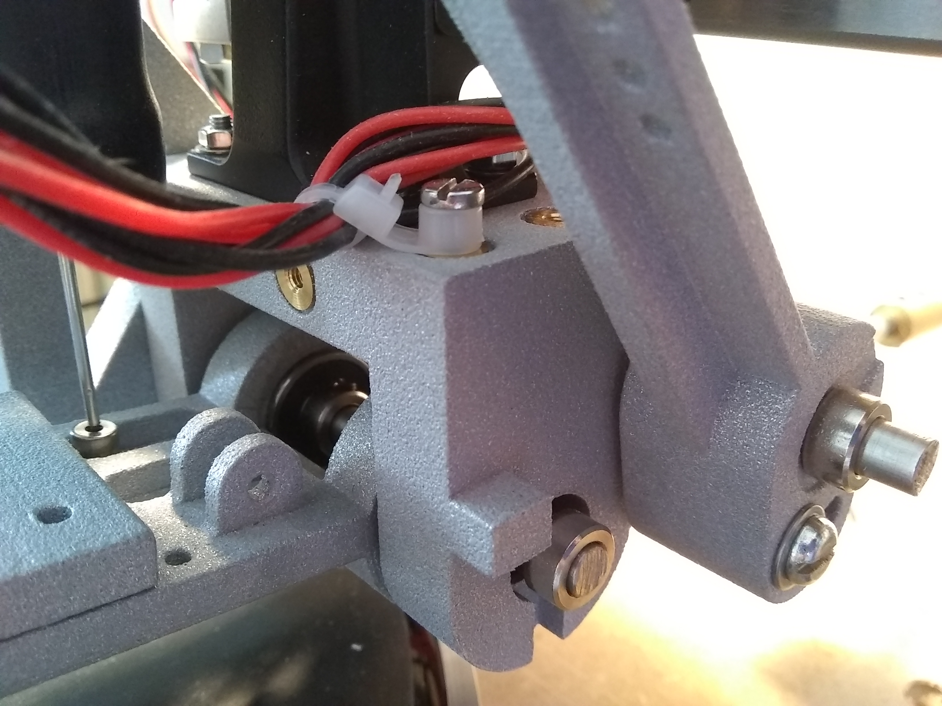Main bracket with bearing plate and lever-arm. Just visible on the left is the cutter head bracket, and behind it the dashpot piston rod and side bracket. To avoid the amplifier wires fouling on the lever-arm they can be clipped together and fixed to the top of the bracket, as shown here.

Motor mounting

How you do this is entirely up to you, but you are going to need some kind of anti-vibration mounting, particularly if the motor will be attached to the frame.
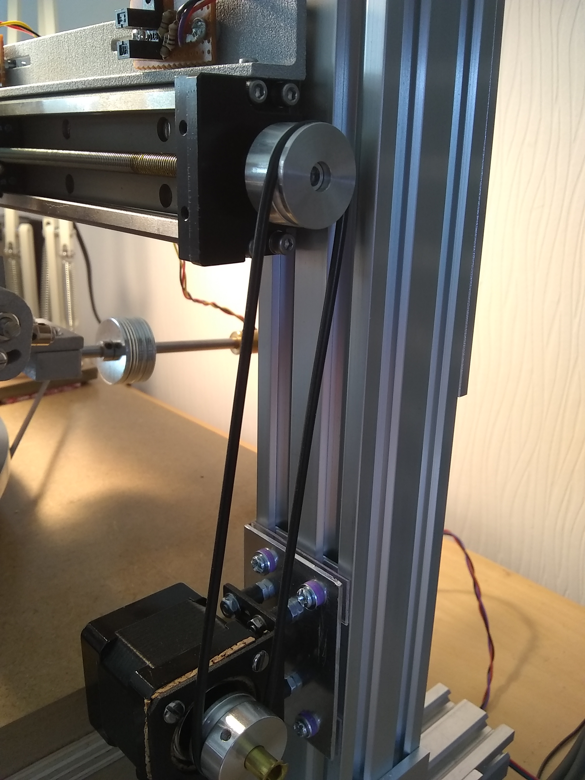Motor and belt assembly. Working from motor towards frame: motor, thin cork sheet, Pololu bracket, M3 anti-vibration mounts, small aluminium plate, M3 screws, silicone grommets (purple), small oblongs of clear polycarbonate, V-Slot.
Note also the large penny-washers acting as a counterweight for the cutter head!

My solution was to attach the motor in its bracket by anti-vibration mounts to an oblong of aluminium plate, which is itself fixed to the frame by four M3 screws passing through rubber grommets. Two tiny sheets of polycarbonate were fitted between the grommets and the frame, so that there was a surface for the grommets to bear against.

I have used a round belt and suitable pulleys for transmission. I originally had an MXL timing belt but I found that it added noise, which was coming out as rumble on my recordings. The round belt is left fairly slack, with just enough tension to turn the linear rail pulley.

(For driving the motor I used the Trinamic TMC2208 stepper driver, controlled by an Arduino Uno. The TMC2208 can be programmed to micro-step the motor almost noiselessly.)

A word on turntables
In my earlier experiments with disc recording, I found that there are very few domestic record players available that can provide sufficient torque (or, informally, rotational force) to the turntable platter. A record deck is designed to cater for a tracking force imposed by the pick-up of up to about 8 grams at the most; the embossing stylus I use recommends 35 to 40 grams in order to impress a groove in soft polycarbonate plastic. An average domestic record player will struggle under such a load, certainly slowing down if not coming to a stop altogether.

I've heard (mostly) good things about certain direct-drive DJ decks such as the Technics SL-1200, but decided to make my own deck using a stepper motor and the arm and platter from a scrapped Lenco L75. This is simply a solid block of layers of MDF and plywood, with holes bored throughout for the bearing, arm wires and motor.

Whichever turntable you use, you will need to adjust the height of the crossbar of your lathe frame so that the recording stylus meets the blank disc at the correct angle. Move the crossbar into the approximately correct range, tighten the bolts holding it in place, ensuring that it is level, and then use the Z-axis slide for finely adjusting the carriage height. You will also need to position the turntable and lathe frame so that the stylus point is exactly on a radius of the platter, and remains on the radius as it moves gradually towards the centre of the platter.

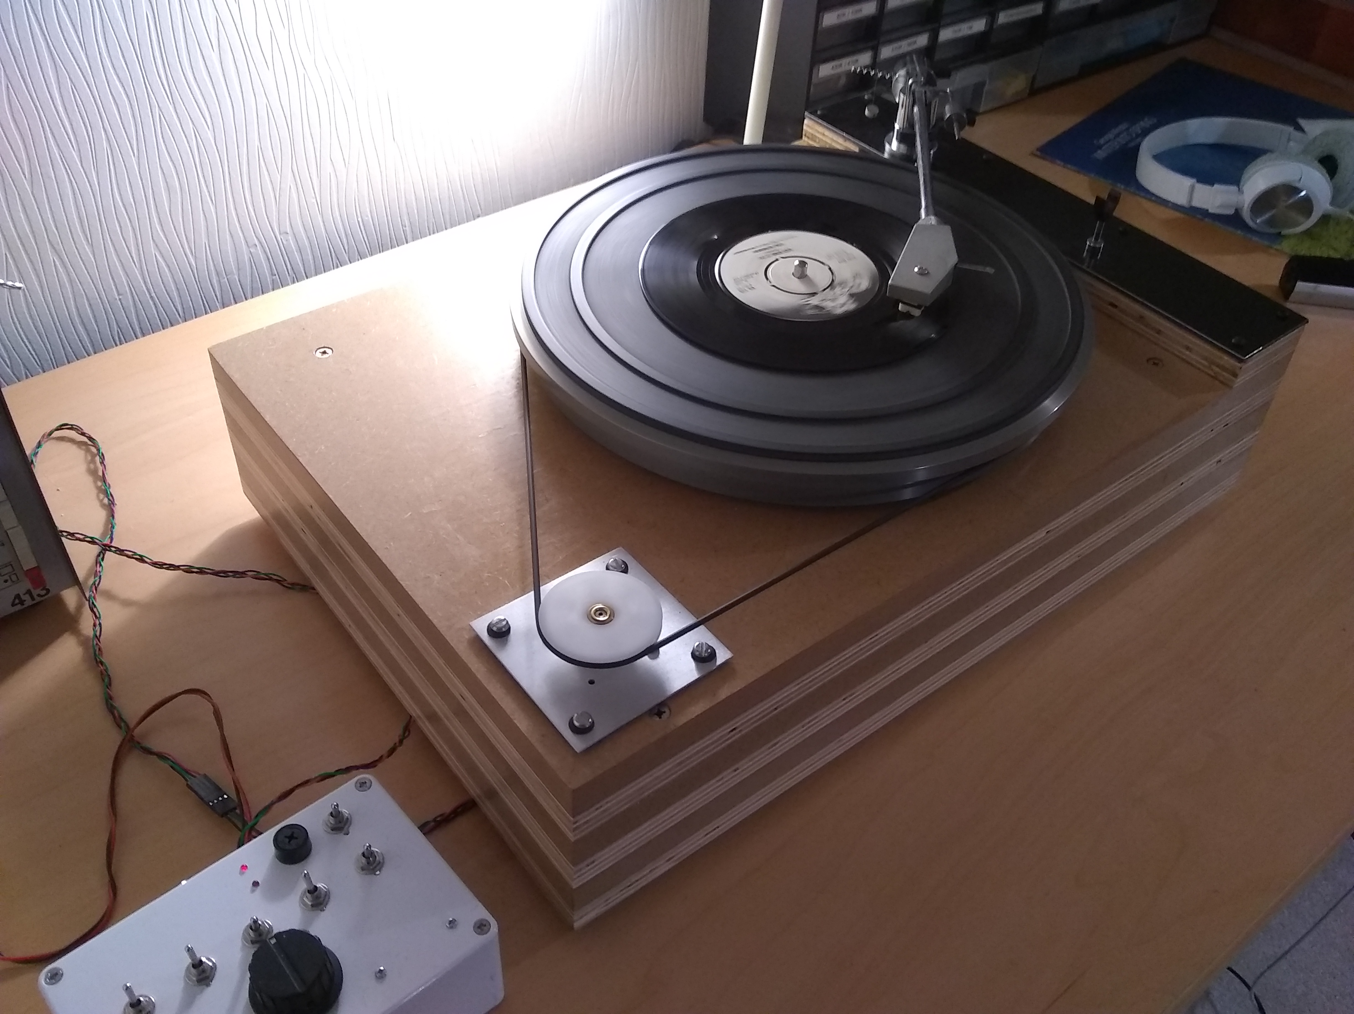My turntable deck, built out of DIY boards and bits of old Lenco. The platter is driven by a stepper motor and micro-step capable driver.

Software
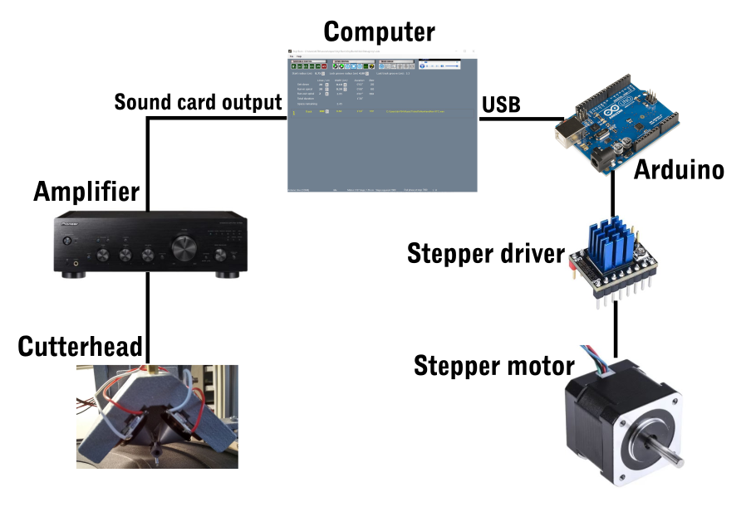
The basic building blocks of my lathe system are shown in the above image. An Arduino controls the stepper motor driver, thus advancing the cutter head carriage along the linear rail at a speed set by the user on a PC to which the Arduino is linked by USB.

The C# software (“Vinyl Burn”) runs on the PC, and enables a record side to be planned, which sound files to use for each track and the groove pitch for each track. The data for the whole side is recalculated whenever any setting is changed. When the 'Cut record' icon is clicked, the software plays the files in the specified order through the PC's sound card, while sending signals to the Arduino which tell it how fast to advance the stepper motor. The Arduino returns signals based on the number of steps made, which enable the PC to keep track of what is going on and send a new set of signals if required – for example, to increase the motor speed for an inter-track gap.

I have included my C# and Arduino code in this package. Be aware that these programs are extremely unlikely to run at all without extensive rewriting to suit your own hardware, motors, logic circuits etc. They are included merely as a possible starting point for your own project.

