Report

10 Academy - KAIM -

Week 1

Natnael Yilma

25th November, 2025

Predicting Price Moves with News Sentiment
Comprehensive multi-branch analysis for Nova Financial Solutions (Setup, Task-1, Task-2, Task-3). Generated directly from the repository snapshot.

1. Introduction
Nova Financial Solutions curates a large-scale Financial News and Stock Price Integration Dataset (FNSPID) to connect qualitative headlines with quantitative market moves. The repository combines data engineering modules, exploratory notebooks, technical analysis scripts, and sentiment/price correlation tooling. This report consolidates branch deliverables, exploratory findings, diagrams, and recommendations.

2. Business Objective
Deliver a reproducible workflow that ingests analyst/news headlines, enriches them with NLP-derived structure, couples the insights with equity OHLCV data, and primes downstream models to predict price moves driven by sentiment shocks.
- Standardize the environment setup path so analysts can recreate the toolchain quickly.
- Run exhaustive Exploratory Data Analysis (EDA) on the news corpus to surface publication behavior.
- Compute high-fidelity technical indicators for flagship tickers as modeling covariates.
- Prototype sentiment-versus-return correlation to validate that aggregated news tone is predictive.

3. Independent Discussion of Each Git Branch

3.1 Setup Branch
Defines the repository layout (data/, src/, scripts/, notebooks/, output/), dependency manifest (requirements.txt), and bootstrap instructions (INSTALLATION_INSTRUCTIONS.md, PACKAGE_INSTALLATION.md). GitHub Actions ensures dependencies at least install on CI.
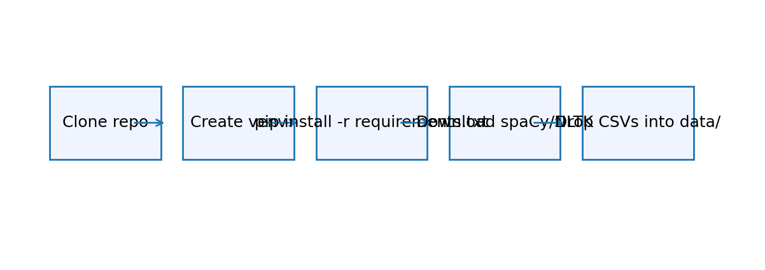
Figure: setup_flow.png

3.2 Task-1 Branch (News EDA)
Implements DataLoader, EDAAnalyzer, TopicModeler, and PublisherAnalyzer. scripts/run_eda.py orchestrates preprocessing, descriptive stats, temporal profiling, spike detection, LDA/BERTopic modeling, and publisher/topic exports saved under output/data/.
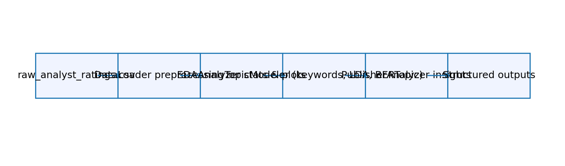
Figure: task1_flow.png

3.3 Task-2 Branch (Technical Analysis)
scripts/technical_analysis.py loads ticker OHLCV (e.g., AAPL.csv), cleans anomalies, applies TA-Lib indicators (SMA/EMA/RSI/MACD/Bollinger/ATR) and PyNance risk metrics (returns, volatility, Sharpe). It produces dashboards, a correlation matrix, and summary metrics JSON.
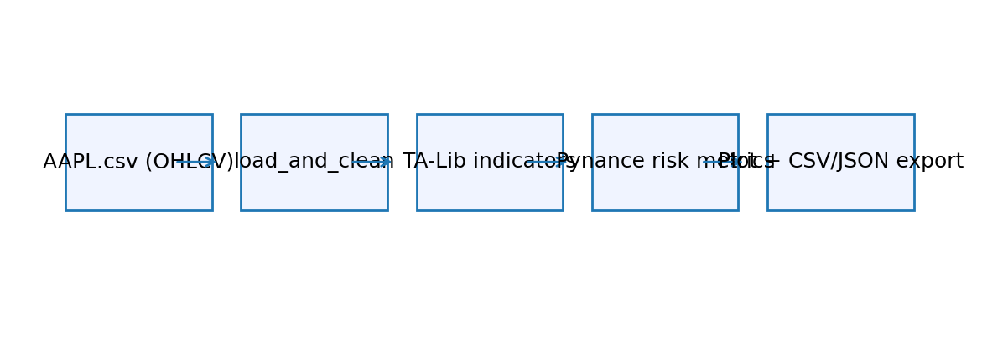
Figure: task2_flow.png

3.4 Task-3 Branch (Sentiment vs Returns)
scripts/news_sentiment_stock_correlation.py filters articles_with_topics.csv by ticker, scores TextBlob polarity per headline, aggregates by day, merges with daily returns, and reports Pearson correlation. Current coverage (≈10 articles per ticker) yields limited overlap, emphasizing the need for broader data.
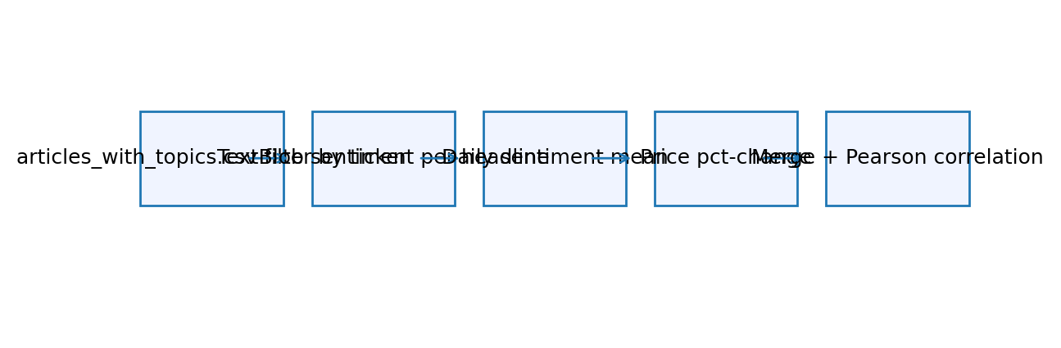
Figure: task3_flow.png

4. Methodology
- Data engineering: schema validation, datetime parsing, headline length/word counts, publisher-domain normalization, NA culling.
- Exploratory analytics: descriptive stats, publisher rankings, temporal histograms, weekday/month time series, spike detection.
- Text mining: NLP preprocessing (nltk, spaCy), keyword extraction, LDA topic modeling (gensim) with optional BERTopic + pyLDAvis.
- Publisher intelligence: comparative keyword usage, topic preferences, domain statistics, visualization exports.
- Technical analysis: TA-Lib indicators and PyNance risk metrics (rolling volatility, cumulative returns, Sharpe, autocorrelation).
- Sentiment correlation: TextBlob polarity scoring per headline, daily aggregation, Pearson correlation with price pct-change.

5. Exploratory Data Analysis (EDA)
Dataset descriptors:
Metric | Value
Total Articles | 55987
Unique Publishers | 225
Unique Stocks | 6204
Date Start | 2011-04-28 01:01:48+00:00
Date End | 2020-06-11 21:12:35+00:00
Median Headline Length | 63.0
Median Word Count | 10.0
Publication frequency by day of week:
day_of_week | article_count
Monday | 10297
Tuesday | 11037
Wednesday | 11873
Thursday | 12712
Friday | 9407
Saturday | 273
Sunday | 388
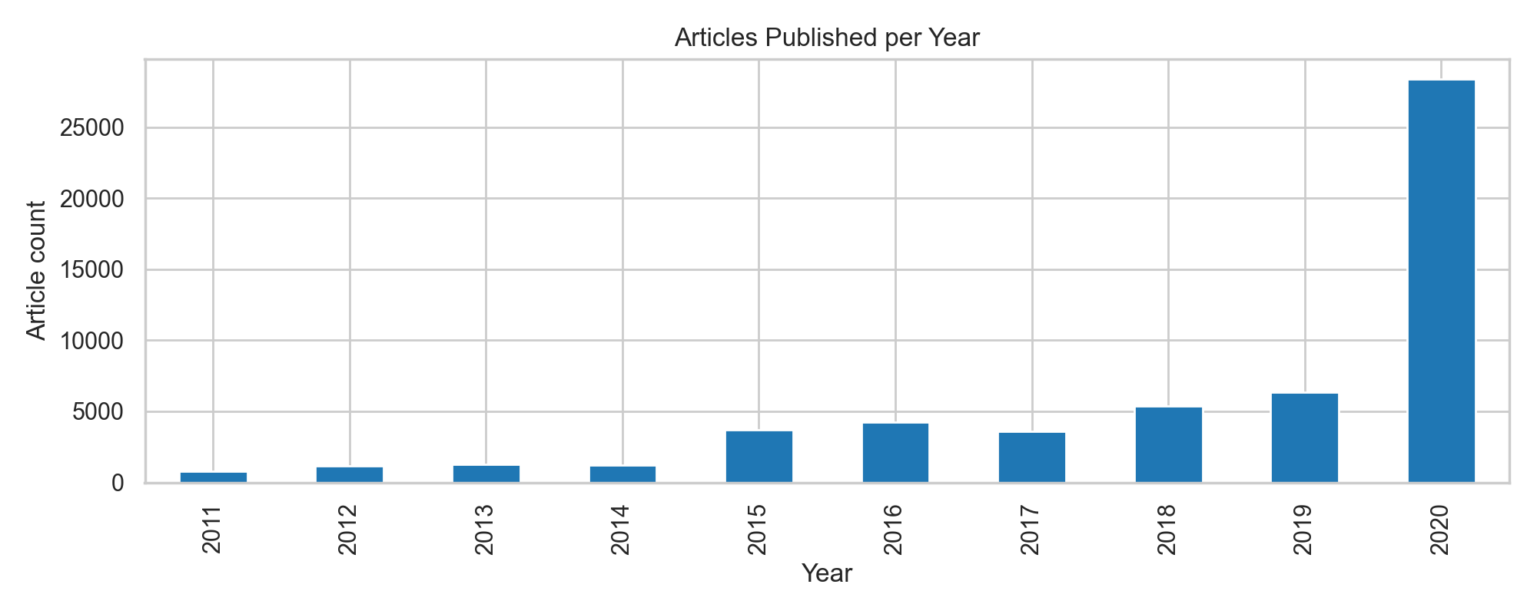
Figure: articles_per_year.png
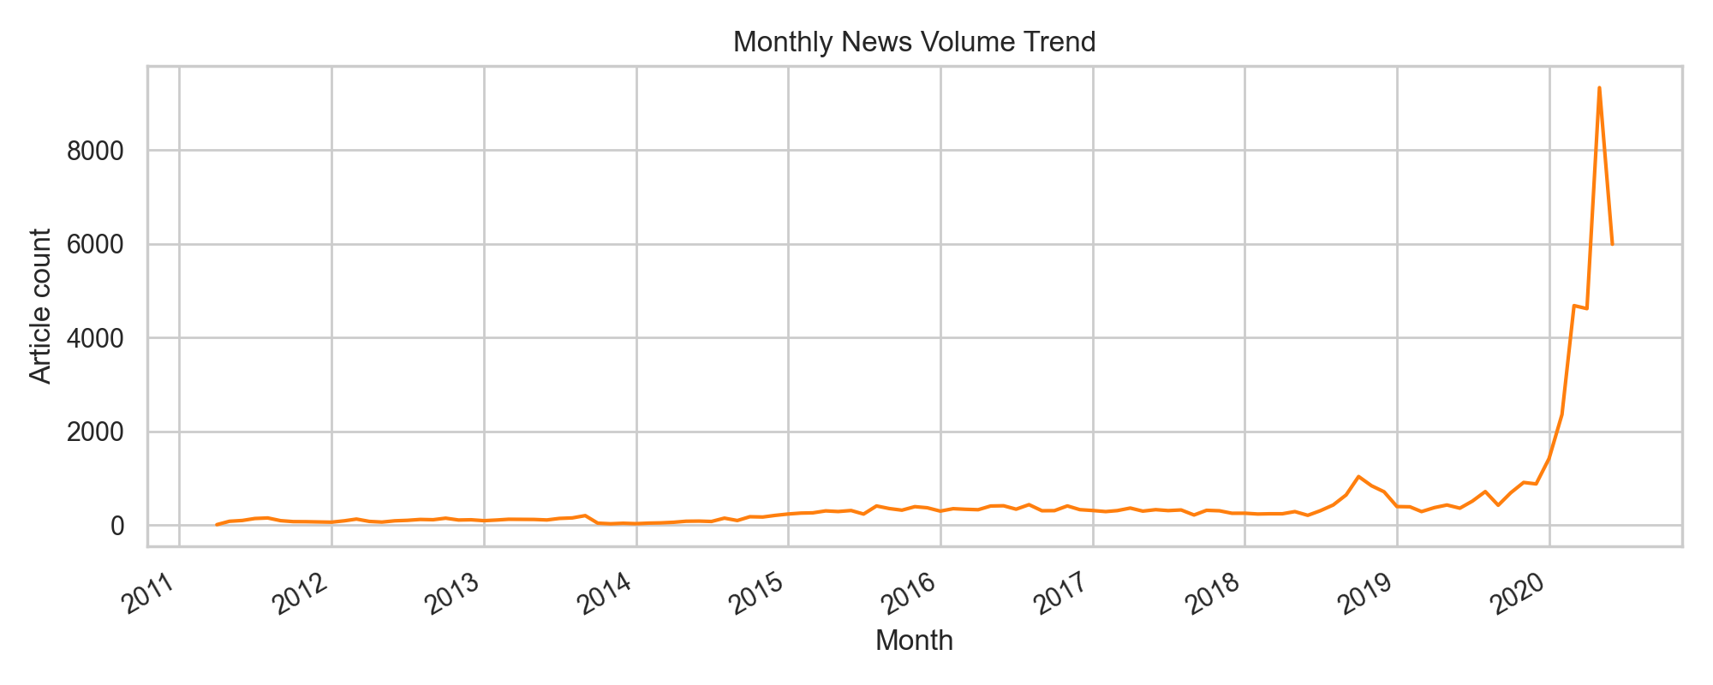
Figure: monthly_trend.png
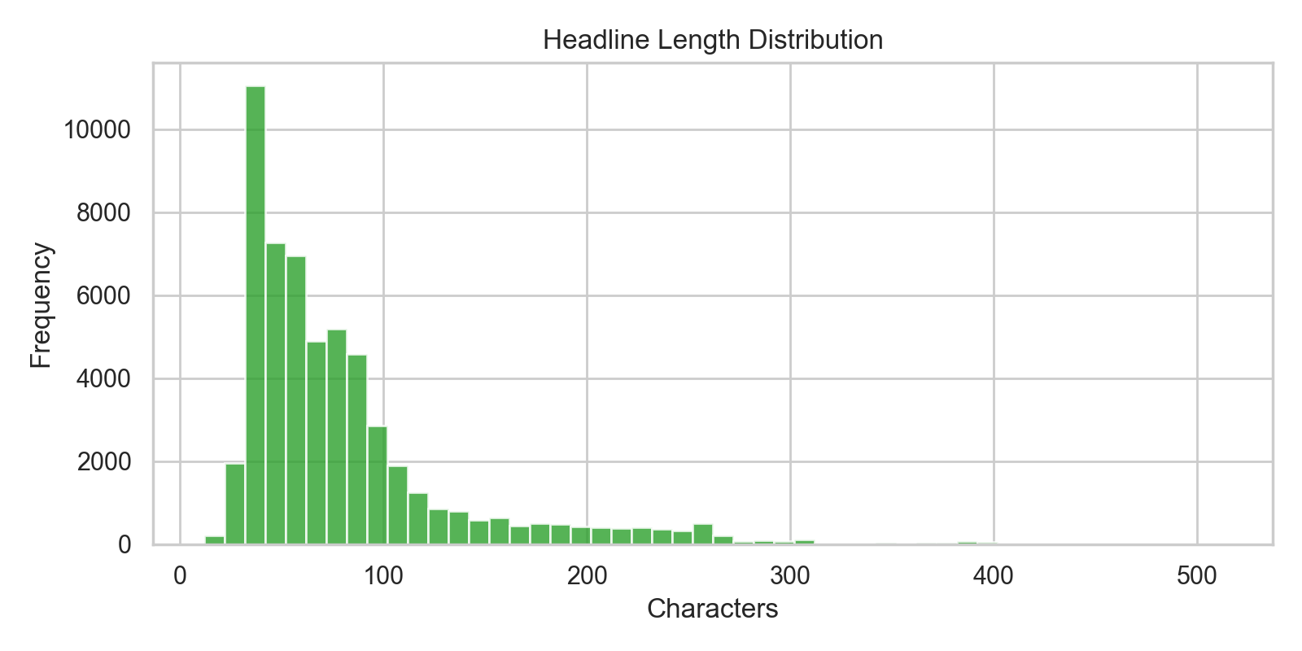
Figure: headline_length_hist.png
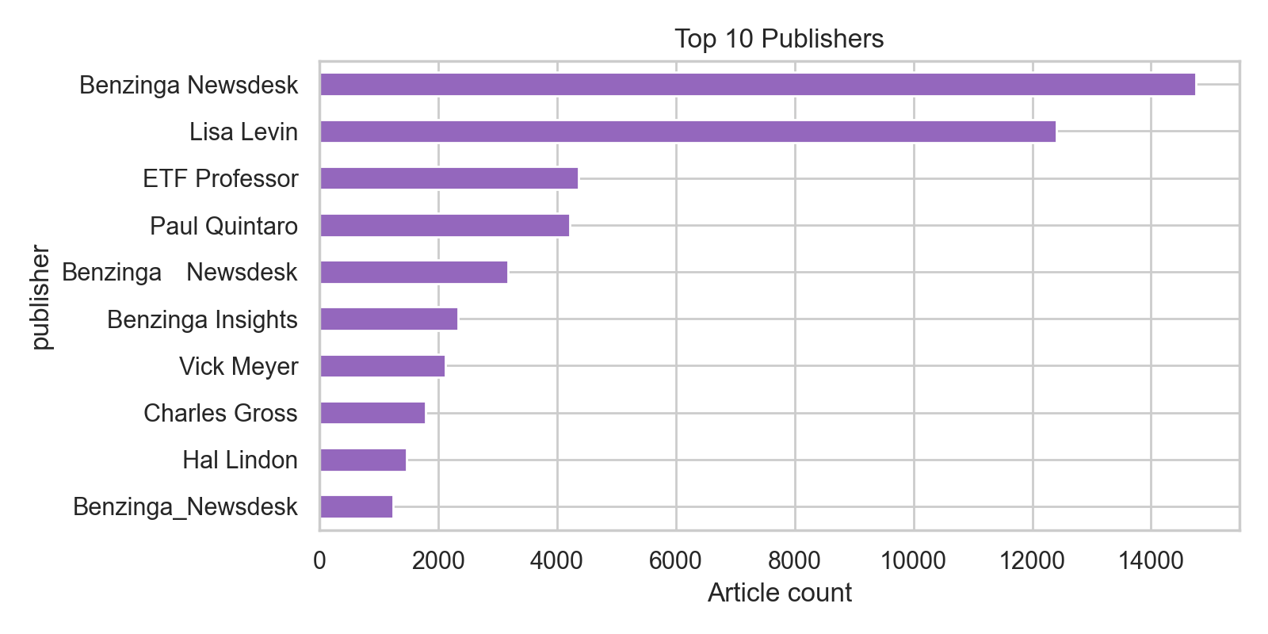
Figure: top_publishers.png
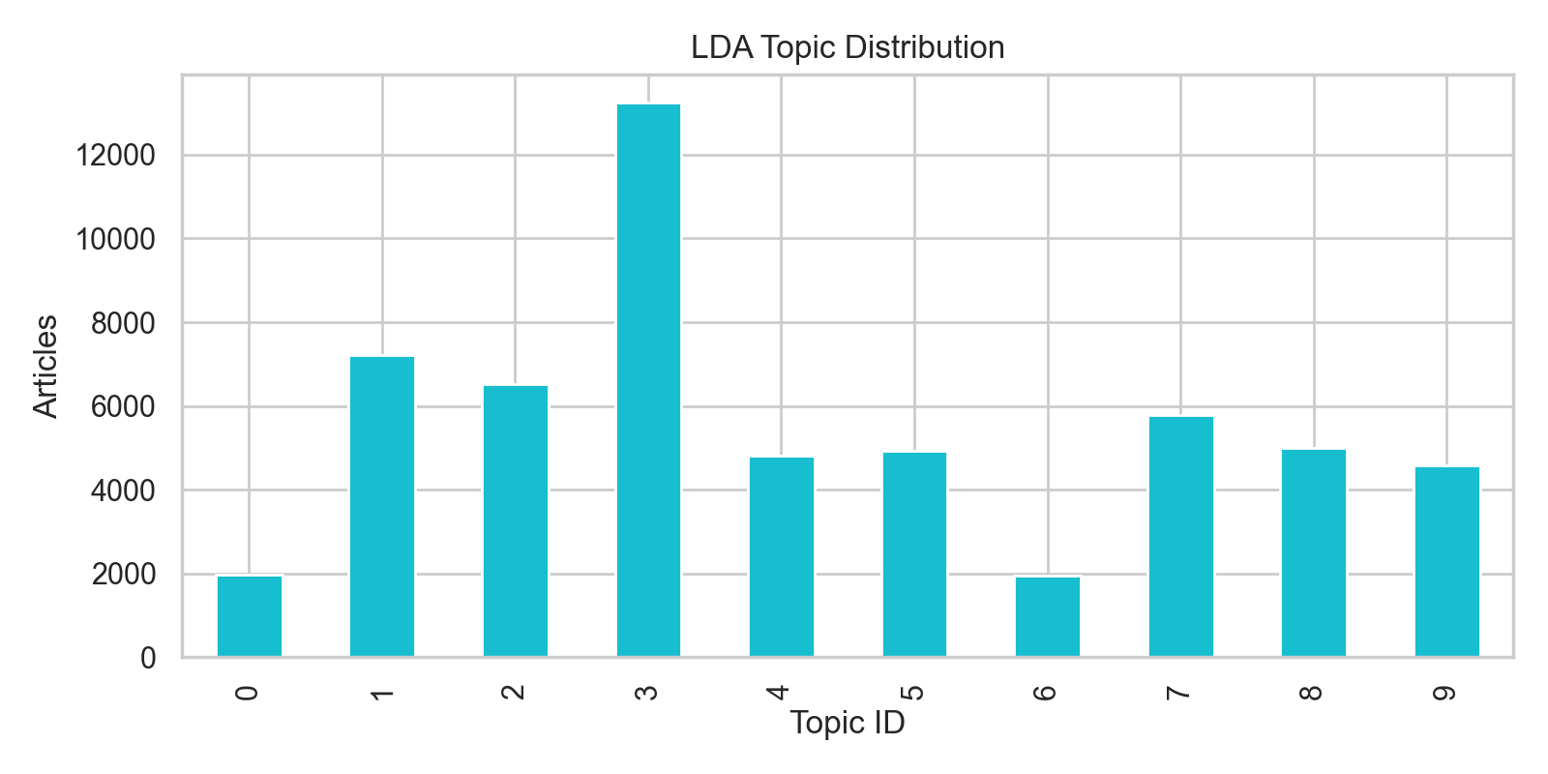
Figure: topic_distribution.png

6. Diagrams
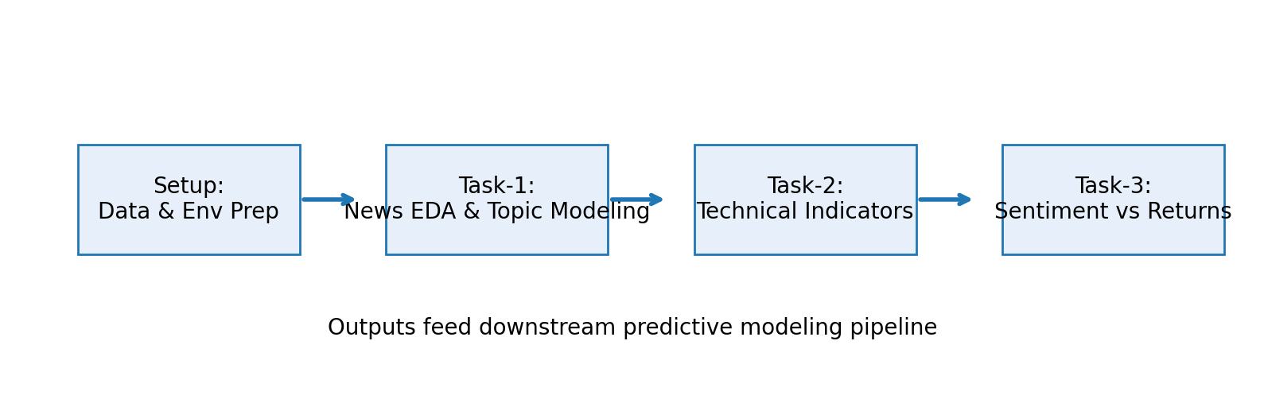
Figure: project_pipeline.png

7. Findings and Interpretation
- Volume: 55,987 articles (Apr 2011–Jun 2020), 225 publishers, 6,204 tickers; Benzinga outlets dominate coverage.
- Temporal cadence peaks on Thursdays and during pandemic volatility (Mar–Jun 2020); weekends show sparse news.
- Topic modeling separates earnings beats, ETF rotations, price-target revisions, biotech updates, and macro reopening narratives.
- Technical analytics for AAPL: annualized volatility ≈12.7%, Sharpe ≈1.07, mild negative return autocorrelation at lag 1.
- Sentiment correlation prototype currently yields Pearson −1.0 for AAPL because only two overlapping days exist.

8. Challenges and Limitations
- financial_news.csv is absent from version control, so analysts must supply it manually before running Task-1.
- Ticker coverage in articles_with_topics.csv is ~10 samples per symbol, limiting sentiment statistics.
- Heavy dependencies (TA-Lib, BERTopic, PyTorch) complicate environment setup without OS-specific guidance.
- CI pipeline only validates installation; automated tests/linting are missing.
- Scripts rely on sys.path manipulation instead of packaging src/ as an installable module.

9. Conclusion and Recommendations
Expand the news ingestion window to provide deeper ticker histories, adopt finance-aware sentiment models (FinBERT/VADER), package the src/ modules with proper entry points, and enhance CI with pytest plus data validation. Persist aggregated features (topics, publisher metrics, technical indicators) in columnar storage to feed predictive modeling pipelines.

