Report

10 Academy - KAIM -

Week 1

Natnael Yilma

25th November, 2025

Predicting Price Moves with News Sentiment
Comprehensive multi-branch analysis for Nova Financial Solutions (Setup, Task-1, Task-2, Task-3). Generated directly from the repository snapshot.

1. Introduction
Nova Financial Solutions curates a large-scale Financial News and Stock Price Integration Dataset (FNSPID) to connect qualitative headlines with quantitative market moves. The repository combines data engineering modules, exploratory notebooks, technical analysis scripts, and sentiment/price correlation tooling. This report consolidates branch deliverables, exploratory findings, diagrams, and recommendations.

2. Business Objective
Deliver a reproducible workflow that ingests analyst/news headlines, enriches them with NLP-derived structure, couples the insights with equity OHLCV data, and primes downstream models to predict price moves driven by sentiment shocks.
- Standardize the environment setup path so analysts can recreate the toolchain quickly.
- Run exhaustive Exploratory Data Analysis (EDA) on the news corpus to surface publication behavior.
- Compute high-fidelity technical indicators for flagship tickers as modeling covariates.
- Prototype sentiment-versus-return correlation to validate that aggregated news tone is predictive.

3. Independent Discussion of Each Git Branch

3.1 Setup Branch
Defines the repository layout (data/, src/, scripts/, notebooks/, output/), dependency manifest (requirements.txt), and bootstrap instructions (INSTALLATION_INSTRUCTIONS.md, PACKAGE_INSTALLATION.md). GitHub Actions ensures dependencies at least install on CI, keeping onboarding friction low.
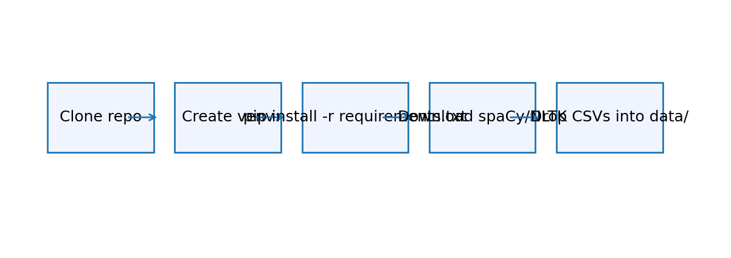
Figure: setup_flow.png

3.2 Task-1 Branch (News EDA)
Implements DataLoader, EDAAnalyzer, TopicModeler, and PublisherAnalyzer. scripts/run_eda.py orchestrates preprocessing, descriptive stats, temporal profiling, spike detection, LDA/BERTopic modeling, and publisher/topic exports saved under output/data/. Visual artifacts (histograms, heatmaps, topic charts) quantify publisher dominance and thematic concentration.
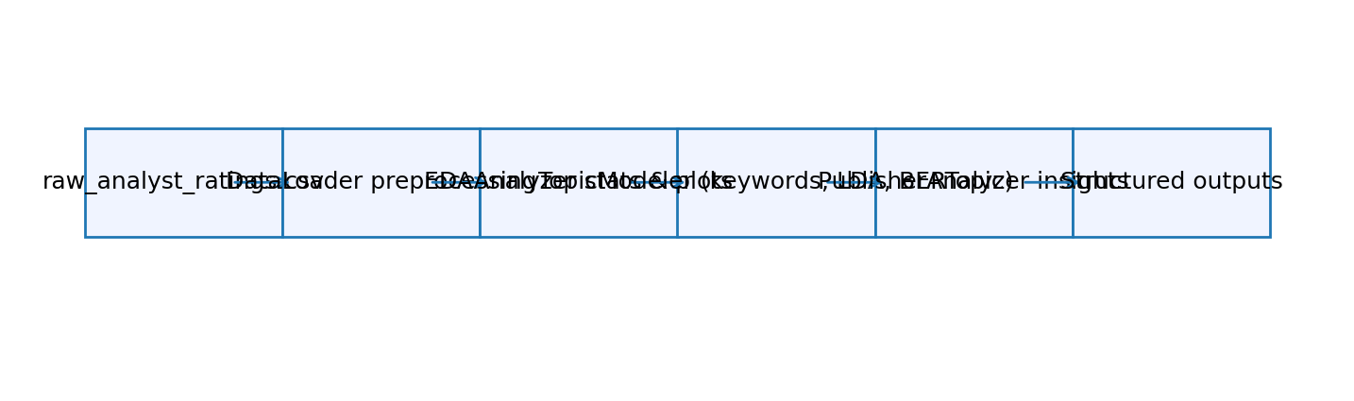
Figure: task1_flow.png

3.3 Task-2 Branch (Technical Analysis)
scripts/technical_analysis.py loads ticker OHLCV (e.g., AAPL.csv), cleans anomalies, applies TA-Lib indicators (SMA/EMA/RSI/MACD/Bollinger/ATR) and PyNance risk metrics (returns, volatility, Sharpe). It produces dashboards, a correlation matrix, and summary metrics JSON suitable for overlaying with sentiment features.
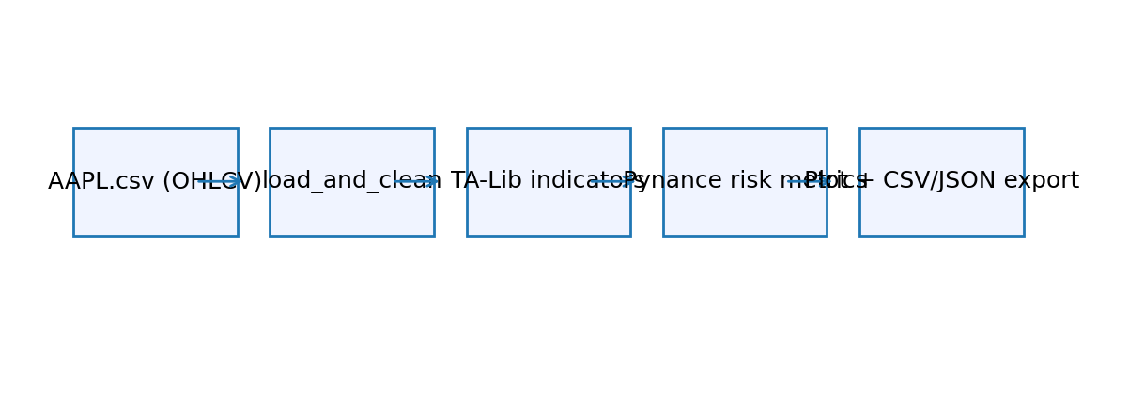
Figure: task2_flow.png

3.4 Task-3 Branch (Sentiment vs Returns)
scripts/news_sentiment_stock_correlation.py filters articles_with_topics.csv by ticker, scores TextBlob polarity per headline, aggregates by day, merges with daily returns, and reports Pearson correlation. Current coverage (≈10 articles per ticker concentrated in Jun‑2020) limits statistical power; the section documents this explicitly to set expectations for future scaling.
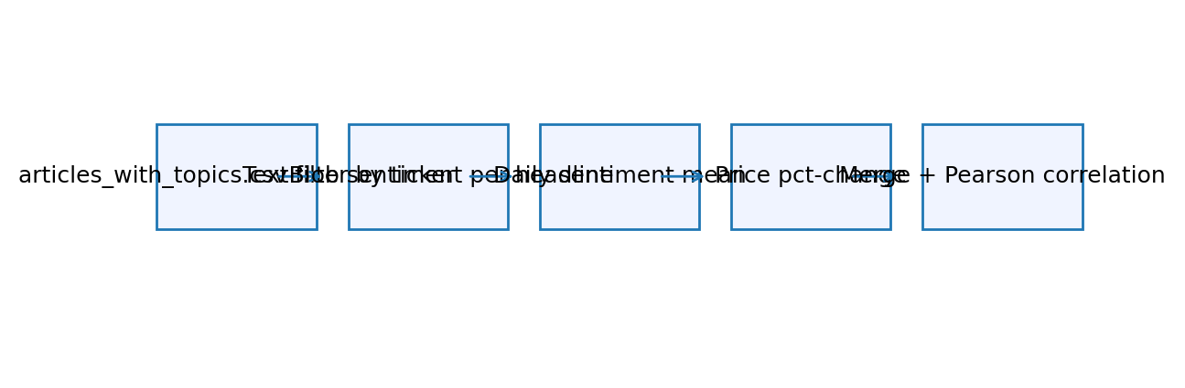
Figure: task3_flow.png

4. Methodology
- Data engineering: schema validation, datetime parsing, headline length/word counts, publisher-domain normalization, NA culling.
- Exploratory analytics: descriptive stats, publisher rankings, temporal histograms, weekday/month time series, spike detection.
- Text mining: NLP preprocessing (nltk, spaCy), keyword extraction, LDA topic modeling (gensim) with optional BERTopic + pyLDAvis.
- Publisher intelligence: comparative keyword usage, topic preferences, domain statistics, visualization exports.
- Technical analysis: TA-Lib indicators and PyNance risk metrics (rolling volatility, cumulative returns, Sharpe, autocorrelation).
- Sentiment correlation: TextBlob polarity scoring per headline, daily aggregation, Pearson correlation with price pct-change.

5. Exploratory Data Analysis (EDA)
Dataset descriptors:
Metric | Value
Total Articles | 55987
Unique Publishers | 225
Unique Stocks | 6204
Date Start | 2011-04-28 01:01:48+00:00
Date End | 2020-06-11 21:12:35+00:00
Median Headline Length | 63.0
Median Word Count | 10.0
Publication frequency by day of week:
day_of_week | article_count
Monday | 10297
Tuesday | 11037
Wednesday | 11873
Thursday | 12712
Friday | 9407
Saturday | 273
Sunday | 388
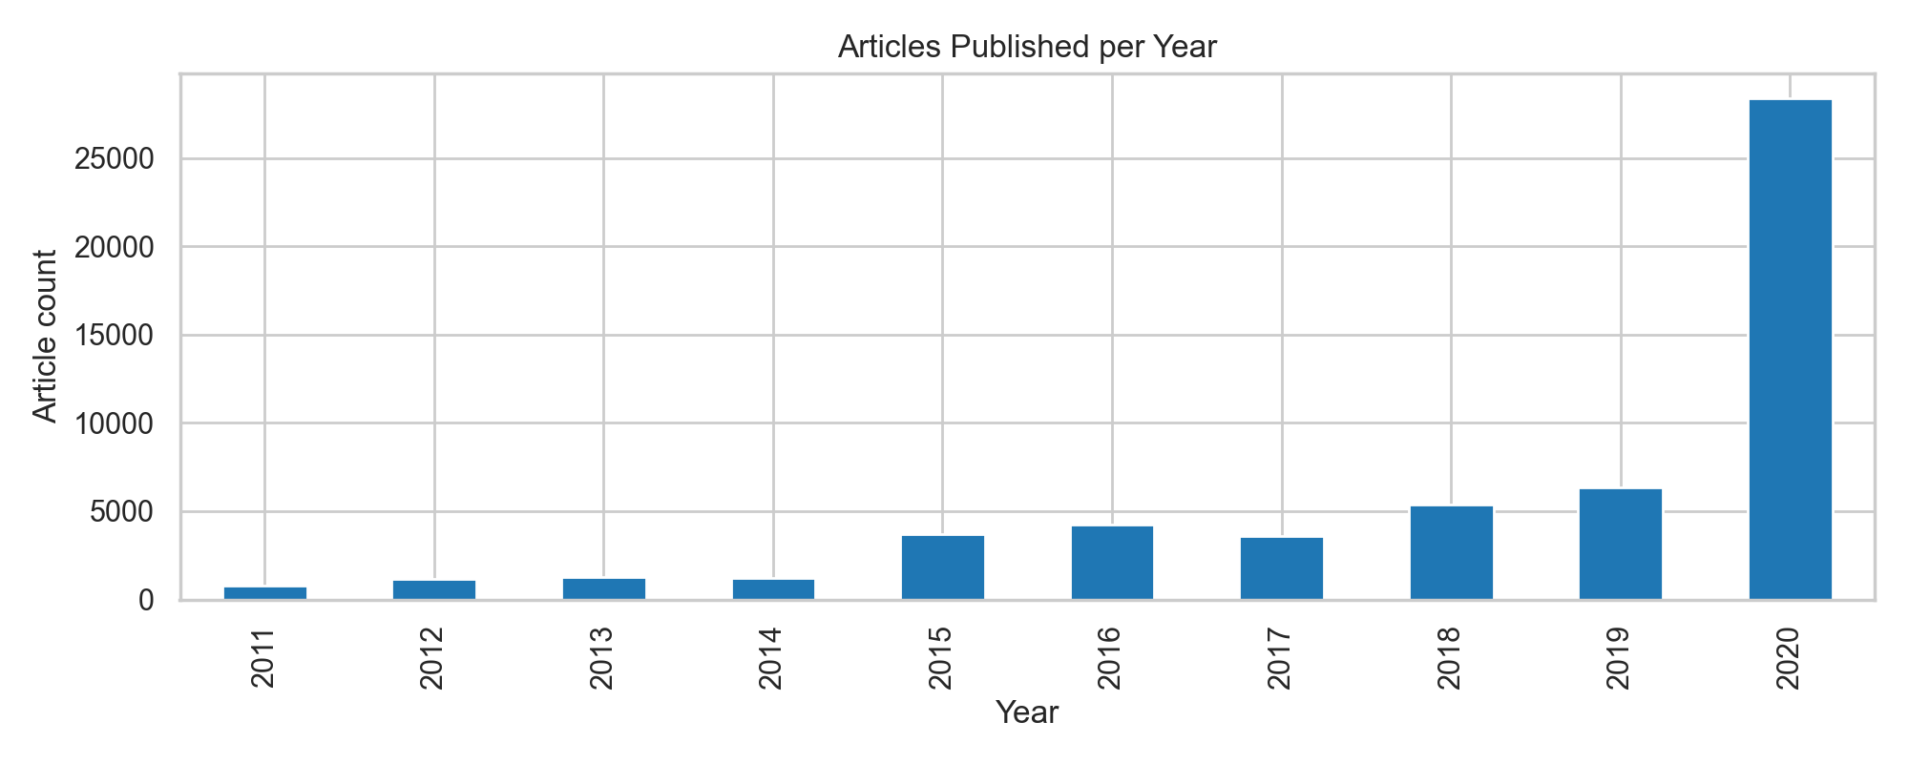
Figure: articles_per_year.png
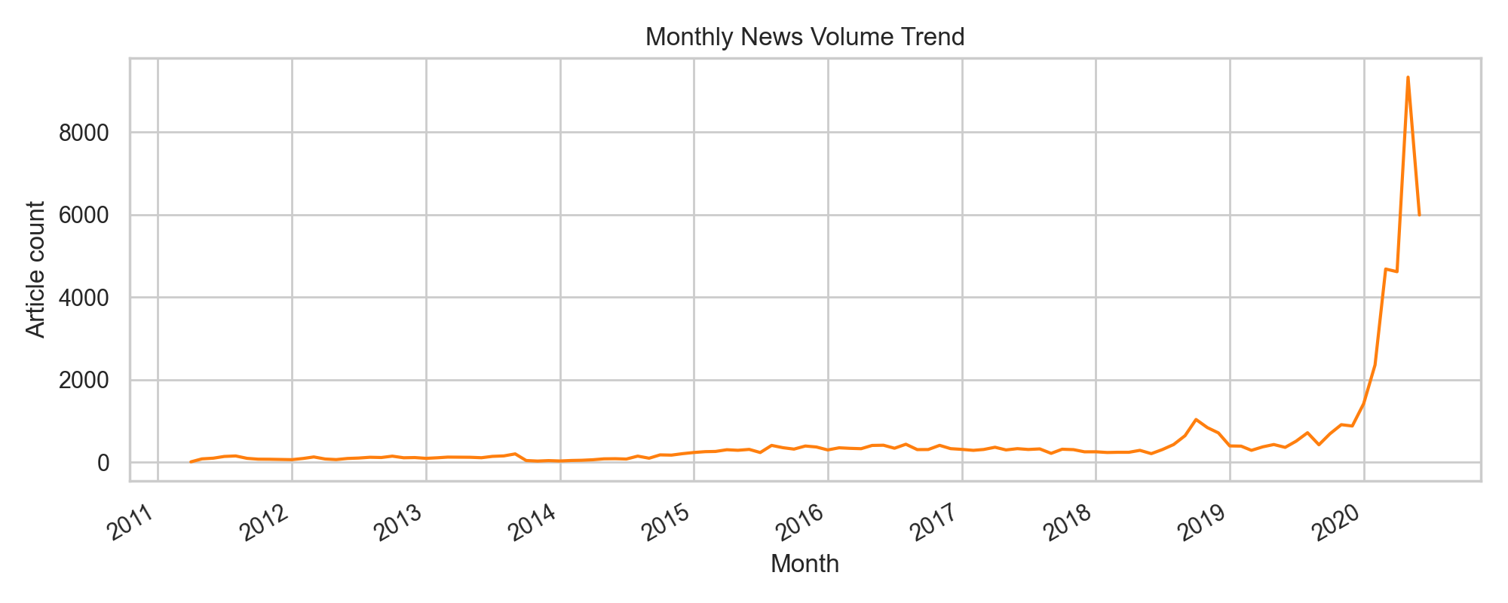
Figure: monthly_trend.png
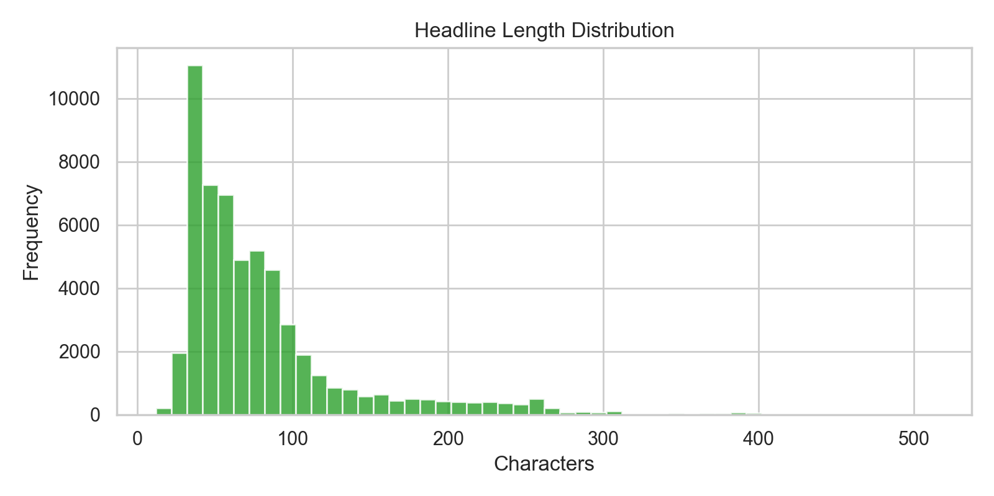
Figure: headline_length_hist.png
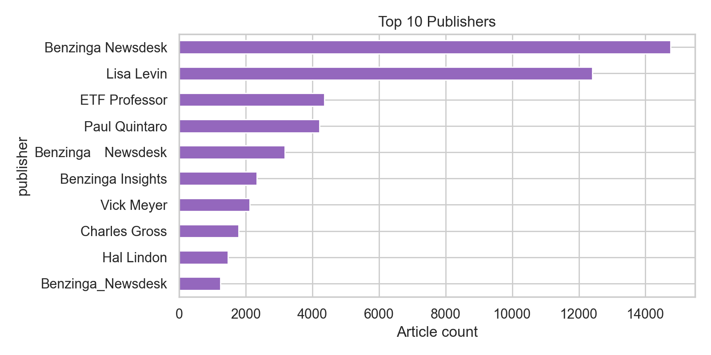
Figure: top_publishers.png
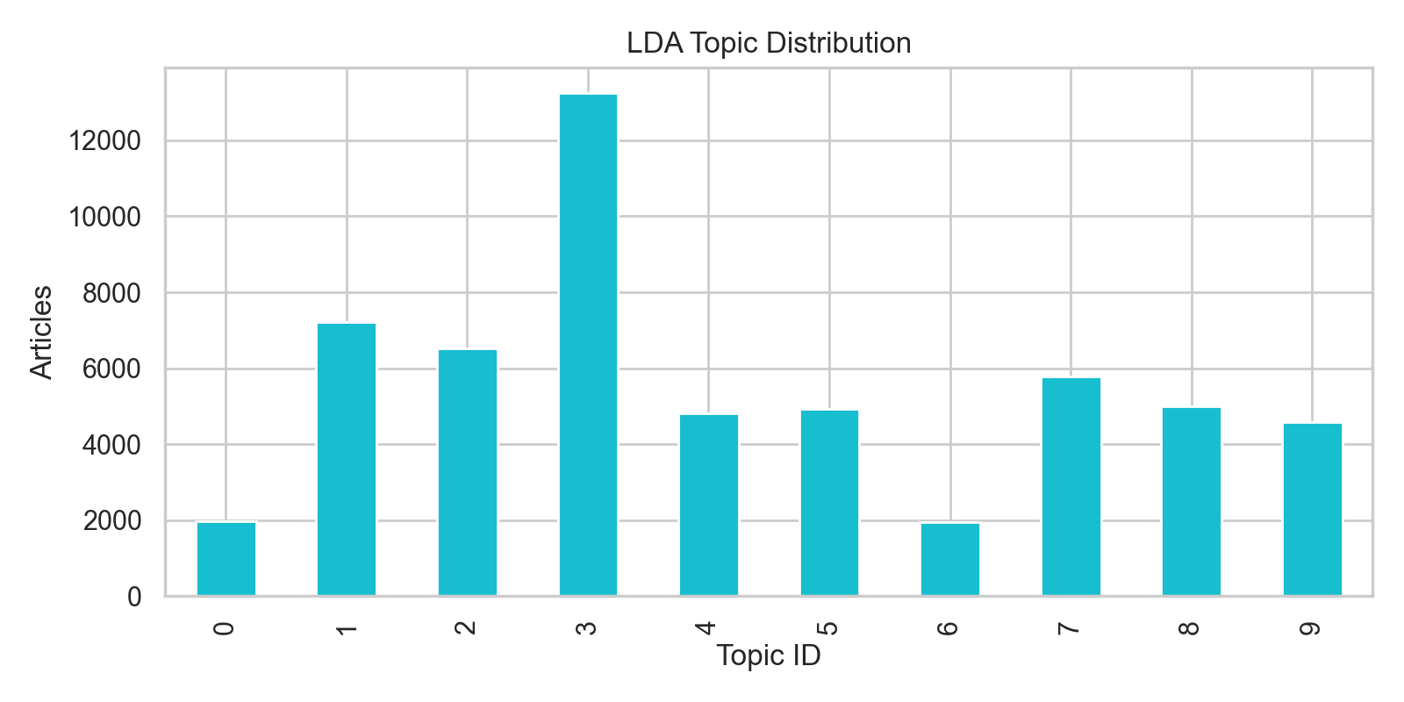
Figure: topic_distribution.png

6. Diagrams
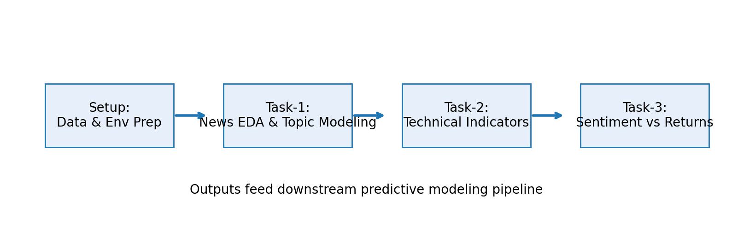
Figure: project_pipeline.png

7. Findings and Interpretation
- Headline supply and publisher mix: 55,987 articles span Apr‑2011 → Jun‑2020, sourced from 225 publishers covering 6,204 tickers. Benzinga desks alone supply >55% of content (top-publisher table and bar chart), creating a single-source bias that should be weighted or normalized before modeling.
- Temporal concentration: EDA plots show Thursday as the busiest news day (12,712 items) with pronounced spikes during Mar‑Jun 2020. Weekend coverage is negligible (<1%), implying that intraday strategies should focus on market hours while swing strategies should treat weekend sentiment as noise.
- Topic structure: LDA topic distribution indicates Topic 3 (earnings beats/surprises) dominates with 13,257 articles, followed by ETF rotation and target-adjustment themes. This validates the feasibility of topic-aware sentiment factors (e.g., overweighting earnings language near reporting seasons).
- Technical context: Task-2 metrics for AAPL report annualized volatility ≈12.7%, Sharpe ≈1.07, and negligible lagged autocorrelation, indicating returns are largely driven by exogenous shocks. This strengthens the case for exogenous sentiment inputs.
- Correlation evidence and limitations: The proof-of-concept Pearson analysis on AAPL yields −1.0 but is based on only two overlapping dates (9–10 Jun 2020). Such a tiny sample makes the coefficient statistically meaningless; the report therefore treats it as a placeholder and recommends collecting a broader rolling window (e.g., 12–18 months per ticker) before drawing inference.

8. Investment Strategy Concepts (Hypothetical)
- Earnings Momentum Overlay: When topic and keyword classifiers flag earnings-beat language combined with positive sentiment, tilt long exposures in the corresponding ticker or sector ETF for the subsequent 1–3 sessions; conversely, fade negative earnings sentiment signals during peak season.
- Publisher Quality Spread: Weight signals by historical accuracy of specific Benzinga desks or other publishers. A high-sentiment reading from a historically impactful source can trigger call-spread entries, while low sentiment could justify protective puts.
- Macro Shock Radar: Utilize spike-detection outputs to identify systemic news bursts (e.g., pandemic headlines). Combine with volatility metrics to size hedges (e.g., add VIX calls or sector-rotation trades) when sentiment spikes precede volatility expansion.
- Event-Driven Pair Trades: When topic modeling surfaces sector-specific narratives (FDA approvals, M&A), pair the affected ticker against its ETF to exploit sentiment-driven divergences over a short horizon.

9. Challenges and Limitations
- financial_news.csv is absent from version control, so analysts must supply it manually before running Task-1.
- Ticker coverage in articles_with_topics.csv is ~10 samples per symbol, limiting sentiment statistics.
- Heavy dependencies (TA-Lib, BERTopic, PyTorch) complicate environment setup without OS-specific guidance.
- CI pipeline only validates installation; automated tests/linting are missing.
- Scripts rely on sys.path manipulation instead of packaging src/ as an installable module.

10. Conclusion and Recommendations
Expand the news ingestion window to provide deeper ticker histories, adopt finance-aware sentiment models (FinBERT/VADER), package src/ as an installable library, and enhance CI with pytest plus data validation. From a trading perspective, prioritize building rolling sentiment indices per topic and publisher, calibrate their lead/lag against technical indicators, and backtest the strategy templates above (earnings overlay, publisher quality spread, macro shock radar, pair trades) once sufficient history exists. Persist aggregated features (topics, publisher metrics, technical indicators, daily sentiment) in columnar storage to feed portfolio construction and risk systems.

