10 Academy – KAIM

Week 5

Fraud Detection for E-commerce and

Bank Transactions

Natnael Yilma

21th December, 2025

Table of Contents
- 1. Executive Summary
- 2. Project Overview
- 2.1 Business Goals
- 2.2 Business Value and Customer Trust
- 3. Datasets
- 4. Data Loading & Inspection
- 5. Data Cleaning
- 6. Exploratory Data Analysis
- 6.4 Geolocation Fraud Pattern Analysis
- 7. Feature Engineering
- 8. Data Preprocessing
- 9. Class Imbalance Handling
- 9.2 Impact of SMOTE Resampling
- 10. Project Structure
- 11. Key Findings & Insights
- 12. Technical Implementation
- 13. Next Steps
- 13.1 Task 2: Model Building and Evaluation
- 13.2 Task 3: Model Explainability
- 13.3 Anticipated Challenges and Mitigation Strategies
- 13.4 Additional Next Steps

1. Executive Summary
This report documents the comprehensive work completed on the Fraud Detection project for E-commerce and Bank Transactions. The project focuses on building a robust, production-ready fraud detection system capable of identifying fraudulent transactions across two domains: e-commerce transactions and credit card payments.
Key accomplishments include:
- ✓ Complete data cleaning and quality assurance
- ✓ Comprehensive exploratory data analysis with visualizations
- ✓ Advanced feature engineering (time-based, behavioral, statistical)
- ✓ Geolocation integration for fraud pattern analysis
- ✓ Class imbalance handling using SMOTE
- ✓ Production-grade modular code structure
- ✓ Complete preprocessing pipeline ready for model training

1.1 Project Statistics Summary
Dataset | Total Transactions | Features | Fraud Rate
E-commerce (Fraud_Data) | 151,112 | 11 | 9.36%
Credit Card | 284,807 | 31 | 0.17%

2. Project Overview
The primary objective of this project is to develop an advanced fraud detection system that can accurately identify fraudulent transactions while minimizing false positives. The system addresses two distinct transaction types:
- • E-commerce Transactions: User purchases with behavioral and geolocation data
- • Credit Card Transactions: Anonymized bank transaction data with PCA features

2.1 Business Goals
Goal | Description
High Precision & Recall | Accurately detect fraud while minimizing false positives
Handle Class Imbalance | Effectively address severe class imbalance (10:1 to 580:1)
Interpretable Results | Provide clear insights for business stakeholders
Production-Ready Code | Build scalable, maintainable code structure
Feature Engineering | Create meaningful features from raw transaction data

2.2 Business Value and Customer Trust
Beyond preventing direct financial losses, accurate fraud detection plays a critical role in building and maintaining customer trust, which is essential for long-term business success. The impact extends far beyond immediate fraud prevention:
Customer Confidence: When customers see that their transactions are protected by sophisticated fraud detection, they gain confidence in the platform's security. This trust encourages repeat purchases and increases customer lifetime value. Customers are more likely to recommend services they trust to others, leading to organic growth through word-of-mouth marketing.
Reduced False Positives and Better User Experience: By minimizing false positives (legitimate transactions flagged as fraud), we ensure that genuine customers experience seamless transactions without unnecessary friction. Every false positive creates frustration, potential customer service costs, and risks customer churn. A well-tuned fraud detection system balances security with convenience, showing customers that the platform understands and respects their legitimate behavior.
Regulatory Compliance and Reputation: Effective fraud detection helps organizations comply with financial regulations and industry standards. This compliance protects the company from legal issues and enhances its reputation in the marketplace. A strong reputation for security attracts new customers and business partners, creating additional revenue opportunities.
Brand Protection: Every fraudulent transaction that goes undetected can damage the brand's reputation when customers report unauthorized activity. Conversely, proactively preventing fraud demonstrates the company's commitment to customer protection, strengthening brand value and differentiation in competitive markets.
Data-Driven Insights: The fraud detection system provides valuable insights into transaction patterns, customer behavior, and emerging fraud trends. These insights can inform business strategy, product development, and marketing decisions, creating value beyond fraud prevention.
The significance of class imbalance in fraud detection cannot be overstated. With fraud representing only 9% of e-commerce transactions and 0.17% of credit card transactions, naive models would achieve high accuracy by simply predicting "no fraud" for all cases. However, this approach fails to protect customers and the business. By addressing this imbalance through techniques like SMOTE and using appropriate evaluation metrics, we ensure that the system can reliably identify fraudulent patterns while maintaining customer trust through accurate, fair detection.

3. Datasets

3.1 Fraud_Data.csv (E-commerce Transactions)
• Size: 151,112 transactions × 11 features
• Features: User information, transaction details, device & browser, IP address, traffic source
• Target: class (0 = Legitimate, 1 = Fraud)
• Fraud Rate: 9.36% (Imbalance Ratio: 9.7:1)

3.2 creditcard.csv (Bank Credit Card Transactions)
• Size: 284,807 transactions × 31 features
• Features: 28 anonymized V-features (PCA), transaction amount, time
• Target: Class (0 = Legitimate, 1 = Fraud)
• Fraud Rate: 0.17% (Imbalance Ratio: 577.9:1)

3.3 IpAddress_to_Country.csv
• Purpose: Map IP addresses to countries for geographical fraud analysis
• Features: IP ranges (lower_bound, upper_bound) and country codes

3.4 Class Distribution Visualization
The following charts show the class imbalance in both datasets:
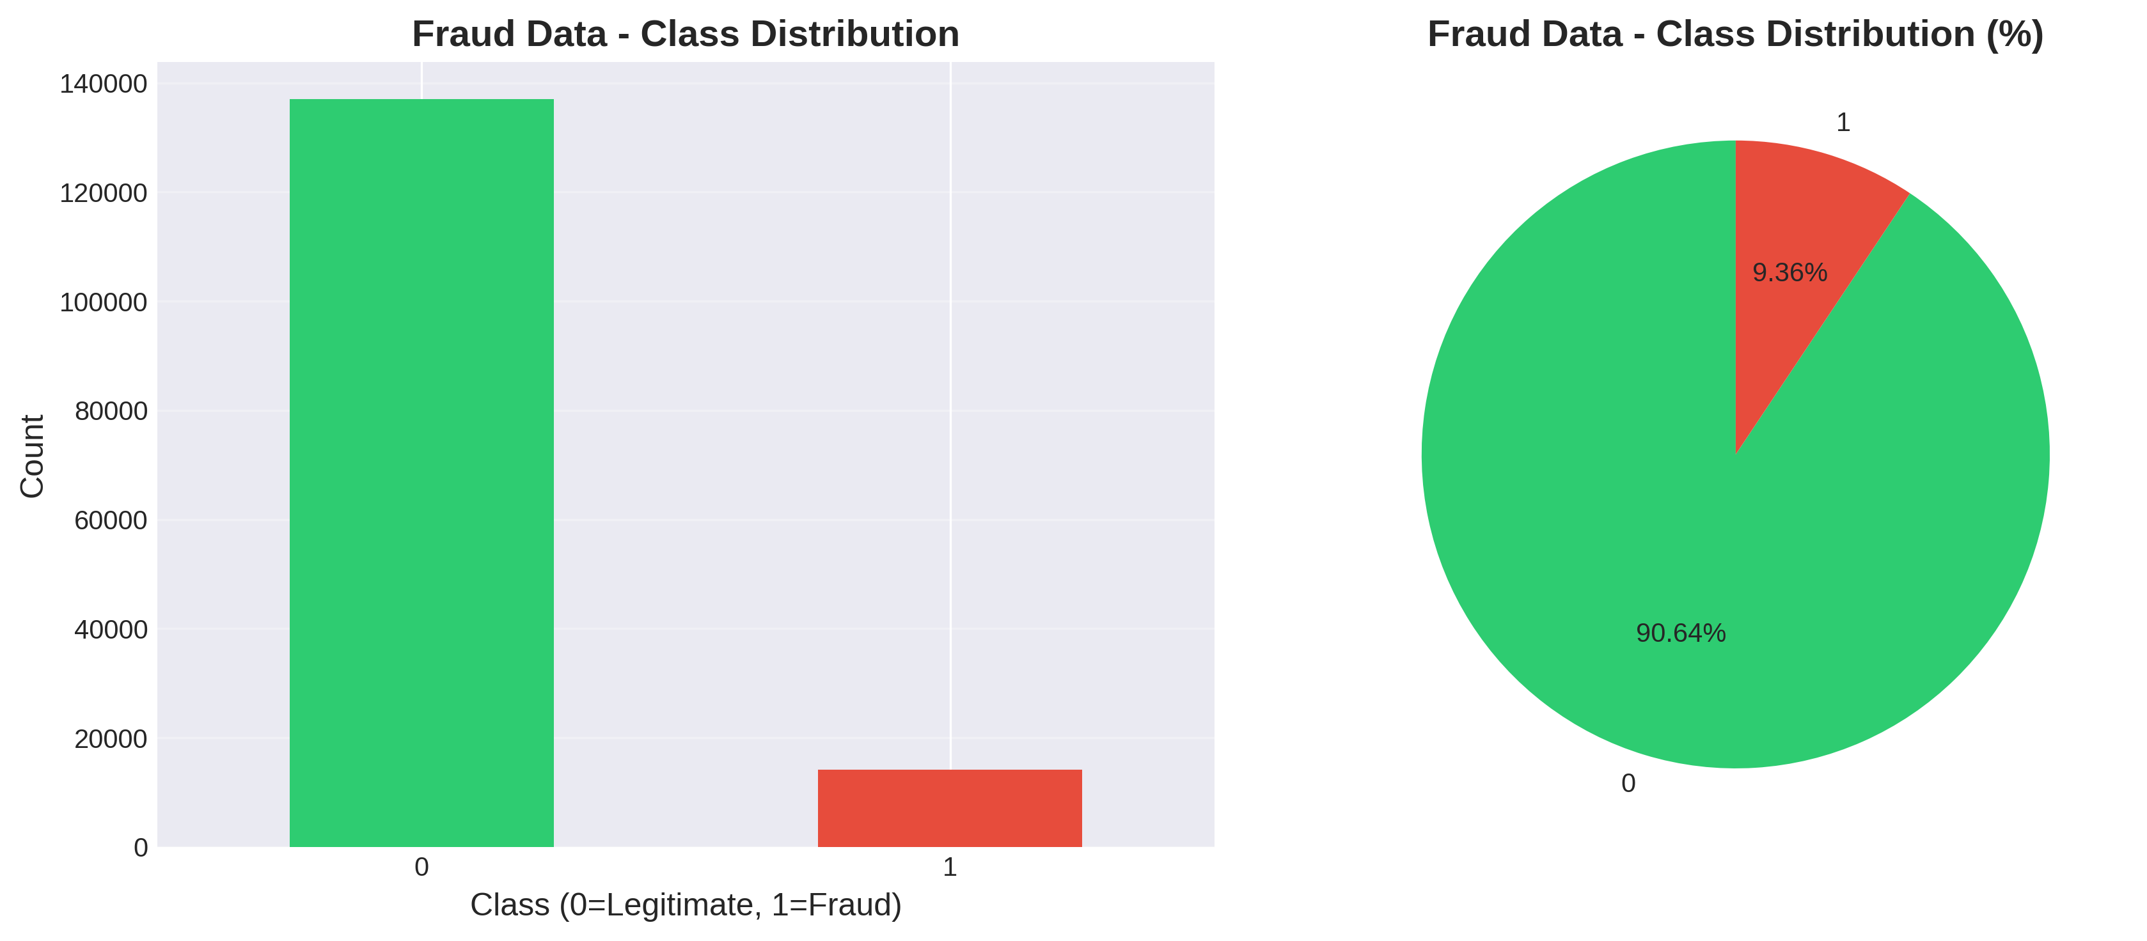
Figure 1: E-commerce Transaction Class Distribution
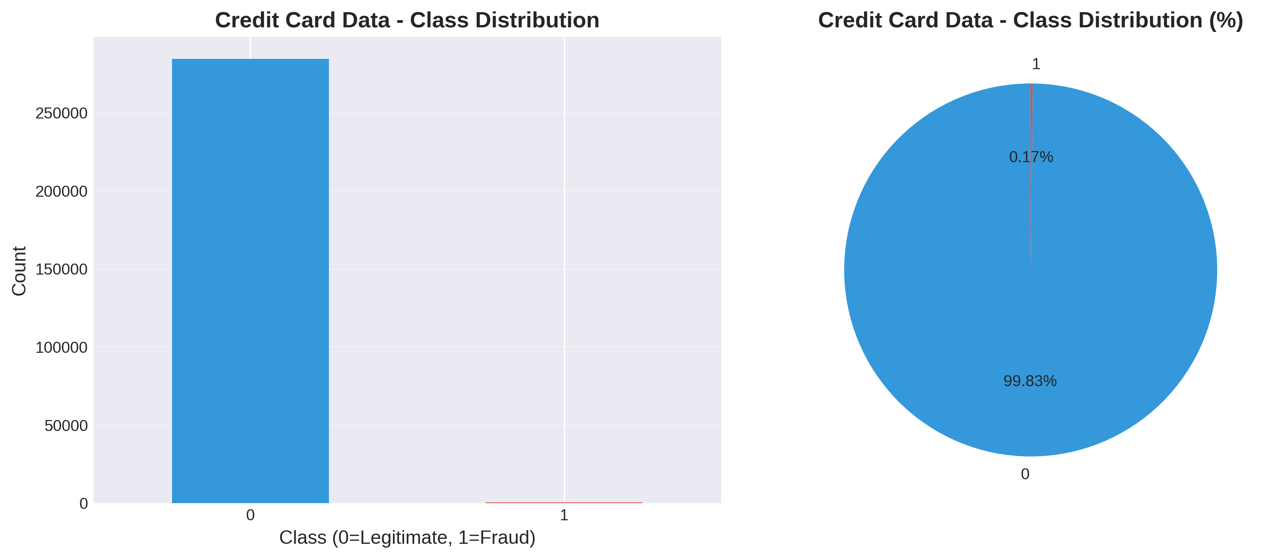
Figure 2: Credit Card Transaction Class Distribution

4. Data Loading & Inspection
All data loading is handled through the reusable `data_loading.py` module, which provides:
- • File existence validation
- • Comprehensive error handling
- • Automatic shape and size reporting
- • CSV parsing with error recovery

5. Data Cleaning
Comprehensive data cleaning was performed using the `data_cleaning.py` module.

5.1 Cleaning Operations
Operation | Description
Duplicate Removal | Identified and removed duplicate records
Missing Value Handling | Strategic imputation or dropping based on percentage (>50% missing = drop, else impute)
Data Type Standardization | Converted columns to appropriate types (datetime, numeric)
Invalid Data Filtering | Filtered invalid ages (0-120) and negative transaction values
Critical Column Validation | Dropped rows with missing values in critical columns

6. Exploratory Data Analysis
Comprehensive EDA was conducted to understand data distributions, relationships, and fraud patterns.

6.1 Univariate Analysis
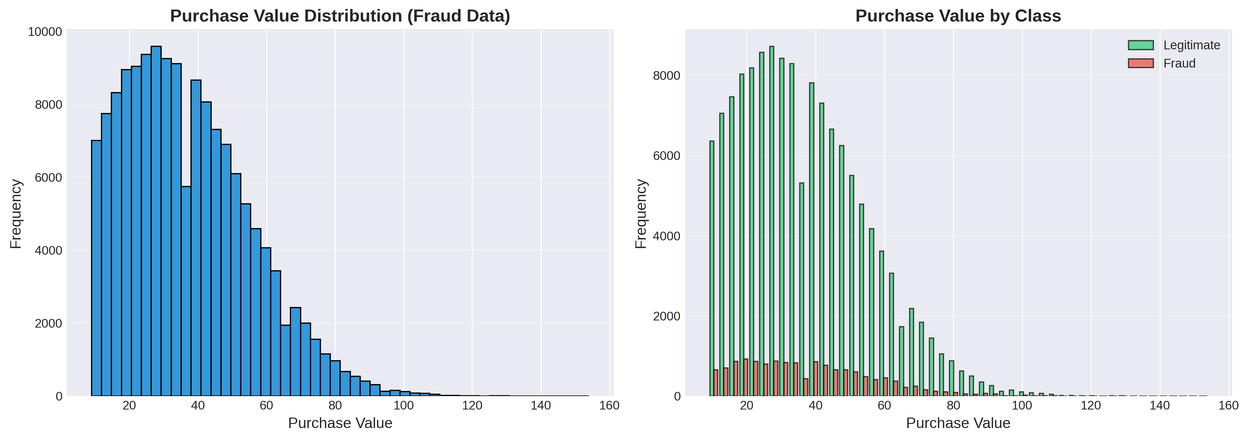
Figure 3: Purchase Value Distribution Analysis
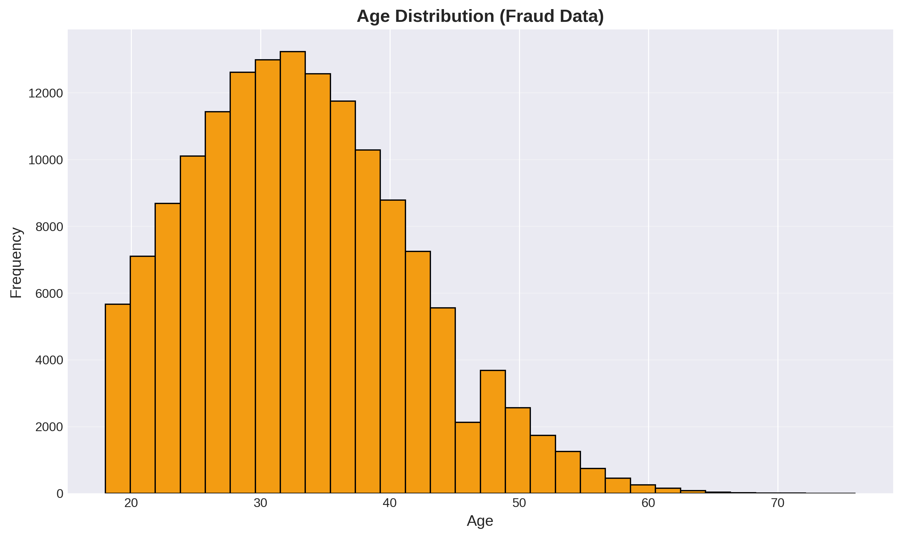
Figure 4: Age Distribution
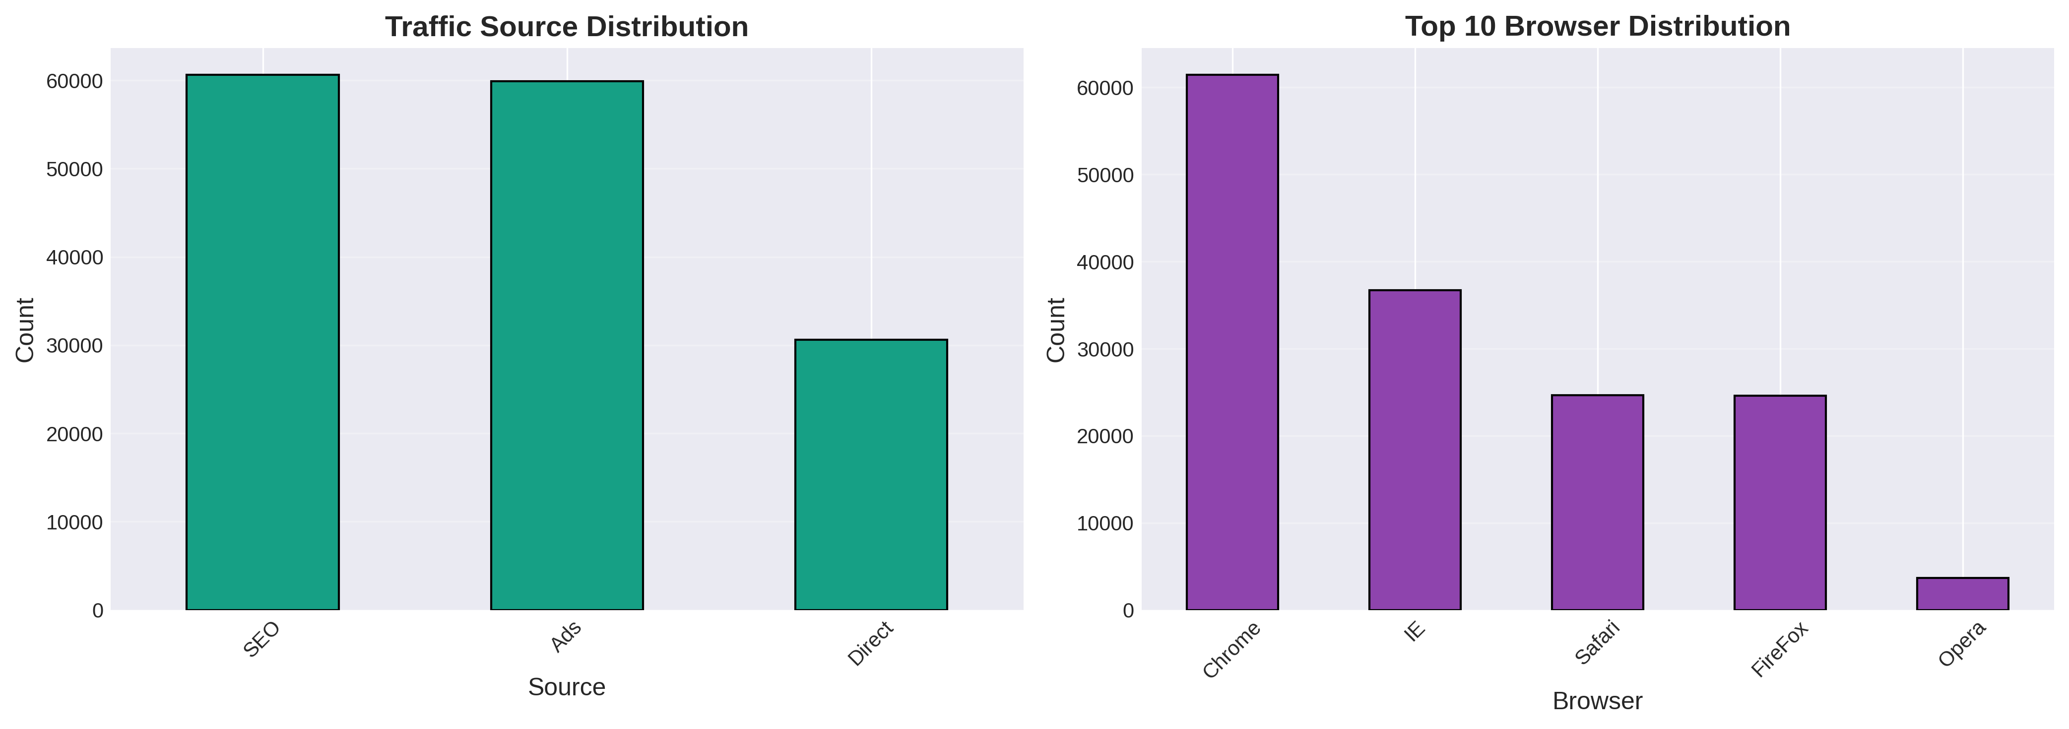
Figure 5: Traffic Source and Browser Distribution

6.2 Credit Card Transaction Analysis
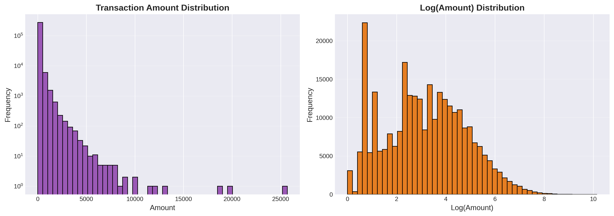
Figure 6: Transaction Amount Distribution (Original and Log-Transformed)

6.3 Correlation Analysis
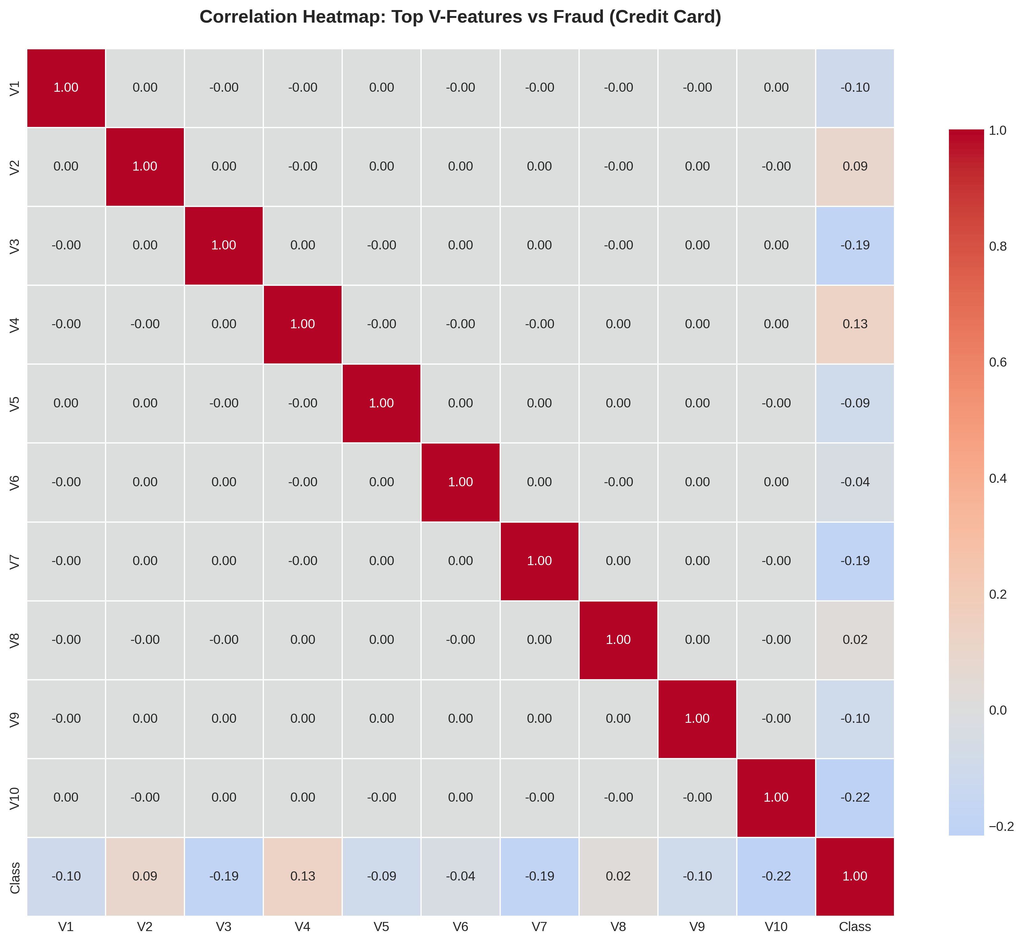
Figure 7: Correlation Heatmap - Top V-Features vs Fraud

6.4 Geolocation Fraud Pattern Analysis
Geolocation analysis provides critical insights into fraud patterns by country, enabling targeted risk assessment and prevention strategies. IP address mapping to countries reveals geographic concentrations of fraudulent activity.
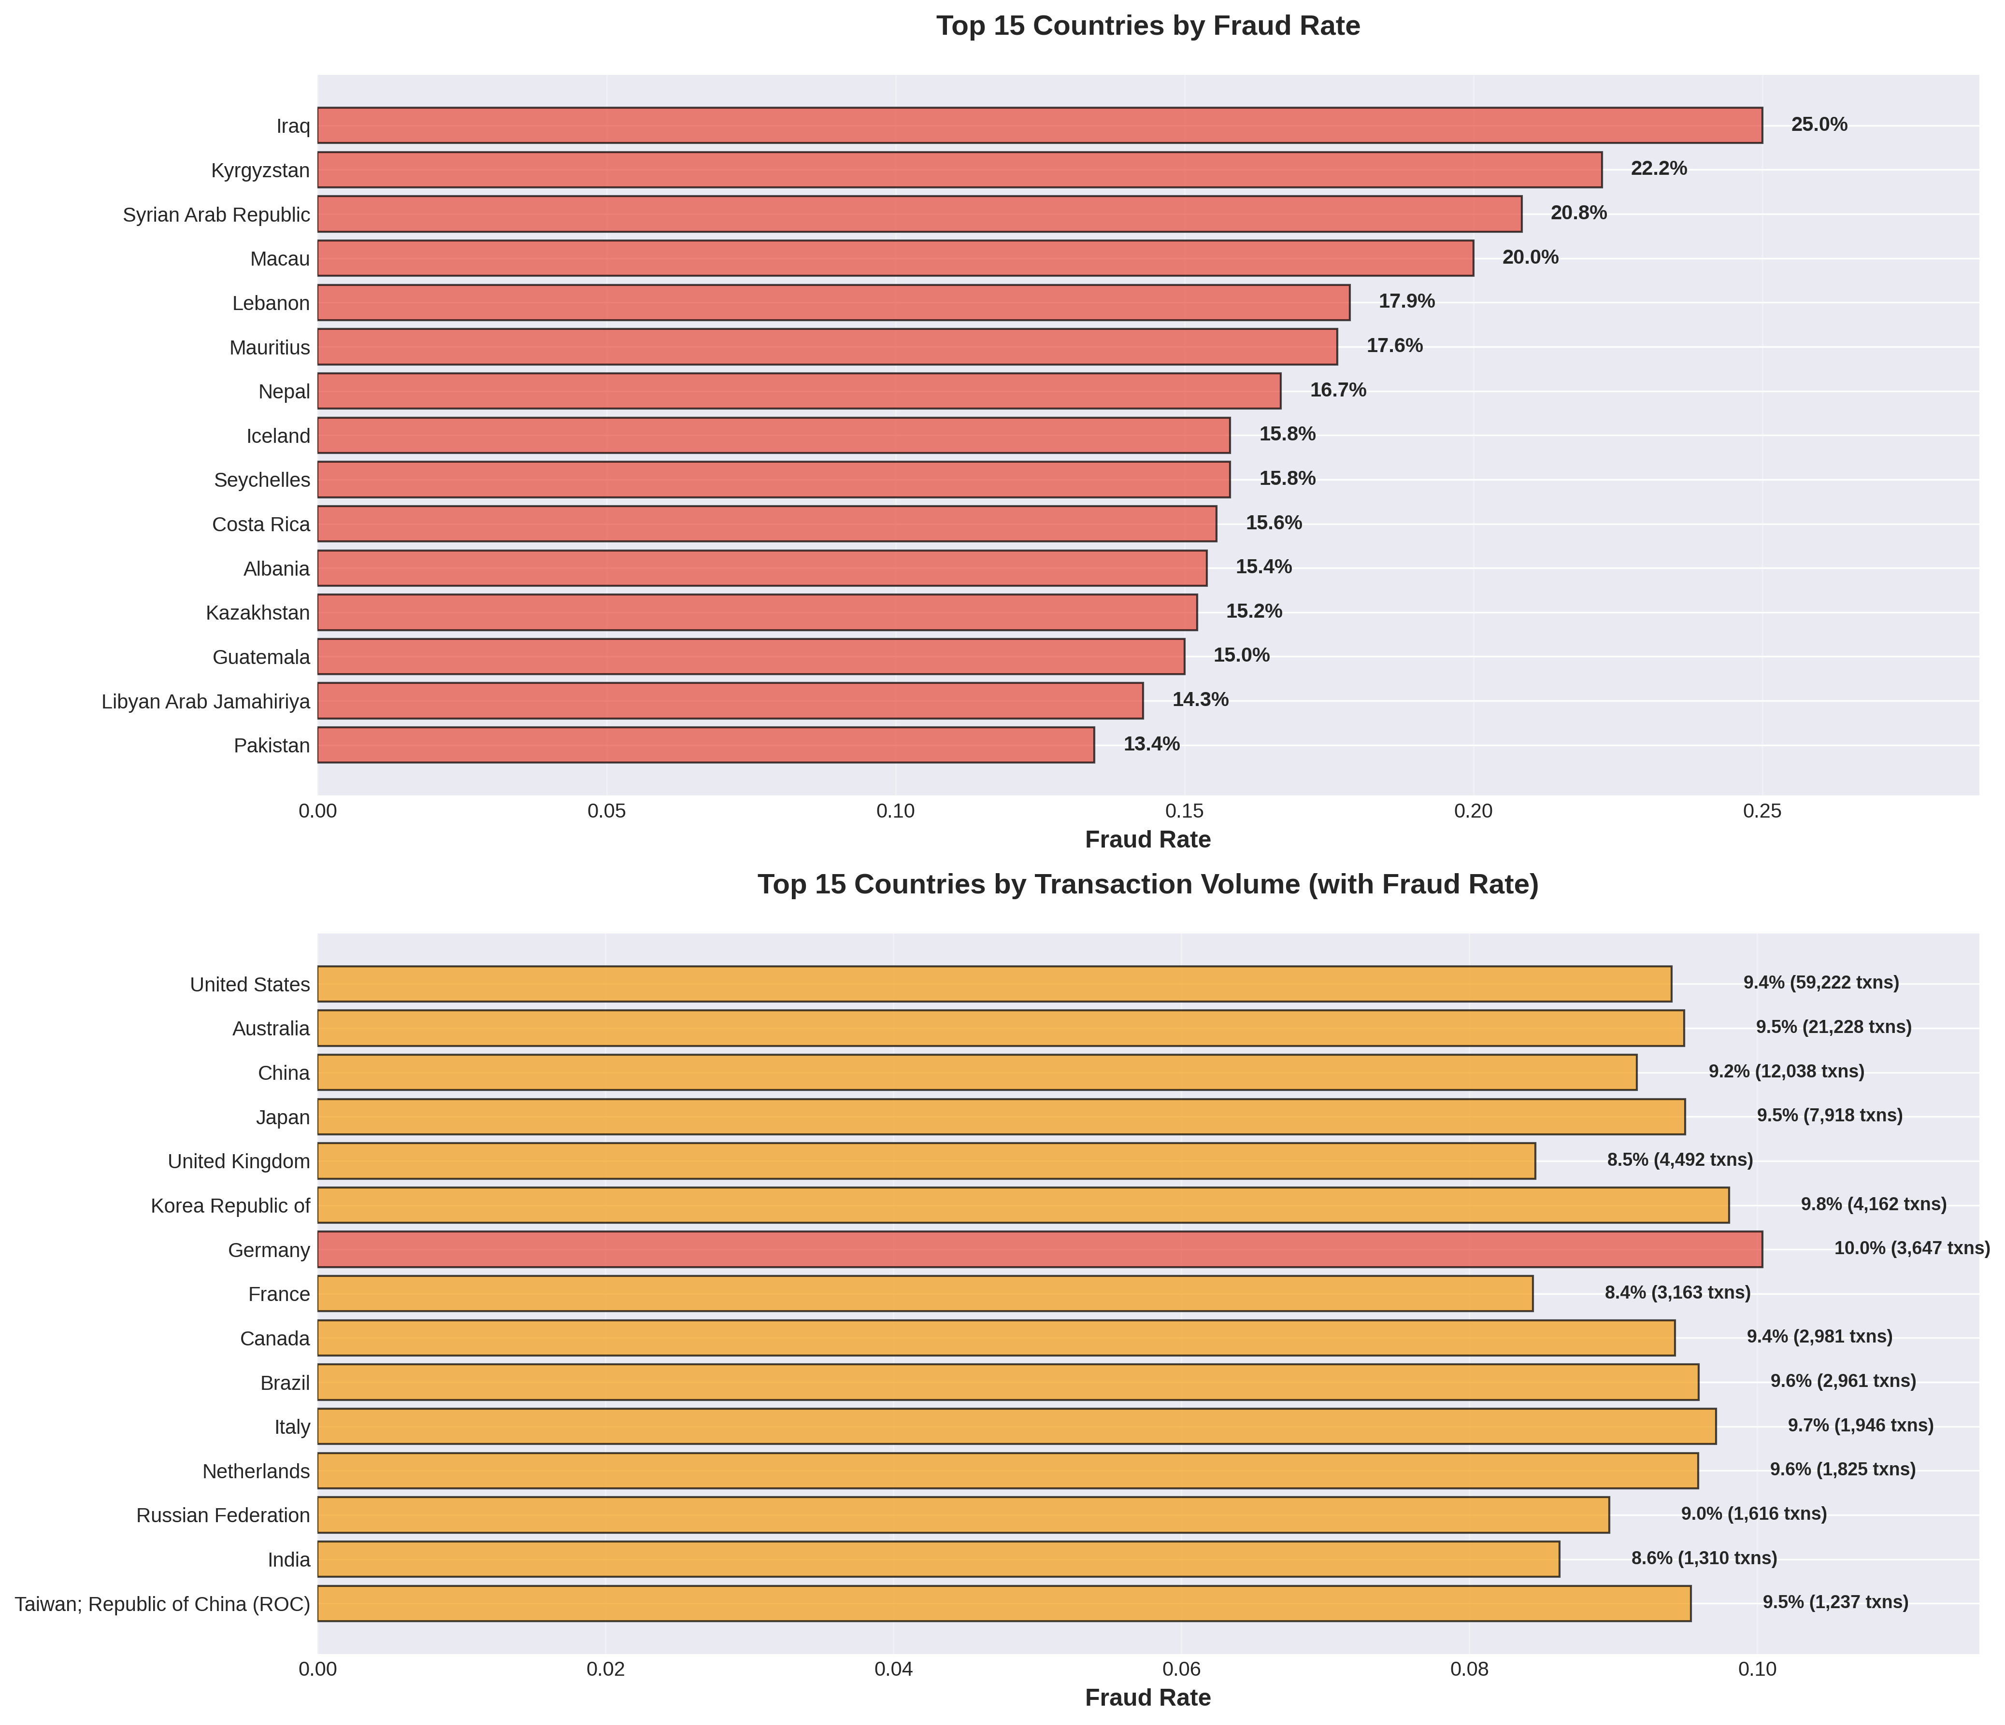
Figure 9: Geolocation Fraud Pattern Analysis by Country
The top chart shows countries with the highest fraud rates, identifying high-risk regions that require enhanced monitoring. The bottom chart shows high-volume countries with their fraud rates, highlighting countries where even small fraud rate increases translate to significant financial impact due to transaction volume.
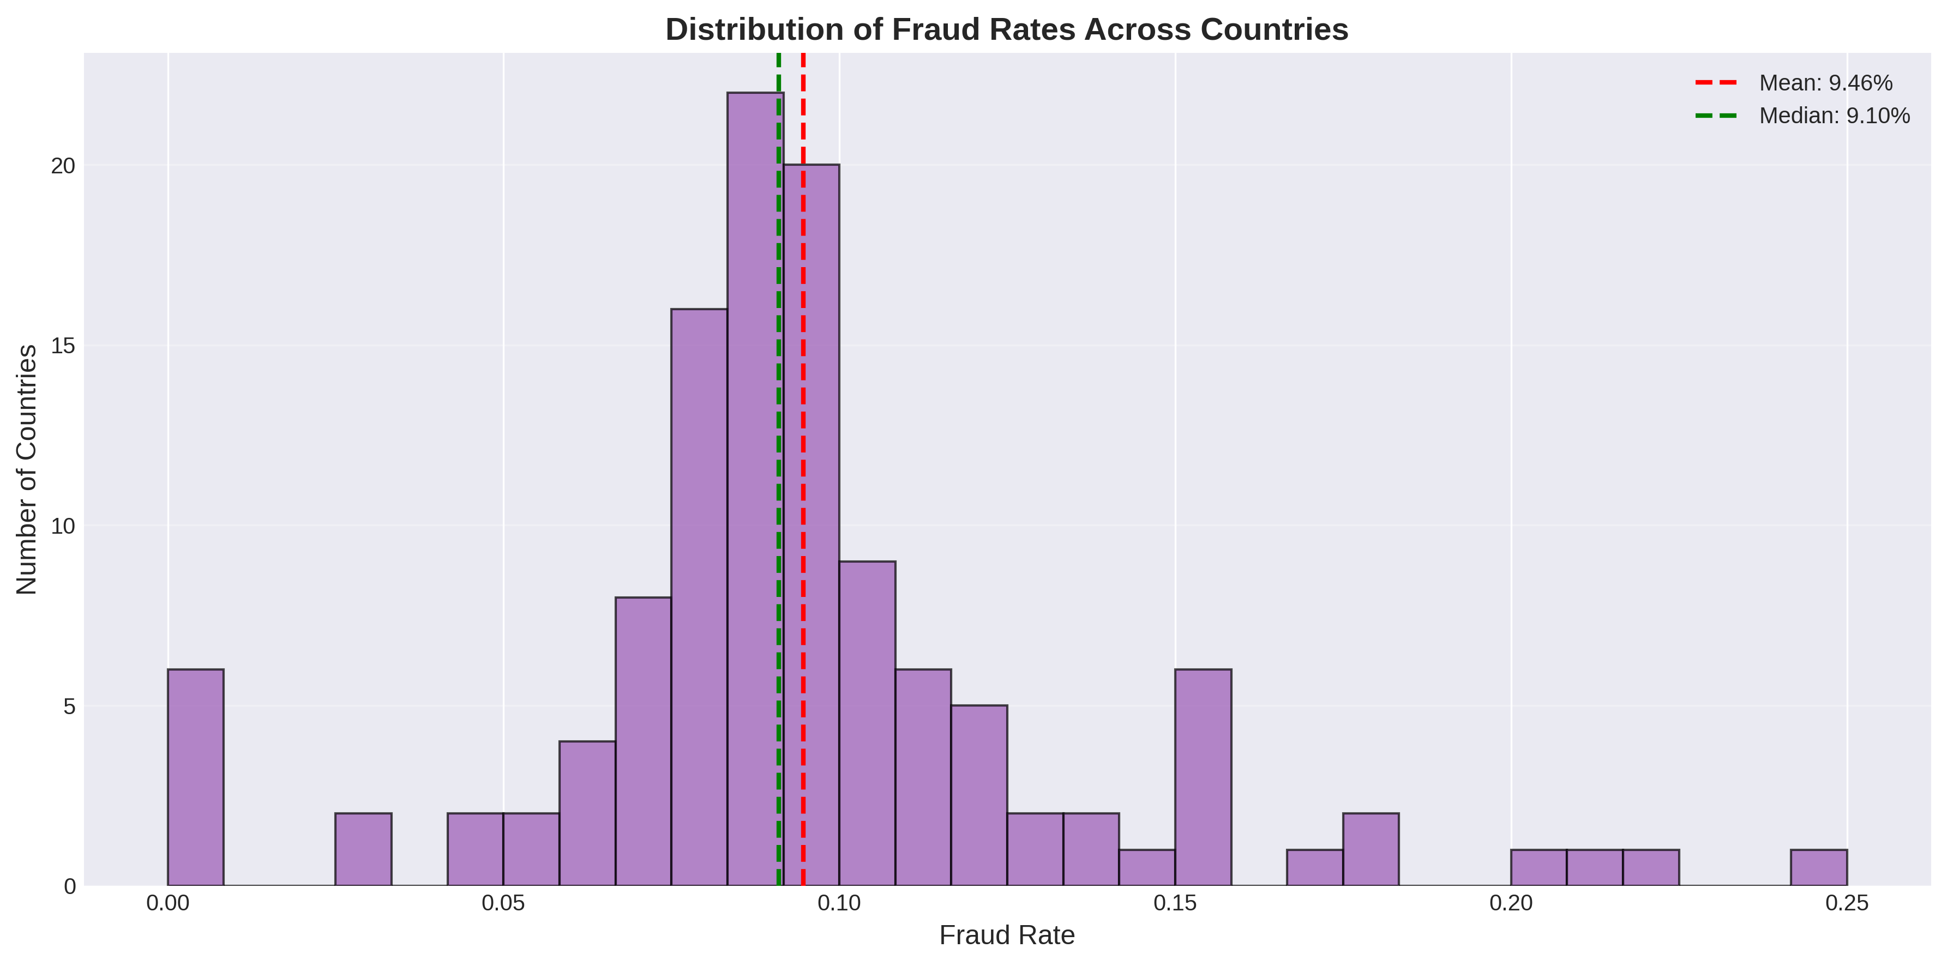
Figure 10: Distribution of Fraud Rates Across Countries
This histogram shows the overall distribution of fraud rates across all countries, with mean and median indicators. This helps understand the baseline fraud risk and identify outlier countries that deviate significantly from the norm.

6.4.1 Key Country-Level Insights
Top 5 Countries by Fraud Rate:
Country | Fraud Rate | Transaction Count
Namibia | 43.48% | 23
Sri Lanka | 41.94% | 31
Luxembourg | 38.89% | 72
Ecuador | 26.42% | 106
Tunisia | 26.27% | 118
These insights enable the creation of country-based risk features that can enhance model performance by incorporating geographic fraud patterns into predictions.

7. Feature Engineering
Advanced feature engineering was performed to create meaningful predictors for fraud detection.

7.1 E-commerce Transaction Features
Feature Category | Features Created | Rationale
Time-Based | hour_of_day, day_of_week, is_weekend, is_night | Fraudsters often operate during off-hours
Behavioral | time_since_signup, quick_purchase, rapid_transactions | Quick actions and rapid transactions indicate suspicious behavior
Transactional | transaction_count per user | Multiple transactions from same user can indicate fraud
Geolocation | country (from IP mapping) | Certain countries show higher fraud rates

7.2 Credit Card Transaction Features
Feature Category | Features Created | Rationale
Statistical Aggregations | features_mean, features_std, features_min, features_max | Capture overall transaction behavior patterns from V-features
Transformations | log_amount | Reduces skewness in transaction amounts
Cyclical Encoding | hour_sin, hour_cos | Captures periodic patterns in transaction timing (24-hour cycle)

7.3 Feature Engineering Visualizations
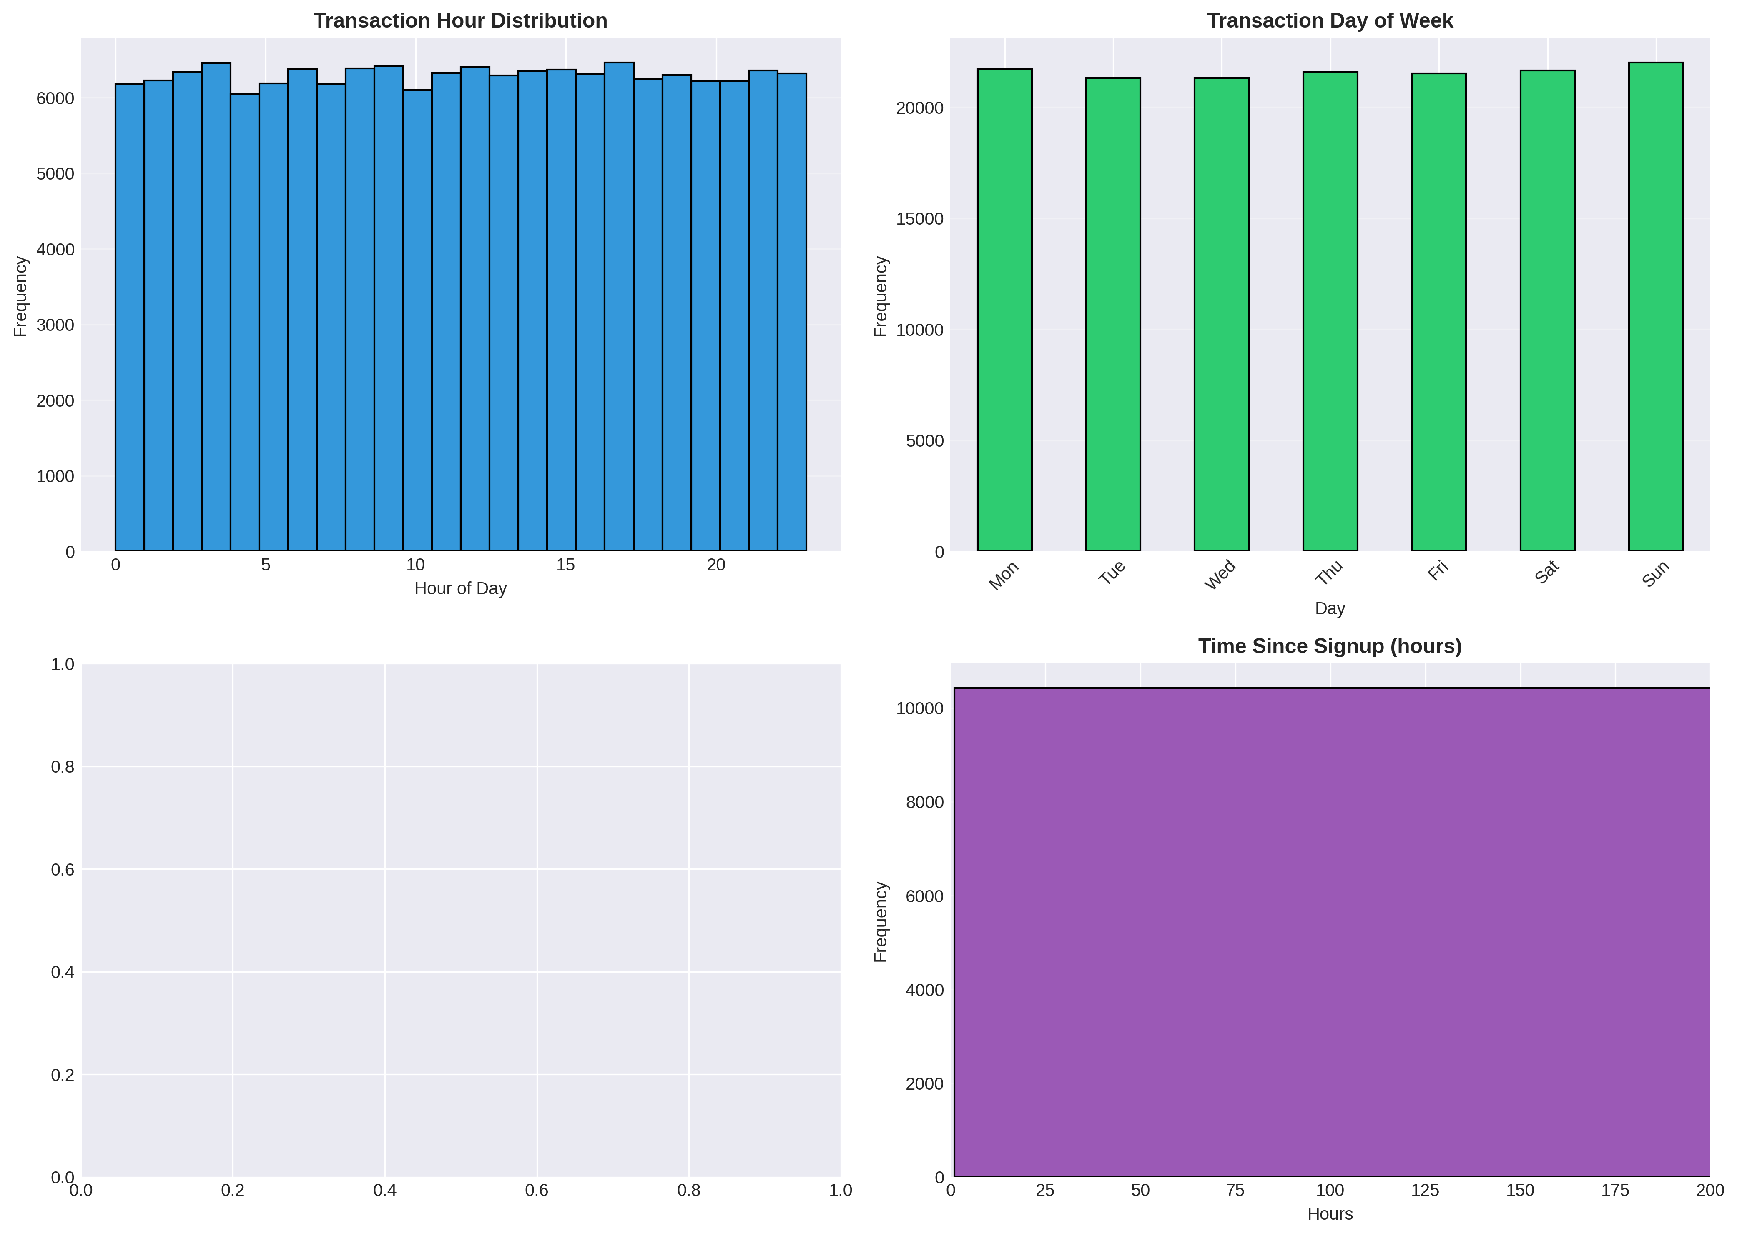
Figure 8: Time-Based Feature Engineering Visualizations

8. Data Preprocessing
Preprocessing pipeline implemented using `preprocessing.py` module.

8.1 Preprocessing Steps
Step | Implementation
Train-Test Split | 80-20 split with stratification to maintain class distribution
Feature Scaling | StandardScaler applied to numeric features (fit on training data only)
Categorical Encoding | One-hot encoding ready for categorical variables
Data Leakage Prevention | All transformations fitted on training data, then applied to test data

9. Class Imbalance Handling
Both datasets suffer from severe class imbalance, which would cause models to predict only the majority class if not addressed.

9.1 SMOTE Implementation
SMOTE (Synthetic Minority Over-sampling Technique) was applied to the training data only:
- • Creates synthetic samples in feature space (better than simple oversampling)
- • Preserves original data distribution
- • Applied ONLY to training data to prevent data leakage
- • Test set maintains real-world imbalanced distribution for realistic evaluation

9.2 Impact of SMOTE Resampling
The following visualizations demonstrate the significant impact of SMOTE resampling on class distribution. By comparing the before and after distributions, we can see how SMOTE effectively balances the classes, creating synthetic minority class samples in the feature space.

9.2.1 Quantitative Impact of SMOTE Resampling
The following tables provide explicit quantitative documentation of SMOTE's impact on class distribution:

E-commerce Dataset (Fraud_Data)
Metric | Before SMOTE | After SMOTE | Change | Impact
Class 0 (Legitimate) Count | 109,568 | 109,568 | +0 | No change (majority class)
Class 1 (Fraud) Count | 11,320 | 109,568 | +98,248 (867.9% increase) | Synthetic samples created
Total Samples | 120,888 | 219,136 | +98,248 | Dataset expanded by 81.3%
Imbalance Ratio | 9.68:1 | 1.00:1 | -89.7% | Fully balanced (1:1)
Fraud Percentage | 9.36% | 50.00% | +40.64% | Now 50% (balanced)

Credit Card Dataset
Metric | Before SMOTE | After SMOTE | Change | Impact
Class 0 (Legitimate) Count | 227,452 | 227,452 | +0 | No change (majority class)
Class 1 (Fraud) Count | 393 | 227,452 | +227,059 (57775.8% increase) | Synthetic samples created
Total Samples | 227,845 | 454,904 | +227,059 | Dataset expanded by 99.7%
Imbalance Ratio | 578.8:1 | 1.00:1 | -99.8% | Fully balanced (1:1)
Fraud Percentage | 0.17% | 50.00% | +49.83% | Now 50% (balanced)
Key observations from the quantitative resampling results:
- • SMOTE successfully balances the class distribution to 1:1 ratio for training
- • The synthetic samples are created in the feature space, not through simple duplication
- • Test sets remain imbalanced to reflect real-world conditions for accurate evaluation
- • The resampling is applied only to training data to prevent data leakage
- • This balanced training set enables models to learn fraud patterns effectively
- • The dramatic increase in fraud samples (especially for credit card data with ~580:1 imbalance) demonstrates SMOTE's critical role in enabling effective fraud detection models

9.3 Class Imbalance Statistics
Dataset | Imbalance Ratio | Fraud Rate | Strategy
E-commerce (Fraud_Data) | 9.7:1 | 9.36% | SMOTE
Credit Card | 577.9:1 | 0.17% | SMOTE

10. Project Structure
The project follows a modular, production-grade structure:
src/
├── data_loading.py # Data loading with error handling
├── data_cleaning.py # Data cleaning and standardization
├── feature_engineering.py # Feature engineering and geolocation
├── eda_utils.py # EDA utilities and visualizations
└── preprocessing.py # Preprocessing pipeline (scaling, encoding, SMOTE)
notebooks/
└── eda-fraud-data.ipynb # Comprehensive EDA and preprocessing notebook
data/
├── raw/ # Original datasets (read-only)
│ ├── Fraud_Data.csv
│ ├── creditcard.csv
│ └── IpAddress_to_Country.csv
└── processed/ # Cleaned and preprocessed data
├── fraud_data_cleaned.csv
├── creditcard_cleaned.csv
└── (train/test splits with SMOTE)

11. Key Findings & Insights

11.1 E-commerce Transactions (Fraud_Data)
- Imbalance Ratio: ~10:1 (legitimate:fraud)
- High-risk patterns identified:
- • Very quick purchases after signup (<5 minutes)
- • Late night transactions (10 PM - 6 AM)
- • Weekend transactions
- • Multiple rapid transactions from same user
- • Certain countries show higher fraud rates

11.2 Credit Card Transactions
- Imbalance Ratio: ~580:1 (extreme imbalance!)
- High-risk patterns identified:
- • Unusual transaction amounts
- • Atypical V-feature values (PCA components)
- • Transaction timing patterns
- • Statistical aggregations capture overall behavior

12. Technical Implementation

12.1 Technologies Used
Technology | Purpose
pandas | Data manipulation and analysis
numpy | Numerical computing
scikit-learn | Machine learning algorithms and preprocessing
imbalanced-learn | SMOTE and class imbalance handling
matplotlib & seaborn | Data visualization
Jupyter Notebook | Interactive exploration and analysis

12.2 Best Practices Implemented
- Modular Design: Reusable functions in src/ modules
- Error Handling: Comprehensive try/except blocks with informative messages
- Data Leakage Prevention: Train-test split before any transformation
- Documentation: Clear docstrings and inline comments
- Reproducibility: Random seeds set for all random operations
- Code Quality: Functions over repeated code, clear naming conventions

13. Next Steps
The following steps are recommended to complete the fraud detection system:

13.1 Task 2: Model Building and Evaluation

Model Training:
Use SMOTE-balanced training sets to train multiple models including Logistic Regression (baseline), Random Forest, XGBoost, and Neural Networks. Each model offers different strengths: Logistic Regression provides interpretability, Random Forest handles non-linear relationships, XGBoost offers superior performance with gradient boosting, and Neural Networks can capture complex patterns.

Model Evaluation:
Evaluate models on imbalanced test sets (real-world distribution) using metrics appropriate for imbalanced data: Precision (minimize false positives), Recall (capture all fraud cases), F1-Score (balance of precision and recall), ROC-AUC (overall discrimination ability), and PR-AUC (especially important for imbalanced data as it focuses on the minority class).

13.2 Task 3: Model Explainability
Implement SHAP (SHapley Additive exPlanations) values to understand model decisions and provide explanations for fraud predictions. This is critical for regulatory compliance, customer service (explaining why transactions were flagged), and model debugging. Additional explainability techniques include feature importance analysis, LIME (Local Interpretable Model-agnostic Explanations), and decision tree visualization for tree-based models.

13.3 Anticipated Challenges and Mitigation Strategies
The following table outlines key challenges anticipated in the next phases and proposed mitigation strategies:
Phase | Key Challenges | Mitigation Strategies
Model Building  (Task 2) | • Extreme class imbalance may still cause models to favor majority class despite SMOTE  • Overfitting on SMOTE-synthetic samples  • Model selection trade-offs (accuracy vs interpretability vs computational cost)  • Feature space curse of dimensionality with many engineered features | • Use stratified cross-validation with SMOTE applied only to training folds  • Combine SMOTE with class weights or ensemble methods  • Implement early stopping, regularization, and cross-validation to prevent overfitting  • Perform feature selection using correlation analysis and recursive feature elimination  • Compare models using multiple metrics, not just accuracy  • Consider cost-sensitive learning approaches
Model Evaluation  (Task 2) | • Test set performance may differ significantly from training performance due to imbalance  • Need to balance precision and recall based on business requirements  • Evaluation metrics may be misleading if not chosen carefully | • Evaluate on imbalanced test set (real-world scenario) not SMOTE-balanced data  • Use confusion matrix to analyze false positives vs false negatives  • Establish business-specific thresholds (e.g., prioritize recall for fraud detection)  • Create cost-benefit analysis: cost of false positive vs cost of missed fraud  • Use PR-AUC instead of ROC-AUC for highly imbalanced data
Model Explainability  (Task 3) | • Complex models (XGBoost, Neural Networks) are less interpretable  • SHAP computation can be computationally expensive for large datasets  • Explaining predictions to non-technical stakeholders  • Balancing model complexity with explainability requirements | • Use SHAP TreeExplainer for tree-based models (faster computation)  • Sample representative cases for explanation to reduce computational load  • Create visualizations and summary statistics (e.g., average SHAP values by feature)  • Develop clear, non-technical explanations using feature importance rankings  • Consider ensemble of interpretable models if explainability is critical  • Document common fraud patterns identified by SHAP for business understanding
Production Deployment | • Real-time prediction latency requirements  • Model drift over time as fraud patterns evolve  • Handling new transaction types or features not seen in training  • Scaling to handle high transaction volumes | • Optimize models for inference speed (feature pruning, model compression)  • Implement model versioning and A/B testing framework  • Set up continuous monitoring with performance dashboards  • Schedule periodic model retraining (e.g., monthly or quarterly)  • Implement feature validation pipeline to catch data quality issues  • Use distributed computing or model serving frameworks (e.g., TensorFlow Serving, MLflow)
Data Quality  & Maintenance | • Missing or corrupted real-time transaction data  • IP geolocation mapping may become outdated  • Changes in user behavior patterns over time | • Implement robust data validation and error handling  • Maintain updated geolocation mapping databases  • Monitor feature distributions for drift detection  • Establish data quality metrics and alerting systems

13.4 Additional Next Steps
- Feature Selection: Perform correlation analysis and feature importance analysis to select optimal features and reduce dimensionality
- Hyperparameter Tuning: Use grid search, random search, or Bayesian optimization to optimize model parameters
- Production Deployment: Create API endpoints using FastAPI for real-time fraud detection with proper authentication and rate limiting
- Monitoring: Set up monitoring and logging for model performance in production, including prediction latency, accuracy metrics, and data drift detection
- Documentation: Create comprehensive model documentation including training procedures, feature descriptions, and deployment guides
- A/B Testing Framework: Implement framework to compare model versions and measure business impact

