Just-DNA-Lite: a Local-First, Open-Source Platform for Personal Genome Annotation and Polygenic Risk Scoring
Draft v0.5 (Paper 1 of 2). This is the platform paper: the local-first platform and the compute engines it runs — the annotation pipeline, the just-prs computation library and its just-prs-mcp access layer, the no-code module format, the web UI, just-dna-format, and the module registry. The boundary with the companion paper is consuming versus authoring: this paper covers how a compiled module or a published score is discovered, computed against a genome, and reported, including from an AI assistant that calls these operations as typed tools. The companion paper covers the other direction — an assistant producing new annotation content: the authoring plugin, the enrichment and compilation toolchain, and how modules are published and versioned. It is Creating and Sharing Genomic Annotation Modules with AI: The Just-DNA Ecosystem (entered at EASRP 2026 and not selected for the final, so its journal is still to be chosen; draft mirror: paper2-just-module-creator.md). See docs/manuscript/v0.3/manuscript-strategy-v0.3.md and, for venues, docs/manuscript/manuscript_journal_strategy.md (section "Venues, October 2026").
Authors: Kulaga Anton^{1,2,4,†}, Usanov Nikolay^{3,4,†}, Borysova Olga⁴, Karmazin Alexey⁴, Koval Maria⁴, Fedorova Alina⁴, Pushkareva Malvina⁴, Evfratov Sergey⁴, Ryangguk Kim⁸, Zaharia Livia³, Fuellen Georg^{1,*}, Tacutu Robi^{2,9,*}
Affiliations:
- Institute for Biostatistics and Informatics in Medicine and Ageing Research, Rostock University Medical Center, Rostock, Germany
- Institute of Biochemistry of the Romanian Academy, Bucharest, Romania
- HEALES (Healthy Life Extension Society)
- SecvADN SRL
- CellFabrik SRL
- MitoSpace
- M. Glushkov Institute of Cybernetics of National Academy of Sciences of Ukraine
- Oak Bioinformatics, LLC
- Romanian Bioinformatics Cluster, Târgu Mureș, Romania
† These authors contributed equally. * Co-supervising authors.

Abstract
Motivation: People who receive a personal genome file still face a practical problem: how to connect their variants to published evidence, inspect the analysis and retain control of their data.
Results: Just-DNA-Lite is an open-source platform for variant annotation and polygenic risk scoring with a web interface. Annotation modules are versioned packages of variant-trait tables and their sources, added without code and distributed through a registry. Reports list each matched variant with its reported effect and sources. The just-prs library scores through web, command-line, Python and Model Context Protocol (AI-assistant) interfaces and shows percentiles within a reference population matched to the genome's inferred ancestry, with all models for a trait together. Core annotation and scoring run locally on downloaded reference data; optional external AI services introduce a separate data-sharing boundary. The platform is meant for research and education and does not provide diagnoses or establish clinical validity for the associations it reports.
Availability and implementation: Just-DNA-Lite (AGPL-3.0) and just-prs (MIT) are written in Python and run on Linux, macOS and Windows. Source code: https://github.com/dna-seq/just-dna-lite and https://github.com/dna-seq/just-prs. The two co-author genomes used in the benchmarks are public on Zenodo (records 18370498 and 19487816).
Contact: fuellen@uni-rostock.de, robi.tacutu@gmail.com
Supplementary information: Supplementary data accompany this manuscript. <!-- AUTHOR TODO: add the archive DOI (Zenodo or Software Heritage) of the submitted software version and test data to the Availability paragraph before submission. -->

1. Introduction
Researchers and individuals who receive raw variant files (VCFs) containing millions of variants often lack an accessible way to annotate them against published databases without specialized bioinformatics expertise (Chen et al., 2023), a learning curve that takes time away from the questions they set out to answer; many turn to third-party interpretation services instead (Nelson et al., 2019; O'Daniel et al., 2025).
By 2025, manufacturers advertised the sequencing of a human genome for US$80 to US$200 (Illumina, 2023; Ultima Genomics, 2025). Clinical laboratory studies report higher costs after including labour, equipment and analysis, with estimates depending on the workflow and costing scope (Mordaunt et al., 2024; Ehman et al., 2025). The National Human Genome Research Institute (NHGRI) estimates that the first human genome cost US$500 million to US$1 billion (NHGRI, 2021). Several companies now offer direct-to-consumer sequencing services (O'Daniel et al., 2025).
Existing solutions generally belong to two extremes. Commercial platforms such as DNA Complete (formerly Nebula Genomics) and Dante Labs provide curated reports, but the curation is opaque: users cannot verify which polymorphisms contributed to a score, whether the methodology is appropriate for their ancestry, or how findings were weighted. At the other end, research-grade tools like PLINK, ANNOVAR, and VEP are powerful but demand command-line proficiency and a lengthy setup. Open-source projects between these extremes each cover part of the task, such as local annotation with installable modules, ancestry-normalized scoring of PGS Catalog models, or access to a genome from an AI assistant. Table S7 compares the documented features of 23 tools for personal-genome annotation, polygenic scoring and AI-assisted interpretation; none of them documents a graphical interface, annotation sets added without code, PGS Catalog scoring and ancestry-matched percentiles together.
Recent progress in the genetics of longevity illustrates the need for such extensible annotation tools. After correction for extrinsic mortality, the intrinsic heritability of lifespan has been estimated at about 50%, against 20–25% in twin studies (Shenhar et al., 2026). Genetic association studies have repeatedly linked loci such as APOE and FOXO3 to longevity (Broer et al., 2015; Caruso et al., 2022). Databases such as LongevityMap within the Human Ageing Genomic Resources (HAGR) (Tacutu et al., 2018) have compiled thousands of variants tested for association with longevity, but no existing tool makes it straightforward to annotate a personal VCF against these databases transparently and extensibly. More broadly, variant-trait associations are published faster than any single curation team can integrate them, which supports the case for platforms where new annotation modules can be added rapidly.
Such a platform has to be easy to use, transparent in its methods and extensible without code. It also has to protect privacy. Genomic data are among the most sensitive personal information, and uploading them to third-party servers carries risks that individuals and regulations such as the General Data Protection Regulation (GDPR) seek to avoid.
Just-DNA-Lite is a local, open-source platform for annotating a personal genome and computing polygenic scores. We developed it as a ground-up rewrite of Just-DNA-Seq (Kulaga et al., 2024), whose first generation (Generation I) was a set of annotation and report modules for OakVar, a Python variant-analysis framework derived from OpenCRAVAT. Just-DNA-Lite (Generation II) removes the OakVar dependency entirely and uses a standalone annotation engine. It also replaces Python annotation plugins with declarative modules discoverable from configured sources (Section 2.2). Supplementary S1 describes Generation I.
The resulting workflow lets users choose published annotation content, apply it to their own genome and inspect the evidence behind the report. The reusable just-prs scoring library adds polygenic scores and reference-population comparisons to the same web interface. Researchers can contribute new annotation modules through the open-source registry, and Model Context Protocol (MCP) interfaces make the annotation and scoring operations available to AI assistants.

2. System and Methods: Platform Architecture
The architecture separates local computation, annotation content and user interfaces. The pipeline reads modules as data artifacts, so the catalogue can change independently of the application code, and columnar storage with streaming operations limits memory use. A web application is the main interface, and typed MCP tools serve AI assistants (Section 3.2.1).

2.1 Annotation Pipeline
The standalone annotation engine uses polars-bio for VCF reading (a genomics library with a Polars interface; Wiewiórka et al., 2025), Polars for columnar processing, and DuckDB for out-of-core joins.
The pipeline is built from Dagster (Dagster Labs, 2026) software-defined assets, which record data lineage and, for every step, its duration, CPU use and resident memory at the step's start and end. An annotation run proceeds as follows:
- VCF ingestion. The user supplies a VCF or VCF.gz file, as delivered by a sequencing provider, downloaded from a public genome repository or produced by their own pipeline; Just-DNA-Lite does not perform sequencing, alignment or variant calling. The file is read with polars-bio, "a Python library that enables fast, parallel and out-of-core operations on large genomic interval datasets" (Wiewiórka et al., 2025).
- Normalization. The raw VCF undergoes quality filtering (configurable via modules.yaml): only variants passing specified FILTER values (by default, PASS and ".") are retained, with minimum depth (DP ≥ 10) and quality (QUAL ≥ 20) thresholds that are on by default and can be turned off. A passing record that states no depth or quality is judged by its FILTER value alone. Chromosome names are normalized ("chr7" becomes "7", "chrM" becomes "MT") for consistency with annotation databases. The normalized data are written as a Parquet file, which is the shared input for all downstream annotations.
- Module annotation. For each selected annotation module, the pipeline performs a streaming join between the normalized VCF Parquet and the module's lead table (for most modules, weights.parquet). The join is by chromosome, position and genotype, with the reference allele required to agree where the module states one. Genotypes, the alleles the sample carries, are compared as written, so an indel matches only when the VCF and the module spell it the same way. Older modules without coordinates are joined by rsID and genotype; such a module is listed as not read, with the reason, when the VCF carries no rsIDs. The module joins use Polars streaming execution. The optional Ensembl annotation uses DuckDB with configurable memory limits.
- Ensembl annotation (optional). When enabled, the pipeline also joins the normalized VCF against the Ensembl Variation database (Dyer et al., 2025). For each variant, it adds clinical -significance flags, the variant class (such as SNV, insertion or deletion) and cross-references (the rsID and the sources that list the variant). The database is cached locally as chromosome-level Parquet files, downloaded from HuggingFace and checked against each file's published size and SHA-256.
- Report generation. Annotated results are written as Parquet files and rendered as downloadable HTML reports, which a browser can print to PDF.
The current annotation engine also distinguishes called genotypes from inferred homozygous-reference genotypes. For variant-only call sets classified as whole-genome, it can restore a module's authored reference-genotype rows at sites the caller did not emit. Reports label restored rows as inferred and keep their counts separate from called matches. A restored site must lie within a set distance of a called variant, and nearby calls do not establish per-base callability. Supplementary S12 gives the whole-genome classification thresholds, distance limit and exclusion rules. This annotation procedure is distinct from the optional PRS restoration described in Section 3.2.

2.2 Annotation Modules as Data
In Just-DNA-Lite, annotation modules are data, not executable plugins: the annotation engine reads their published Parquet tables directly. A typical weighted-association module contains weights.parquet, with accompanying annotations.parquet and studies.parquet when available; other module families have a different lead table.

For researchers creating new modules, a separate authoring route accepts module_spec.yaml and CSV tables such as variants.csv and studies.csv. The just-dna-compiler library validates and compiles these specifications into Parquet artifacts and a manifest during custom-module registration. Documentation and thumbnails may accompany the module. This route lets authors prepare annotation content without writing Python code. CSV files are used only for authoring: at runtime the platform reads the compiled Parquet tables, so existing Parquet modules need no CSV files.
The just-dna-format library defines the authored specification and the manifest, integrity and versioning contract of compiled artifacts. Discovery reads a module's declared files from its manifest, or finds the tables directly in older Parquet modules that have none.
Module discovery uses sources configured in modules.yaml, with repository defaults and a local working copy for runtime changes. Sources may include HuggingFace datasets, GitHub repositories, HTTP/HTTPS servers, cloud storage, or local paths accessible through fsspec. The open-source just-dna-registry service (https://module-registry.just-dna.life) lets users submit and share their own annotation modules and browse and retrieve versioned modules contributed by others. Artifact manifests provide identity and integrity information. The platform records the digest each module states but does not yet recompute it when it discovers or installs a module; such a check would establish that downloaded content matches the recorded artifact, not that its scientific claims are correct.

2.3 Web Interface and Self-Exploration
The interface covers file management, module selection (including the optional Ensembl annotation), a sortable and filterable results grid, report download (one HTML report per run, with a section for each selected module), and self-exploration (Figure 1). Users can browse the full variant table with sorting, filtering, and search, cross-referenced against Ensembl for clinical -significance flags, the variant class and whether a phenotype or disease association is recorded. All data can be exported as Parquet for downstream analysis in Python, R, DuckDB, or any Arrow-compatible tool. The web interface is built with Reflex (Reflex, 2026), a Python framework that compiles to React; the whole interface is written in Python.
Users can install and run the web interface on their own computers to analyse their personal genomes locally. A hosted demonstration at https://lite.just-dna.life/ provides access using public genomic data only; uploads of private genome files are disabled in this deployment.
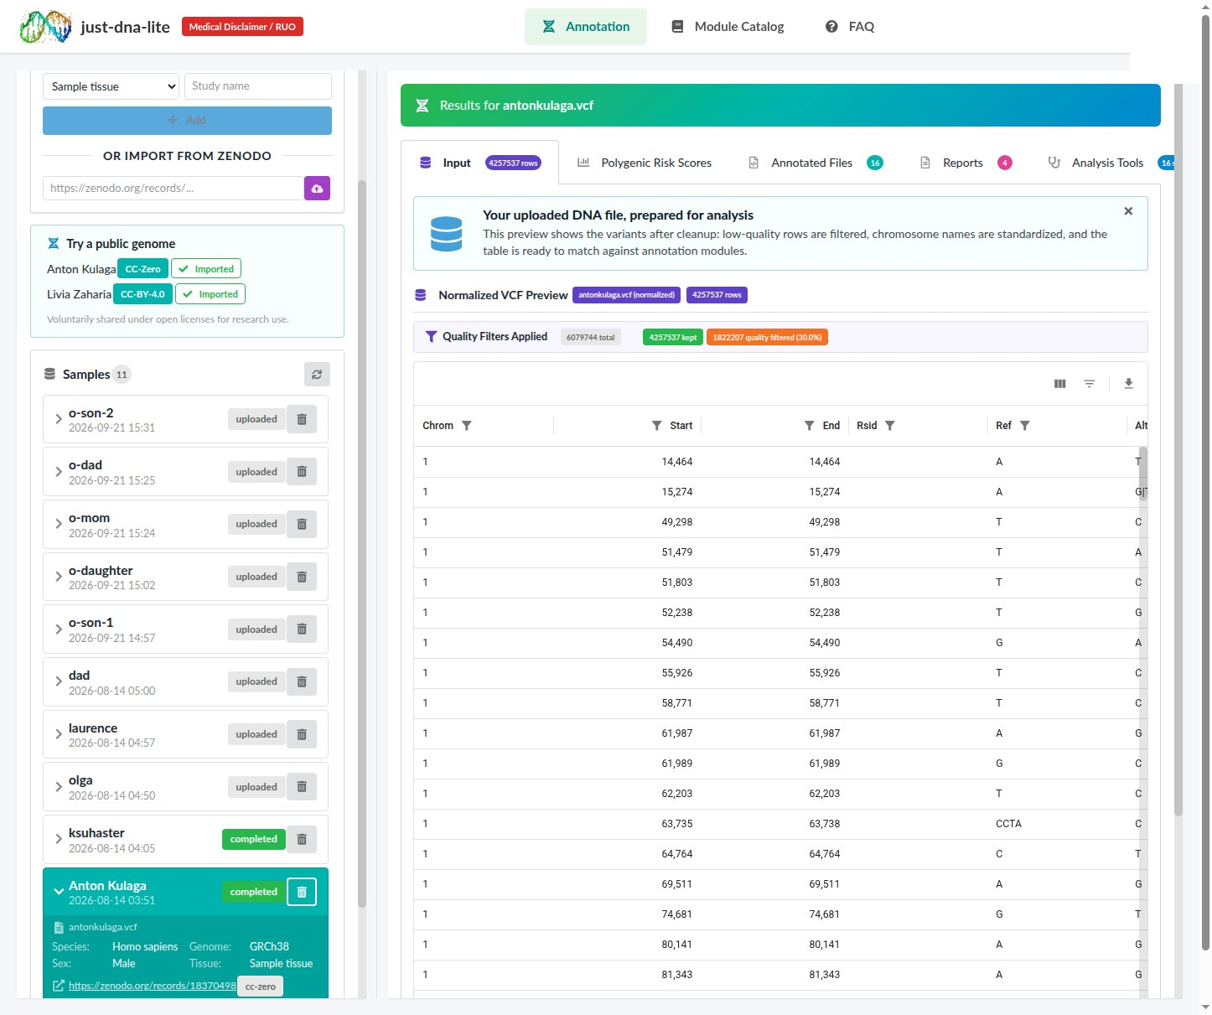{width=95%}
Figure 1. The Just-DNA-Lite web interface showing the selected sample, quality-filter summary, normalized variant grid, and tabs for polygenic scores, annotated files, reports and analysis tools.

3. Algorithm and Implementation: Annotation Modules and Polygenic Scoring
Just-DNA-Lite ships with a default set of annotation modules, either curated by experts from the published literature or derived from public databases (ClinVar, Landrum et al., 2018; ClinPGx, Whirl-Carrillo et al., 2021), which illustrate the module system across several trait domains. The platform is designed so that other researchers (e.g. bioinformaticians and geneticists) can add their own modules without writing code, either by hand or with AI assistance (Section 3.4). The modules annotate user variants against published variant-trait association databases; they do not perform clinical interpretation or generate diagnoses.
The default modules originate in Generation I, the OakVar-based Just-DNA-Seq (Kulaga et al., 2024). That system was built around longevity and longevity-associated traits, which is why the default set centres on that domain; for Generation II, most modules were ported, largely unchanged, to serve as worked examples of the no-code module format rather than as a definitive trait catalogue.
The default collection brings together longevity-associated variants, disease-predisposing variants and drug-response associations (Table 1). These were the linked questions behind Generation I.
Table 1. Annotation modules published by the Just-DNA-Lite project in the module registry (namespace just-dna-seq), as of 2026-10-10 18:00 UTC. Later versions may differ; versions, digests and every source are listed in Table S4.
Module | Description | Curator
Longevity Map | Longevity-associated variants from the LongevityMap database, ported from the Generation I module: 528 variants in 272 genes, citing 126 papers (sources in Table S4) | Expert (Olga Borysova)
Coronary Artery Disease | Coronary artery disease risk associations from published studies, ported from the Generation I module: 27 variants in 22 genes, citing 59 papers (sources in Table S4) | Expert (Olga Borysova)
Lipid Metabolism | Lipid metabolism and cardiovascular risk variants from published studies: 15 variants in 12 genes, citing 37 papers (sources in Table S4) | Expert (Olga Borysova)
VO2 Max | Published studies of the oxygen-uptake response to exercise training: 13 variants in 12 genes, citing 7 papers (sources in Table S4) | Expert (Olga Borysova)
Superhuman (protective alleles) | Rare protective and enhancing alleles from the Church laboratory's list, checked against the primary literature: 74 variants in 28 genes, citing 29 papers (sources in Table S4) | Expert (Olga Borysova)
Thrombophilia | Inherited blood-clotting risk variants (Factor V Leiden, prothrombin and related loci) from published studies: 8 variants in 8 genes, citing 24 papers (sources in Table S4) | Expert (Olga Borysova)
Cardio | Pathogenic and likely pathogenic variants from ClinVar (release 2026-06-27, review status of at least one star) in 297 cardiac-disease genes (sources in Table S4) | Database-derived (ClinVar)
Cancer | Pathogenic and likely pathogenic variants from ClinVar (release 2026-06-27, at least one star) in 298 cancer-predisposition genes (sources in Table S4) | Database-derived (ClinVar)
Pathogenic | Genome-wide flag for ClinVar pathogenic and likely pathogenic variants (release 2026-06-27, at least one star) across 4,793 genes (sources in Table S4) | Database-derived (ClinVar)
Pharmacogenomics | Drug response by genotype from the ClinPGx (PharmGKB) clinical annotations at evidence levels 1A to 2B (release 2025-07-05): 240 annotations, 65 drugs, 35 genes (sources in Table S4) | Database-derived (ClinPGx)

3.1 Longevity Variants Module (example)
The Longevity Variants module connects an individual's genotypes to studies of survival and exceptional longevity, with the source populations and findings available for inspection. It builds upon the LongevityMap database (Tacutu et al., 2018), which contains 3,144 variants in 884 genes (build 3, June 2017); the module keeps those with significant associations (Table S4). We did not re-annotate or re-validate these variants; our contribution is (1) curation and expansion with post-2017 literature, adding 50 new entries and editing 876 existing records; (2) assignment of weighted scores based on study quality, replication across populations, and statistical significance; and (3) pathway-based categorization for structured browsing.
The module's displayed score is the product of two component weights, W_display = w_SNP × w_genotype. The SNP weight (w_SNP) summarizes the strength of statistical evidence for a variant-trait association (number of independent significant studies, reported p-values, number of replicating populations). The genotype weight (w_genotype) captures the direction and magnitude of the reported association for a specific genotype: 0 for a genotype without the associated allele, and ±0.5 or ±1.0 for heterozygous or homozygous carriers of the positively or negatively associated allele. The associated allele can be the reference allele, as for FOXO3 rs2802292 below. The report groups variants into 12 functional pathway categories, such as insulin/IGF-1 signalling, mTOR, sirtuins and genome maintenance.
A report in use. In a stored Longevity Variants report for Anton Kulaga's public genome, FOXO3 rs2802292 is called G/T, one copy of the reference G allele that the module associates with longevity, and appears in the insulin-signalling category with a module weight of 0.475. The expanded row shows the genotype's direction (Protective) and weight, the module's stored conclusion and five linked study records from Japanese-American, Southern Italian, Han Chinese and Danish populations. The stored Danish-study conclusion distinguishes survival to old age from survival during old age. The reader can therefore inspect which finding and population underlie the annotation. The weight ranks the curated association; it is not a predicted change in lifespan. Supplementary S13 preserves the extracted row and its provenance.
Figure 2 traces this report row from the called genotype to its linked studies.
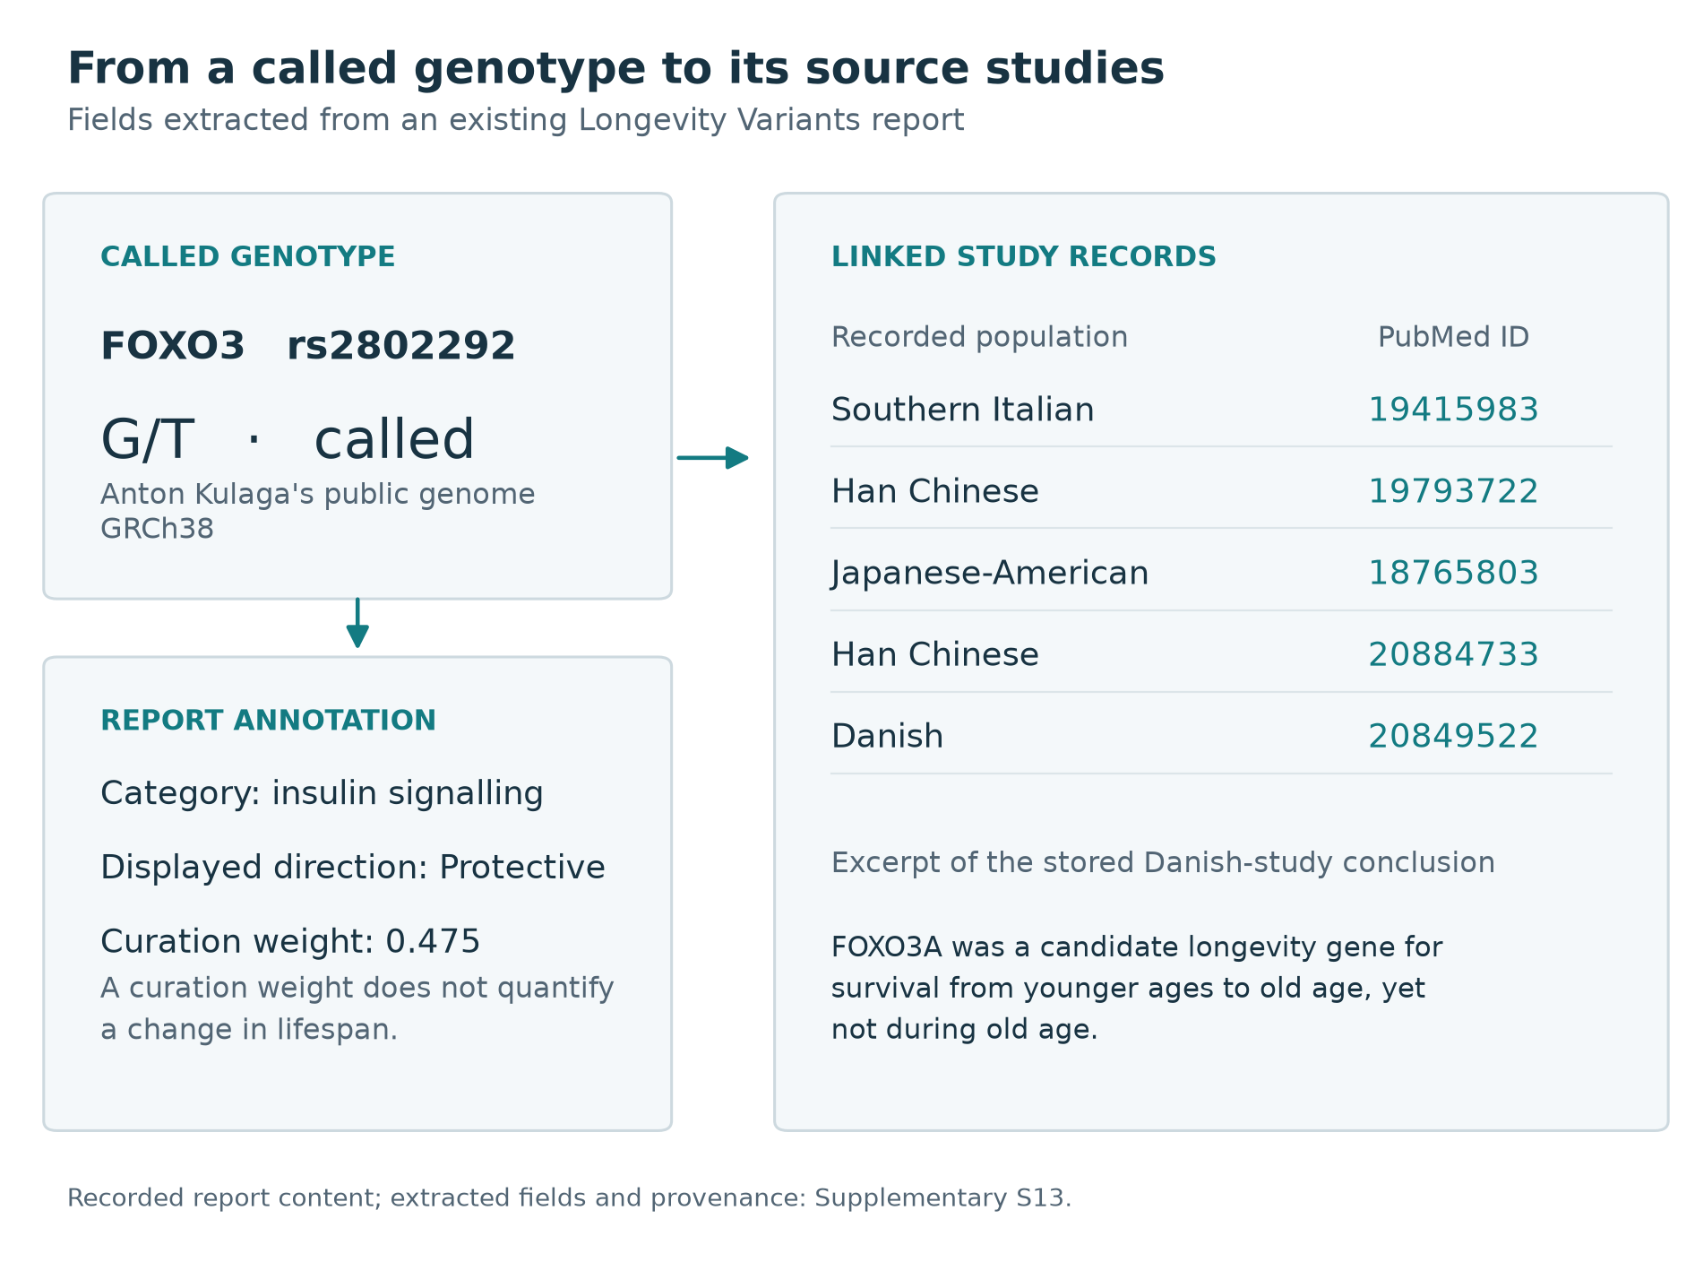{width=100%}
Figure 2. A genotype linked to its annotation and sources. Selected fields from the Longevity Variants report for Anton Kulaga's public genome: the called FOXO3 genotype, the module's insulin-signalling category, curation weight and five linked study records. The diagram reconstructs recorded report fields; the conclusion excerpt is reproduced as stored by the module. Supplementary S13 provides the extracted fields, provenance and source report.

3.2 Polygenic Risk Scores
For traits with several published models, the interface displays the scores together, with their coverage and reference population, so that users can inspect agreement and disagreement (Figure 3).
Polygenic risk scores (PRS) aggregate the effects of many variants into a single weighted sum (Lambert et al., 2021), which is read as a position within a reference population for a given trait. We developed the just-prs library (github.com/dna-seq/just-prs) as the PRS computation engine for Just-DNA-Lite; it can also be used on its own (Section 3.2.1). just-prs scores the harmonized scoring files of the PGS Catalog (Lambert et al., 2021; harmonized files documented at https://www.pgscatalog.org/downloads/): a file-level audit of just-prs 0.10.1 against the September 2026 release placed 6,910 of 6,991 files in Table S5's “as specified” category, 76 in “approximated” and 5 in “cannot be scored”. These categories assess scoring-file compatibility, using a 10% absolute-weight threshold for omitted or ambiguous rows. The first category can therefore include files with some omitted weight; it does not establish complete coverage in an individual genome or predictive validity.
Generation I derived its PRS percentiles by simulating 10,000 genotypes from pooled gnomAD allele frequencies and fitting a normal distribution to the simulated scores (Kulaga et al., 2024). just-prs instead scores the 3,202 individuals of the 1000 Genomes reference panel (Byrska-Bishop et al., 2022) with each model, summarizes the observed scores as a mean and standard deviation for each of five superpopulations (AFR, AMR, EAS, EUR, SAS), and places a user's score on the corresponding normal distribution, so the reference reflects real genotypes and their linkage structure rather than simulated ones. The reference superpopulation is inferred from the genome (Section 3.2.2) and the user can choose another; the percentile is the user's position within that distribution.
just-prs provides two scoring engines: DuckDB (SQL-based, out-of-core scoring; Raasveldt and Mühleisen, 2019) and Polars (LazyFrame joins). For diploid genotypes both engines compute the same score. They join the scoring file to the genome by chromosome and position, then check that the genotype record is the scoring row's variant, since an indel shares its first base with any SNV at that position: an SNV row scores only from a record with an SNV alternate allele, and an indel row only from a record whose alleles include its effect allele and, where the scoring file names one, its other allele. Multi-allelic records are split into their alleles. The dosage is the number of called alleles equal to the effect allele (0, 1 or 2), and the score is the sum of dosage times effect weight. No strand flipping is applied. A position whose records all fail the check is handled as an absent locus, like a missing genotype. The engines differ in how the join runs. DuckDB runs it as SQL, joining large scoring files in chunks of 250,000 to 2,000,000 variants sized from available memory, under a memory limit of 75% of RAM by default. Polars runs it as a single lazy in-memory dataframe join. On the sex chromosomes and the mitochondrial genome, both engines count copies of the effect allele, using the sample's inferred karyotype (Supplementary S9). PLINK2 is used only as an external comparator in the benchmark (Section 4.2); it is not a just-prs engine.
For variant-only whole-genome VCFs, just-prs can optionally count absent scoring loci as homozygous reference, using a reference-allele dataset. This raises coverage for many scores, assuming those loci were callable; it is off by default and not applied to gVCF input.
For consumer arrays (23andMe, AncestryDNA), which, as of October 2026, the just-prs library reads but the platform's web upload does not (Section 5.4), precomputed linkage disequilibrium (LD) proxy tables estimate untyped scoring variants from typed ones where suitable tables exist. Coverage, and the assumption used to recover each missing locus, remain part of the result's interpretation.
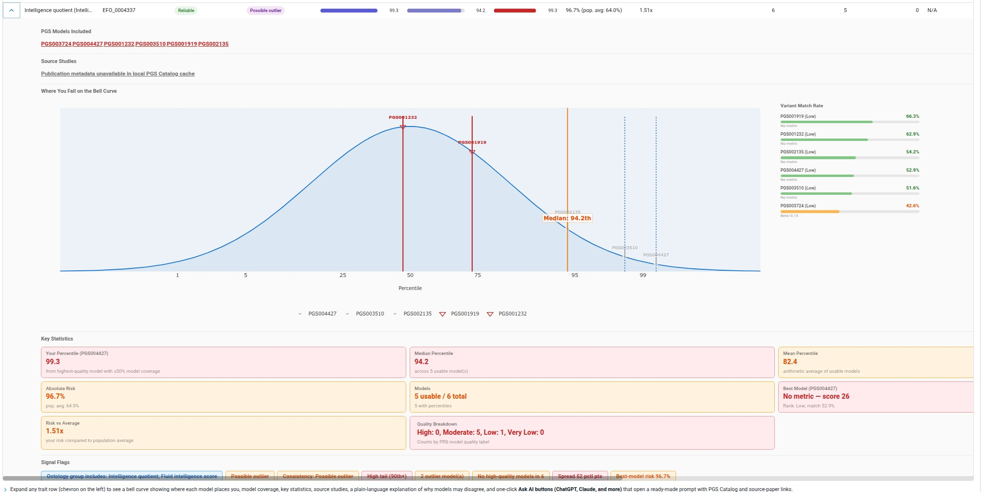{width=95%}
Figure 3. PRS trait view in an earlier Just-DNA-Lite interface. Multiple PGS Catalog models for one trait are displayed together, with model identifiers, percentile markers and variant -match rates. This existing screenshot illustrates the interface layout; its absolute-risk display and inconsistent quality labels require replacement before submission and are not results reported in this paper. Showing models together, including where they disagree, is deliberate (see Section 5.3).
<!-- AUTHOR TODO: Replace the existing images/just_prs_trait_consensus.jpg with a current screenshot for Figure 3. The existing image shows an absolute-risk percentage for intelligence and inconsistent quality labels. Capture a current trait view with the reference population, model IDs, coverage, and settings visible, then embed it here and align the caption with the final image. -->

3.2.1 Standalone PRS Use and MCP Access
Users who only want polygenic scores can run just-prs on its own, through its Python API, command-line interface, dedicated web UI, or just-prs-mcp server, without the annotation-module workflow.
Just-DNA-Lite also has its own MCP server for the full workflow (samples, modules, annotation jobs and their results), while just-prs-mcp covers PRS alone; both let AI assistants call the software through typed tools rather than write their own analysis code. The PRS tools cover catalogue search, model metadata, genome-build and ancestry detection, scoring, reference-population comparison and result-quality assessment.
The tools return PGS IDs, variant-match rates, model quality tiers, reference populations, percentiles, and agreement or disagreement among models for a trait. These fields provide the assistant with computational context; however, their presence does not ensure that an assistant will explain them correctly. Both servers run locally, but a remotely hosted assistant may receive tool outputs containing genomic results. Whether scoring is local and whether the conversation is private are therefore separate questions (Section 5.2).
All these interfaces call one scoring implementation, so equivalent inputs, reference data and settings should give equivalent results with the same just-prs version. The engine benchmark in Section 4.2 does not test each interface separately, nor the accuracy of assistant-generated explanations.

3.2.2 Ancestry Inference
The reference superpopulation is chosen by a k-nearest-neighbour classifier on principal components, built once from the 1000 Genomes high-coverage panel (Byrska-Bishop et al., 2022) and downloaded as a fixed model (HuggingFace dataset just-dna-seq/pgs-catalog, folder data/ancestry). Its training data are the panel's unrelated individuals, 2,575 after related ones were removed with a KING kinship list, each labelled with one of five superpopulations (AFR, AMR, EAS, EUR, SAS), and 53,526 autosomal biallelic SNVs kept after quality control and linkage pruning in PLINK2 (Chang et al., 2015): minor allele frequency at least 0.05, Hardy–Weinberg P at least 10⁻⁴, and r² below 0.05 within windows of 1,000 variants. A principal component analysis of these genotypes defines the space. A user's genome is projected into it with the online augmentation, decomposition and Procrustes method of FRAPOSA (Zhang et al., 2020), and its superpopulation is the majority among its 20 nearest reference individuals on the first 10 components. Model sites a variant-only VCF does not list are coded as homozygous reference, and sites whose alleles disagree with the model as missing. There is no separate test set. In leave-one-out classification of the reference individuals, on principal components computed from the whole panel, 99.65% are assigned their own superpopulation (2,566 of 2,575); seven of the nine misassigned individuals belong to the admixed American group, of whom 344 of 351 are assigned correctly. This measures how well the five groups separate within the panel; accuracy on admixed genomes and on populations the panel does not sample was not measured (Section 5.4). When fewer than 20% of the model's sites can be matched in the genome, the ancestry is reported as unknown and the user chooses the reference.

3.3 Additional Trait Annotation Modules
The platform includes several additional modules curated by hand from the published literature: coronary artery disease (SNPs selected on meta-study p-values and the number of studies across populations), lipid metabolism (selected by the same criteria), VO2 max (published studies of the oxygen-uptake response to exercise training, mostly candidate-gene and cohort studies) and Superhuman (rare protective alleles from the Church laboratory's Protective and Enhancing Alleles list, checked against the primary literature). Table S4 gives each module's curation and every source it cites. All modules work by joining the user's VCF against curated variant-trait databases, adding annotation columns (weight, state, gene, conclusion) to matching variants.

3.4 Growing the Module Ecosystem
Because modules are data, new content reaches users through configured repositories or just-dna-registry without changes to the annotation engine or a new application release, while evidence review and scientific curation stay with module contributors. Rather than embedding its own assistant, the platform exposes its operations to the AI assistants authors already use. Modules can be drafted in such an assistant through the just-module-creator plugin (github.com/dna-seq/just-module-creator); the result is the same kind of artifact, validated and compiled the same way. Its manifest can mark it as AI-generated through its authorship entries, which tag each contributor as human or AI. Through the platform's MCP server, the assistant can then install the draft, annotate a genome with it and inspect the result (Section 3.2.1).

4. Benchmarking and Validation

4.1 Annotation Speed
On Anton Kulaga's published call set, the median full Generation II run took 33.2 s against 6,005.4 s for Generation I, an approximately 181-fold speedup; across the three call sets Generation I ran on, it was 128- to 231-fold (Table 2). Most Generation I runs on the other two call sets were made with the desktop in light use (Supplementary S2). Against a whole-genome reference database the gap narrows. Generation II with Ensembl annotation on took a median of 103.1 s and Generation I with dbSNP alone 3,537.2 s, about 34-fold (two runs each; 24- to 57-fold across pairs of runs). These ratios apply to these configurations and these inputs, rather than to OakVar generally. A warm run took a median of 16.3 s.
The benchmark used SSD storage and a workstation with 63 GiB RAM; it does not directly establish performance on a laptop or on rotational disks. Peak memory of a Just-DNA-Lite run with Ensembl off was 2,054 to 2,270 MB on that call set across warm, full and cold runs and at most 4,525 MB on any genome (a cold run of Livia Zaharia's genome), against at most 4,611 MB for Generation I. Supplementary Table S10 gives the full runs, and the repository's generated tables (docs/manuscript/benchmarks/a3/tables.md) the warm and cold runs. With Ensembl annotation on, peak memory was 5,568 to 5,750 MB over all four such runs: the two Table 2 reports, a run on the first night and the second day's warm-up.
We benchmarked Just-DNA-Lite against the Generation I OakVar-based system on one workstation (Table S6). The main input was Anton Kulaga's published whole-genome call set (Zenodo record 18370498, CC0), also used for the PRS benchmark in Section 4.2. Three more inputs vary the caller and the size: Livia Zaharia's public genome, called with DRAGEN (Behera et al., 2024; Zenodo record 19487816, CC BY 4.0), the HG002 reference sample (Zook et al., 2016) as output by the DeepVariant 1.0.0 whole-genome case study (Poplin et al., 2018), and an earlier, unpublished call set of Anton Kulaga's genome (the 2023 call set), on which the earlier Generation I times were measured (Supplementary S2). The benchmark scripts, the record of every run and the script that generates every benchmark table from them are in the repository (docs/manuscript/benchmarks/a3/), so the benchmark can be reproduced on the three public genomes, for Generation I given an OakVar store account (Table S2).
Generation II annotated each genome with the ten modules of Table 1, with Ensembl annotation off, in three modes: warm runs reuse the sample's quality-filtered table, so the VCF is not read again; full runs start from a fresh instance and read the VCF, as every OakVar run does, so they are the counterpart of an OakVar run (same VCF and same kind of report, not the same computation); cold runs are full runs after the operating system's page cache has been dropped. Generation I, OakVar 2.13.1 with its modules and annotation databases installed from the OakVar store, ran three times on Anton Kulaga's published call set and once on his 2023 call set with the machine idle. Both systems were also timed on a second day with the desktop in light use (Generation I on the 2023 call set and on Livia Zaharia's genome), and Generation I with its dbSNP annotator alone was timed against Generation II with Ensembl annotation on. Supplementary S2 gives the run order and the Generation I setup.
Table 2. Annotation wall time, from command start to report written: Just-DNA-Lite (Generation II) vs OakVar (Generation I). n, number of repeated runs; SEM, standard error of the mean; SD, standard deviation. For the three genomes Generation I ran on, the ten full Generation II runs pool five made with the machine idle and five on a second day in light desktop use; most Generation I runs on the 2023 call set and Livia Zaharia's genome were also made in light use (Supplementary S2). The last column divides the median Generation I time by the median of the row; a dash marks a row with no comparison: a warm run, which does not read the VCF, or the HG002 genome, on which Generation I was not run. In the last section, the reference is Generation I with its dbSNP annotator alone, and the first run of each series is dropped as its warm-up.
Genome / run | n | Median (min–max), s | Mean ± SEM, s | SD, s | Generation I ÷ this (medians)
Anton Kulaga, published call set (Zenodo 18370498)
Generation II, warm | 11 | 16.3 (16.2–17.2) | 16.4 ± 0.1 | 0.3 | —
Generation II, full | 10 | 33.2 (31.9–50.8) | 35.2 ± 1.8 | 5.7 | 181×
Generation II, cold | 3 | 35.9 (35.6–36.0) | 35.9 ± 0.1 | 0.2 | 167×
Generation I (OakVar 2.13.1), full | 3 | 6,005.4 (5,889.3–6,068.5) | 5,987.7 ± 52.5 | 90.9 | 1× (ref.)
Livia Zaharia (Zenodo 19487816)
Generation II, warm | 11 | 20.2 (20.1–20.8) | 20.3 ± 0.1 | 0.2 | —
Generation II, full | 10 | 65.1 (62.0–107.6) | 72.7 ± 5.0 | 15.8 | 128×
Generation II, cold | 3 | 65.6 (65.3–65.7) | 65.5 ± 0.1 | 0.2 | 127×
Generation I (OakVar 2.13.1), full | 3 | 8,337.6 (8,325.7–10,627.7) | 9,097.0 ± 765.4 | 1,325.6 | 1× (ref.)
Community reference (HG002, DeepVariant case study)
Generation II, warm | 11 | 17.0 (16.9–17.2) | 17.0 ± 0.0 | 0.1 | —
Generation II, full | 5 | 38.4 (38.2–38.5) | 38.3 ± 0.1 | 0.1 | —
Generation II, cold | 3 | 41.9 (41.7–42.0) | 41.8 ± 0.1 | 0.2 | —
Anton Kulaga, 2023 call set (unpublished)
Generation II, warm | 11 | 16.2 (16.1–16.4) | 16.2 ± 0.0 | 0.1 | —
Generation II, full | 10 | 33.7 (33.0–105.0) | 54.4 ± 9.2 | 29.2 | 231×
Generation II, cold | 3 | 36.7 (36.7–36.9) | 36.7 ± 0.1 | 0.1 | 212×
Generation I (OakVar 2.13.1), full | 3 | 7,785.3 (5,995.5–8,281.0) | 7,353.9 ± 694.1 | 1,202.2 | 1× (ref.)
Anton Kulaga, published call set, against a whole-genome reference database (first run of each dropped)
Generation II, full + Ensembl | 2 | 103.1 (64.2–142.0) | 103.1 ± 38.9 | 55.0 | 34×
Generation I (OakVar 2.13.1), dbSNP only | 2 | 3,537.2 (3,446.8–3,627.5) | 3,537.2 ± 90.3 | 127.8 | 1× (ref.)

4.2 PRS Computation
The two just-prs engines agreed closely on the benchmark genome, while agreement with PLINK2 depended on how variants were matched. The allele-aware rerun is reported first. The earlier benchmark, which matched genotypes by position alone, is kept in Tables 3 and 4 and the paragraphs that discuss them, so that its results remain traceable to the recorded protocol.
We benchmarked just-prs's DuckDB and Polars engines against the external tool PLINK2 (Chang et al., 2015) on 100 PGS Catalog scores (listed in Supplementary S3) using Anton Kulaga's published whole-genome VCF of Section 4.1 (4,661,444 records with FILTER PASS or unset, GRCh38; Zenodo 18370498). Engines, timing and memory measurement are those of the benchmark script of just-prs 0.10.1, run through a harness described in Supplementary S3 on the workstation of Table S6. Each observation is a different scoring model applied to the same individual. just-prs 0.10.1 matched genotypes by position alone; the allele check of Section 3.2 came in 0.10.2, and the rerun below uses that check.
The just-prs project reran the same 100 scores on the same genome with just-prs 0.10.2, against the same PLINK2 build reading the PASS records; both tools read chromosomes 1 to 22 only. Against PLINK2, Pearson r was 0.99999996 and the largest score difference 0.049, for DuckDB and Polars alike; median runtimes were 0.082 s (DuckDB), 0.309 s (Polars) and 0.602 s (PLINK2). Of the remaining absolute difference, 92% came from 30 scores at multi-allelic sites where the effect or other allele is the second or a later alternate allele, and 8% from 15 scores at SNVs where the sample carries a third allele beside the effect allele and just-prs counts the one effect-allele copy. Tables 3 and 4 keep the 0.10.1 run, which used the harness and the fixed list of scores in Supplementary S3.
PLINK2 was given two inputs, described in Supplementary S3: the original input that the just-prs benchmark script builds, and a fixed input built from the same records just-prs reads, with identifiers for every candidate other allele. Table 3 reports the fixed input; Table 4 reports both. PLINK2's time excludes preparing its score file, as in the just-prs script; including it moves PLINK2's median from 0.602 s to 0.604 s (Table 3).
Table 3. Runtime of PRS computation engines (seconds per PGS ID) in the just-prs 0.10.1 benchmark, fixed PLINK2 input; the text reports the 0.10.2 rerun. "Excl." excludes the 7 PGS IDs with ≥ 1M variants. The speedup is PLINK2's median divided by the engine's; the median of the per-score ratios is shown beside it. PLINK2 runs as a separate process whose end the harness notices only at its next memory sample, taken every 0.1 s, so its times can exceed the true run time by up to 0.1 s (90 of its 100 times are 0.602 s, here and in the 0.10.2 rerun); its median therefore lies between about 0.50 and 0.60 s, and the speedups between about 6.2× and 7.4× for DuckDB and between 1.6× and 2.0× for Polars. With the original input, PLINK2 stopped on the four largest scores (Supplementary S3).
Engine | N scored | Median (all), s | Mean (all), s | Median (excl. 7 with ≥ 1M variants), s | PLINK2 median ÷ engine median | Median per-ID PLINK2 ÷ engine
just-prs DuckDB | 100 | 0.081 | 0.188 | 0.081 | 7.4× | 7.4× (n=100)
just-prs Polars | 100 | 0.305 | 0.371 | 0.301 | 2.0× | 2.0× (n=100)
PLINK2 | 100 | 0.602 | 0.754 | 0.602 | 1.0× | 1.0× (n=100)
PLINK2 + score-file preparation | 100 | 0.604 | 1.555 | 0.604 | — | —
Table 4. Score concordance between engines in the just-prs 0.10.1 benchmark, with both PLINK2 inputs; the text reports the 0.10.2 rerun. With the original input, PLINK2 scored 96 of the 100 scores. r is computed across the scores of one genome, so the largest scores dominate it.
Engine pair | PLINK2 input | N PGS | Pearson r | Max |Δ score|
just-prs DuckDB ↔ just-prs Polars | fixed | 100 | 1.000000 | 5.68e-14
just-prs DuckDB ↔ PLINK2 | fixed | 100 | 0.999997 | 0.501
just-prs Polars ↔ PLINK2 | fixed | 100 | 0.999997 | 0.501
just-prs DuckDB ↔ PLINK2 | original | 96 | 0.999859 | 21.4
just-prs Polars ↔ PLINK2 | original | 96 | 0.999859 | 21.4
DuckDB and Polars agreed to within 5.68 × 10⁻¹⁴ on this input. Both apply the same dosage rule and weighted sum and differ mainly in how the join runs, so their agreement checks the implementation, not the method. With the fixed input, scores agreed closely with the external PLINK2 comparator (Pearson r = 0.999997; maximum absolute score difference 0.501); with the original input, in which PLINK2 lost every candidate other allele but the first and counted reference-call records, r was 0.999859 and the maximum difference 21.4. The workflows differ in variant identification: just-prs 0.10.1 joins on chromosome and position and counts the effect allele if it equals the reference or alternate allele, with no strand flipping and with restoration off, while PLINK2 matches exact chr:pos:ref:alt identifiers. The two can therefore include different variants (chrX, which the PLINK2 runs leave out; multi-allelic sites; positions where the alleles disagree), and scores can differ despite the same weighted-sum calculation. These differences come from the PLINK2 configuration used here and are not a general limitation of PLINK2. Supplementary S3 reports memory.
With the fixed input, the median share of a score's variants that were matched was 53% for just-prs (range 22 to 79%) and 51% for PLINK2 (range 22 to 78%); the counts are not the same measure (scoring rows with a called genotype at their position for just-prs, variants processed and matched by identifier for PLINK2). These values describe the benchmark configuration: homozygous-reference restoration, off here, and the LD-proxy estimation of the array workflow (Section 3.2) can raise coverage, and this comparison measures neither. The reported speedups are ratios of median runtimes over the same 100 scores; the medians of the per-score ratios agree with them to the precision shown (Table 3). Per-score timings exclude VCF normalization and genotype-file preparation for every engine. They measure scoring from prepared inputs; scoring-file parsing is included for just-prs, and the separately measured PLINK2 score-file preparation is shown in Table 3.
The rerun covers chromosomes 1 to 22; Supplementary S9 reports a run of 195 scores with X, Y, the pseudoautosomal regions and the mitochondrial genome included.

5. Discussion
The platform connects a genome to the evidence used to annotate it, from an individual variant's supporting studies to the reference population behind a polygenic percentile. The Longevity Variants example makes that connection visible at one locus; the module format lets researchers extend it to other questions without changing the annotation engine. Local execution and visible provenance address two practical barriers to exploration. Their value depends on the underlying calls, studies and curation, whose limits are discussed below.

5.1 Limitations of Variant Annotation
Variant annotation tools are based on statistical associations from published literature. Most reported variants are GWAS associations without an established causal mechanism; many GWAS hits are tagging SNPs, and effect sizes typically shrink in replication. Heritability is a population-level statistic, not a measure of individual determinism, and estimates change with environment, study design, and cohort. A polygenic risk score is a linear weighted sum that reflects where an individual falls in a reference population's distribution. However, not all biological effects are linear, and a polygenic score does not always capture gene-gene and gene-environment interactions, feedback loops, developmental windows, and compensatory mechanisms. Most PGS Catalog scoring files were derived from predominantly European cohorts, so associations may not transfer to other ancestries (Section 5.4).
AI-generated modules carry additional uncertainty: they are automated drafts produced by language models reading published papers, and they will contain mistakes. Users should trust them less than expert-curated modules and review the underlying evidence. Errors can also enter before and during annotation: raw VCFs contain false positives, and automated annotations have inherent error rates. Just-DNA-Lite is a research tool, not a clinical pipeline, and it does not interpret results in a clinical context.

5.2 Local Processing and Data Privacy
Core annotation and PRS computation use local genome files, cached reference datasets, and local result storage. Downloading reference data does not require uploading the user's genome. This architecture reduces the need to disclose genomic data to a hosted analysis service. However, local execution is not a guarantee against disclosure through other parts of the workflow. Optional AI explanations and MCP clients, for example, require a separate assessment. In an annotation report, each variant row with an rsID has links that open a prepared question about it in ChatGPT, Claude, Perplexity or Grok. Following one sends that variant's genotype, gene and stored interpretation to that provider. More generally, when an assistant uses an external model provider, prompts and tool outputs may transmit sensitive results even if the raw VCF remains local. Privacy therefore depends on the deployment, the selected services, and the information shared with them. The platform's local architecture alone does not establish regulatory compliance.

5.3 Platform Philosophy: Transparency and the Right to Read Your Own Genome
Just-DNA-Lite starts from the view that people have the right to read and explore their own genomic data, and that well-intentioned researchers have the right to work with public genomes without a gatekeeper's permission. In the European Union, the GDPR's right of access (Article 15) entitles individuals to obtain a copy of their personal data, and the emerging European Health Data Space is designed to give people access to and control over their own health information. A tool that runs locally and shows users useful information in their own genome helps them exercise a right they already have.
Genomic findings can be misinterpreted or provide false reassurance, particularly when analytical errors and ancestry differences are overlooked (Tandy-Connor et al., 2018; Manrai et al., 2016). The interface presents model provenance, variant-match rates, ancestry context, and differences among scores to make these limitations inspectable. Displaying this information is a design choice; whether it improves user understanding requires a usability study. The platform is not intended to provide medical advice.

5.4 Limitations
Transferability across ancestries. The 1000 Genomes-based percentile distributions provide population-specific reference points (AFR, AMR, EAS, EUR, SAS), but most modules and PGS Catalog scoring files derive from predominantly European cohorts; transferability to non-European populations is a known limitation of the source data. Ancestry selection. The reference superpopulation is inferred from the genome and can be changed by the user, but five continental superpopulations do not represent admixed or finer-scale ancestry. Input format. The platform supports WGS and WES VCFs on GRCh38, and, experimentally, VCFs made from genotyping arrays (with far lower coverage, which the platform shows to users). Reading consumer raw files (23andMe, AncestryDNA) is so far a feature of the just-prs library and is planned for the web interface. The just-prs library can score a GRCh37 sample against the PGS Catalog's harmonized GRCh37 files, but annotation is GRCh38-only and the web interface currently treats every sample as GRCh38. The pipeline does not check a VCF's build, so a GRCh37 file would be joined at GRCh38 coordinates without a warning. T2T references are not supported. Benchmark scope. Annotation runtime was measured on four whole-genome call sets from three people, three of the call sets public, and score agreement on one. These benchmarks describe computational performance; they do not establish predictive accuracy or agreement in rankings across individuals. Nor do they test whether annotations are correct, which depends on two things: whether the cited studies are right, and whether each module records their findings faithfully (which variant, allele and genotype, and what the report says about it).

5.5 Future Directions
Several extensions are underway or planned: GRCh37/hg19 support across annotation and the web interface, fuller consumer-microarray support, and T2T reference support. Multi-species support (companion-animal genomics) and methylation or transcriptomic ageing clocks, among the analyses users most often request, are under consideration. Within the ROGEN consortium, population-calibrated polygenic risk scores are planned for a Romanian genomic cohort of approximately 5,000 individuals; that cohort is currently being sequenced, and none of the work reported here uses cohort data. Modules published by others are not treated as accurate by default: community- and AI-generated modules will contain mistakes. Instead of gatekeeping, the platform mitigates this by making provenance visible (the curator, method and authorship fields, declared by each module's builder and not verified, which can record whether an expert or an AI drafted a module) so that trust can be calibrated. How best to curate and validate a large, decentralized ecosystem of genomic annotations is not yet known; Just-DNA-Lite is offered both as a usable platform and as a testbed for that question.

5.6 Conclusion
Just-DNA-Lite integrates local variant annotation, polygenic scoring, and inspectable reports with a portable annotation-module contract and versioned content discovery. Typed MCP tools make the annotation workflow and the PRS engine available to AI assistants. The reported benchmarks show faster annotation than the OakVar-based Generation I system run on the same machine and close numerical agreement between scoring engines, albeit on four call sets from three people for annotation and one for scoring. Evaluation across individuals, reference populations, and matched-variant sets remains necessary to establish the broader reliability of these workflows. The platform provides infrastructure for research and education, without establishing clinical validity for the findings it reports. Researchers can begin with the public-data demonstration, inspect the sources behind a report, and then apply or extend the same workflow locally for their own research questions.

Contribution Statements
- Kulaga Anton: co-founded the project, bioinformatic pipeline development, Just-DNA-Lite architecture (Dagster/Polars/DuckDB pipeline, uv workspace), just-prs library development and benchmarking, web UI development, team management, article writing
- Usanov Nikolay: co-founded the project, Just-DNA-Lite platform development, the module system, the population ancestry discriminator (detection and algorithm), AI-assisted module authoring, fundraising
- Borysova Olga: module curation and report content (longevity variants, cardiovascular traits, lipid metabolism, thrombophilia, VO2 max, athletic performance, pharmacogenomics, and the Superhuman module, built from George Church's Protective and Enhancing Alleles list), LongevityMap database curation and expansion, pathway categorization, report structure, data collection and analysis
- Karmazin Alexey: lead architect of the report system of Generation I (the OakVar-based Just-DNA-Seq), OakVar report modules and preparation utilities, PRS modules
- Koval Maria: report modules, report template, code of the trait annotation modules (thrombophilia, cardiovascular)
- Fedorova Alina: bioinformatic utilities, scientific literature exploration
- Pushkareva Malvina: software development and testing
- Evfratov Sergey: pharmacogenomics (drug) module development
- Ryangguk Kim: created and maintained OakVar, extended it for the Generation I platform
- Zaharia Livia: beta-testing, provided her whole genome for testing and benchmarking
- Fuellen Georg: co-supervision, valuable suggestions and comments
- Tacutu Robi: co-supervision, bioinformatics and ageing research advising, LongevityMap database
Acknowledgments: Volodymir Semenuik for help with documentation.
Use of AI tools. Claude Code (Anthropic; mostly the Claude Opus 5.5 model) was the main AI assistant in this work, and Codex (OpenAI; mostly GPT-6.1 Sol) served as a second model that checked Claude Code's output from time to time, through harnesses the authors wrote to catch potential mistakes. [What the tools were used for, and in which parts: for example writing and testing the software and benchmark scripts, checking text against tables and sources, editing or drafting manuscript text.] The authors reviewed the output and take full responsibility for the content. Details are in Supplementary Note S11.

Funding
This work was supported by the Ministry of Investments and European Projects, through the Managing Authority for the Health Program [PS/272/PS_P5/OP1/RSO1.1/PS_P5_RSO1.1_A9–ROGEN Project, MySMIS 324809, to A.K. and R.T.]; and the Romanian Academy [to R.T.].

Code Availability
Source code: Just-DNA-Lite (AGPL-3.0), https://github.com/dna-seq/just-dna-lite; just-prs (MIT), https://github.com/dna-seq/just-prs. Table S8 lists the repositories of both generations.
Annotation modules and reference datasets are published to the just-dna-seq organization on HuggingFace (annotators, ensembl_variations, clinvar, pgs-catalog, prs-percentiles), which is the default source for module auto-discovery. Other fsspec-compatible sources are also supported.

Data Availability
The two personal genomes used in the benchmarks are public on Zenodo: Anton Kulaga's whole-genome VCF (Kulaga, 2026; https://doi.org/10.5281/zenodo.18370498, CC0 1.0) and Livia Zaharia's (Zaharia, 2026; https://doi.org/10.5281/zenodo.19487816, CC BY 4.0). The HG002 VCF is the public output of the DeepVariant 1.0.0 whole-genome case study (https://storage.googleapis.com/deepvariant/case-study-outputs/1.0.0/WGS/output/HG002.output.vcf.gz). The 2023 call set of Anton Kulaga's genome (DeepVariant 1.3.0), on which the earlier Generation I times were measured, is not deposited. The annotation modules of Table 1 are published in the module registry (https://module-registry.just-dna.life, namespace just-dna-seq), in the versions the benchmark used (Table S4), and the reference datasets the platform downloads are published on HuggingFace (https://huggingface.co/just-dna-seq). The HuggingFace mirror of the modules (just-dna-seq/annotators), which the platform reads by default, differs from the registry for four of them (Table S4). The benchmark scripts, the record of every run and the generated tables are in the just-dna-lite repository (docs/manuscript/benchmarks/a3/) [and in the archived release, DOI to be added]; the just-prs rerun reported in Section 4.2 is in the just-prs repository (just-prs/benchmarks/results/2026-10-11/; https://github.com/dna-seq/just-prs/tree/main/just-prs/benchmarks/results/2026-10-11). Supplementary Tables S4 and S5 are provided as data files with this article.

Competing Interests
- Ryangguk Kim is a co-founder of OakVar Inc.
- Anton Kulaga, Olga Borysova, Maria Koval, Nikolay Usanov, and Alexey Karmazin are co-founders of SecvADN SRL, which provides additional services on top of the open-source modules.

Ethics Statement
The personal genomes analysed are those of two of the authors, Anton Kulaga and Livia Zaharia, each of whom published their whole-genome VCF on Zenodo on their own initiative, under an open licence (see Data Availability); Anton Kulaga's genome is also analysed in an earlier, unpublished call set. Each consents to the publication of the results from their own genome shown in this paper. HG002 is the Genome in a Bottle reference sample, analysed through public variant calls (Zook et al., 2016). No data from the ROGEN cohort were used. The Ethics Committee of the Institute of Biochemistry of the Romanian Academy examined the work and determined that it does not constitute research on human subjects and does not require the Committee's approval (ethics register no. 17, 23 September 2026). <!-- AUTHOR TODO: confirm with Livia Zaharia that she consents to publishing the results from her genome, before this statement says so. -->

Bibliography
Chen, T., et al. (2023). VCFshiny: an R/Shiny application for interactively analyzing and visualizing genetic variants. Bioinformatics Advances, 3(1), vbad107. doi:10.1093/bioadv/vbad107.
Ehman, M., et al. (2025). The cost and cost trajectory of genome sequencing and bioinformatics analysis for Indigenous children with suspected rare diseases. Genetics in Medicine, 27(11), 101568. doi:10.1016/j.gim.2025.101568.
Illumina (2023). Illumina's revolutionary NovaSeq X exceeds 200th order milestone in first quarter 2023. Press release, 4 April 2023 ("$200 per genome"), https://www.illumina.com/company/news-center/press-releases/2023/4b48580b-42d4-419b-8512-5adcbb069836.html; NovaSeq X product page ("$200 USD genome", sequencing consumables only, 100 Gb per genome), https://www.illumina.com/systems/sequencing-platforms/novaseq-x-plus/applications/broad-sequencing.html (accessed 10 October 2026).
Mordaunt, D. A., et al. (2024). The cost of proband and trio exome and genome analysis in rare disease: a micro-costing study. Genetics in Medicine, 26(4), 101058. doi:10.1016/j.gim.2023.101058.
National Human Genome Research Institute (2021). The Cost of Sequencing a Human Genome. https://www.genome.gov/about-genomics/fact-sheets/Sequencing-Human-Genome-cost (accessed 10 October 2026).
Nelson, S. C., et al. (2019). Third-Party Genetic Interpretation Tools: A Mixed-Methods Study of Consumer Motivation and Behavior. American Journal of Human Genetics, 105(1), 122–131. doi:10.1016/j.ajhg.2019.05.014.
O'Daniel, J. M., et al. (2025). Direct-to-Consumer Genetic Testing. NEJM Evidence, 4(11), EVIDra2400455. doi:10.1056/EVIDra2400455.
Ultima Genomics (2025). Ultima Genomics increases output by over 50% and lowers sequencing costs by a further 20% with the introduction of UG 100 Solaris. PR Newswire, 24 February 2025. https://www.prnewswire.com/news-releases/ultima-genomics-increases-output-by-over-50-and-lowers-sequencing-costs-by-a-further-20-with-the-introduction-of-ug-100-solaris-302382977.html
Wiewiórka, M., Khamutou, P., Zbysiński, M., & Gambin, T. (2025). polars-bio: fast, scalable, and out-of-core operations on large genomic interval datasets. Bioinformatics, 41(12), btaf640. doi:10.1093/bioinformatics/btaf640.
Behera, S., et al. (2024). Comprehensive genome analysis and variant detection at scale using DRAGEN. Nature Biotechnology, 43(7), 1177–1191. https://doi.org/10.1038/s41587-024-02382-1
Broer, L., et al. (2015). GWAS of longevity in CHARGE consortium confirms APOE and FOXO3 candidacy. The Journals of Gerontology: Series A, 70(1), 110–118. https://doi.org/10.1093/gerona/glu166
Byrska-Bishop, M., et al. (2022). High-coverage whole-genome sequencing of the expanded 1000 Genomes Project cohort including 602 trios. Cell, 185(18), 3426–3440.e19. https://doi.org/10.1016/j.cell.2022.08.004
Caruso, C., et al. (2022). How important are genes to achieve longevity? International Journal of Molecular Sciences, 23(10), 5635. https://doi.org/10.3390/ijms23105635
Chang, C. C., et al. (2015). Second-generation PLINK: rising to the challenge of larger and richer datasets. GigaScience, 4, 7. https://doi.org/10.1186/s13742-015-0047-8
Dagster Labs (2026). Dagster: an orchestration platform for data assets. https://github.com/dagster-io/dagster
Dyer, S. C., et al. (2025). Ensembl 2025. Nucleic Acids Research, 53(D1), D948–D957. https://doi.org/10.1093/nar/gkae1071
[dataset] Kulaga, A. (2026). Anton Kulaga genome. Zenodo. https://doi.org/10.5281/zenodo.18370498.
Kulaga, A., et al. (2024). Just-DNA-Seq, open-source personal genomics platform: longevity science for everyone. arXiv:2403.19087. https://arxiv.org/abs/2403.19087
Lambert, S. A., et al. (2021). The Polygenic Score Catalog as an open database for reproducibility and systematic evaluation. Nature Genetics, 53(4), 420–425. https://doi.org/10.1038/s41588-021-00783-5
Landrum, M. J., et al. (2018). ClinVar: improving access to variant interpretations and supporting evidence. Nucleic Acids Research, 46(D1), D1062–D1067. https://doi.org/10.1093/nar/gkx1153
Manrai, A. K., et al. (2016). Genetic misdiagnoses and the potential for health disparities. The New England Journal of Medicine, 375(7), 655–665. https://doi.org/10.1056/NEJMsa1507092
Poplin, R., et al. (2018). A universal SNP and small-indel variant caller using deep neural networks. Nature Biotechnology, 36(10), 983–987. https://doi.org/10.1038/nbt.4235
Raasveldt, M., & Mühleisen, H. (2019). DuckDB: an embeddable analytical database. Proceedings of the 2019 International Conference on Management of Data (SIGMOD '19), 1981–1984. https://doi.org/10.1145/3299869.3320212
Reflex (2026). Reflex: web apps in pure Python. https://github.com/reflex-dev/reflex
Shenhar, B., Pridham, G., De Oliveira, T. L., Raz, N., Yang, Y., Deelen, J., Hägg, S., & Alon, U. (2026). Heritability of intrinsic human life span is about 50% when confounding factors are addressed. Science, 391(6784), 504–510. https://doi.org/10.1126/science.adz1187
Tacutu, R., et al. (2018). Human Ageing Genomic Resources: new and updated databases. Nucleic Acids Research, 46(D1), D1083–D1090. https://doi.org/10.1093/nar/gkx1042
Tandy-Connor, S., et al. (2018). False-positive results released by direct-to-consumer genetic tests highlight the importance of clinical confirmation testing for appropriate patient care. Genetics in Medicine, 20(12), 1515–1521. https://doi.org/10.1038/gim.2018.38
Whirl-Carrillo, M., et al. (2021). An evidence-based framework for evaluating pharmacogenomics knowledge for personalized medicine. Clinical Pharmacology & Therapeutics, 110(3), 563–572. https://doi.org/10.1002/cpt.2350
[dataset] Zaharia, L. (2026). Livia Zaharia genome. Zenodo. https://doi.org/10.5281/zenodo.19487816.
Zhang, D., et al. (2020). Fast and robust ancestry prediction using principal component analysis. Bioinformatics, 36(11), 3439–3446. https://doi.org/10.1093/bioinformatics/btaa152
Zook, J. M., et al. (2016). Extensive sequencing of seven human genomes to characterize benchmark reference materials. Scientific Data, 3, 160025. https://doi.org/10.1038/sdata.2016.25

